NURSERY 2 — SECOND TERM
Pupil's book · every subject offered to this class, every teaching week of the term.
11 subjects · 105 lessons · 13 sections. Weeks 7, 10, 11 and 12 are Mid-Term Break, Revision, Examination and Closing: no lesson is written for a week the school keeps for those, except where the school's own table prints a teaching row there.
Each lesson ends with a worksheet and a piece of my own work; each subject ends with the term practice paper — 30 objective, 10 sub-objective and 5 theory questions. The contents page lists every part and every lesson of this book.

CONTENTS
11 subjects · 105 lessons · 13 term practice papers. Each part begins on a fresh page.
Basic Science 3
WEEK 1 — FOOD: WHY WE EAT, AND WHERE FOOD COMES FROM 3
WEEK 2 — LIVING THINGS AND NON-LIVING THINGS 4
WEEK 3 — GROWTH IN ANIMALS 5
WEEK 4 — GROWTH IN PLANTS 6
WEEK 5 — WATER, AND HOW PEOPLE AND THINGS MOVE 7
WEEK 6 — BONES: THE FRAME INSIDE MY BODY 8
WEEK 8 — TECHNOLOGY AND THE MOBILE PHONE 10
WEEK 9 — MAKING WATER SAFE TO DRINK 11
Cultural and Creative Arts (CCA) 13
WEEK 1 — MAKING AND DESIGNING A HAND FAN 13
WEEK 2 — COLOUR SPLASH ART 14
WEEK 3 — SPIKY HEDGEHOG 15
WEEK 4 — PAPER COLLAGE AND THE FRIENDSHIP TREE 16
WEEK 5 — MAKING JEWELLERY 17
WEEK 6 — RUBBER AND FOAM COLLAGE 18
WEEK 8 — SAND COLLAGE 19
WEEK 9 — DESIGNING A CONE HAT 21
Christian Religious Studies (CRS) 23
WEEK 1 — GOD IS OUR FATHER (PART 1) 23
WEEK 2 — GOD IS OUR FATHER (PART 2) 24
WEEK 3 — GOD IS OUR FATHER (PART 3) 25
WEEK 4 — THINGS WE MUST DO AS CHILDREN OF GOD (PARTS 1 AND 2) 26
WEEK 5 — THINGS WE MUST DO AS CHILDREN OF GOD (PARTS 3 AND 4) 27
WEEK 6 — THINGS WE MUST DO AS CHILDREN OF GOD (PART 5) 28
WEEK 8 — DISCOVERING GOD THROUGH JESUS CHRIST (PART 1) 30
WEEK 9 — DISCOVERING GOD THROUGH JESUS CHRIST (PART 2) 31
Basic Digital Literacy 33
WEEK 1 — CHANGES IN SIZE, SPEED AND COST OVER TIME 33
WEEK 2 — HARDWARE AND SOFTWARE 34
WEEK 3 — INPUT DEVICES: KEYBOARD AND MOUSE 35
WEEK 4 — THE MICROPHONE 36
WEEK 5 — SCANNER, WEBCAM AND OTHER PERIPHERALS 38
WEEK 6 — OUTPUT DEVICES: THE MONITOR 39
WEEK 8 — THE PRINTER 40
WEEK 9 — SPEAKERS AND HEADPHONES 41
Nigerian History 44
WEEK 1 — HEROES AND HEROINES IN THE COMMUNITY (PART 1) 44
WEEK 2 — HEROES AND HEROINES IN THE COMMUNITY (PART 2) 45
WEEK 3 — NIGERIAN NATIONAL HEROES (PART 1) 46
WEEK 4 — NIGERIAN NATIONAL HEROES (PART 2) 47
WEEK 5 — NIGERIAN NATIONAL HEROINES (PART 1) 47
WEEK 6 — NIGERIAN NATIONAL HEROINES (PART 2) 48
WEEK 8 — DEVELOPING THE ATTITUDE OF SELFLESS SERVICE (PART 1) 49
WEEK 9 — DEVELOPING THE ATTITUDE OF SELFLESS SERVICE (PART 2) 50
Physical and Health Education (PHE) 52
WEEK 1 — DEVELOPMENT THROUGH SPORT ACTIVITIES: EMOTIONAL DEVELOPMENT 52
WEEK 2 — DEVELOPMENT THROUGH SPORT ACTIVITIES: SOCIAL DEVELOPMENT 53
WEEK 3 — MARCHING EXERCISE: CONCEPT AND IMPORTANCE 54
WEEK 4 — BODY EXERCISE: SWINGING, TWISTING, JUMPING AND BENDING 55
WEEK 5 — NEUROMUSCULAR SKILLS: CLIMBING 57
WEEK 6 — TRACK EVENTS 58
WEEK 8 — POSTURE 59
WEEK 9 — INDOOR GAMES 61
Prevocational Studies (PVS) 63
WEEK 1 — FARMERS AND THEIR WORK 63
WEEK 2 — FARM VISITS 64
WEEK 3 — COMMON FARM TOOLS: HOE AND CUTLASS 65

WEEK 4 — COMMON FARM TOOLS: RAKE AND WATERING CAN 67
WEEK 5 — COMMON FARM TOOLS: SPADE AND SHOVEL 68
WEEK 6 — COMMON FARM TOOLS: WHEELBARROW AND BASKET 69
WEEK 8 — IDENTIFYING AND DIFFERENTIATING FARM TOOLS 70
WEEK 9 — DIFFERENCES BETWEEN SIMILAR TOOLS 72
Social and Citizenship Studies (SCS) 74
WEEK 1 — MARRIAGE 74
WEEK 2 — RESPONSIBLE PARENTING 75
WEEK 3 — ROLES OF MEMBERS OF THE FAMILY 76
WEEK 4 — CULTURE (PARTS 1 AND 2) 77
WEEK 5 — INTRODUCTION TO NIGERIA 78
WEEK 6 — ATTITUDES AND VALUES 79
WEEK 8 — FINDING HELP IN DANGER (PARTS 1 AND 2) 80
WEEK 9 — SECURE ENVIRONMENT 81
Yoruba 83
WEEK 1 — Ede: Didaruko nnkan ayika ile-iwe / Asa: Eran osin ni ile Yoruba / Litireso: Orin akoniniwa 83
WEEK 2 — Ede: Kika alifabeeti H-Q / Asa: Ounje ile wa / Litireso: Ewi kika (ibowo fagba) 84
WEEK 3 — Ede: Onka 11-20 / Asa: Ere idaraya / Litireso: Alo pipa (apamo / apagbe) 85
WEEK 4 — Ede: Alifabeeti P-Y / Asa: Iwa omoluabi / Litireso: Orin kiko (omo rere) 87
WEEK 5 — Ede: Alifabeeti A-Y (leta nla ati kekere) / Asa: Ojuse ebi / idile / Litireso: Orin kiko lori obi 88
WEEK 6 — Ede: Oro ati idakeji / Asa: Ikini ni asiko iseje / Litireso: Alo apagbe 89
WEEK 8 — Ede: Pipe iro ede (faweli ati konsonanti) / Asa: Iwa rere (ere ranpe) / Litireso: Aroso oloro geere lori aja 90
WEEK 9 — Ede: Atunyewo alifabeeti ati onka 1-20 / Asa: Atunyewo ikini, ounje, eran osin / Litireso: Atunyewo orin, ewi ati alo 92
WEEK 11 — Exam Preparation 93
Mathematics & English 95
WEEK 1 — CAPITAL LETTERS 95
WEEK 2 — SIGHT WORDS: ONE, WE, SOME 96
WEEK 3 — DOUBLE CONSONANTS 97
WEEK 4 — SIGHT WORDS: EGG, ADD, INK, COMB 99
WEEK 5 — ALTERNATIVE SPELLINGS (PART 1): ai / ae / ay AND ee / ea 100
WEEK 6 — ALTERNATIVE SPELLINGS (PART 2): igh/y/ie, oi/oy, ou/ow + SIGHT WORDS: BE, WAS, LIKE, HERE 101
WEEK 8 — TRIGRAPHS: are, air, tch, ure + SIGHT WORDS: HAIR, MATCH, PURE 103
WEEK 9 — ARTICLES: THE USE OF 'a', 'an' AND 'some' + SIGHT WORDS: THERE, LIVE, FOUR, DO, THEY, GIVE 104
WEEK 1 — REVIEW OF THREE-LETTER WORDS (CVC) 105
WEEK 2 — FOUR-LETTER WORDS: CVCC PATTERN (PART 1) 106
WEEK 3 — FOUR-LETTER WORDS: CVCC PATTERN (PART 2) 107
WEEK 4 — FOUR-LETTER WORDS: CCVC PATTERN 109
WEEK 5 — INTRODUCTION TO SIGHT WORDS (PART 1) 110
WEEK 6 — INTRODUCTION TO SIGHT WORDS (PART 2) 111
WEEK 8 — SIMPLE SENTENCE READING AND WRITING 113
WEEK 9 — RHYMING WORDS AND WORD FAMILIES 114
WEEK 1 — WHOLE NUMBERS 1–99 (PART 1: 11–20) 115
WEEK 2 — WHOLE NUMBERS 1–99 (PART 2: 21–50) 116
WEEK 3 — WHOLE NUMBERS 1–99 (PART 3: 51–99) 117
WEEK 4 — ORDERING NUMBERS (QUANTITATIVE APTITUDE) 118
WEEK 5 — ADDITION AND SUBTRACTION (QUANTITATIVE APTITUDE, WITHIN 20) 120
WEEK 6 — OPEN SENTENCES (1) 121
WEEK 8 — OPEN SENTENCES (2) 122
WEEK 9 — MONEY (INTRODUCTION) 123
General Knowledge 125
WEEK 1 — PEOPLE IN MY COMMUNITY: OUR HELPERS 125
WEEK 2 — MY COUNTRY — NIGERIA (INTRODUCTION) 126
WEEK 3 — NIGERIAN FOOD, CLOTHES AND FESTIVALS 127
WEEK 4 — OUR WEATHER AND SEASONS 128
WEEK 5 — PLANTS AROUND ME 129
WEEK 6 — MY SENSES AND SIMPLE SAFETY 130
WEEK 8 — NIGERIAN ANIMALS, BIRDS AND THEIR HOMES 131
WEEK 9 — SONGS, RHYMES AND STORIES OF NIGERIA 132
EXAMINATION PRACTICE — BASIC SCIENCE (Nursery 2 · 2nd Term) 134
EXAMINATION PRACTICE — CULTURAL AND CREATIVE ARTS (CCA) (Nursery 2 · 2nd Term) 136
EXAMINATION PRACTICE — CHRISTIAN RELIGIOUS STUDIES (CRS) (Nursery 2 · 2nd Term) 138
EXAMINATION PRACTICE — BASIC DIGITAL LITERACY (Nursery 2 · 2nd Term) 140
EXAMINATION PRACTICE — NIGERIAN HISTORY (Nursery 2 · 2nd Term) 142
EXAMINATION PRACTICE — PHYSICAL AND HEALTH EDUCATION (PHE) (Nursery 2 · 2nd Term) 144
EXAMINATION PRACTICE — PREVOCATIONAL STUDIES (PVS) (Nursery 2 · 2nd Term) 146
EXAMINATION PRACTICE — SOCIAL AND CITIZENSHIP STUDIES (SCS) (Nursery 2 · 2nd Term) 149
EXAMINATION PRACTICE — YORUBA (Nursery 2 · 2nd Term) 151
EXAMINATION PRACTICE — MATHEMATICS & ENGLISH · LITERACY (LANGUAGE DOMAIN) (Nursery 2 · 2nd Term) 153
EXAMINATION PRACTICE — MATHEMATICS & ENGLISH · LITERACY (LETTER WORK) (Nursery 2 · 2nd Term) 155
EXAMINATION PRACTICE — MATHEMATICS & ENGLISH · NUMERACY (Nursery 2 · 2nd Term) 157
EXAMINATION PRACTICE — GENERAL KNOWLEDGE (Nursery 2 · 2nd Term) 159

BASIC SCIENCE
Weeks 1 to 6, 8 and 9. Week 7 is Mid-Term Break, Week 10 Revision, Week 11 Examination, Week 12 Closing — those weeks carry no note. Depth: NERDC 2025 · Nursery 3 · Basic Science and Technology · Second Term, pp 494–497, and Third Term W1 for water purification.

WEEK 1 — FOOD: WHY WE EAT, AND WHERE FOOD COMES FROM
Depth: NERDC Nursery 3 · Basic Science and Technology · Second Term W2 (pp 494–497).
You will learn to
• say what food is
• give reasons why people eat
• name the three main meals of the day
• say which foods come from plants and which come from animals
Things to know
• Food is anything we eat or drink that gives the body energy and helps it to grow.
• We eat to get energy for work and for play.
• We eat to grow tall and strong, to stay healthy and fight sickness, and to repair the body when we are hurt.
• Food makes us feel satisfied and happy; a hungry child cannot learn.
• Everything living needs food — people, animals and plants too.
• The three main meals are breakfast (morning), lunch (midday) and dinner (evening).
• A snack is a small food between meals; groundnut, fruit or yogurt is a good snack, sweets are not.
• Plant foods: yam, rice, beans, maize, plantain, vegetables, fruit, palm oil.
• Animal foods: eggs, milk, meat, fish, snails.
• Different people eat different foods, and that is good — one family eats rice, another eats yam.
• We wash our hands and the food before we eat, and we do not eat food that has fallen on the floor.
Words for my notebook
Food is anything we eat or drink that gives us energy and helps us to grow. Breakfast, lunch and dinner.
Let us talk
1. What did you eat this morning?
2. Why do we eat food?
3. Name one food that comes from an animal.
4. Which of your meals is the biggest?
5. Whose food at home is different from yours?
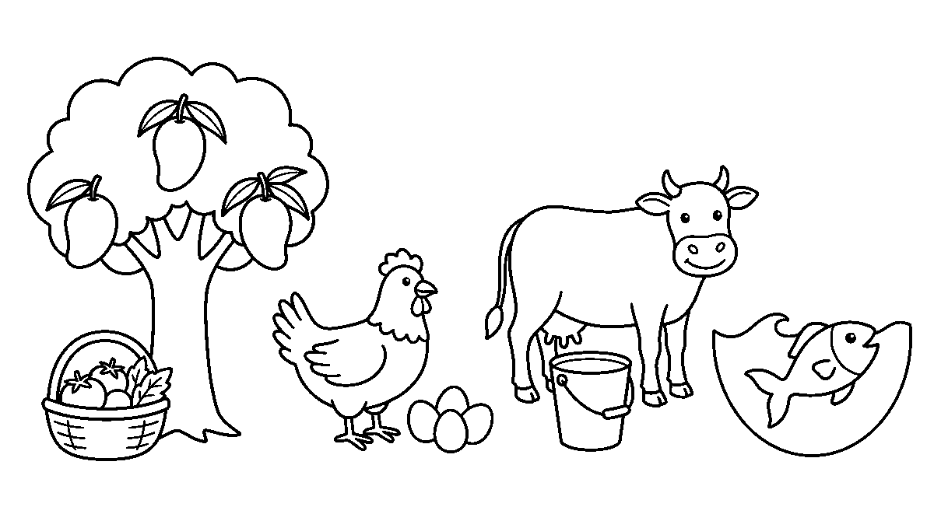
Worksheet
1. Food is anything we A) wear B) eat or drink C) play with D) sleep on
2. The meal we take in the morning is A) supper B) breakfast C) lunch D) dinner

3. We eat food mainly to get A) energy for work and play B) clothes C) a house D) friends
4. Which of these foods comes from an animal? A) maize B) egg C) rice D) yam
5. Fill in: The three main meals are breakfast, ____ and dinner.
6. Mention two reasons why the body needs food.
7. Write two sentences on the food you ate today and where it came from.
My own work
List five foods you ate this week and say for each whether it came from a plant or from an animal.
Draw the plate you ate from this morning: the plant food on one side, the animal food on the other, then colour both sides.

WEEK 2 — LIVING THINGS AND NON-LIVING THINGS
Depth: NERDC Nursery 3 · Basic Science and Technology · Second Term W4 (pp 494–497).
You will learn to
• say what a living thing is
• name the signs of life
• sort things into living and non-living
• observe living things around me
Things to know
• Living things are things that have life.
• Living things: people, animals, birds, fish, insects and plants.
• The seven signs of life — living things move, grow, feed, breathe, have young ones, answer what happens around them, and get rid of waste.
• Movement: an animal walks; a plant turns its leaves towards the light.
• Growth: a chick becomes a hen; a seedling becomes a big tree.
• Feeding: animals eat, plants take light and water from the soil.
• Breathing: every living thing takes in air; a fish breathes with gills in the water.
• Young ones: a hen lays eggs, a cow has a calf — that is reproduction.
• Answering the surroundings: a snail goes inside its shell when you touch it; you pull your hand away from something hot.
• Getting rid of waste: we pass urine and sweat; a tree drops its dry leaves — that is excretion.
• Non-living things — a stone, water, a chair, a bicycle — do not do any of these things by themselves.
• Living and non-living can go together: a river is non-living but fish live in it.
Words for my notebook
Living things have life. They move, grow, feed, breathe, have young ones, answer their surroundings and get rid of waste.
Let us talk
1. Is a mango tree living? Give me a reason.
2. Name two things in this room that are not living.
3. What does a snail do when you touch it?
4. Do fish drink water? How do they breathe?
5. Say three signs you look for before you call a thing living.

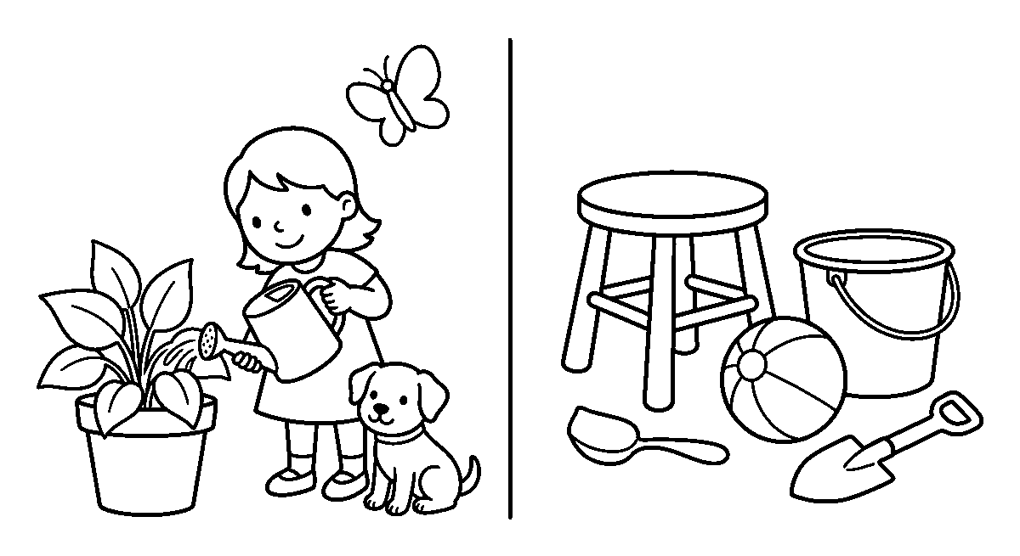
Worksheet
1. Living things are things that A) are found in the market B) can be carried C) make noise D) have life
2. Which of these is NOT living? A) snail B) orange tree C) stone D) hen
3. A baby growing into a child is a sign of A) waste B) breathing C) colour D) growth
4. A plant makes its food with light, air and A) sugar B) sand C) soil water D) chalk
5. Fill in: A fish breathes in water with its ____.
6. Name four signs of life.
7. Write two sentences about one living thing and one non-living thing you can see from the class window.
My own work
Look around your house and write down four living things and four non-living things you can see.

WEEK 3 — GROWTH IN ANIMALS
Depth: NERDC Nursery 3 · Basic Science and Technology · Second Term W7 (pp 494–497).
You will learn to
• say what growth means
• tell the young one of common animals
• put a life cycle in order
• say what animals need to grow
Things to know
• Growth is a change from small to big over a long time — not a thing that happens in one day.
• An animal's life cycle is the order of its growing: baby → young → adult.
• A human grows: baby → toddler → child → teenager → adult.
• A hen: egg → chick → young fowl → hen or cockerel.
• A dog: puppy → young dog → adult dog; a cat: kitten → adult cat.
• A frog: egg → tadpole → froglet → frog — the tadpole lives in water and swims like a fish.
• A butterfly: egg → caterpillar → chrysalis (pupa) → butterfly.
• As animals grow, their size increases, their features develop (wings, teeth, feathers) and at last they can have young ones of their own.
• Animals need food, water, air and shelter to grow; an animal without enough food stays small and weak.
• Baby animals that suck milk from their mothers are called mammals — dog, cat, cow, bat, and you.
• We can watch growth by keeping a snail, a fish or a chick in a box and writing what it does each day.
Words for my notebook
Growth is a slow change from small to big. Egg → chick → hen. A puppy grows into a dog.

Let us talk
1. What do you call a baby hen?
2. Which animal gives birth to a puppy?
3. How is a tadpole different from a frog?
4. Name two things an animal needs to grow.
5. In what way are you bigger now than in Nursery 1?
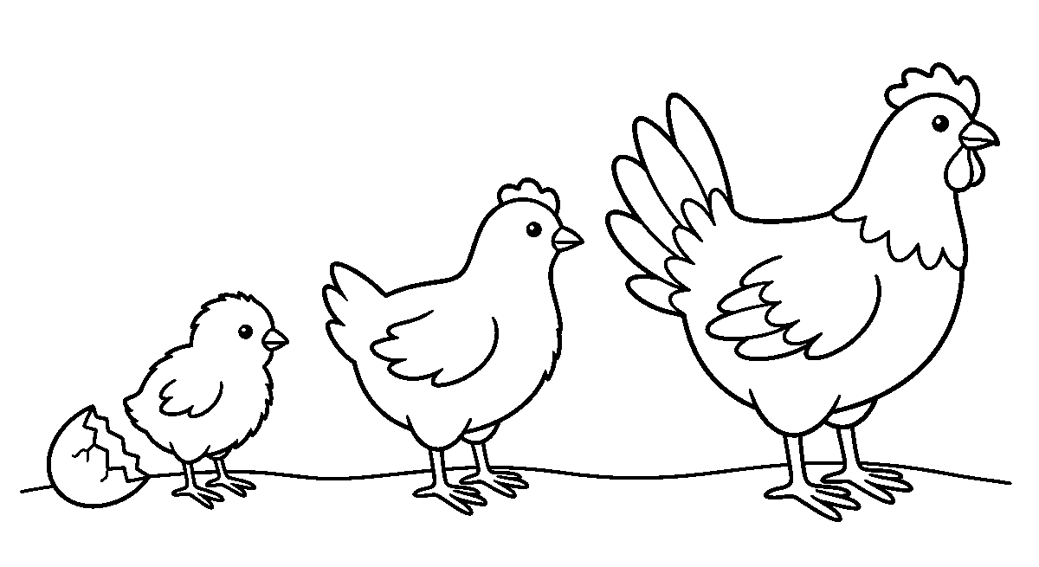
Worksheet
1. Growth means a change from A) hot to cold B) big to small C) small to big over time D) wet to dry
2. The young one of a hen is a A) chick B) foal C) kid D) calf
3. The first stage in the life of a butterfly is the A) pupa B) egg C) wing D) caterpillar
4. Which of these is NOT needed for an animal to grow? A) television B) food C) water D) shelter
5. Fill in: A baby dog is called a ____.
6. Put in order: frog, egg, tadpole, froglet.
7. Write two sentences about something you have seen grow at home.
My own work
Draw the life cycle of a hen in four boxes and write the stage under each box.

WEEK 4 — GROWTH IN PLANTS
Depth: NERDC Nursery 3 · Basic Science and Technology · Second Term W8 (pp 494–497).
You will learn to
• tell the stages of a plant's life
• name what a plant needs to grow
• plant a seed and care for it
• say what changes as a plant grows
Things to know
• A plant grows from a seed into a mature plant, and that plant makes new seeds again.
• The order is: seed → germination → seedling → young plant → mature plant → flowers → fruits → seeds.
• Germination means the seed begins to grow and pushes out its first root and shoot.
• The root grows down into the soil and holds the plant; the shoot grows up towards the light.
• Leaves come out, the stem becomes strong, flowers open, fruits form, and inside the fruit are seeds.
• A plant needs five things: water, sunlight, air, soil (or nutrients) and space.
• Keep a seed in a damp cloth and it will sprout without soil — but it needs soil later to stay strong.
• We plant beans in a tin of soil: water it a little every day, put it where the sun comes, and watch.
• Changes during growth: the plant gets taller, has more leaves, then flowers, then fruits.

• We do not pull young plants, we do not pour paraffin or salt on them, and we shade them from the hot afternoon sun.
• A plant that is not watered turns yellow and dries up; that is how we know it was alive.
Words for my notebook
Seed → seedling → young plant → big plant → flower → fruit → seed. A plant needs water, sunlight, air, soil and space.
Let us talk
1. Where does a new plant come from?
2. Which part grows first, the root or the flower?
3. What happens to a plant if we do not water it?
4. Name something that grows inside a fruit.
5. Why do farmers plant in the rainy season?
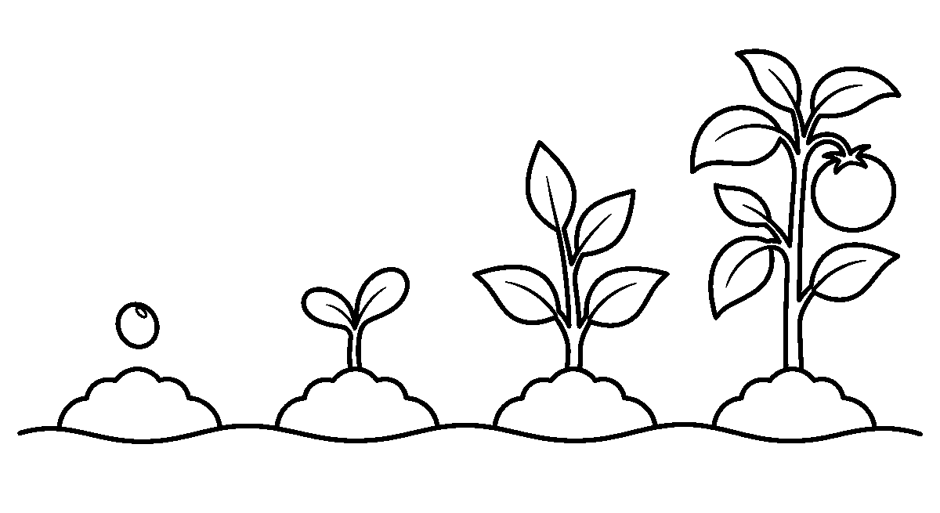
Worksheet
1. A new plant usually grows from a A) shell B) seed C) stone D) leaf only
2. The first part to come out of a germinating seed is the A) seed case B) root C) fruit D) flower
3. Which of these is NOT needed by a plant to grow? A) soil B) sunlight C) water D) music
4. The green part that comes up above the ground is the A) root B) seed C) shoot D) hair
5. Fill in: After the flower comes the ____, and inside it are seeds.
6. Write the four first stages of a plant's life in order.
7. Tell in two sentences how you watered and kept your class plant alive.
My own work
Plant one bean or seed in a tin, water it for five days, and write one line about what you saw each day.
Draw a seed, a small seedling and a tall plant in a row, and colour only the tall one.

WEEK 5 — WATER, AND HOW PEOPLE AND THINGS MOVE
Depth: NERDC Nursery 3 · Basic Science and Technology · Second Term W9 (pp 494–497).
You will learn to
• say what water is used for and where it comes from
• tell clean water from dirty water
• define transportation
• name means of transport on land, water and air
• keep safe while travelling
Things to know
• Water is used for drinking, cooking, bathing, washing, farming and for animals; living things cannot live long without it.
• Sources of water: rain, river, stream, well, borehole and the tap.
• Clean water is clear and has no bad smell; dirty water has mud, colour or smell in it.

• Transportation means moving people and things from one place to another.
• On land: car, bus, motorcycle, bicycle, lorry, train, wheelbarrow.
• On water: canoe, boat, ship, ferry.
• In air: aeroplane, helicopter.
• We travel to go to school, to work, to the market, to the hospital, and to move goods from farm to town.
• Safety in transport: seat belt in a car, life jacket on a boat, hold the rail on a bus, and follow the traffic lights and the zebra crossing.
• A motorcycle is dangerous without a helmet; we never sit on the back of a lorry.
• Water and transport meet: a river can be a road for a canoe, and a ferry carries cars across the water.
Words for my notebook
Water comes from rain, rivers, wells, boreholes and taps. Transport on land, on water and in the air. Buckle the seat belt, wear a life jacket.
Let us talk
1. Name three things you use water for at home.
2. Where does your house get its water?
3. Which vehicle do you come to school in?
4. What must you wear on a motorcycle?
5. How does a canoe move on the river?
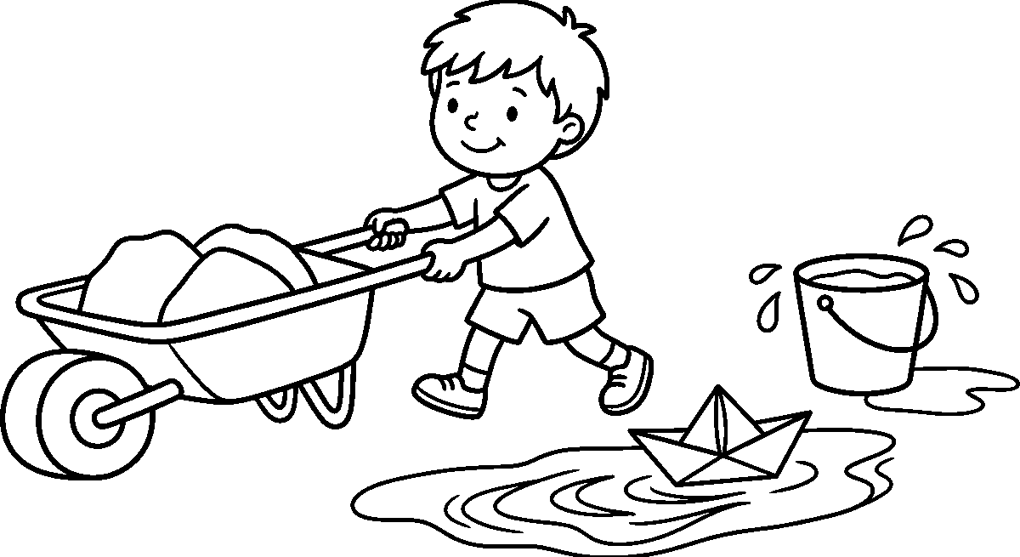
Worksheet
1. Which of these is a source of water? A) borehole B) marketplace C) bicycle D) classroom
2. A vehicle that carries many people to school is a A) bus B) canoe C) plane D) train only
3. Which one travels on water? A) helicopter B) bicycle C) ferry D) lorry
4. In a car we should always wear a A) seat belt B) helmet C) school bag D) life jacket
5. Fill in: Transportation means moving people and things from one ____ to another.
6. Mention four uses of water.
7. Write two sentences on how you travel to school and what you do to be safe.
My own work
Count the vehicles that pass your street for five minutes and write down how many of each kind you saw.

WEEK 6 — BONES: THE FRAME INSIDE MY BODY
Depth: NERDC Nursery 3 · Basic Science and Technology · Second Term W10 (pp 494–497).
You will learn to
• say what bones are and where they are
• name the big bones of the body
• tell what bones do for us

• say how to keep bones strong
Things to know
• Bones are the hard parts inside the body; all the bones together are the skeleton.
• Without bones the body would fall down like a sack of water.
• Bones give the body shape, they support it, they protect the soft parts inside, and with muscles they help us move.
• The skull (the bone of the head) protects the brain.
• The ribs are the bones of the chest; they protect the heart and the lungs.
• The spine is the bone of the back; it lets me bend and keeps me upright.
• The arm bones and the leg bones are long bones; the fingers have many small bones.
• Feel your arm: the hard part under the skin is the bone. Now bend it — that is the joint.
• Bones are still growing at my age; that is why a child must not lift heavy things.
• To keep bones strong: milk, eggs, fish and beans (calcium), playing and running, and sunlight in the morning.
• A broken bone is put in a plaster cast by a doctor and it joins again; we do not pull a hurt arm.
Words for my notebook
Bones are hard parts inside the body. The skeleton gives shape, supports, protects and helps me move. The skull guards the brain.
Let us talk
1. What protects your brain?
2. Where are the ribs?
3. How many bones can you feel in one finger?
4. Name two foods that make bones strong.
5. What does a doctor do for a broken bone?
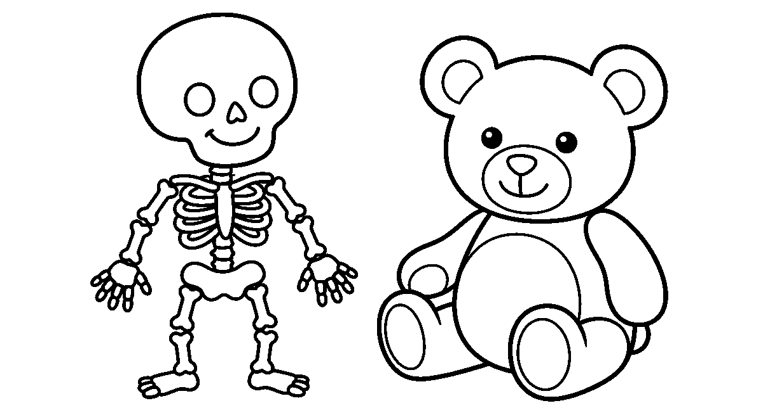
Worksheet
1. Bones are found A) in the soil B) only in the head C) inside the body D) outside the body
2. The bone of the head is called the A) arm B) spine C) rib D) skull
3. The ribs protect the A) heart and lungs B) ears C) stomach only D) brain
4. Which of these makes bones strong? A) sweets only B) milk and eggs C) cold water D) sleeping all day
5. Fill in: All the bones of the body together are called the ____.
6. Name three things bones do for us.
7. Write two sentences on what you eat and do so that your bones grow strong.
My own work
Count and write the number of bones you can feel in your own fingers, then draw a skeleton and label the skull, the spine and the ribs.

WEEK 8 — TECHNOLOGY AND THE MOBILE PHONE
Depth: NERDC Nursery 3 · Basic Science and Technology · Second Term W11 (pp 494–497).
You will learn to
• say what technology means
• name the things people use every day because of technology
• tell what a mobile phone is used for
• keep myself safe with a phone
Things to know
• Technology means the tools and machines people make to do work more easily.
• Old way, new way: we once carried water in a clay pot; now we have a tap and a pump.
• Things made by technology: torch, fan, radio, refrigerator, sewing machine, bicycle, car, generator, phone.
• A mobile phone is a device for talking to people far away without a wire.
• A phone can call, send a message, take pictures, play music, and teach (letters, numbers, stories).
• A phone is very useful in an emergency: calling for help when somebody is hurt or sick.
• A phone is not a toy; it is small, easily dropped, and its screen can break.
• Ask before you use a grown-up's phone; never take a phone that is not yours.
• Do not play with a phone that is charging, and do not touch a charging cable with wet hands.
• Too much time on a phone makes the eyes tired and takes away playtime; a phone is a servant, not a master.
Words for my notebook
Technology is the tools and machines people make to do work easily. A phone calls, messages, photographs and teaches. It is not a toy.
Let us talk
1. Name a machine at home that makes work easier.
2. What does a phone do besides calling?
3. When should we use a phone for help?
4. What is used in your house to keep food cold?
5. Why should a child not stare at a small screen all day?

Worksheet
1. Technology means A) tools people make to do work easily B) animals we keep C) songs we sing D) things found in the bush
2. A phone is mostly used to A) sweep the house B) pound yam C) press clothes D) talk to people far away
3. Which of these is NOT something a phone can do? A) take pictures B) play music C) cook rice D) send messages
4. We should use the phone when A) it is charging in the socket B) somebody is hurt and we need help C) it belongs to a neighbour D) we are swimming

5. Fill in: A phone is not a ____.
6. Mention three machines at home that are made by technology.
7. Write two rules you will keep when you touch a phone.
My own work
Write the name of five machines at home and say one thing each of them does for the family.

WEEK 9 — MAKING WATER SAFE TO DRINK
Depth: NERDC Nursery 3 · Basic Science and Technology · Third Term W1 (pp 497–502) — the school places this week in the second term.
You will learn to
• say why dirty water must be made clean
• name the ways of purifying water
• put the steps of cleaning water in order
• say why we drink only clean water
Things to know
• Purification of water means making dirty water clean and safe to drink.
• We purify water to remove the dirt, to kill the germs, and to keep away the diseases that come from bad water.
• Boiling means heating water until it bubbles for some minutes; this kills germs and it is the common way in the home.
• Boiled water must be left to cool in a clean covered cup before drinking.
• Filtration means passing water through a filter (cloth, sand and charcoal) so the dirt is left behind.
• Adding chemicals means putting in chlorine or a water purification tablet to kill germs.
• Settling and decanting means letting the dirt fall to the bottom, then pouring the clear water off the top.
• In the factory, water goes through all four of these before it enters the pipe — so tap water at a treatment plant is already treated.
• Water from a stream, a pond or a hand-dug well must be boiled or filtered before drinking.
• A covered cup keeps dust and flies out; an open bucket collects them.
• Dirty water brings sickness to the stomach; clean water keeps the body well.
Words for my notebook
Boiling, filtering, adding chlorine, letting it settle — these are the ways we make water safe to drink.
Let us talk
1. Where does your family get drinking water?
2. What do we do to water before drinking it?
3. Why must we cover the cup?
4. Can dirty water make somebody sick? How?
5. Which of the four ways do you see at home most?
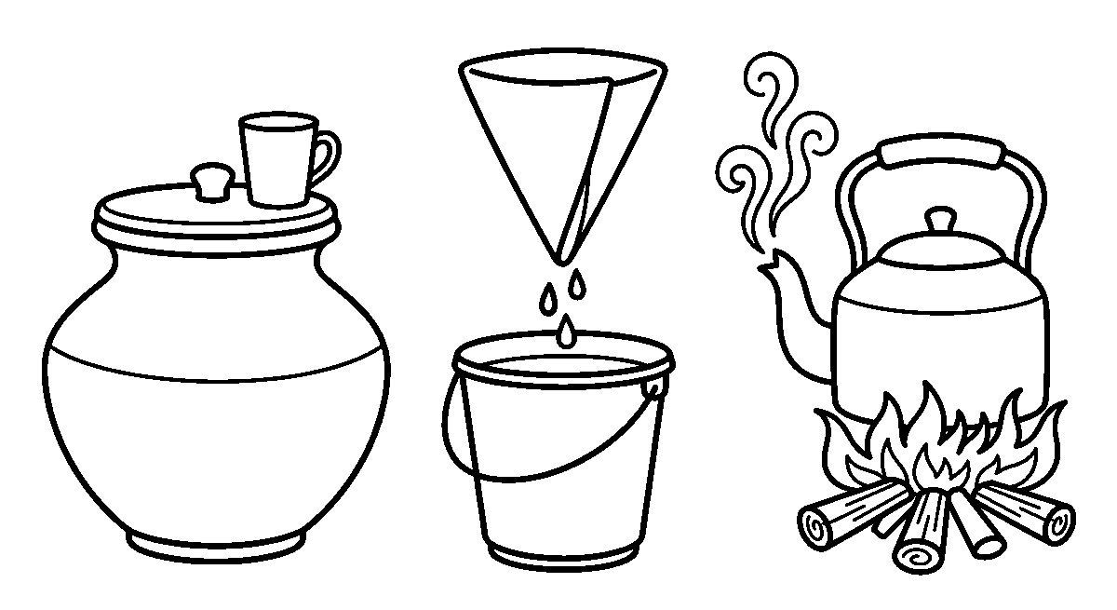

Worksheet
1. Purifying water means making it A) salty B) clean and safe to drink C) hot for bathing D) colourful
2. The common way of making water safe at home is A) keeping it in the sun B) shaking it C) adding pepper D) boiling it
3. Which of these removes dirt from water by passing it through cloth or sand? A) boiling B) singing C) filtration D) settling
4. Chlorine is used to A) kill germs in the water B) colour the water C) warm the water D) sweeten the water
5. Fill in: Before drinking, boiled water must be allowed to ____.
6. Mention two reasons why we purify water.
7. Write the four steps you would use to make river water safe, in order.
My own work
Watch how water for drinking is prepared at home and write the steps in the order you saw them.

CULTURAL AND CREATIVE ARTS (CCA)
Weeks 1 to 6, 8 and 9. Week 7 is Mid-Term Break, Week 10 Revision, Week 11 Examination, Week 12 Closing — those weeks carry no note. Depth: NERDC 2025 · Nursery 2 · Creativity · Second Term W4, W8, W9 and Third Term W1, W2, W4, W8 (pp 415–420), read with the Nursery 3 band (pp 568–575) for the same topics.

WEEK 1 — MAKING AND DESIGNING A HAND FAN
Depth: NERDC Nursery 2 · Creativity · Second Term W4 (pp 415–417); Nursery 3 · Creativity · Second Term W4 (pp 568–571).
You will learn to
• say what a fan is for
• cut and fold a fan from cardboard or thick paper
• fix a handle to my fan
• decorate my fan with a pattern I made myself
Things to know
• A fan is a flat thing we move to and fro so that air comes to us — it keeps us cool.
• Two kinds we can make: the paddle fan (one flat piece with a handle) and the folding fan (paper folded like a fan and joined at one end).
• Materials: cardboard or thick paper, popsicle sticks, glue or tape, crayons, paint, stickers.
• Steps: cut the shape → colour or draw on the flat side → fix the stick handle at the back → let the glue dry → wave it to test it.
• A pattern is a design that repeats: red, blue, red, blue · zigzag, dot, zigzag, dot.
• Folding for the folding fan: turn the paper back and forth in little folds like a plate, then join both ends with a thread or tape.
• The handle must be firm: hold the fan by the stick and shake it — if the paper falls, the glue needs more time.
• Cardboard is stiff and keeps its shape; tissue paper is soft and tears, so thick paper is better for the paddle.
• Art is not only for looking — a fan is a thing I made and can still use on a hot day; that is functional art.
• Care: scissors cut paper, not hair or fingers; the glue pot is closed again; the table is wiped clean.
• We end with a fan wave: everybody stands, counts four, and waves their own fan — the coolest class in the school.
Words for my notebook
A fan moves air and keeps us cool. Cardboard, handle, pattern, glue, dry, wave.
Let us talk
1. What do you use a fan for?
2. Which shape did you cut for your fan?
3. Say the colours of your pattern in order.
4. Why do we put the stick at the back and not in the middle?
5. What other thing at home moves air?
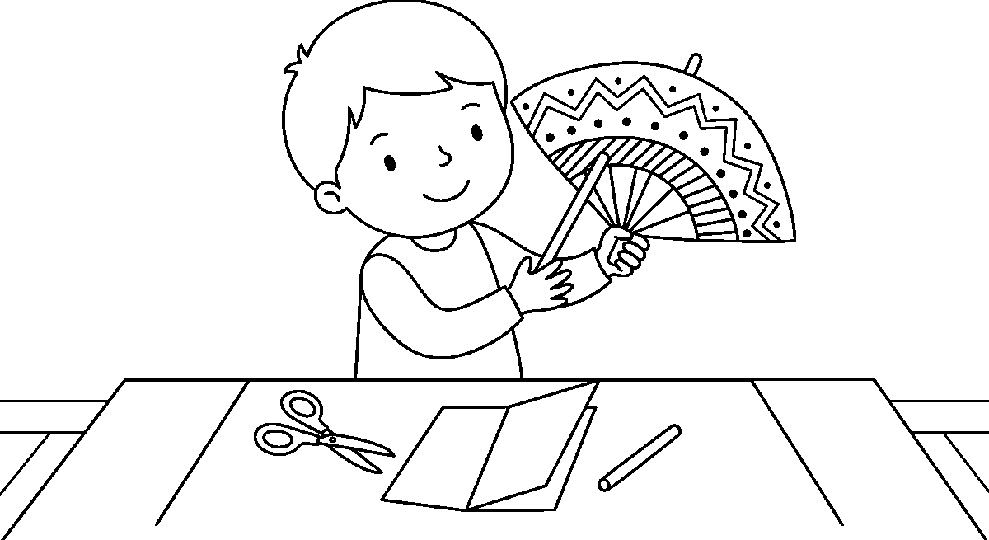

Worksheet
1. A fan is used to A) keep us cool B) cut paper C) carry books D) boil water
2. The stick we hold a fan by is the A) cover B) wing C) spine D) handle
3. A design that repeats is called a A) pattern B) song C) picture D) story
4. Which material is best for a paddle fan? A) cardboard B) cloth of water C) tissue paper D) a leaf only
5. Fill in: The two kinds of fan we can make are the paddle fan and the ____ fan.
6. Say three materials you used to make your fan.
7. Write two sentences on your fan: its shape, its colours and its pattern.
My own work
Wave-test your fan at home on a hot afternoon and write one line about whether it threw enough air; then draw its pattern again in your book.

WEEK 2 — COLOUR SPLASH ART
Depth: NERDC Nursery 3 · Creativity · Second Term W7 (pp 568–571).
You will learn to
• splash paint on paper in a controlled way
• wear my apron and cover my table first
• mix two colours and watch a third appear
• say what abstract art means
Things to know
• Colour splash (splatter) art is made by throwing small drops of paint on paper — not by drawing lines.
• Before paint touches anything: apron on, table covered, sleeves up; paint that dries on cloth is very hard to remove.
• Three ways to splash: flick the wet brush with a finger, drop paint from a height, or tap the brush against a stick.
• From high up the drops are small and many; from low down they are big and few — that is how I control the mess.
• A toothbrush and a comb make a fine spray: pull the brush teeth with a finger over the comb.
• Two colours mixed: blue + yellow = green · red + yellow = orange · red + blue = purple.
• Water makes the colour light; little paint and much water give a pale splash.
• Abstract art does not look like a thing; it shows a feeling — fast lines for joy, dark splashes for anger.
• A famous splash painter, Jackson Pollock, laid his paper on the floor and moved the paint with sticks and his body.
• Name the feeling in your own splash: is it a happy day or a rainy day?
• Cleaning up: brush in the water pot, drops wiped from the table, hands washed with soap, paper left flat to dry.
Words for my notebook
Splash, flick, drop. Blue and yellow make green. Art that shows a feeling and not a thing is called abstract.
Let us talk
1. What do we wear before painting?
2. Show me the hand movement for a flick.
3. Which two colours make purple?
4. Is your splash fast or quiet? What feeling is in it?

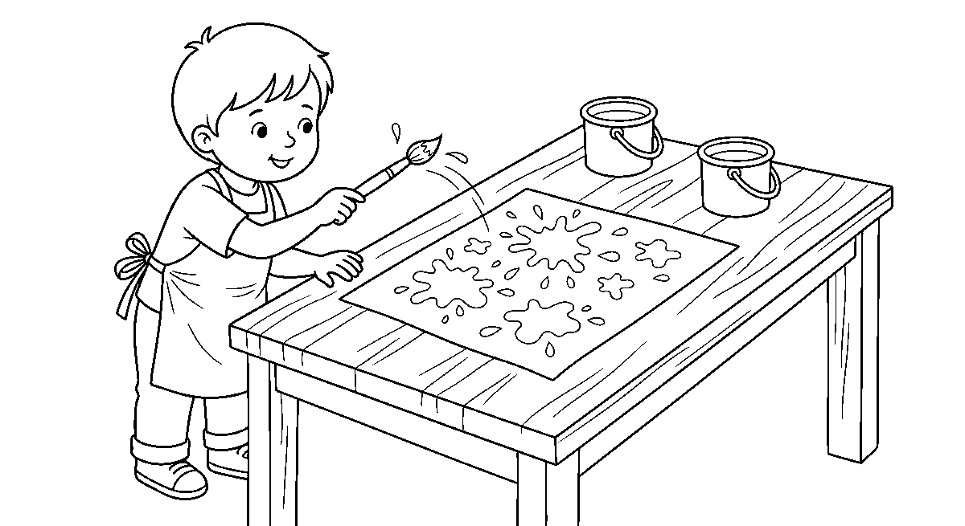
Worksheet
1. Colour splash art is made with drops of A) chalk B) water only C) paint D) clay
2. Before we splash paint we put on an A) apron B) hat only C) school shoe D) glove of straw
3. Blue and yellow mixed together give A) orange B) brown C) green D) black
4. Art that shows a feeling instead of a thing is A) abstract B) a map C) a letter D) a copy
5. Fill in: To make a fine spray we use a toothbrush and a ____.
6. Mention two ways of making drops fall on the paper.
7. Write two sentences on the feeling your splash picture shows.
My own work
Make one splash picture on a small sheet that says "rainy day" and one that says "party day", and write the feeling under each.

WEEK 3 — SPIKY HEDGEHOG
Depth: NERDC Nursery 2 · Creativity · Second Term W8 (pp 415–417); Nursery 3 · Second Term W8 (pp 568–571).
You will learn to
• draw or trace the body of a hedgehog
• make spikes with a fork and with paper strips
• colour the animal brown or grey
• put my hedgehog in a home of leaves and grass
Things to know
• A hedgehog is a small animal with a round body, a pointed nose, short legs and many spikes on its back.
• It rolls into a ball of spikes when it is frightened; the soft front is what it keeps safe.
• Draw the body as a big half circle, then add a pointed nose, two eyes and four small feet.
• For the spikes, dip a fork in paint and print it across the back — the fork teeth leave a fan of lines.
• Other spike ways: glue cut paper strips standing up, press on safe little twigs, or draw spikes with a pencil.
• Mixed media means using more than one material in one picture: paint + paper + twigs.
• Texture is how a thing would feel: smooth, rough, spiky, soft — a hedgehog picture should feel rough.
• Colours of a hedgehog: brown, grey, dark tan, with a lighter face.
• The background is its habitat: grass, dry leaves, a garden wall, the moon at night (it walks at night).
• Glue is spread with a stick, not a finger; too much glue makes the paper wet through.
• The finished hedgehog goes on the class board under the title "Spiky and Safe".
Words for my notebook
A hedgehog has a round body, a pointed nose and spikes on its back. Fork print, paper strips and twigs all make texture.

Let us talk
1. What does a hedgehog do when it is afraid?
2. Which part of the hedgehog is soft?
3. Show me how you press the fork for spikes.
4. Name two materials you used besides paint.
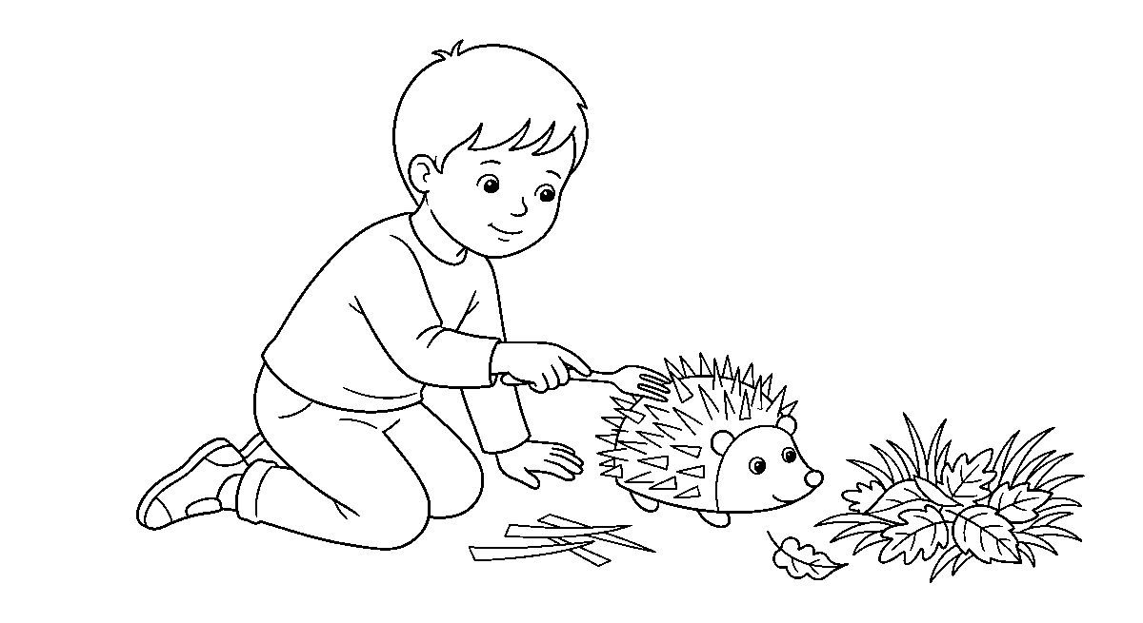
Worksheet
1. A hedgehog's back is covered with A) spikes B) hair only C) feathers D) scales
2. The front of the hedgehog ends in a A) big ear B) pointed nose C) shell D) long tail
3. Using paint, paper and twigs together in one picture is called A) modelled art B) mixed media C) mixing D) splash art
4. How a thing would feel is its A) texture B) name C) colour D) size
5. Fill in: A hedgehog rolls into a ____ when it is frightened.
6. Name three ways of making spikes for your hedgehog.
7. Draw a hedgehog, give it spikes and one line of grass under it.
My own work
Make a second hedgehog in the same size from only paper (no paint), then compare the two and say which one feels spikier.

WEEK 4 — PAPER COLLAGE AND THE FRIENDSHIP TREE
Depth: NERDC Nursery 2 · Creativity · Second Term W9 (Paper Collage, pp 415–417) and Third Term W1 (Friendship Tree, pp 418–420) — the school keeps both in one week, so this note takes both.
You will learn to
• tear and cut coloured paper into small pieces
• stick the pieces inside a drawn shape
• make a tree that carries the names of my friends
• say what patience does for my work
Things to know
• A collage is a picture made by sticking pieces of material on a surface.
• Tearing gives soft, feathered edges; cutting gives hard, straight edges — good pictures use both.
• Fill the inside of the shape, not outside it: the drawing is the wall of the room.
• Small pieces go near the edge, bigger ones in the middle — the shape stays tidy.
• Composition means how things are put together: what is big, what is small, what goes in front.
• Glue is spread little by little with a stick; a wet finger makes the paper wrinkle.
• The friendship tree: draw a strong trunk and wide branches; the leaves are our hand prints or cut paper leaves.
• One leaf carries one name — my own, my friends', my class mates' — so the tree is the class.
• A tree with many leaves stands better than one with two; so everybody's name goes on.

• Collage work takes patience: it is slow, and slow work looks careful.
• When it is finished we stand back and look: can we see the shape of the tree? Are the names readable?
Words for my notebook
Collage means sticking torn or cut paper into a shape. Our friendship tree carries a name on every leaf.
Let us talk
1. What is a collage?
2. Which edge is nicer for the tree trunk — torn or cut?
3. How many names are on your tree?
4. Why is patience part of art?
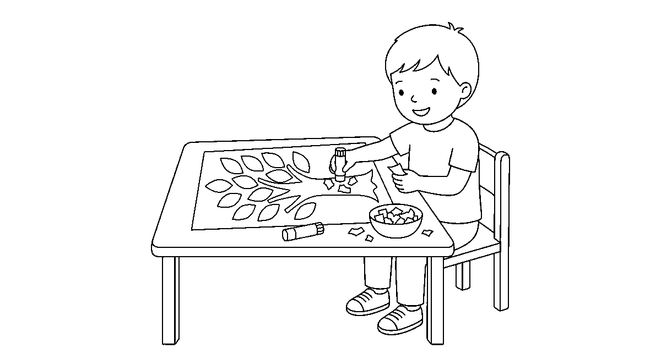
Worksheet
1. A collage is a picture made by A) pouring water B) sticking pieces on a surface C) tying ropes D) singing
2. Torn paper gives an edge that is A) hard B) soft and feathered C) hot D) straight
3. A tree whose leaves carry names in our class is the A) palm tree B) mango tree only C) friendship tree D) family tree
4. How the parts of a picture are put together is its A) glue B) paper C) composition D) size
5. Fill in: Glue is spread little by little with a ____.
6. Mention two things you cut or tore for your collage.
7. Write two sentences on why everybody's name was needed on the friendship tree.
My own work
Cut five small pieces of paper and make a house on a fresh sheet with them: roof, wall, door and a garden.

WEEK 5 — MAKING JEWELLERY
Depth: NERDC Nursery 2 · Creativity · Third Term W2 (pp 418–420); Nursery 3 · Second Term W11 (pp 568–571).
You will learn to
• thread beads in a pattern
• make a necklace, a bracelet and a ring
• match colours that look good together
• keep small things away from the mouth
Things to know
• Jewellery is the ornament people wear: necklace, bracelet, ring, anklet and bead for the wrist.
• Safe materials: big beads, painted pasta shells, buttons, paper beads, pieces of straw, thread or yarn.
• Paper beads: cut a long triangle of paper, roll it from the wide end on a stick, glue the tip, and let it dry — it becomes hard like wood.
• A pattern or sequence is an order that repeats: red, red, blue · red, red, blue.
• Count as you thread: two small, one big, two small, one big.

• Colour matching: yellow looks bright beside blue; white goes with everything; too many colours make the pattern hard to see.
• The thread must be knot-ty at the end; a knot is tied before threading so the beads do not fall off the back.
• To finish: tie the two ends twice and pull — a bracelet is a ring with a knot.
• Safety: beads are not for the mouth, the nose or the ear; a small bead swallowed is dangerous and must be reported at once.
• Scissors cut the thread only; the needle (a blunt plastic one) is carried point-down.
• We wear our own work for one song, then the jewellery goes home in a pouch, not in a pocket.
Words for my notebook
Necklace, bracelet, ring. Red, red, blue — the pattern repeats. Beads never go into the mouth.
Let us talk
1. Say the pattern of your necklace in words.
2. How do we stop the beads falling off the thread?
3. Which colours did you choose, and why?
4. Name one thing that is never safe to put in your mouth.
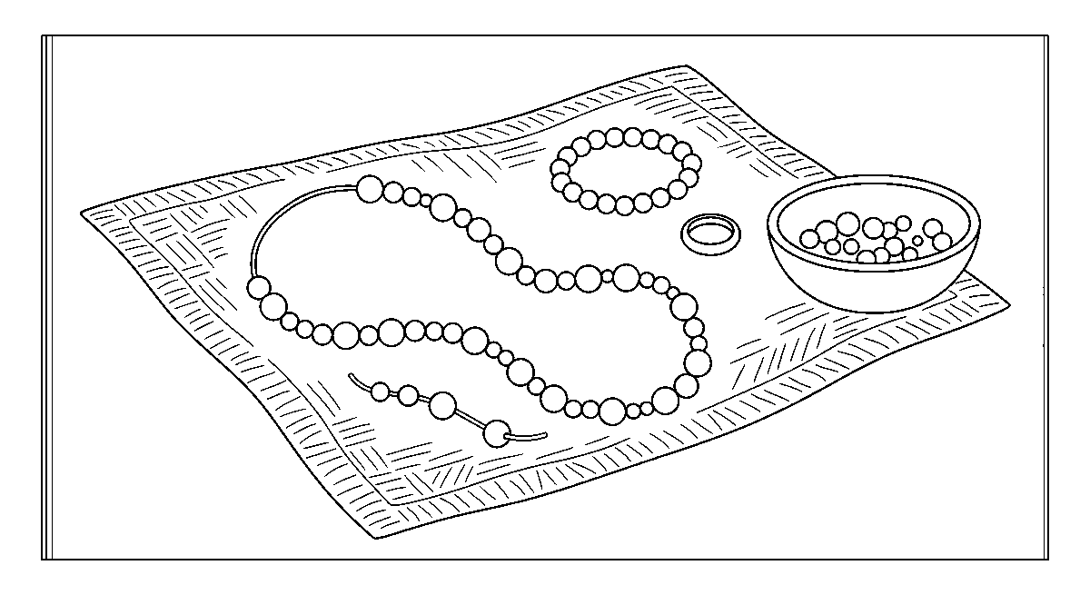
Worksheet
1. Which of these is jewellery worn on the wrist? A) collar B) bracelet C) anklet D) necklace
2. A roll of paper glued and dried can be used as a A) plate B) bead C) cup D) shoe
3. Two small, one big, two small, one big is a A) colour B) song C) story D) pattern
4. Before we tie the ends we must make a A) drawing B) hole C) mark of chalk D) knot
5. Fill in: A bead must never be put into the ____.
6. Name three materials we threaded with.
7. Write two sentences on the necklace you made and the pattern in it.
My own work
Make one bracelet for somebody at home from the last of your beads, and say what colours you chose for them.

WEEK 6 — RUBBER AND FOAM COLLAGE
Depth: NERDC Nursery 3 · Creativity · Third Term W2 (pp 572–575).
You will learn to
• cut shapes from craft foam
• glue foam on paper in layers
• tell a flat collage from a 3D one
• say why a soft material is fun to build with
Things to know
• A foam collage is a picture made by sticking cut pieces of foam or soft rubber on paper.
• Foam comes in craft foam sheets, in old slippers, in sponge and in the packing foam things are sold in.

• Foam is soft, so the scissors must be sharp and small, and the cut is made on a board, not on the hand.
• Flat collage lies on the paper; 3D (dimensional) collage rises up from it because pieces are stacked.
• Layering means sticking one piece on top of another: a big green leaf, then a small dark green leaf on it.
• Layering makes the picture look near and far: the biggest piece is nearest to me.
• Foam holds its shape, so a foam animal has a body that stands out; paint on it looks soft, not shiny.
• Glue for foam must be thick (paste or fabric glue); watery glue lets the piece lift up again after a while.
• Weight matters: too many layers make the paper bend — the base sheet should be card, not foolscap.
• Spatial awareness is what I am learning here: which piece goes above, below, beside or behind another.
• Clean hands before the work is done; foam scraps go in the box, not on the floor for the class to slip on.
Words for my notebook
Cut, layer, press. A flat collage lies down; a 3D collage stands up.
Let us talk
1. Where does the biggest piece of foam go?
2. What kind of glue holds foam best?
3. Name one thing you would not cut foam on.
4. Is your picture flat or raised? Show me.
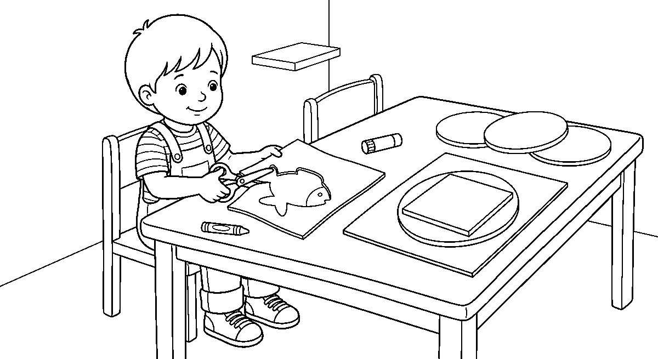
Worksheet
1. A foam collage is a picture made of A) song B) water C) sand only D) cut foam pieces
2. A picture that rises up from the paper is called A) 3D B) old C) quiet D) flat
3. Sticking one piece on top of another is A) waving B) counting C) tearing D) layering
4. Which base is best for a heavy foam picture? A) cardboard B) a leaf C) cloth of water D) foolscap paper
5. Fill in: Foam is soft, so we cut it on a ____, not on the hand.
6. Mention two things that can give us foam for collage.
7. Write two sentences on your foam picture: what you cut and what you layered.
My own work
Cut three foam shapes and build an animal with them on a card — two shapes must be layered under the others.

WEEK 8 — SAND COLLAGE
Depth: NERDC Nursery 2 · Creativity · Third Term W4 (pp 418–420); Nursery 3 · Third Term W3 (pp 572–575).
You will learn to
• put glue only where the sand must stick
• sprinkle sand and shake off the extra
• use sand of different colours

• say what texture a sand picture has
Things to know
• A sand collage is a picture with parts of it covered in sand, so that it feels rough and grainy.
• Steps: draw the picture → paint glue on one small area at a time → sprinkle sand over it → shake off what did not stick → let it dry.
• Glue the parts first with clean paper beside them, or the sand will stick everywhere.
• Natural sand is pale yellow; sand can be coloured by mixing it with a little dry cement or paint powder and drying it on paper.
• Different sands give different feelings: fine sand is smooth, coarse sand is rough, gravel is bumpy.
• Sand is a natural material — like clay, stick, leaf and shell, it came from the earth and not from a factory.
• Sections: sky (no sand), beach (fine sand), sea (blue paper), rocks (grit) — the eye sees the difference.
• Sprinkle low and gently; from a height the sand flies out of the shape.
• Sand goes on the paper, not on the floor, and never near the eyes; hands are washed after the work.
• Extra sand is poured back into the tin — it is still good for the next class.
• A sand picture is finished when the glue is dry and the surface is firm: touch it and it should not move.
Words for my notebook
Glue a small area, sprinkle, shake off the extra, let it dry. Sand is a natural material; it gives texture.
Let us talk
1. What does a sand picture feel like?
2. Why do we put glue only on part of the drawing?
3. Name one other thing that comes from the earth and is used in art.
4. What do we do with the sand that does not stick?
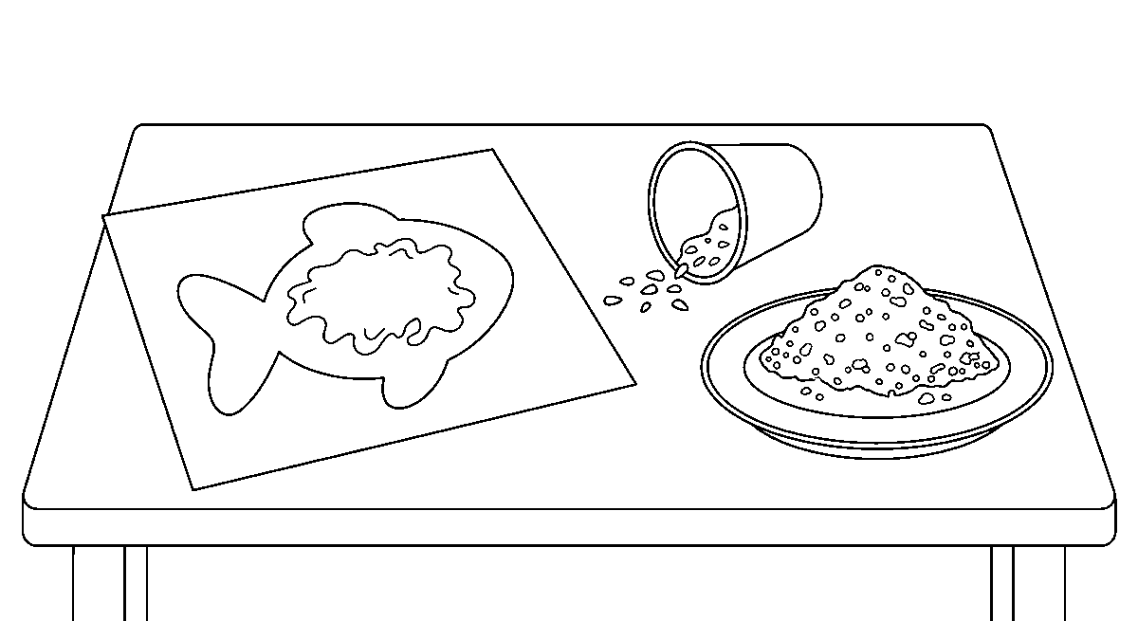
Worksheet
1. In a sand collage, sand sticks because of A) glue B) sun C) water D) chalk
2. After sprinkling sand we ____ A) burn it B) press with the foot C) shake off the extra D) wet it again
3. Sand, clay and shells are A) painted things B) natural materials C) factory things D) soft foods
4. Which part of a beach picture is best left without sand? A) the rocks B) the path C) the sand bank D) the sky
5. Fill in: Coarse sand feels ____ while fine sand feels smooth.
6. Say the four steps of putting sand on a picture, in order.
7. Write two sentences on the texture of your sand picture and where you got the sand.
My own work
Collect a little sand at home, dry it on paper in the sun, and use it to fill one shape you have drawn.

WEEK 9 — DESIGNING A CONE HAT
Depth: NERDC Nursery 2 · Creativity · Third Term W8 (pp 418–420); Nursery 3 · Third Term W8 (pp 572–575).
You will learn to
• roll paper into a cone
• fix the cone so that it keeps its shape
• decorate my hat with ribbons, stars and colour
• wear my hat in the class parade
Things to know
• A cone hat is a hat that comes to a point at the top, like a party hat or the cap of a fishing net.
• Roll a fan-shaped piece of cardboard: the wide arc becomes the bottom, the point becomes the top.
• A sector is that fan shape — a circle with a wedge cut out of it.
• Hold the roll with a clothes pin while the glue dries; tape or staples can do the same work.
• Do not roll it too tight — the head must go inside; try it on a friend's head before the glue sets.
• Decorate with paint, crayons, stickers, ribbons, pom-poms, paper stars and streamers; a hat is the place for the brightest colours.
• A band of paper round the base hides the rough edge and makes the hat stronger.
• To keep it on the head, thread an elastic or string through two holes at the base and tie it.
• The hat parade: one by one, walk to the drum, turn at the end of the line, and come back; nobody laughs at another's hat.
• Wearable art is 3D art — it moves with the body, so it must be light and must not cover the eyes.
• When the parade is over, the hat is kept on a shelf, not folded — a cone that is crushed cannot be opened again.
Words for my notebook
Roll, hold, glue, dry, decorate, wear. A cone hat has a point at the top and a band at the base.
Let us talk
1. What shape must the paper be before you roll it?
2. What holds the roll while the glue dries?
3. Which decorations did you put on your hat?
4. Why must the hat be light?
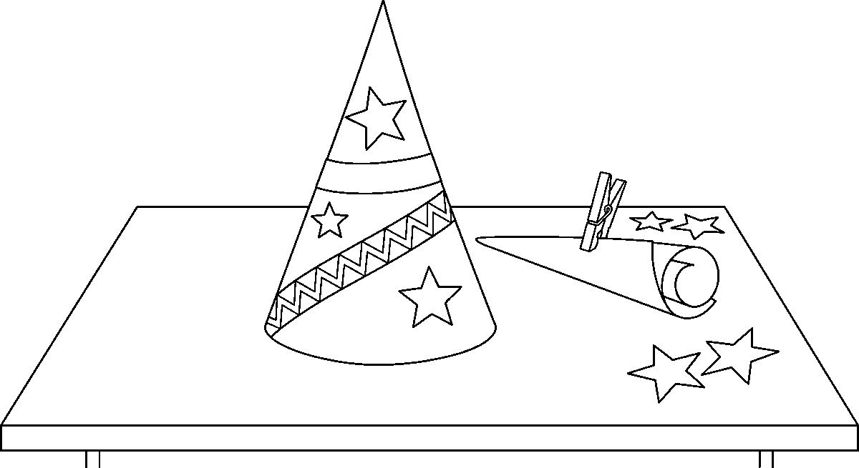
Worksheet
1. A cone hat ends at the top in a A) point B) flat board C) hole D) wheel
2. Before rolling, the paper is cut in the shape of a A) square B) triangle of cloth C) long rope D) circle with a wedge out
3. While the glue dries, the roll can be held with a A) shoe B) stone C) clothes pin D) wet cloth
4. A band of paper round the base of the hat A) hides the eyes B) makes it heavier C) shortens it D) hides the rough edge

5. Fill in: To keep the hat on the head we tie an ____ or string under the chin.
6. Mention four things used to decorate a cone hat.
7. Write two sentences on your hat and what happened in the class hat parade.
My own work
Make a small cone hat for a doll or a bottle from a leftover piece of paper, and give it one pattern of three repeating colours.

CHRISTIAN RELIGIOUS STUDIES (CRS)
Weeks 1 to 6, 8 and 9. Week 7 is Mid-Term Break, Week 10 Revision, Week 11 Examination, Week 12 Closing and Awards — those weeks carry no note. Depth: NERDC 2025 · Primary 1 · Christian Religious Studies · Second Term W1–W10 (pp 640–641) and Third Term W1–W2 (pp 642–643) — the school moves these topics down to Nursery 2, so each week is written at Nursery 2 language with the Primary 1 content kept whole.

WEEK 1 — GOD IS OUR FATHER (PART 1)
Depth: NERDC Primary 1 · CRS · Second Term W1 (pp 640–641).
You will learn to
• say that God is my Father in heaven
• tell how God loves and cares for me
• name the good things God gives me every day
• say how a father on earth is different from God
Things to know
• A father in the family is the man who owns the house, works and takes care of the children.
• God is my Father in heaven — He is not in the house, He is in heaven, but He still keeps me and gives me all good things.
• God loves me: the Bible says God so loved the world that He gave His only Son (John 3:16).
• God cares for me: He gives rain, sunshine, food, sleep and the people who keep me.
• God provides: He gave birds food, and He gives me my daily bread.
• A father on earth is a man; he can be far away, he can be tired, he can die. God is a spirit — He is always near, never tired, and He never dies.
• A father can give a shoe; God gives the feet that put on the shoe.
• God's love is perfect — it has no mistake in it; God's love is everlasting — it does not finish.
• Nobody is too small for God: the little child in the class is as much God's child as the big man.
• I am not God's child because I am good; I am God's child because God chose to love me.
• We close with a small prayer: Thank you God, our Father, for today.
Words for my notebook
God is my Father in heaven. He loves me, cares for me and provides for me.
Let us talk
1. Who is your father at home?
2. Who is your Father in heaven?
3. Name three things God gave you today.
4. How is God different from the father at home?
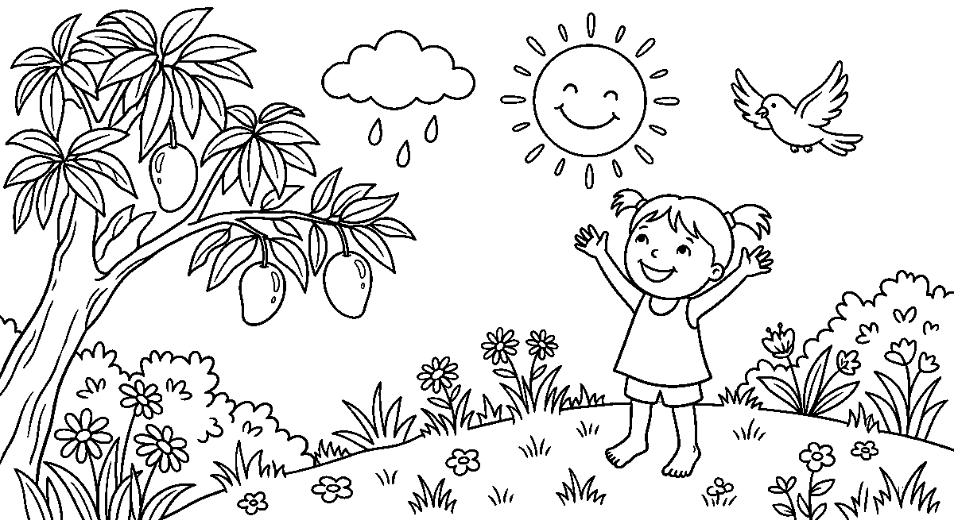
Worksheet
1. God is called our Father in A) school B) the market C) heaven D) the river

2. God's love for us is described as perfect and A) far B) everlasting C) cold D) small
3. Which of these shows that God provides? A) He sleeps B) He gives rain and food C) He cannot hear D) He is far away
4. A father on earth and God are different because God A) eats our food B) is a spirit and never dies C) goes to work D) lives next door
5. Fill in: The Bible says God so loved the ____ that He gave His only Son.
6. Mention three ways God cares for you.
7. Write two sentences on why God is called your Father.
My own work
Count the good things that came to you today and write four of them in your book as thanks to God.
Draw your own home and colour the window that is lit in the evening.

WEEK 2 — GOD IS OUR FATHER (PART 2)
Depth: NERDC Primary 1 · CRS · Second Term W2 (pp 640–641).
You will learn to
• say that prayer is talking to God
• tell God everything I need
• say sorry when I do wrong
• begin the Lord's Prayer
Things to know
• Prayer is talking to God. It does not need big words; it can be whispered, and God hears it.
• God hears every prayer, even the one said in the heart with no sound at all.
• God answers prayers: sometimes He says yes, sometimes wait, sometimes no — all three are answers.
• When I do wrong, I say sorry to God; that is confession, and God forgives and cleans me.
• God protects me like a father shields his child from the road, the dog and the rain.
• The Lord's Prayer is the prayer Jesus taught: "Our Father who art in heaven, hallowed be thy name. Thy kingdom come, thy will be done, on earth as it is in heaven."
• Give God the name He loves: Father.
• Four easy ways to pray: thank Him, ask Him, sorry, and praise Him.
• We can pray anywhere: in bed, at the table, in the bush, in class; and any time: morning, noon and night.
• A prayer may be one line: "God, keep me tonight." God is not tired of short prayers.
• Kneeling, folding hands or lifting them is the body's way of praying; the mouth's way is the word.
Words for my notebook
Prayer is talking to God. God hears, answers, forgives and protects.
Let us talk
1. What did you thank God for this morning?
2. Is prayer a big talk or a talk to a Father?
3. What do we say when we have done something wrong?
4. Say the first line of the Lord's Prayer with me.

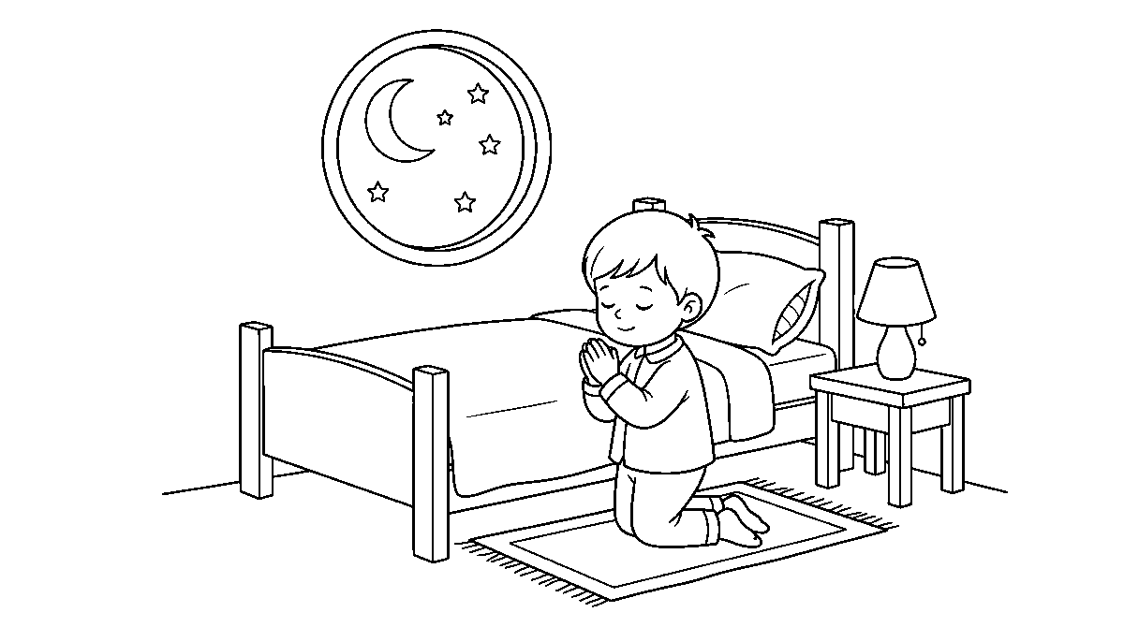
Worksheet
1. Prayer is best described as A) reading to a friend B) singing C) talking to God D) sleeping
2. When I do wrong and say sorry, God A) forgives me B) forgets me C) punishes all children D) leaves me
3. The prayer Jesus taught His disciples is the A) school prayer B) morning song C) Lord's Prayer D) harvest prayer
4. God's answer to a prayer can be yes, no or A) wait B) never C) maybe not D) again
5. Fill in: The Lord's Prayer begins "Our Father who art in ____."
6. Name four things we can bring to God in prayer.
7. Write the prayer you said last night before you slept.
My own work
Say one prayer of thanks and one prayer of asking on each of the next three nights, and write tomorrow what you asked for.
Draw one good thing God gives you every day and colour it.

WEEK 3 — GOD IS OUR FATHER (PART 3)
Depth: NERDC Primary 1 · CRS · Second Term W3 (pp 640–641).
You will learn to
• say that we are all children of God
• know that God knows me well
• say that I am never alone
• trust God when I am afraid
Things to know
• All of us in this class are children of God — that makes us brothers and sisters.
• God calls me to call Him "Father"; a servant says master, a child says Father.
• God knows everything about me: my name, my face, my thoughts, what I ate, where I am.
• The Bible says God even knows the number of the hairs on my head.
• God is always with me: at school, at home, in the bus, in the dark, when nobody else is there.
• Because He is with me, I am never alone; being alone is not the same as God leaving me.
• Trust means depending on somebody: trusting God is leaning on Him the way I lean on a strong wall.
• What trust looks like: not crying in the dark, sharing when I am afraid of having nothing, saying sorry first, telling the truth when lying would pay me.
• Children of God do not fight over who is God's favourite; God loves each one fully.
• Fear and trust cannot sit together on the same chair — when I trust God, fear goes out of the chair.
• We say the verse together: "The Lord is my helper; I will not be afraid."

Words for my notebook
I am a child of God. God knows me, God is with me, I can trust God.
Let us talk
1. Whose children are we all?
2. Does God know your name? Does He know your thoughts?
3. When are you most afraid? Who is with you there?
4. What is one thing you can stop worrying about today?
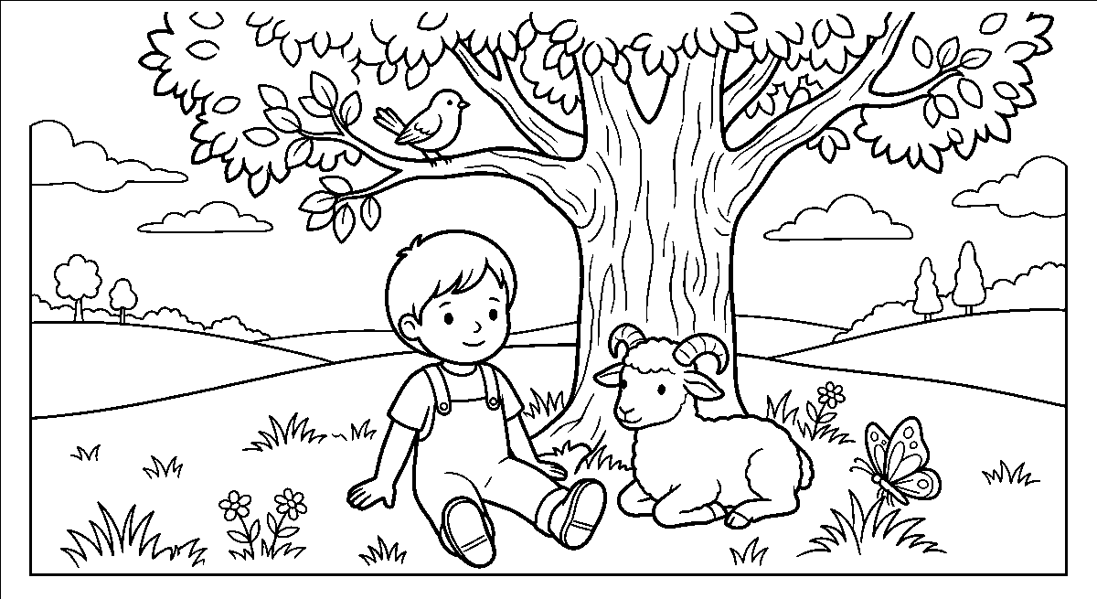
Worksheet
1. Every child in our class is a child of A) the school only B) the driver C) the market D) God
2. God knows my name, my face and my A) desk B) thoughts C) bag D) shoes only
3. Because God is with me, I am never A) hungry B) alone C) small D) late
4. Trusting God is like leaning on a A) tall ladder B) weak rope C) strong wall D) wet cloth
5. Fill in: A child of God says "Father"; a servant says "____."
6. Mention three things God knows about you.
7. Write two sentences on a time you were afraid and God was with you.
My own work
Write the name of three children in your class and pray one line for each of them tonight.
Draw a family sitting together and colour the shirt of the one who takes care of you.

WEEK 4 — THINGS WE MUST DO AS CHILDREN OF GOD (PARTS 1 AND 2)
Depth: NERDC Primary 1 · CRS · Second Term W4 (Part 1) and W7 (Part 2), pp 640–641 — the school puts two parts in one week.
You will learn to
• pray in the morning, at the table and at night
• thank God and ask Him for help
• obey and respect those who keep me
• be kind to the children in my house
Things to know
• Part 1 is about prayer; Part 2 is about obedience.
• Praying every day: morning prayer before I leave the bed, meal prayer before I eat, night prayer before I sleep.
• Thanking God for everything He gives — food, clothes, school, health, family.
• Asking God for help when I need it: for strength in an exam, for protection on the road, for a sick person.
• Saying sorry when I do wrong, the same day, not after one week.
• A simple prayer I know: "God, thank You for today. Forgive my wrong. Help me tomorrow. In Jesus' name, Amen."
• Obey means do what you were told, the first time, without crying about it.
• Children, obey your parents in the Lord, for this is right (Ephesians 6:1) — the first commandment with a promise.

• Respect and honour my father and mother: answer them politely, do not shout them down, stand when they come, carry what they hand me.
• Be kind to brothers and sisters: share the chair, do not tear their book, do not tell on them for small things.
• Help with the small work of the house: fetch water, sweep, arrange shoes, wash the plate after eating.
• Obedience is proved by what I do when nobody is watching.
Words for my notebook
Morning, table and night — pray every day. Obey and respect those who keep me (Ephesians 6:1).
Let us talk
1. When do you pray in a day?
2. What do you say before you eat?
3. Name two things you were told to do at home today.
4. How do you show respect to your father and mother?
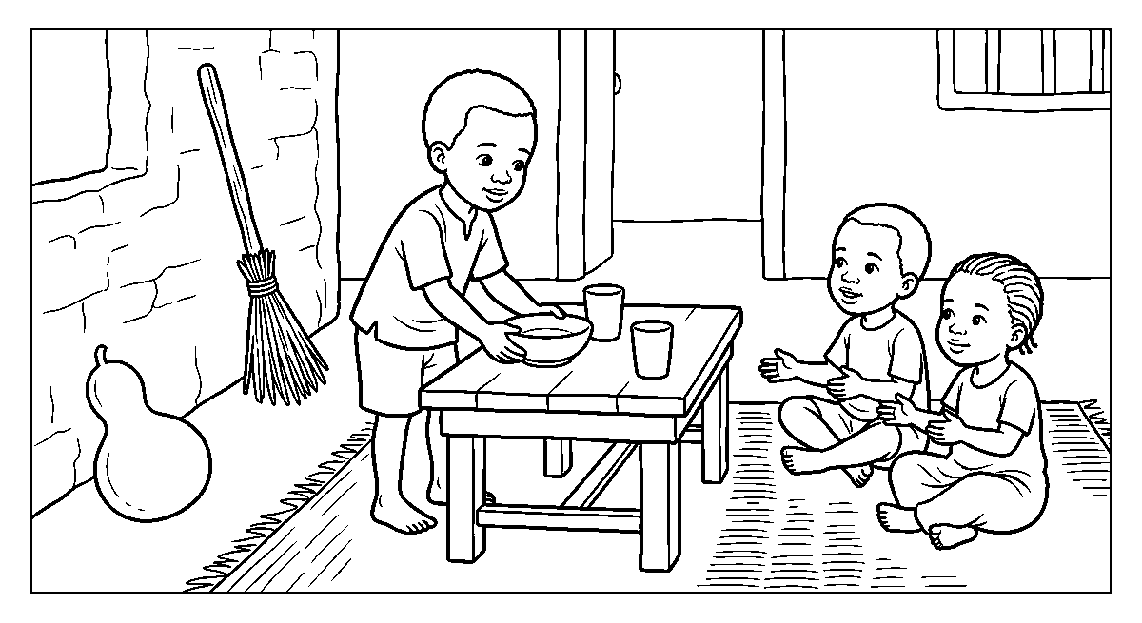
Worksheet
1. Which of these is a time for prayer every day? A) morning, table and night B) when I am punished C) Saturday only D) morning only
2. Before we eat we ____ God for the food. A) thank B) forget C) owe D) blame
3. "Children, obey your parents" is found in A) Ephesians 6:1 B) the arithmetic book C) the song sheet D) the alphabet
4. Respecting my father and mother means A) answering them politely B) shouting at them C) ignoring them D) hiding from them
5. Fill in: When I do wrong I say ____ to God the same day.
6. Mention three times we are to pray each day and one thing we ask God for.
7. Write two sentences on how you help in the house and why it pleases God.
My own work
For one week, write in a tick-box the prayers you said in the morning, at the table and at night, and show it on Friday.
Draw two things you do because you are a child of God, and colour the one you did this week.

WEEK 5 — THINGS WE MUST DO AS CHILDREN OF GOD (PARTS 3 AND 4)
Depth: NERDC Primary 1 · CRS · Second Term W8 (Part 3) and W9 (Part 4), pp 640–641 — the school puts two parts in one week.
You will learn to
• speak the truth when a lie would pay me
• share my things and play nicely
• forgive those who hurt me
• worship God in the church on the Lord's day
Things to know
• Part 3 is about living with people; Part 4 is about worship.
• Be truthful and honest: do not tell lies, do not take what is not yours, do not hide a broken thing and say the cat did it.
• A lie is a small gain and a great loss; the truth keeps my name clean for a long time.

• Share what I have: the chalk, the bench, the orange, the ball; a child of God is not tight-fisted.
• Be friendly and play nicely: take turns, do not push, do not laugh at the one who loses.
• Forgive those who offend me: if my friend broke my pen and said sorry, I let it go.
• Say sorry myself when I hurt somebody — first, before the other comes.
• Going to church to worship God: sit well, listen, sing, do not run in the aisle.
• In church I listen to Bible stories and learn about God; the Bible is God's word.
• Singing songs of praise is also prayer: a happy voice teaches the heart.
• Giving offerings is done with a cheerful heart — God loves the one who gives gladly, not the one who grumbles.
• We keep Sunday (the Lord's day) special for God: church, rest, and doing good.
Words for my notebook
Truth, sharing, forgiveness. On the Lord's day we go to church to hear God's word, sing and give.
Let us talk
1. Which is better: a lie that saves me or the truth that pains me for a while?
2. What do you do when somebody takes your thing?
3. What happens when you forgive?
4. Name three things you do in church.
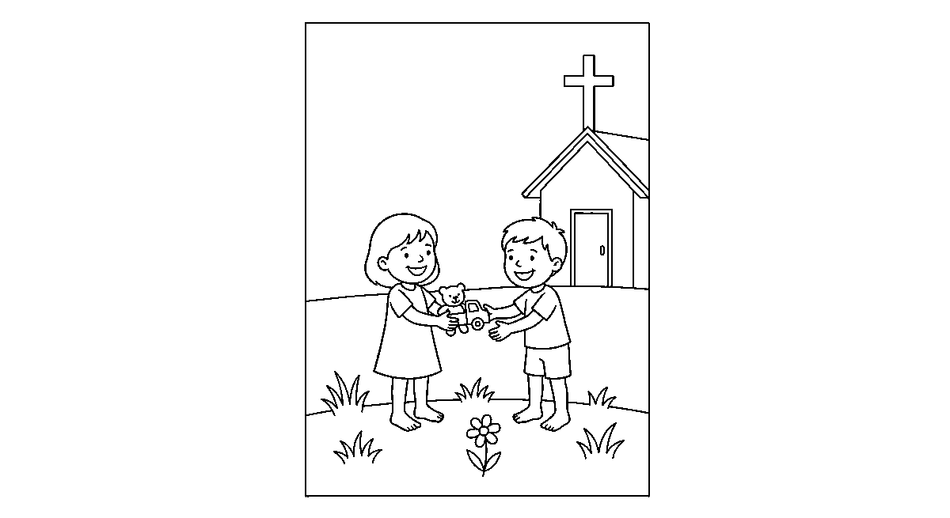
Worksheet
1. Being honest means A) copying B) hiding things C) telling lies D) not taking what is not yours
2. When a friend hurts me and says sorry, I should A) never speak to him again B) fight him C) forgive him D) take his bag
3. The day we keep special for God is A) Saturday only B) Monday C) Sunday D) Friday
4. Giving an offering should be done with a ____ heart. A) sleepy B) angry C) cheerful D) quiet
5. Fill in: In church we listen to ____ stories and learn about God.
6. Mention four things children of God must do among people.
7. Write two sentences on the last time you forgave somebody.
My own work
Write one thing you will share tomorrow at school and one person you will say sorry to or forgive.
Draw a hand that helps and a hand that hurts; colour the helping hand.

WEEK 6 — THINGS WE MUST DO AS CHILDREN OF GOD (PART 5)
Depth: NERDC Primary 1 · CRS · Second Term W10 (Part 5, pp 640–641) — care for what God created.
You will learn to
• take care of the things God made

• be kind to animals
• keep plants and trees from destruction
• keep my environment clean
Things to know
• God made the world and He said it was very good; so what I break, I break from His hands.
• Kindness to animals: give water to the dog, do not tie the goat's leg too tight, do not stone the cat, do not take the bird's eggs for fun.
• The Bible says a good man cares for the life of his beast.
• Do not destroy plants and trees: do not snap the young stem, do not pluck the bark, do not burn the grass round the tree; water what is planted.
• Trees give shade, fruit, clean air and wood; a cut tree takes years to be replaced.
• Keeping the environment clean: sweep the compound, throw refuse in the bin, do not pour water on the road, keep the drain open.
• Dirty water and blocked drains breed mosquitoes; cleanliness protects the health God gave us.
• Do not waste what God made: turn the tap off, use one cup of water, do not throw away half a bread.
• Do not make noise on purpose; the ears of the neighbours are part of my care too.
• Caring for creation is worship: when I look after the garden, I am serving God with my hands.
• We end with a walk round the school: pick what is on the ground, and say — God made this and gave it to us to keep.
Words for my notebook
God made the world and gave it to us to keep. Be kind to animals, spare the plants, keep the place clean.
Let us talk
1. What did God say about the world He had made?
2. How do we show kindness to the animals in our street?
3. Name two things that spoil the environment.
4. How is cleaning the compound a way of serving God?
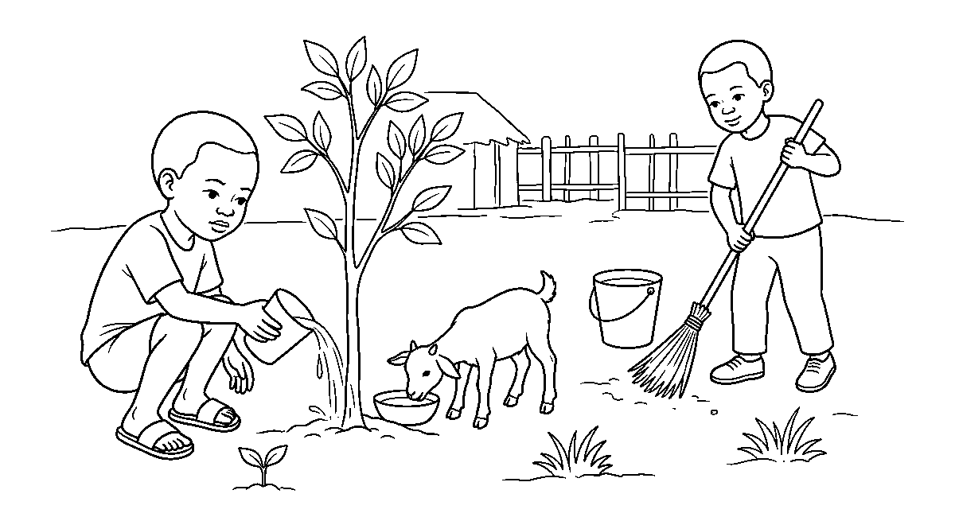
Worksheet
1. When God had finished making the world He said it was A) finished only B) small C) very good D) bad
2. Kindness to an animal includes A) tying its leg tight B) giving it water C) taking all its eggs D) stoning it
3. Cutting down trees carelessly takes away shade, fruit and A) clean air B) water only C) books D) music
4. Blocked drains are dangerous because they A) save water B) keep the road cool C) grow food D) breed mosquitoes
5. Fill in: Wasting water is not right because God made it for our ____ and not for spoiling.
6. Mention four ways of taking care of the things God created.
7. Write two sentences on one thing you will do this week to keep your environment clean.

My own work
Water one plant every day this week and pick five things from the ground around your house; write what happened to the plant on Saturday.

WEEK 8 — DISCOVERING GOD THROUGH JESUS CHRIST (PART 1)
Depth: NERDC Primary 1 · CRS · Third Term W1 (pp 642–643).
You will learn to
• say who Jesus is
• know that Jesus shows us what God is like
• name two miracles of Jesus
• say that Jesus teaches us about God's love
Things to know
• Jesus is the Son of God who came to earth as a baby in Bethlehem, born of Mary.
• Jesus came to show us God: nobody has seen God, but when we look at Jesus we see what God is like.
• The life of Jesus is God's love written in action — healing the sick, feeding the hungry, receiving the outcast.
• A miracle is a work that only God can do, done in front of people to show His power.
• Miracles of Jesus: water changed into wine, the five loaves and two fish feeding five thousand, the blind receiving sight, Lazarus raised from death, the storm calmed.
• Jesus had no sin in Him: He never lied, never hated, never took what was not His.
• Jesus died on the cross for our sins and rose again on the third day — that is the gospel we preach.
• He walked about doing good and is still alive; He sits at the right hand of God and prays for us.
• Learning about Jesus makes me know God better: God does not sit far off, He came near.
• The Bible that tells us this is called the New Testament; the four first books are Matthew, Mark, Luke and John.
• We say the verse together: "For God so loved the world that He gave His only begotten Son" (John 3:16).
Words for my notebook
Jesus is the Son of God. He shows us God, does miracles, died for our sins and rose again.
Let us talk
1. Where was Jesus born, and of whom?
2. What is a miracle?
3. Name two miracles of Jesus.
4. How does Jesus show us what God is like?
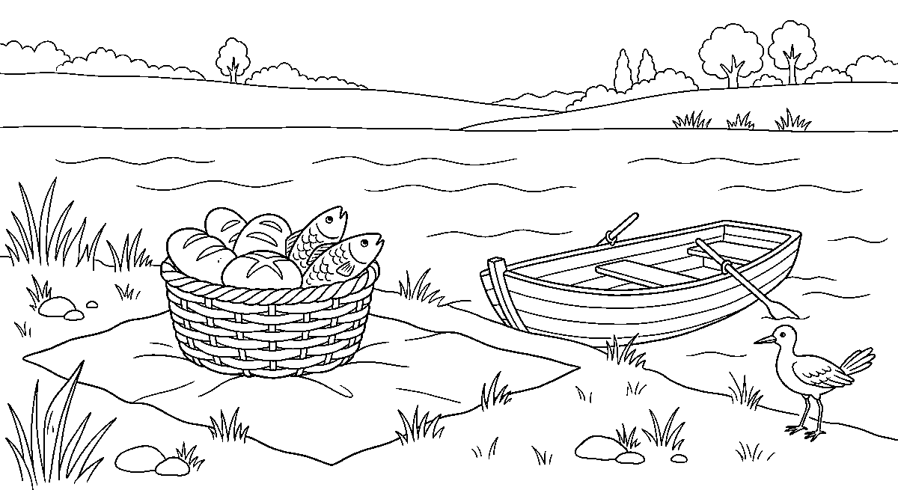
Worksheet
1. Jesus is called the ____ of God. A) brother B) prophet only C) servant D) Son
2. A work that only God can do, done in public, is called a A) journey B) miracle C) parable D) fast

3. With five loaves and two small fish Jesus A) bought a house B) built a boat C) fed a great crowd D) healed the wall
4. Jesus died on the cross and rose again on the ____ day. A) tenth B) seventh C) first D) third
5. Fill in: The four books that first tell us about Jesus are Matthew, Mark, Luke and ____.
6. Mention four miracles of Jesus.
7. Write two sentences on how Jesus shows us the love of God.
My own work
Write or draw one miracle of Jesus and one line under it on what the miracle tells us about God.

WEEK 9 — DISCOVERING GOD THROUGH JESUS CHRIST (PART 2)
Depth: NERDC Primary 1 · CRS · Third Term W2 (pp 642–643).
You will learn to
• say that Jesus was a teacher
• explain what a parable is
• tell how Jesus was kind to everybody
• know that Jesus loves children
Things to know
• Jesus was a teacher; people called Him Rabbi, which means master teacher.
• Jesus taught mostly by stories called parables — a simple story with a deep lesson in it.
• The sower: the seed that fell on good ground grew and gave much fruit; the good ground is the heart that hears God's word.
• The prodigal son (the lost son): the boy left home and wasted all he had, but when he returned his father ran to embrace him — that is how God receives a returning sinner.
• The good Samaritan: a stranger helped the beaten traveller when the religious men passed by; my neighbour is anybody I can help.
• Jesus was kind to everybody: children, grown-ups, the sick, the poor, the woman at the well, the tax collector Zacchaeus.
• Jesus loved children: they were brought to Him, He took them in His arms and blessed them.
• "Suffer the little children to come unto me, and forbid them not: for of such is the kingdom of God" (Mark 10:14) — let the children come, do not stop them.
• Jesus is not only kind to the good people; He ate with sinners and forgave them.
• The way Jesus taught is the way I learn to talk: tell the truth in a story people can hold.
• What Jesus asks of me: love God, and love my neighbour as myself.
Words for my notebook
Jesus was a teacher who used parables. Jesus loved children and said, "Let the little children come to me."
Let us talk
1. What is a parable?
2. Who was the good neighbour in the story of the beaten traveller?
3. What did Jesus do when children were brought to Him?
4. Say the lesson of the sower in your own words.

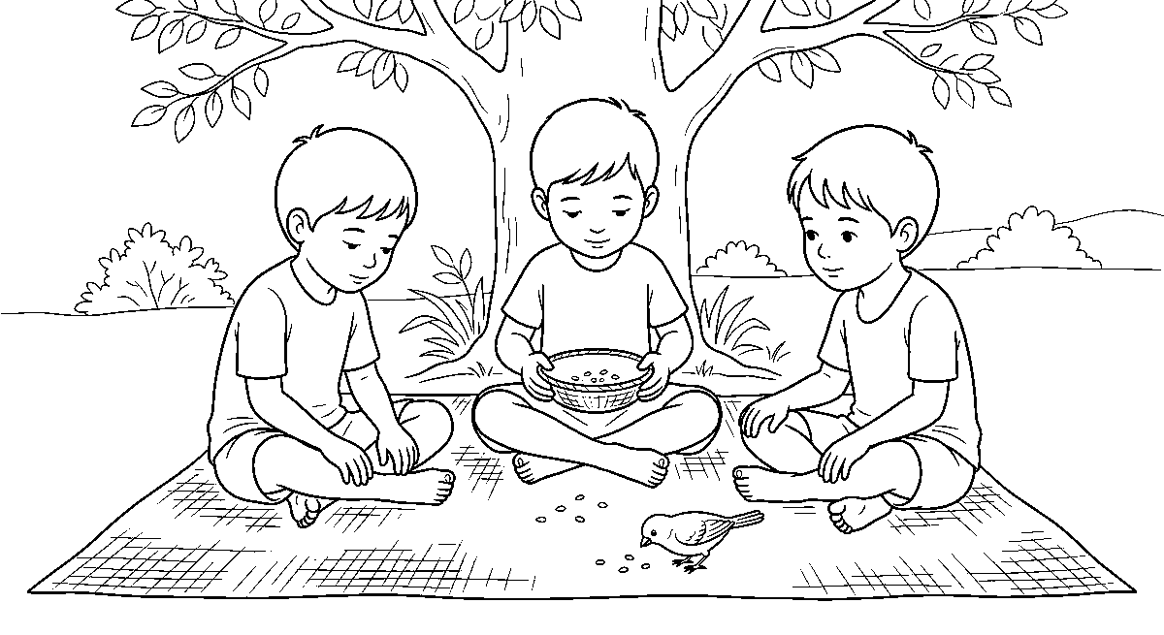
Worksheet
1. A simple story with a deep lesson is called a A) psalm B) parable C) miracle D) hymn
2. In the story of the sower, the good ground means A) the farm B) the road C) the heart that hears God's word D) the rain
3. Jesus said, "Suffer the little ____ to come unto me." A) children B) dogs C) kings D) birds
4. In the story of the good Samaritan, the man who helped was A) a stranger B) the ruler C) the owner D) a priest
5. Fill in: People called Jesus ____, which means master teacher.
6. Mention three people Jesus was kind to.
7. Write two sentences on what the story of the lost son teaches us about God.
My own work
Tell one parable of Jesus to a friend or a younger child at home, then write the lesson in one sentence.
Draw one picture for the parable Jesus told, and colour it.

BASIC DIGITAL LITERACY
Weeks 1 to 6, 8 and 9. Week 7 is Mid-Term Break, Week 10 Revision, Week 11 Examination, Week 12 Closing — those weeks carry no note. Depth: NERDC 2025 · Primary 4 · Basic Digital Literacy · First Term W2, W3, W4, W7, W8, W9 and W10 (pp 827–828) — the school redistributes this content into the lower classes, so the Primary 4 week is the depth floor and every line here is pitched as naming, pointing and handling, not as reading and writing code. The school's own rows decide what each week is about.

WEEK 1 — CHANGES IN SIZE, SPEED AND COST OVER TIME
Depth: NERDC Primary 4 · Basic Digital Literacy · First Term W2 (History of Digital Devices, pp 827–828).
You will learn to
• say that machines became smaller and faster as time went on
• name the abacus as an old counting machine
• tell that the first computers were as big as a room
• say that a thing once too dear for anybody is now in many hands
Things to know
• The abacus is a frame with beads on wires; people slide the beads to count, long before any computer.
• Charles Babbage is called the father of the computer — he made the plan of a counting machine.
• Ada Lovelace wrote the steps for that machine — the first programme, and the first person to see that a computer could do more than count.
• A generation is one stage of a machine's life; the computer has passed through five generations.
• 1st: vacuum tubes — big glass bulbs that ate power and gave out heat. 2nd: transistors — small, cool, they made machines smaller.
• 3rd: integrated circuits — many tiny parts put on one little chip. 4th: microprocessors — the whole brain of the computer on one chip.
• 5th: artificial intelligence (AI) — a machine that can learn, answer questions and recognize a face or a voice.
• Over time, three things kept changing: size went down, speed went up, cost per job went down.
• The first computer filled a whole hall and cost more than a house; the phone in a shop today is faster than that hall of machines and thousands of people can afford one.
• Things got smaller: room → cupboard → table → lap → hand → wrist.
• Words for counting speed: a machine does a million sums in a second; my finger does one in a second.
• Small, fast and cheap is why a machine that only officers had is now in the hands of traders, farmers and children.
Words for my notebook
Old: big, slow, dear. New: small, fast, cheaper. Babbage planned the computer; Ada Lovelace wrote its first programme.
Let us talk
1. What did people use to count with before machines?
2. Which was bigger — the first computer or today's phone?
3. Name one thing that has become cheaper over time.
4. What does a machine of the fifth generation do that old ones could not?

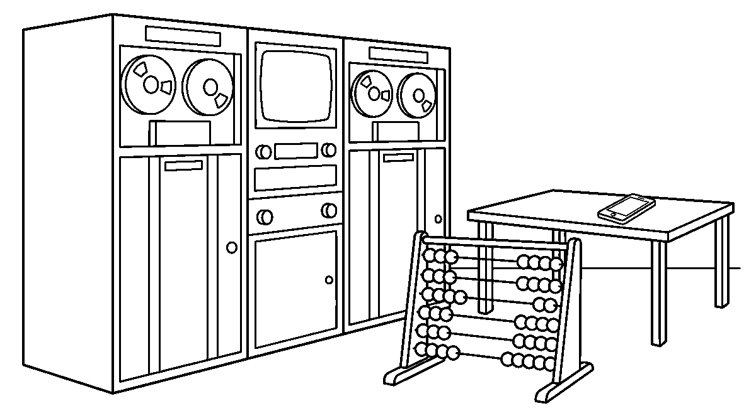
Worksheet
1. The counting machine with beads on wires is the A) monitor B) fan C) abacus D) printer
2. As computers changed, they became smaller and A) faster B) heavier C) wetter D) slower
3. Charles Babbage is known for the plan of A) the computer B) the bus C) the radio D) the cutlass
4. The fifth generation of computers is about A) steam B) wood C) artificial intelligence D) paper tape
5. Fill in: The first computers were as big as a ____.
6. Mention the three things that kept changing about digital devices.
7. Write two sentences on how a phone today is better than the first computers.
My own work
Ask for one old thing at home or in the house of a neighbour — a radio, a burner, a small torch — and write one line on how the new one is smaller or faster.
Draw three things from long ago and the same three today, then colour the modern one in each pair.

WEEK 2 — HARDWARE AND SOFTWARE
Depth: NERDC Primary 4 · Basic Digital Literacy · First Term W3 and W4 (Parts of Digital Devices I and II, pp 827–828).
You will learn to
• tell hardware from software
• name the parts I can touch and the parts I cannot touch
• say what the CPU, the memory and the store are for
• say that the two must work together
Things to know
• Hardware is every part of the computer I can touch: screen, keys, mouse, box, wires.
• Software is the part I cannot touch — the instructions and the pictures inside; it is what tells the hardware what to do.
• I can break hardware with a stone; I cannot spill water on software.
• A program (an app) is a piece of software: the drawing app, the counting app, the music app.
• Inside the box are four parts to know: the CPU, RAM, the hard drive (storage) and the motherboard.
• The CPU is the brain — it does the work and gives the orders.
• RAM is temporary memory — it holds what I am doing now; when power goes off, what is in RAM is gone.
• The hard drive is permanent memory — it keeps my drawing and my story until I ask for them again.
• The motherboard is the big board that connects everything, the way the road joins the houses.
• The computer also has a power supply (it brings the electricity in) and a cooling fan (it carries the heat out, or the machine becomes too hot to work).

• Input devices bring work in: keyboard, mouse, microphone, scanner, webcam. Output devices take work out: monitor, printer, speakers, headphones.
• The parts work as one team: I press a key (input) → the CPU thinks (work) → the screen shows it (output).
• A machine with no software is like a schoolbag with no book in it.
Words for my notebook
Hardware is what I touch; software is what tells it what to do. CPU = brain, RAM = now, hard drive = later.
Let us talk
1. Point to three pieces of hardware on this computer.
2. Can you hold software in your hand? Why not?
3. Which part is the brain?
4. What happens to what is in RAM when the power goes off?
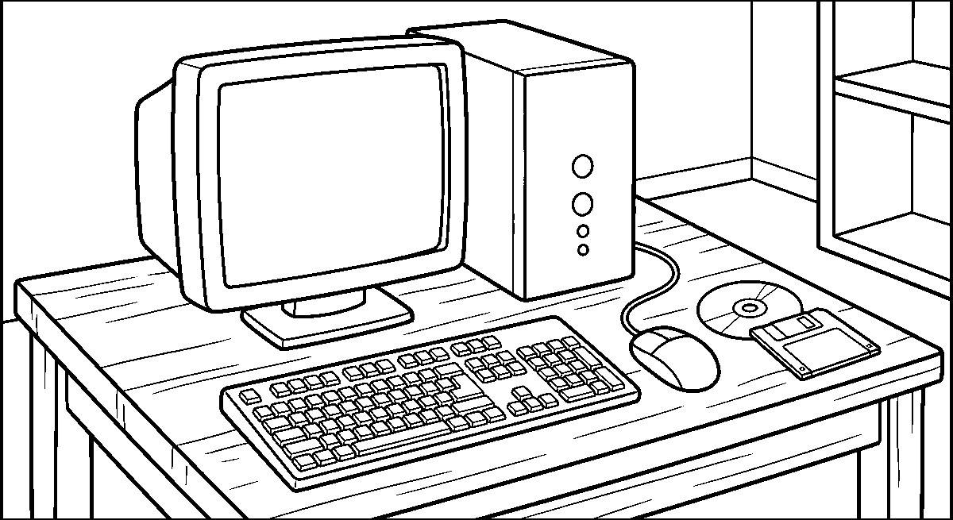
Worksheet
1. Hardware means the parts of a computer that we can A) dream of B) forget C) touch D) name only
2. The brain of the computer is the A) CPU B) cover C) mouse pad D) chair
3. Work kept in the machine until I ask for it is stored in the A) hard drive B) fan C) key D) screen glass
4. Which one is software? A) mouse B) keyboard C) drawing app D) cable
5. Fill in: The big board that connects all the parts is the ____.
6. Mention the four inside parts of a computer.
7. Write two sentences on how input, work and output go round once when I press a key.
My own work
Draw the box of a computer and put four labels on it: keyboard, mouse, screen and CPU.

WEEK 3 — INPUT DEVICES: KEYBOARD AND MOUSE
Depth: NERDC Primary 4 · Basic Digital Literacy · First Term W8 (Input Devices, pp 827–828), with W3–W4 for care.
You will learn to
• find letters and numbers on the keyboard
• say what the special keys do
• click, double-click, drag and drop with the mouse
• care for the keyboard and the mouse
Things to know
• The keyboard is for typing; its letters are not in ABC order but in the QWERTY layout — the first six letters on the top row of letters.
• Keys to know: letters, numbers, Space bar (makes a gap), Enter (goes to the next line / says "go"), Backspace (takes out what is before the mark), Caps Lock (makes big letters).
• The letters should be typed with the fingers, not pecked one by one with two thumbs.
• The keyboard is kept flat and clean; nothing is placed on it, and no food or drink is beside it.

• Crumbs in the keys make them stick; the keyboard is turned upside down and shaken gently, or wiped with a dry cloth.
• The mouse is for pointing; on it are a left button, a right button and a wheel between them.
• Click = press once (to choose). Double-click = press twice fast (to open). Right-click = show a little list of choices.
• Scroll = roll the wheel up and down to move the page without pressing anything.
• Drag and drop = hold the left button on the icon, move the mouse, let the button go — the icon follows my hand.
• The touchpad on a laptop does the mouse's work: slide one finger to move, tap to click. A touchscreen answers the finger directly.
• A mouse with a ball underneath is turned over and the ball wiped clean when it stops moving well; an optical mouse only needs its glass wiped.
• The cable is held, not pulled; a yanked wire breaks the socket inside.
Words for my notebook
Keyboard: keys for typing. Mouse: click, double-click, scroll, drag and drop. No water near either.
Let us talk
1. Show me the space bar and say what it does.
2. Which key takes out a wrong letter?
3. What must I do to open a picture: click or double-click?
4. Show me drag and drop on the screen.
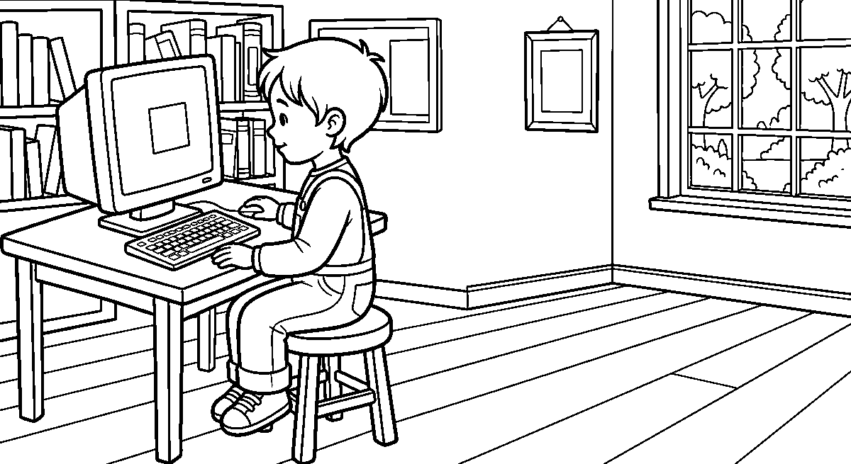
Worksheet
1. The arrangement of letters on a keyboard is called the ____ layout. A) ABC B) QWERTY C) Friday D) number
2. The key that moves us to the next line is A) Esc B) Caps Lock C) Enter D) Shift
3. To open a folder we usually A) click once B) shake the mouse C) double-click D) pull the cable
4. Holding the button, moving the mouse and letting go is A) printing B) drag and drop C) saving D) scanning
5. Fill in: The key that makes all the letters big is ____.
6. Mention three things that spoil a keyboard.
7. Write two sentences on how you move a picture from one place to another on the screen.
My own work
Type or trace your own name, then your father's name, using only the correct letters, on a keyboard or a drawn paper keyboard.

WEEK 4 — THE MICROPHONE
Depth: NERDC Primary 4 · Basic Digital Literacy · First Term W10 (Computer Care and Safety, pp 827–828) for the care lines, with W3–W4 for the device itself.
You will learn to
• say what a microphone is for
• show how voice goes in and comes out

• handle the microphone well
• sit well and rest the eyes when I work
Things to know
• A microphone is an input device that takes sound in — my voice, a song, a hand-clap.
• It changes sound into something the machine can keep, so I can hear it again, or send it to a friend.
• Things that use a microphone: the phone (calling), the recorder, the radio, the computer for voice typing, the microphone on a stage, a headset.
• Speak across the microphone, not into it — a hard "p" and "b" blow pop sounds into it.
• Keep it about the width of two fingers from the mouth; hold it by the body, never by the cable.
• Care: never drop it, keep it from water, from dust and from being pulled; a microphone that has fallen must be shown before it is used again.
• With earphones the sound goes in as well as out: I speak, I hear myself — that is how a recording is checked.
• Sound must not be too loud: loud sound in the ear hurts the small parts inside and can spoil hearing for life.
• Ergonomics is sitting well: back straight against the chair, both feet on the floor, the screen level with the eyes, arms loose, keyboard flat.
• The eyes rest too: every little while, look far away out of the window for a count of twenty, and blink.
• Lab rules: one to a machine unless told otherwise, no food or drink, hands clean and dry, ask before the power is switched on, switch off at the end and push the chair in.
• A surge protector saves the machine when lightning or a fault sends too much power along the line; the plug is held by the hard part, not the wire.
• Virus protection means: do not put in a flash drive that is not yours, and do not click strange pictures that say you have won something.
• Shut down the right way — the machine closes itself; pulling the plug while it is thinking spoils the work in RAM.
Words for my notebook
A microphone takes sound in. Hold it by the body, speak across it, keep it dry. Sit straight, screen at eye level.
Let us talk
1. Which kind of device is a microphone — input or output?
2. Why do we not shout into the microphone?
3. Show me how you sit when you use the computer.
4. What do we do before switching a machine off?
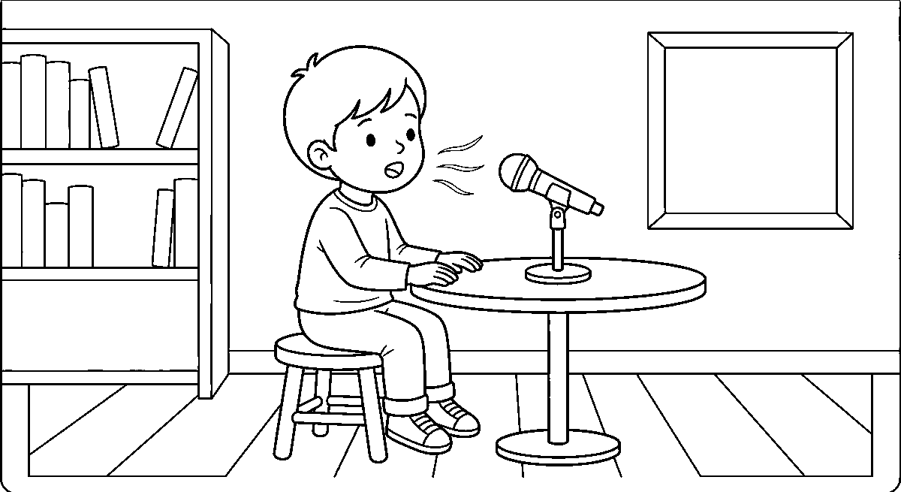
Worksheet
1. A microphone is used to A) cool the CPU B) print paper C) store files D) take sound in
2. We hold a microphone by its A) body B) cable C) shadow D) plug pin
3. Sitting well while we work keeps our A) shoes clean B) hands wet C) back straight D) bag closed

4. The small rest our eyes need is to look A) far away B) at the floor C) nearer D) down
5. Fill in: A ____ protector saves the machine when too much power comes along the line.
6. Mention four rules of the computer lab.
7. Write two sentences on a time you spoke into a microphone or a recorder.
My own work
Record one verse of a song or say your own name into a phone and play it back, then write one line on whether the sound was clear.
Draw a microphone standing on a desk and colour it; then draw your own mouth open as you speak into it.

WEEK 5 — SCANNER, WEBCAM AND OTHER PERIPHERALS
Depth: NERDC Primary 4 · Basic Digital Literacy · First Term W8 (Input Devices) and W7 (Peripheral Devices, pp 827–828).
You will learn to
• say what a scanner and a webcam do
• tell a scanned picture from a photographed one
• name the plugs that join a device to a machine
• say what a peripheral is
Things to know
• A scanner takes in a flat paper thing — a drawing, a letter, a photo — and puts it into the computer as a picture.
• The paper lies face-down on the glass; the light bar travels under it once; the cover is closed so daylight does not wash the picture out.
• A webcam is a small camera on top of the screen; it takes in moving pictures and my face for a call, not paper.
• Scanner = still and flat; webcam = live and moving. A phone camera is like a webcam I can carry.
• Use of a scanner: to keep a drawing, to send a homework, to put a birth certificate on paper of a computer, to copy a picture into a story.
• Care: the glass is wiped with a soft dry cloth and never with water; nothing heavy is stood on the lid; the paper is flat, no clip or pin on the glass.
• A peripheral is an outside device connected to the computer to give it more power.
• Peripherals I know: printer, scanner, external hard drive, USB flash drive, webcam, speakers, mouse, keyboard, headset.
• They join by USB (the small rectangular plug for most things), HDMI (the wide flat plug for picture and sound to a television) or Bluetooth (joining with no wire at all).
• A flash drive is small, carries my work in my pocket, and is pulled out only after the machine says it is safe — pulling it while it writes spoils the file.
• With Bluetooth I must first put the device in pairing so the two find each other; then it works from across the room.
• The cable is unrolled, not wound tight round the plug, and the plug goes in the right way — force bends the pins.
Words for my notebook
A scanner takes in paper; a webcam takes in my face and the room. A peripheral is a device joined by USB, HDMI or Bluetooth.
Let us talk
1. Which device would you use to put your drawing into the computer?
2. Where does the paper lie on the scanner?
3. Name a peripheral that needs no wire.
4. Why must a flash drive not be pulled out while it is writing?

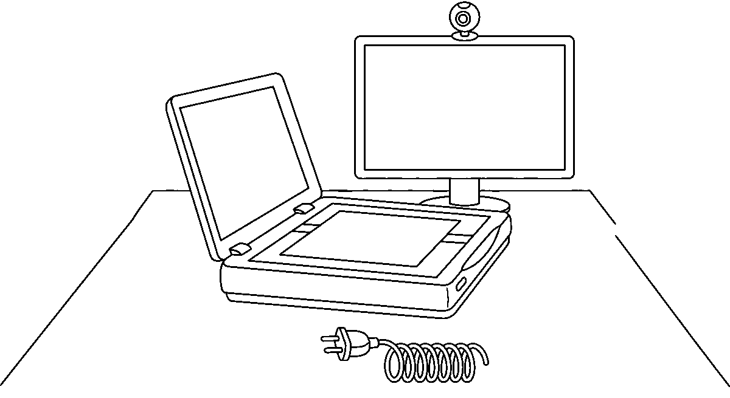
Worksheet
1. A scanner is used to A) sweep the floor B) take in a paper picture C) print nothing D) cook food
2. A small camera on top of the screen is the A) printer B) webcam C) mouse D) fan
3. Which one joins a device without a wire? A) Bluetooth B) HDMI C) a nail D) USB
4. A flash drive carries A) my work B) food C) chalk D) water
5. Fill in: On the scanner, the paper lies face-____ on the glass.
6. Mention five peripherals of a computer.
7. Write two sentences on how a scanned picture and a photographed picture differ.
My own work
Have your best drawing scanned or photographed, and write one line under it saying who made it and when.

WEEK 6 — OUTPUT DEVICES: THE MONITOR
Depth: NERDC Primary 4 · Basic Digital Literacy · First Term W9 (Output Devices, pp 827–828), with W3–W4 for care.
You will learn to
• say what a monitor shows me
• tell the screen from the box
• keep the screen clean and my eyes safe
• say what "resolution" means for a picture
Things to know
• The monitor (also called the screen or display) is the output device that shows me the work with pictures and words.
• It shows only what the computer has already done — it does not do the thinking; the box does that.
• A television is like a big monitor for the sitting room; a monitor is for the computer on the table.
• A screen is measured across, in inches: the class machines are about the size of a book opened wide; the television at home is much wider.
• Resolution is how many small dots make up the picture: many dots give a sharp picture, few dots give a blurry one with blocks.
• LCD screens are flat and light; the old heavy ones (CRT) were deep boxes with a curve on the glass.
• Care: switch off when leaving, wipe with a soft dry cloth in a circle, never spray water or detergent on the glass (it runs down into the edge and kills it).
• Do not press a finger on the glass, do not knock it, do not hang on it; a crack inside cannot be mended, only the whole screen changed.
• Keep the screen out of the sun's bright line and away from a window's glare, so I can see it without squinting.
• The top of the screen should be about the level of my eyes and an arm's length away; that is why the stand can be raised or lowered.
• Brightness is turned down in a dark room and up in daylight; too much light on the eyes makes the head ache.

• A projector is an output device too — it throws the picture big onto a wall for the whole class to see.
Words for my notebook
The monitor shows the work. Many dots make a sharp picture. Wipe with a dry cloth, never with water.
Let us talk
1. Is the monitor an input or an output device?
2. What makes a picture look blurry?
3. Show me how high the top of the screen should be for you.
4. What must we never spray on a screen?
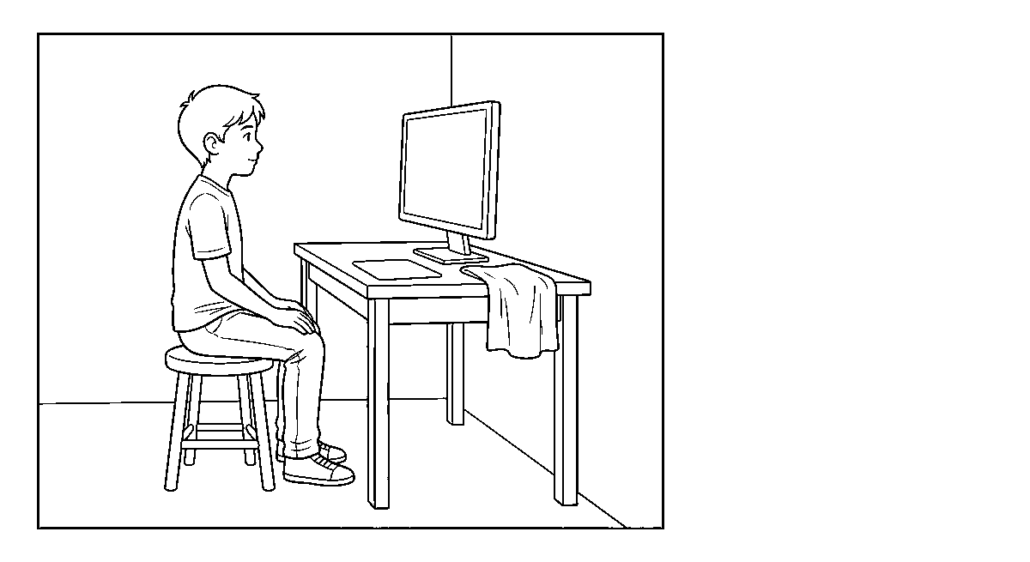
Worksheet
1. The monitor is a device that A) shows work on a screen B) stores files C) prints paper D) takes in sound
2. A picture made of many small dots looks A) dark B) blurry C) sharp D) wet
3. A screen is cleaned with A) water and soap B) a wet mop C) sandpaper D) a soft dry cloth
4. Which device throws the picture big on the wall for the class? A) projector B) flash drive C) keyboard D) scanner
5. Fill in: The old heavy monitors were deep boxes; the flat light ones are ____ screens.
6. Mention four things that can spoil a monitor.
7. Write two sentences on how you sit when you look at a screen.
My own work
Watch a television or a screen at home for ten minutes and write one line on what was shown and one line on how you kept your eyes comfortable.
Draw a monitor on your desk and colour the picture that is showing on its screen.

WEEK 8 — THE PRINTER
Depth: NERDC Primary 4 · Basic Digital Literacy · First Term W10 (Computer Care and Safety, pp 827–828) for care, with W9 for the device.
You will learn to
• say what a printer does
• tell an inkjet printer from a laser printer
• put paper in the tray without crumpling it
• care for the printer and the ink
Things to know
• A printer is an output device that puts the work from the screen onto paper so that I can hold it.
• An inkjet printer squirts tiny drops of liquid ink on the page; it is good for my coloured drawing and it is the common home printer.
• A laser printer uses powder (toner) and heat to burn the picture onto the paper; it is fast, gives sharp black words, and is the kind in the school office.
• Steps of printing: the work is sent → the machine wakes → paper is pulled up one sheet at a time → the page comes out and dries.

• Paper goes in flat in the tray, against the guide, and not too many sheets at once — too many makes the machine jam.
• A jam means the paper is stuck inside; the machine is switched off and the paper pulled out slowly with both hands so no bit tears off inside.
• Ink/toner is a cartridge: it is handled gently and kept away from the fingers and the eyes; a black smear on the shirt is hard to wash.
• Do not open the printer while it is moving; the inside parts are hot in a laser printer.
• Quality: choose the paper type — plain paper for words, coated paper for the coloured picture; wrong paper gives a wet or a pale print.
• A printer left on a shelf gathers dust on the rollers; it is covered when not in use.
• Before printing I look at it on the screen first (a preview) — printing by mistake wastes paper and ink.
• The spare page from a wrong print is not dust: the back is used for rough work.
Words for my notebook
A printer puts work on paper. Inkjet uses liquid ink; laser uses powder and heat. Too much paper in the tray causes a jam.
Let us talk
1. What comes out of a printer?
2. Which printer is better for a coloured drawing?
3. What do we do when the paper sticks inside?
4. Why do we look at the picture on the screen before printing?
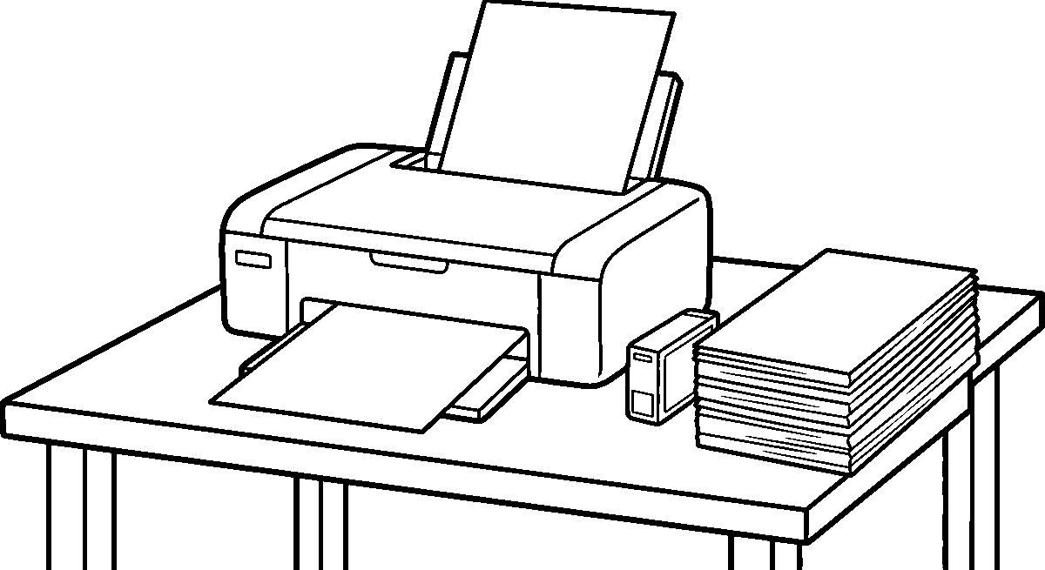
Worksheet
1. A printer puts the computer's work on A) the floor B) paper C) a plate D) water
2. The printer that squirts liquid ink is the A) laser B) inkjet C) speaker D) scanner
3. Too much paper in the tray makes the printer A) cool B) sleep C) jam D) sing
4. Before we print we look at A) the wall B) the shoes C) a preview on the screen D) the clock
5. Fill in: A laser printer uses powder called ____ and heat.
6. Mention three rules for taking care of a printer.
7. Write two sentences on printing one page: what you sent and what came out.
My own work
Print or have printed one page of your own writing or drawing, and keep the wrong print from the pile for rough work at the back.
Draw a printer with one sheet of paper coming out of it, and colour the paper white.

WEEK 9 — SPEAKERS AND HEADPHONES
Depth: NERDC Primary 4 · Basic Digital Literacy · First Term W10 (Computer Care and Safety, pp 827–828) for care and volume, with W9 for the devices.

You will learn to
• say what a speaker and a headphone are for
• know that both are output devices
• keep the sound at a safe level
• care for the small parts that make the sound
Things to know
• A speaker is an output device that sends sound out of the machine so the room can hear it.
• A headphone (or earphone) also sends sound out, but only one person hears it — the sound goes straight into the ear.
• Sound comes from a thin part that vibrates (moves to and fro very fast) and pushes the air; that push is what the ear catches.
• The volume control makes the sound bigger or smaller; too loud is not more fun, it is damage.
• Loud sound for a long time hurts the ear for life — the ear does not grow back what the noise killed. So: low volume, short time, and I can still hear somebody speaking next to me.
• Do not share earphones — the ear passes small dirt and infection from one person to another.
• Care: speakers hate water; the headphone is not wound tight round the plug but looped loosely; the cable is not pulled over the desk edge or under a chair leg.
• The small holes of the earphone are kept clean and free of fluff; a blocked hole sounds quiet and tempts me to raise the volume.
• Speakers come in pairs — one for the left and one for the right — so that I know which side a sound came from.
• Sound is also made by the machine's internal buzzer; if the sound comes from the phone or the monitor, that is called a built-in speaker.
• Music in class is used for time and for movement: it starts, it stops, and when it stops the class is quiet — that is the rule for the speaker.
• If nothing is heard, first check the volume and the plug, then tell the person in charge of the machine; do not open it.
Words for my notebook
Speakers fill the room; headphones serve one ear. Loud sound for long hurts the ear. Keep them dry and clean.
Let us talk
1. Is a speaker an input or an output device?
2. Why should we not share earphones?
3. How do you know the sound is too loud for you?
4. What do you do first when no sound comes at all?
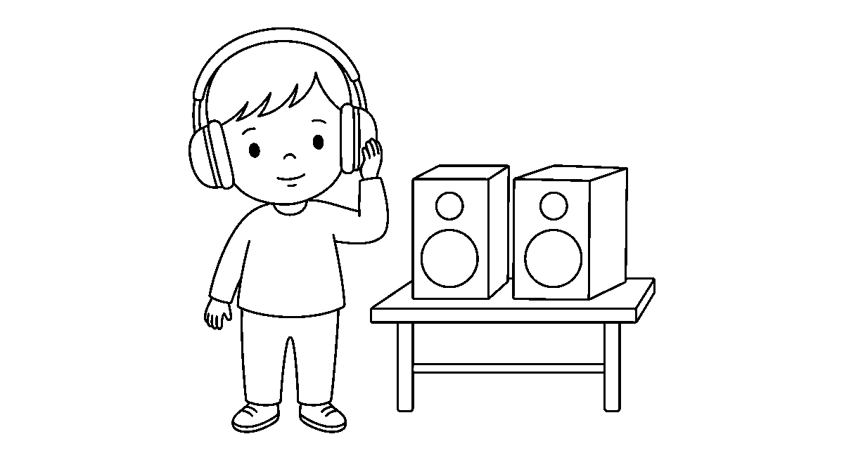
Worksheet
1. A speaker sends ____ out of the machine. A) wind B) paper C) water D) sound
2. A headphone is for A) one person B) the class C) the driver D) the whole room
3. Sound is made when a part of the speaker A) freezes B) dries C) sleeps D) vibrates

4. The safest way to listen is with the volume A) low and steady B) shaking C) at the highest D) off all day
5. Fill in: A blocked hole in an earphone makes us raise the ____, and that hurts the ear.
6. Mention four ways of caring for speakers and headphones.
7. Write two sentences on what sound is and how we keep our ears safe.
My own work
Listen to one song or one story at a low volume, then write one line on whether you could still hear a voice in the same room.
Draw the headphones that go over your ears and colour the two cups the same colour.

NIGERIAN HISTORY
Weeks 1 to 6, 8 and 9. Week 7 is Mid-Term Break, Week 10 Revision, Week 11 Examination, Week 12 Closing and Awards — those weeks carry no note. Depth: NERDC 2025 · Primary 1 · Nigerian History · Second Term W1–W4, W7–W10 (pp 651–652) — the school moves these topics down to Nursery 2, so the Primary 1 content is the minimum extent of depth and the names, dates and deeds below are kept exactly as the scheme sets them.

WEEK 1 — HEROES AND HEROINES IN THE COMMUNITY (PART 1)
Depth: NERDC Primary 1 · Nigerian History · Second Term W1 (pp 651–652).
You will learn to
• say what a hero and a heroine are
• name the qualities that make a hero
• tell bravery, kindness and selfless service in my words
• name people who help others in our community
Things to know
• A hero is a person we admire because of what he does for others; a heroine is a woman who does the same.
• A hero is not somebody with power over people; a hero is somebody with hands out to people.
• Three qualities every hero has: bravery, kindness and selfless service.
• Bravery is doing the right thing even when the heart is beating fast with fear.
• Kindness is a soft heart: helping without being asked, speaking gently, sharing what I have.
• Selfless service is work done for others without asking for payment or praise.
• A hero tells the truth when telling it is dangerous, and keeps his word when keeping it is costly.
• Heroes are also ordinary: the woman who carries a neighbour's water, the man who fills the hole in the road with stones.
• Heroes are remembered — with a name on a street, a story told to children, a statue, a day in the calendar.
• A bully is the opposite of a hero; so is a thief, and so is a liar, whatever his size.
• In our own community the hero may be the nurse at the primary health centre who stays after closing.
• We say it together: a hero is known by what he gives, not by what he takes.
Words for my notebook
A hero or heroine is a person we admire for helping others — brave, kind and selfless.
Let us talk
1. What is a heroine?
2. Tell me something brave you have done, and something you were afraid to do.
3. Who helps people in our community without pay?
4. Why do people remember heroes?
Worksheet
1. A hero is a person we A) fear B) pay money C) avoid D) admire for helping others
2. Doing the right thing when you are afraid is A) bravery B) pride C) rest D) play
3. Selfless service means helping others A) without asking for reward B) for a prize C) only on Sunday D) for payment
4. Which is NOT a quality of a hero? A) bravery B) bullying C) truth D) kindness
5. Fill in: A woman who is a hero is called a ____.
6. Mention the three qualities of a hero.
7. Write two sentences on one person in our community who helps others.

My own work
Write the name of one person you call a hero in our area and one thing he or she did.
Draw one person who helps your community and colour the cloth they wear.

WEEK 2 — HEROES AND HEROINES IN THE COMMUNITY (PART 2)
Depth: NERDC Primary 1 · Nigerian History · Second Term W2 (pp 651–652).
You will learn to
• name the local heroes of our community
• say what each helper does for us
• tell why teachers, nurses and drivers are heroes
• say that everyday heroes are heroes too
Things to know
• A local hero is a person who serves the people near us; we can see them, greet them and thank them.
• Teachers are heroes: they give knowledge away every day, mark books after class, and stay with a child who has not understood.
• Doctors and nurses are heroes: they heal the sick, sit up at night in the clinic, and give medicine without looking at whose child it is.
• Police officers are heroes: they keep us from thieves, stand at the crossing, and take those who hurt others to court.
• Firefighters are heroes: they run into the smoke when everybody else runs out, and they put out the fire on the house and in the bush.
• Other helpers in the same row: the midwife, the driver who takes the sick to hospital, the cleaner who sweeps the market before dawn, the water-seller, the imam and the pastor who counsel the quarrelling.
• Parents and guardians are everyday heroes: they work, they feed us, they pay school fees, they wake before us and sleep after us.
• Everyday heroes do not wear a special uniform; their heroism is that they do it again tomorrow.
• We can thank a local hero: greet them, say "thank you, sir/madam", keep the class clean for the cleaner, do not litter in front of the market woman.
• A hero is also known by the risk he takes: the nurse holds the needle, the firefighter holds the pipe, the driver holds the wheel on a bad road.
• Our class will make a wall chart: "Heroes of our community" with one drawing each.
Words for my notebook
Teacher, nurse, doctor, police officer, firefighter, parent — all are heroes because they serve us.
Let us talk
1. What does a teacher give that nobody can take back from you?
2. What do firefighters do while other people run out?
3. Who is an everyday hero at home, and what did they do yesterday?
4. How can we thank the cleaner of the market?
Worksheet
1. Teachers are heroes because they A) drive buses B) sell books C) give us knowledge D) close the school
2. The people who put out fires are A) firefighters B) farmers C) traders D) soldiers
3. Police officers are heroes because they A) sweep the road B) keep us safe from thieves C) cook for the class D) heal the sick
4. An everyday hero at home is A) the man in the stadium B) a father or mother who works for the family C) a stranger on television D) the king only
5. Fill in: The ____ stays with a child who has not understood the lesson.
6. Mention five heroes of our community and what each does.
7. Write two sentences on the helper you would most like to thank.

My own work
Draw two heroes of our community and write under each what he or she does for us.

WEEK 3 — NIGERIAN NATIONAL HEROES (PART 1)
Depth: NERDC Primary 1 · Nigerian History · Second Term W3 (pp 651–652).
You will learn to
• say what a national hero is
• name Herbert Macaulay and what he did
• say why he is called the father of Nigerian nationalism
• tell his story in four sentences
Things to know
• A national hero is a person whose work was for the whole country, not for one family or one town.
• Herbert Samuel Johnson Macaulay was born in Lagos in 1864 and died in 1946.
• His grandfather was one of the first freed slaves returned to Africa; the family lived in Lagos.
• Macaulay was trained as a surveyor and engineer — he measured land and mapped towns for the government.
• He left the government service because the colonial rulers would not treat Nigerians fairly, and then he spent his life fighting for Nigerians with words, courts and papers instead of guns.
• He founded the first political party in Nigeria (the Nigerian National Democratic Party, 1923) — before that, Nigerians had no party of their own to choose leaders with.
• He started a newspaper so that the people could read the truth and not only hear what the chiefs were told.
• He led protests against unfair taxes and against the removal of the people's land; he took the people's cases to court.
• That is why he is called the Father of Nigerian Nationalism: he first made Nigerians feel like one people with one demand.
• Nationalism means loving your country and asking that it be run by its own people.
• Macaulay is remembered in Lagos by a street name, and in the story every school child learns.
• Picture study: an old gentleman in a cap and long coat, with mutton-chop whiskers; that is how the photographs of him look.
Words for my notebook
Herbert Macaulay (1864–1946) — father of Nigerian nationalism; he formed the first political party and used the newspaper and the court for Nigeria.
Let us talk
1. What is a national hero?
2. Where was Macaulay born?
3. With what three things did he fight for the people?
4. Why is he called the father of nationalism?
Worksheet
1. A national hero is a person whose work was for A) the church only B) one shop C) one family D) the whole country
2. Herbert Macaulay was born in the year A) 1999 B) 1960 C) 2000 D) 1864
3. Macaulay formed the first political ____ in Nigeria. A) bus line B) school C) party D) farm
4. Macaulay is called the father of Nigerian A) cinema B) army C) nationalism D) farming
5. Fill in: Macaulay was trained as a ____ and engineer.
6. Mention four things Macaulay did for Nigeria.
7. Write two sentences on why we remember Herbert Macaulay.
My own work
Copy his name and dates in your book and write one line on what you would do for your country if you were brave like Macaulay.

WEEK 4 — NIGERIAN NATIONAL HEROES (PART 2)
Depth: NERDC Primary 1 · Nigerian History · Second Term W4 (pp 651–652).
You will learn to
• name Nnamdi Azikiwe and his praise-name
• say that he was the first President of Nigeria
• tell how he loved education and Nigeria
• take three lessons from his life
Things to know
• Nnamdi Azikiwe was born in 1904 in Onitsha land and died in 1996.
• People called him "Zik of Africa" — a name the whole continent knew.
• He was a journalist who wrote about freedom for black people, and a student who read widely and worked hard.
• He founded a newspaper (The West African Pilot) and used it to teach Nigerians that they could govern themselves.
• He helped to found a political party (NCNC) and worked with other leaders to win independence for Nigeria in 1960.
• When Nigeria became a republic in 1963, Azikiwe became the first President of Nigeria — the first Nigerian to hold that seat.
• He built a university at Nsukka and gave scholarships to Nigerian students; he said education was the way forward for the country.
• Lessons from his life: read, write the truth, do not beg for what you can win, put the country before your pocket, keep on when people say no.
• Azikiwe spoke of one Nigeria above tribe; he asked that the Igbo, Yoruba and Hausa child sit in the same class.
• His name is on the airport in Abuja, on Nnamdi Azikiwe University, on the 1960s coins and on the street in every city.
• Both our national heroes this term — Macaulay and Azikiwe — fought with the pen and the platform, not with a machete.
Words for my notebook
Nnamdi Azikiwe (1904–1996), "Zik of Africa", journalist and first President of Nigeria (1963).
Let us talk
1. What was Azikiwe's praise-name?
2. What did he use to teach the people about freedom?
3. What office did he hold in 1963?
4. Which lesson from his life will you keep?
Worksheet
1. Nnamdi Azikiwe was called Zik of A) Lagos B) Africa C) Europe D) the school
2. Azikiwe became the first ____ of Nigeria. A) driver B) chief C) president D) farmer
3. The tool Azikiwe used to teach the people was the A) newspaper B) flute C) net D) cutlass
4. Azikiwe was born in the year A) 1999 B) 1904 C) 2015 D) 1960
5. Fill in: Azikiwe helped to win ____ for Nigeria in 1960.
6. Mention four lessons we can take from the life of Azikiwe.
7. Write two sentences on what Macaulay and Azikiwe have in common.
My own work
Write the praise-name of Azikiwe and one thing you will do this week that shows you love learning.
Draw the flag of Nigeria with green at each side and white in the middle, then colour it.

WEEK 5 — NIGERIAN NATIONAL HEROINES (PART 1)
Depth: NERDC Primary 1 · Nigerian History · Second Term W7 (pp 651–652).
You will learn to
• say what a heroine is
• tell the story of Queen Amina of Zazzau

• name the things she built and won
• say that women can be heroes too
Things to know
• A heroine is a woman whose bravery and work people remember; Nigeria has many.
• Queen Amina ruled Zazzau — the city we now call Zaria — in the old Hausa land, long ago (she is placed by historians about the 1500s).
• She was the daughter of a chief and was trained from girlhood: riding, fighting, and leading.
• She became the ruler of her people and led her own armies on horseback.
• Amina was a warrior queen: she fought to make her kingdom safe and wide, and her cavalry was feared.
• She is remembered for the city walls — the long banks and ditches round towns called ganuwa — some of which are still standing and were named after her.
• She opened roads and markets and made the trade routes safe, so that grain, cloth, leather and iron could travel.
• Under her, Zazzau grew rich and strong; her people were fed in the dry season from what the farms stored.
• The lesson the school takes from Amina: a woman can lead, plan, build and defend; she is not a side character in history.
• Girls in the class are told her name for the same reason boys are: heroes are not a male word.
• We look at the picture of the Zaria city walls and count how many gates we can see.
Words for my notebook
Queen Amina of Zazzau (Zaria), a warrior queen about the 1500s, who led armies and built the city walls called ganuwa.
Let us talk
1. Where did Queen Amina rule?
2. What did she learn when she was a girl?
3. What buildings are still remembered with her name?
4. Why do we tell girls about Amina?
Worksheet
1. A heroine is A) a queen's servant B) a woman people remember for brave work C) a market title D) a song
2. Queen Amina ruled at A) Zazzau (Zaria) B) Ibadan C) Calabar D) Benin
3. Queen Amina was famous for leading A) a ship B) a farm C) armies on horseback D) a choir
4. The walls round the old towns built in her time are called A) compound wall B) ile C) moat D) ganuwa
5. Fill in: Queen Amina made the trade ____ safe so goods could travel.
6. Mention three things Queen Amina did for her people.
7. Write two sentences on what Queen Amina teaches the girls of our class.
My own work
Draw a city wall with a gate and write under it: "Queen Amina of Zazzau built walls to keep her people safe."

WEEK 6 — NIGERIAN NATIONAL HEROINES (PART 2)
Depth: NERDC Primary 1 · Nigerian History · Second Term W8 (pp 651–652).
You will learn to
• tell the story of Funmilayo Ransome-Kuti
• say how she helped women
• name Margaret Ekpo and her work
• name other notable Nigerian women

Things to know
• Funmilayo Ransome-Kuti (1900–1978) was a teacher from Abeokuta and one of Nigeria's greatest women.
• She led the Abeokuta Women's Union — thousands of market women who were angry that unfair taxes were put on them.
• In 1946–1949 she marched, sang and negotiated with the chiefs and the colonial officer until the tax on the women was taken away.
• Her people called her the "Lioness of Lisabi" and Iye oja — mother of the market.
• She wore her adedaye cloth and her cap in front of the rulers so that the women's dress became a badge of dignity, not of shame.
• She fought for women's right to vote and to be chosen as representatives; she stood for office herself.
• She was the first Nigerian woman to drive a car, she studied abroad, and she travelled to many countries for her people.
• Margaret Ekpo (1914–2006) of Aba did the same work in the east: she organized the market women, taught them to register to vote, and became one of the first women in the regional and federal House of Representatives.
• Both women used peaceful protest, the song and the petition — they never told their followers to burn or kill.
• Other notable Nigerian women to name: Queen Moremi of Ile-Ife, who gave herself to save her town; Madam Efunroye Tinubu of Abeokuta and Lagos, a trader and kingmaker. Professor Grace Alele-Williams, mathematician and the first Nigerian woman to be a vice-chancellor; and Chimamanda Ngozi Adichie, whose books tell Nigeria to the world.
• We celebrate our heroines with a song, a line of writing and one drawing each on the class board.
Words for my notebook
Funmilayo Ransome-Kuti led the Abeokuta market women and removed an unfair tax; Margaret Ekpo organized the women of Aba.
Let us talk
1. What were the market women of Abeokuta angry about?
2. What did Funmilayo use instead of fighting?
3. What did Margaret Ekpo do in Aba?
4. Name two other notable Nigerian women and one thing each did.
Worksheet
1. Funmilayo Ransome-Kuti was a teacher from A) Jos B) Warri C) Sokoto D) Abeokuta
2. She led the Abeokuta Women's ____ against an unfair tax. A) club B) farm C) choir D) union
3. Margaret Ekpo worked among the market women of A) Enugu only B) Kano C) Aba D) Ibadan
4. Funmilayo Ransome-Kuti was the first Nigerian woman to A) drive a car B) build a road C) own a school D) print paper
5. Fill in: Queen Moremi gave herself to save the town of ____.
6. Mention four ways the heroines of this week fought for their people.
7. Write two sentences on why we call Funmilayo a heroine of Nigeria.
My own work
Write the name of one Nigerian heroine and one line on what you would do for your people if you were her.
Draw one heroine you learned about this week and colour the thing she carried.

WEEK 8 — DEVELOPING THE ATTITUDE OF SELFLESS SERVICE (PART 1)
Depth: NERDC Primary 1 · Nigerian History · Second Term W9 (pp 651–652).
You will learn to
• say what selfless service is
• help others without expecting a reward
• be kind to my classmates and friends
• share what I have

Things to know
• Selfless service is working for somebody's good while you look after their need, not your own gain.
• The test of it: if nobody pays you and nobody thanks you, do you still do it?
• Small acts at school: carry a friend's bag when the strap has cut his hand, share chalk, lend a pencil, hold an umbrella for a smaller child, help a blind pupil across the yard.
• Being kind to classmates: greet them, do not call names, include the child sitting alone, do not laugh when somebody answers wrongly.
• Sharing: if I have three oranges and three of us, each takes one; if I have one, the one who has none is given half and I do not make a noise about it.
• Simple service at home: fetch water, wash my plate, sweep, carry firewood, fan somebody with heat, arrange the chairs — without being told twice.
• Kindness costs nothing and buys everything; a hard word builds a wall, a soft word pulls it down.
• A selfish child helps only when he is watched; a selfless child helps when he sees the need.
• What selflessness is not: doing good to be made class captain, giving so that you are given back, helping only the rich child.
• Service has a cost of its own: time, comfort, sometimes the football match I missed while I helped; that paid price is the proof.
• Our class rule for this week: do one unasked thing every day and put a tick beside the day in your book.
Words for my notebook
Selfless service is helping others without asking for a reward or a thank-you.
Let us talk
1. What is selfless service?
2. What did you do for someone this week without being asked?
3. Why should we include the child sitting alone?
4. When is giving not yet sharing?
Worksheet
1. Selfless service means helping others A) for money B) only at home C) for a prize D) without expecting a reward
2. Which is a small act of service at school? A) holding an umbrella for a smaller child B) taking his bag C) pushing him D) hiding his chalk
3. If I have one biscuit and a friend has none, I should A) share it B) sell it to him C) hide it D) eat it quickly
4. A selfish child helps only when A) the bell rings B) he is tired C) it rains D) he is watched
5. Fill in: A hard word builds a wall; a ____ word pulls it down.
6. Mention four acts of service you can do at home without being told.
7. Write two sentences on one unasked thing you did this week and how it felt.
My own work
Keep a tick-box for five days: one unasked helpful thing each day, and write on Friday whether anybody thanked you.

WEEK 9 — DEVELOPING THE ATTITUDE OF SELFLESS SERVICE (PART 2)
Depth: NERDC Primary 1 · Nigerian History · Second Term W10 (pp 651–652).
You will learn to
• volunteer to help in the community
• keep our environment clean
• help elderly people
• say what a good citizen does
Things to know
• To volunteer is to put your hand up and say "I will do it" before anybody asks you.

• Service in the community: the class sweeps the street in front of the school, clears the gutter, plants and waters seedlings, picks plastic from the field.
• Keeping the environment clean is service to everybody: the dust that is burned or buried is one less sickness in the street.
• Rules of clean service: refuse in the bin, not on the gutter; broken glass wrapped in paper so the sweeper is not cut; wash hands after the work.
• Helping elderly people: give them your seat, carry their load, cross them the road, open the door, do not answer them rudely, sit when they speak and listen to the whole story.
• The aged have time for a child that the busy do not; their stories are our history without books.
• Being a good citizen in Nursery 2 language: obey the school rules, pay for what you take, do not cheat in the game, tell the truth at the market, respect the flag, keep public property.
• Public property belongs to everybody and to nobody — so a desk with a broken top is somebody's younger brother's problem.
• In a role play we practise: one child carries a heavy basin, what do you do? An old man cannot find his way, what do you say?
• Service is taught by being seen: when the class leader picks a paper without complaining, three others do the same on the way home.
• Nigeria is held together by people who serve without looking at tribe or religion; help the child who is not from your father's town first.
• We close with our own pledge: I will keep my place clean, I will help without being asked, I will not wait to be paid for kindness.
Words for my notebook
Volunteer — offer before you are asked. Clean street, helped elder, kept public property: that is a good citizen.
Let us talk
1. What does it mean to volunteer?
2. Name three things our class can do to keep the community clean.
3. How do you help an old person at the market?
4. What is a good citizen's behaviour with a school desk?
Worksheet
1. To volunteer means to A) refuse work B) wait to be paid C) run away D) offer to help before being asked
2. Cleaning the gutter helps the community because A) it looks busy B) nobody sees it C) water will flow and sickness will fall D) we skip class
3. Broken glass should be A) wrapped in paper before disposal B) kicked aside C) left on the ground D) thrown into the gutter
4. When an old person is speaking we should A) shout B) walk off C) answer rudely D) sit and listen
5. Fill in: A school desk belongs to everybody, so it is called ____ property.
6. Mention four ways of serving our community.
7. Write two sentences on a service you gave the community this term and what it taught you.
My own work
Plan one service your group can give before the term ends — a clean sweep of one corner, or watering the school garden for a week — and write the day you will do it.

PHYSICAL AND HEALTH EDUCATION (PHE)
Weeks 1 to 6, 8 and 9. Week 7 is Mid-Term Break, Week 10 Revision, Week 11 Examination, Week 12 Closing — those weeks carry no note. Depth: NERDC 2025 · Nursery 3 · Physical and Health Education · Second Term W2, W3, W4, W7, W8, W9 and W10, Third Term W1 (pp 552–563) — the master puts this band one class below the scheme, so what is printed here is the minimum extent of depth to reach.

WEEK 1 — DEVELOPMENT THROUGH SPORT ACTIVITIES: EMOTIONAL DEVELOPMENT
Depth: NERDC Nursery 3 · PHE · Second Term W2 (pp 552–557).
You will learn to
• name the feelings that come when I play
• tell the good feelings from the hard ones
• say how a game helps me manage my feelings
• play on after losing without becoming wild
Things to know
• Emotions are the feelings of the heart: joy, fear, anger, pride, disappointment.
• Games and sports move my feelings; that is one reason play teaches more than the leg.
• Good feelings from play: zeal (I am eager to try), excitement (my heart is quick with happiness). contentment (I am satisfied just to have taken part), joy, confidence (I believe I can), pride in a thing I have done well.
• Hard feelings from play: anxiety (nervous before the race), apathy (I do not care at all), anger (somebody fouled me), boredom (this game is not for me), hostility (I want to hurt the other side), disappointment (we lost).
• Every hard feeling has a way through it: anxiety is beaten by practice; apathy is beaten by choosing a game I like; anger is beaten by self-control. boredom is beaten by trying something new; hostility is beaten by playing peacefully; disappointment is beaten by good sportsmanship.
• Sportsmanship means: play fairly, lose quietly, win without insulting, shake the hand of the one you beat.
• Winning and losing are both part of a game — the one who has never lost has never really played.
• Resilience is the heart coming back: I fall, I am sad, and I still run the next race.
• The body and the feeling work together: when I breathe deep and slow, the fear in the chest goes down; when I jump and shout, the joy grows.
• Feeling talk: it is right to say "I am angry"; it is not right to hit because I am angry.
• After every game we ask two questions: What did I enjoy? and What do I do with what I felt?
Words for my notebook
Play brings joy, excitement, confidence and pride; it also brings fear, anger and disappointment. Managing those feelings is what sport teaches.
Let us talk
1. How did you feel the last time your team lost?
2. What do you do when you are angry in a game?
3. Name a feeling you like to have while playing.
4. What does "contentment" mean after a game you did not win?

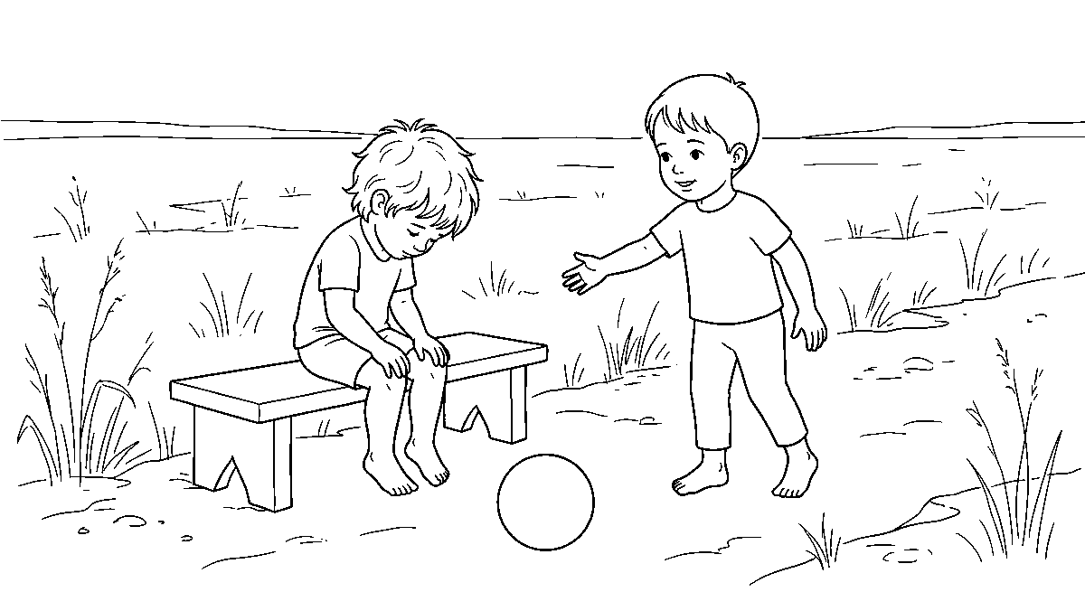
Worksheet
1. Emotions are the A) feelings of the heart B) rules of the game C) shoes we wear D) muscles of the leg
2. Feeling sure that you can do it is called A) fear B) anger C) confidence D) sleep
3. When we lose and do not fight or cry wildly we show good A) sportsmanship B) noise C) speed D) dress
4. Nervousness before a race is best beaten by A) running away B) shouting C) practice D) skipping
5. Fill in: The heart coming back after a fall or a loss is called ____.
6. Mention three good feelings that come from playing and two hard feelings.
7. Write two sentences on a game that made you angry and what you did about it.
My own work
Play one game this week and write one line on the feeling you had at the start, one at the end, and what you did with it.
Draw two children sharing one ball and colour the ball.

WEEK 2 — DEVELOPMENT THROUGH SPORT ACTIVITIES: SOCIAL DEVELOPMENT
Depth: NERDC Nursery 3 · PHE · Second Term W3 (pp 552–557).
You will learn to
• play with others toward one goal
• name the ten social things a game teaches
• take turns at leading and at following
• welcome a new player into my game
Things to know
• Social development is learning to live and work with other people; a game is a small town with rules.
• Cooperation is working together and helping a team-mate when his line fails.
• Teamwork is all of us pushing toward one goal, each knowing his own job: one throws, one catches, one runs.
• Tolerance is accepting that another child is slower and I do not laugh; being patient with a mistake.
• Friendliness is kind words to team-mate and to opponent; a game makes friends faster than a classroom does.
• Fairness is playing by the rules, not cheating, and accepting what the one who judges says.
• Hospitality in a game means welcoming the new child who does not know the rules yet, and teaching him instead of sending him out.
• Respect is for the one who trains us, for the opponent, for the team-mate, for the equipment and for the rule.
• Communication is speaking clearly to my side ("here!", "mine!") and listening when instructions come; shouting nonsense is not communication.
• Leadership has two faces: sometimes I lead the line, sometimes I follow — both are needed and neither is bigger.

• These are life skills: the child who can wait for his turn in a game can wait his turn at a counter when he is grown.
• Character is built when nobody is watching the ball and I still do not push.
Words for my notebook
Cooperation, teamwork, tolerance, friendliness, fairness, hospitality, respect, communication, leadership — a game teaches all ten.
Let us talk
1. What is the difference between cooperation and teamwork?
2. A new child does not know the rules: what do you do?
3. When is it your turn to lead, and when to follow?
4. Which social lesson was hardest for you this week?
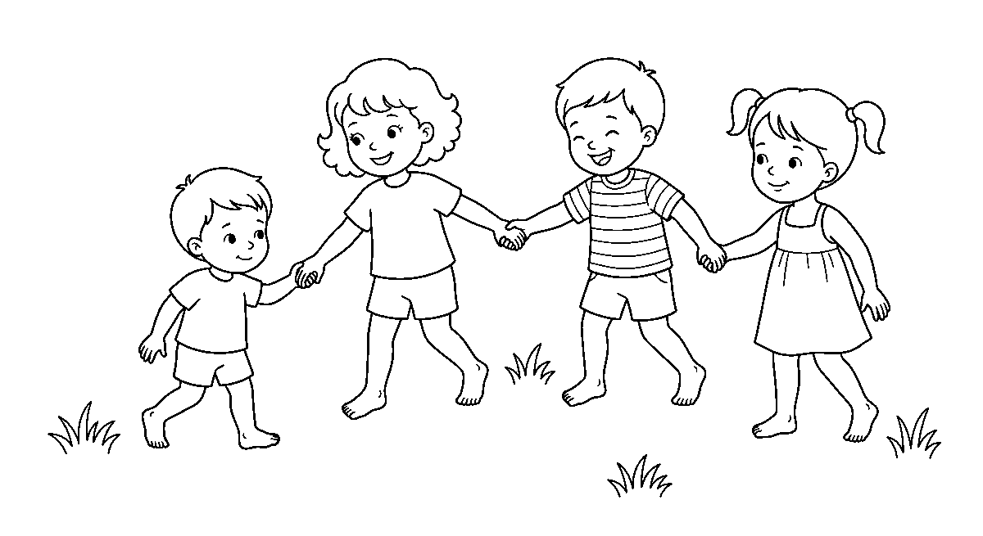
Worksheet
1. Working together toward one goal is A) teamwork B) resting C) running D) fighting
2. Accepting another child's mistake without laughing is A) speed B) luck C) tolerance D) anger
3. Welcoming a new player into your game is A) hospitality B) silence C) fear D) pride
4. Sometimes leading and sometimes following is called A) rest B) leadership C) luck D) shouting
5. Fill in: Speaking clearly to your side and listening to instructions is ____.
6. Mention five things a game teaches us about living with people.
7. Write two sentences on a time you helped a team-mate.
My own work
Play one team game this week and write the name of one thing you did for the team rather than for yourself.
Draw the team you played with and colour every shirt a different colour.

WEEK 3 — MARCHING EXERCISE: CONCEPT AND IMPORTANCE
Depth: NERDC Nursery 3 · PHE · Second Term W4 (pp 552–557).
You will learn to
• stand at attention
• march on the spot and march forward in time
• turn left, right and about on command
• say why we march
Things to know
• Marching is organized walking in rhythm and in a formation — the feet step, the arms swing, everybody moves as one.
• At attention: heels together, toes a little apart, body straight, arms at the sides, eyes front, mouth quiet, chest up.
• Arm swing: the arm swings from the shoulder, not the elbow; the hand goes to about the level of the waist-belt in front and a little behind.
• High knee on the spot: lift the knee toward the chest, put the foot down on the ball, alternate.
• Forward march: the left foot starts; the step is short and even; I do not look at my feet.

• Spacing: an arm's length to the child in front and to each side, so that no one is kicked and no one is left behind.
• Commands: "Attention!" "Forward — march!" "Halt!" "Left turn!" "Right turn!" "About — face!"
• Turning: on "Left turn" I turn on the heel of the left foot and the ball of the right, ninety degrees, sharp and without stumbling.
• About-face is a half turn to the left, done in one movement, not two.
• Marching teaches discipline and focus: the ear listens for the word, the body waits for it.
• It gives good posture, coordination of hand and leg, teamwork (all feet fall on the same beat), and it trains listening.
• We march for events: parade, the founding day, the sports fete, a funeral honour, the flag day — marching is how a people show that they are organized and respectful.
• The beat comes from a drum; the left foot falls on the strong beat, so a class of forty makes one sound.
Words for my notebook
Attention — forward march — halt. Left foot starts, arms swing from the shoulder, one arm's length between us.
Let us talk
1. Which foot starts when we march forward?
2. What does "at attention" look like?
3. Why must there be space between us?
4. Name two events where people march.
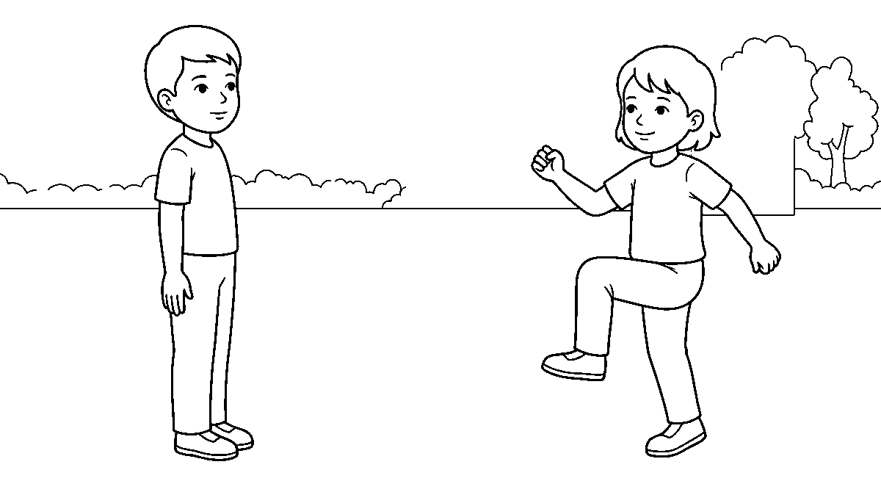
Worksheet
1. Marching is best described as A) organized walking in rhythm B) sleeping well C) hopping on one leg D) running freely
2. The command that makes everybody stand straight and quiet is A) Halt B) Attention C) March D) Rest
3. When we march forward the first foot to move is the A) right B) both C) left D) none
4. The distance we keep from the child in front is about A) an arm's length B) a mile C) two steps only D) a foot
5. Fill in: "____ — face!" turns us right round.
6. Mention four benefits of marching.
7. Write two sentences on how the class looked and sounded when you marched as one.
My own work
Practice marching on the spot in your own space for one minute, twenty times high knee, and write whether your arms and legs went together.
Draw six children marching one behind the other and colour their shoes.

WEEK 4 — BODY EXERCISE: SWINGING, TWISTING, JUMPING AND BENDING
Depth: NERDC Nursery 3 · PHE · Second Term W7 (Swinging and Twisting) and W8 (Jumping and Bending), pp 552–557 — the school keeps both in one week.
You will learn to
• swing arms and legs with control

• twist the trunk from side to side
• jump on two feet and land soft
• bend forward, sideways and down
Things to know
• Swinging moves a body part back and forth, or round and round, without leaving the ground.
• Arm swings: forward and back, side to side, big circles front and big circles back; both arms together, then one after the other.
• Leg swings: hold the wall or a bench, swing one leg forward and back, then across the body side to side.
• Trunk swing: bend a little from the waist and let both arms swing from side to side, touching the ground on each side.
• Twisting turns a part round on itself: hands on waist, hips still, shoulders left and right — look over the shoulder each time.
• Neck turns are gentle and slow: chin toward the shoulder, never a hard circle. Wrist and ankle rotations go round both ways.
• Swinging loosens the joints, twisting improves flexibility and range of motion, and both warm the muscles before the fast work.
• Jumping: two feet together, arms up, land with the knees bent — a soft landing means the feet say nothing.
• Kinds of jump: jumping jacks (arms and legs out, then in), jump and turn a quarter or half way, jump forward and back, side to side, over a rope on the ground, into a pattern of squares.
• High jump reaches up to touch; long jump goes forward for distance from a short run and two feet.
• Bending: forward bend to touch the toes, side bend left and right with the arm over the head, knee bends (squats) with the heels down and back straight.
• A backward bend is done only with help and on a soft mat, never alone and never on a hard floor.
• All movement is controlled, not jerky; a bounce that hurts is a sign to stop.
• The four movements go into a routine: warm with swings, turn with twists, be loud with jumps, end with slow bends and a breath.
Words for my notebook
Swing, twist, jump, bend. Warm up first, land softly with bent knees, never jerk a movement.
Let us talk
1. Which movement loosens the joints first?
2. Show me a soft landing.
3. Why do we not do a hard circle with the neck?
4. Count your jumping jacks aloud — how many did you do?
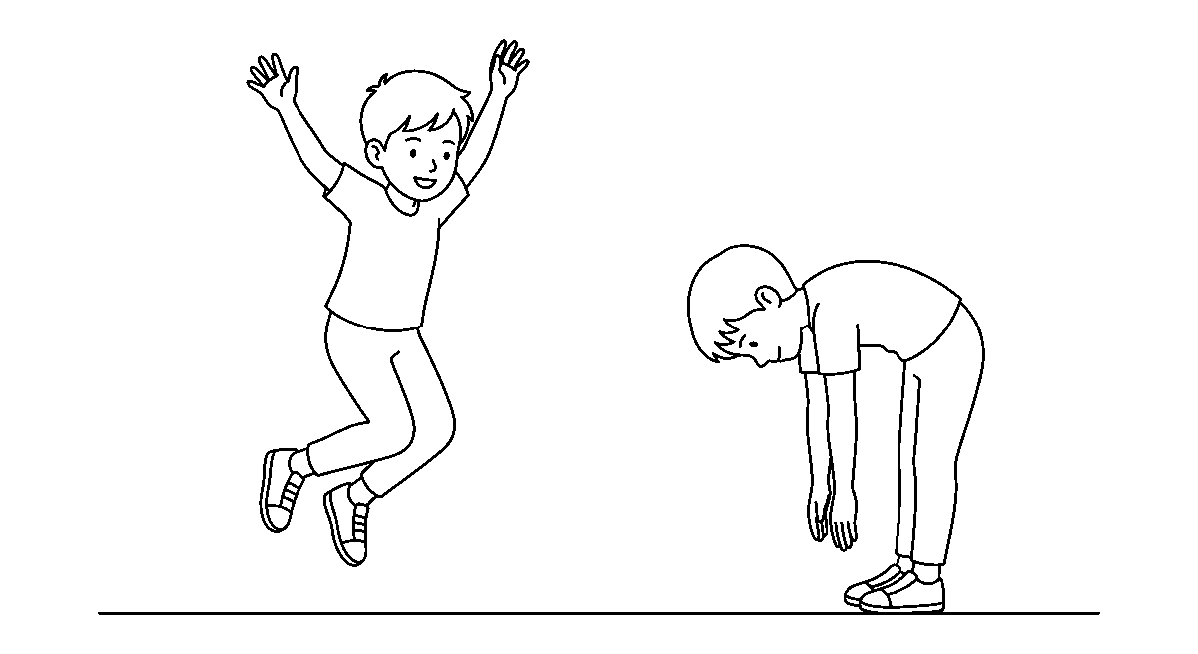
Worksheet
1. Moving a body part to and fro without leaving the ground is A) swinging B) jumping C) bending only D) sleeping
2. A jump lands best with the knees A) crossed B) locked C) straight D) bent
3. Twisting the shoulders from side to side improves A) appetite B) eyesight C) flexibility D) hearing

4. A backward bend should be done A) with eyes closed only B) on a hard floor C) alone and fast D) with help on a soft mat
5. Fill in: A routine begins with ____ so that the muscles are warm.
6. Mention four kinds of jump and two kinds of bend.
7. Write two sentences on the movement that was hardest for you today.
My own work
Do ten arm swings, ten twists each way, ten jumps and ten forward bends in your own space, and write which one made you breathe hardest.
Draw yourself jumping in the air and colour the shoes you jumped in.

WEEK 5 — NEUROMUSCULAR SKILLS: CLIMBING
Depth: NERDC Nursery 3 · PHE · Second Term W9 (pp 552–557).
You will learn to
• say what neuromuscular means
• climb steps, a low ladder and a frame with control
• place my hands and feet before I move my weight
• say the safety rules of climbing
Things to know
• Neuromuscular means the nerves (brain and messages) working with the muscles: the eye sees, the brain decides, the muscle moves, and the body keeps balance.
• Climbing is moving the body up or over something using hands and feet together.
• Before I move: three points stay, one point moves — two hands and a foot on the ladder while the other foot searches for the rung.
• Hand-eye and foot-eye coordination: the hand goes exactly where the eye put it; the foot finds the rung without looking down too much.
• Body awareness is knowing where my legs are without looking; it is trained by slow climbing, not fast.
• Ways to climb stairs: forward one step at a time, two steps at a time, sideways holding the rail, and backward very carefully with help.
• Ways on the playground: up the jungle gym bars, along the ladder, down the slide's steps; over obstacles — a mat, a bench at low height, a soft block.
• A wall climb is only on a wall made for it, with a mat below and the belt and the hold checked.
• Strength needed: arms to hold, legs to push (the legs do most of the work), trunk to keep the body steady.
• Problem solving: I look up first and plan my route — which hand, which rung, where to come down.
• Confidence and courage: I climb as high as I am ready; the fear that stops me at a bad hold is a good teacher, and I come down slowly rather than jump.
• Safety: only where an adult has said yes, on a mat or sand below, no pushing under me. No climbing with a slick hand, nothing sharp or heavy in the pocket, one child on a rung range at a time.
• Climbing is a full-body work; after it we shake the hands and walk the legs before sitting.
Words for my notebook
Neuromuscular = brain, nerves and muscles working together. In climbing: three points stay, one moves; plan the route first.
Let us talk
1. What does "three points stay, one moves" keep you from?
2. Which part of the body does most of the pushing in a climb?
3. What do you check before you put your weight on a hold?
4. Name two safety rules of the climbing frame.

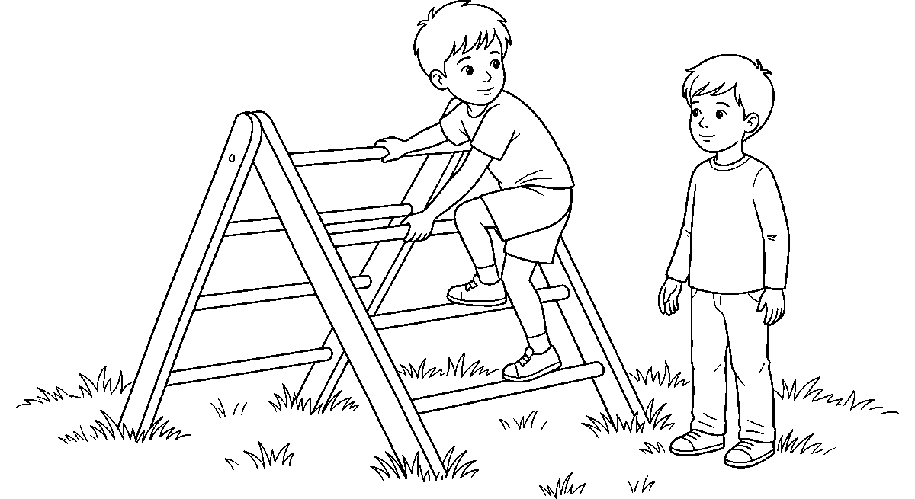
Worksheet
1. Neuromuscular means the nerves working with the A) ball B) shoes C) muscles D) ears
2. On a ladder, while one foot moves, how many points should still be on it? A) none B) one C) three D) half
3. In climbing, most of the pushing is done by the A) legs B) chin C) nose D) fingers
4. Looking up to decide which rung to use is a form of A) problem solving B) singing C) jumping D) sleeping
5. Fill in: We climb only where an adult has said ____ and with a mat below.
6. Mention four things climbing improves in the body.
7. Write two sentences on the highest thing you climbed this week and how you felt.
My own work
Climb a low, safe thing twice — once slowly and once a little faster — and write which one felt more in control.
Draw a ladder and colour the rung your hand reaches highest.

WEEK 6 — TRACK EVENTS
Depth: NERDC Nursery 3 · PHE · Second Term W10 (pp 552–557).
You will learn to
• run a short race straight to the line
• take the standing and the crouching start
• run a race in pairs with a partner
• keep the rules and the spirit of the race
Things to know
• A track event is a race run on a marked path called the track; on the day of the sports fete we run in our lane and do not cross into another child's.
• Our short distance is the 25-metre race — about the length of the class hall laid flat.
• The standing start: feet one behind the other, weight forward, eyes on the line.
• The crouching start: on the marks, hands behind the line, fingers making a bridge, one knee down; at the word the legs push the body out low.
• The signal: "On your marks — set — go!" (or a whistle); I move only at the last sound, not before.
• Running form: eyes front, mouth a little open, arms bent and swinging from the shoulder, knees lifting, land on the front of the foot, do not twist the body.
• Do not slow down before the line: run through the finish, ten steps past it, then walk — never stop dead, because the legs must carry the blood back.
• Rules: stay in your lane, no pushing, no cutting the corner, no blocking, do the false start again if told, and take the result of the one who judges.

• Sportsmanship: greet before, shake hands after, thank the one who lost to you; a win by cheating is a loss.
• In running in pairs the two of you run side by side to the line at the same speed; one waits if the other stumbles.
• A harder pair game: the two hold a bean bag or a small stick between you without hands and run without dropping it — that is cooperation carrying speed.
• Everybody who runs is celebrated, not only the first: we clap the last child home loudest, because he did not stop.
Words for my notebook
Track = the marked path. Move only at "go", run through the line, walk after, shake hands whatever happened.
Let us talk
1. How far is our short race?
2. Show me the position of the hands at a crouching start.
3. Why do we not stop dead at the line?
4. What do you do if your partner stumbles in a pair race?
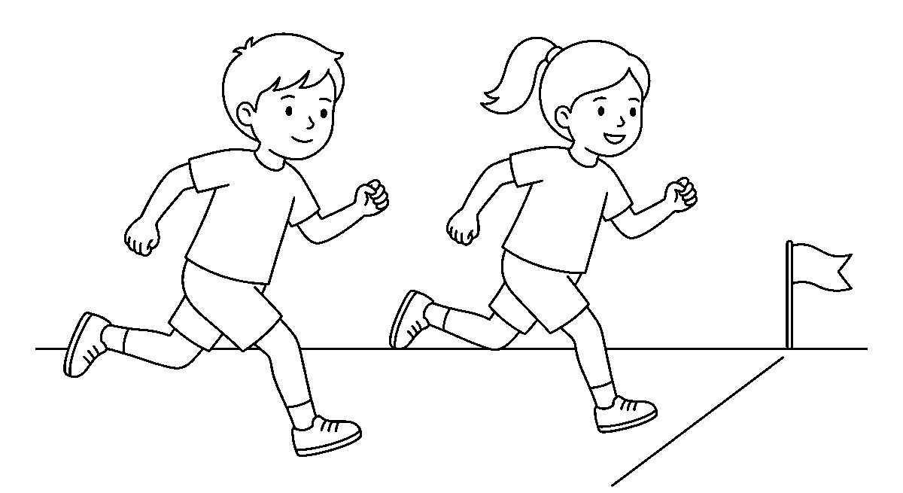
Worksheet
1. A track event is a A) board game B) song C) race on a marked path D) swim in a bucket
2. The word we move on is A) the last signal, such as a whistle B) "run" whispered C) the bell for break D) the clapping
3. Good running form keeps the eyes A) closed B) upward only C) to the front D) on the feet
4. After crossing the line we should A) lie on the track B) turn back fast C) sit down at once D) keep going a little then walk
5. Fill in: In a pair race, if your partner stumbles, you ____ for him.
6. Mention the two kinds of start and three rules of a race.
7. Write two sentences on a race you ran and how you behaved at the end.
My own work
Time yourself over ten long steps on a safe ground three times, and write which run was the fastest and how you started it.

WEEK 8 — POSTURE
Depth: NERDC Nursery 3 · PHE · Second Term W11 (pp 552–557).
You will learn to
• say what posture means
• sit, stand, read and sleep well
• tell what bad posture does to the body
• keep a straight back when I write
Things to know
• Posture is the position in which I hold my body when I sit, stand, move or rest.
• Good sitting posture: back against the chair, bottom well back, both feet flat on the floor, back straight, shoulders relaxed, head level and not pushed forward.

• Bad sitting: slouching (body sunk down, back curved), one leg under the body, chin on the desk, the head bent to one hand.
• Sitting badly hurts the back and the neck, makes breathing shallow (the chest is squeezed), and makes it hard to concentrate; the child who looks tired may only be sitting crooked.
• Good standing posture: feet about hip-width apart, weight on both feet evenly, knees not locked, stomach gently in, shoulders back and down, head up, chin level, arms loose at the sides.
• Bad standing: leaning on one hip, head forward, shoulders rolled in, knees bent backwards — these tire the legs and bend the spine.
• Good reading posture: the book or paper held about the length of a forearm from the eyes, at a level a little below the eyes. Back supported, light coming from in front or the side, not lying on the stomach or in a dark corner; rest the eyes now and then.
• Reading in bad light or too close pulls the eyes and gives a headache; that is why we do not read while walking or in a moving bus.
• Good sleeping posture: on the side with the knees a little bent and a pillow between them, or on the back with a thin pillow; the front (tummy) position twists the neck and presses the chest — avoid it.
• The pillow should not push the head high; the mattress should be firm enough that the back does not sink into a hammock.
• Carrying posture: the school bag is worn on both shoulders and sits high on the back; a bag hung on one shoulder pulls the spine sideways.
• A simple check: heels, bottom and shoulders touching the wall, eyes front — if the head cannot find the wall without tilting, the sitting of this week has bent it forward.
• Good posture looks confident before it feels healthy: the straight child appears ready, and in our mock examination practice we sit tall on purpose.
Words for my notebook
Posture = how I hold my body. Feet flat, back straight, eyes an arm's length from the book, bag on both shoulders.
Let us talk
1. What is posture?
2. Show me how you should sit when you write.
3. Which sleeping position should we avoid?
4. Why is a one-shoulder bag bad for the back?
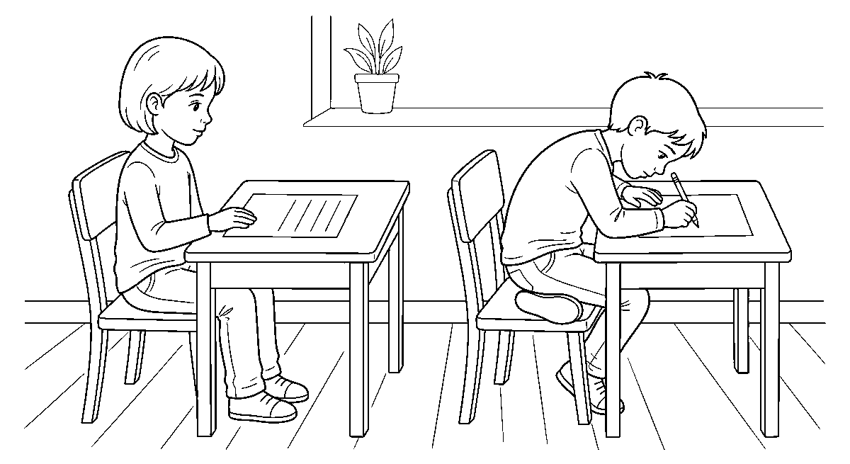
Worksheet
1. Posture means the way we A) choose shoes B) hold our body C) sing D) eat food
2. While sitting to write, the feet should be A) raised B) flat on the floor C) crossed behind D) on the stool rung
3. The best sleeping position among these is A) face down with a tall pillow B) on the side C) on the elbow D) on the tummy
4. A school bag should be carried on A) both shoulders B) the head only C) the fingers D) one shoulder
5. Fill in: While reading, the book should be about an arm's length from the ____.

6. Mention two effects of bad sitting on the body.
7. Write two sentences on the posture you must correct in yourself.
My own work
Set a line on your exercise book and write one page sitting tall with both feet flat; then write a second line slouched and compare the two.
Draw one child sitting straight and one bending over; colour the one with good posture.

WEEK 9 — INDOOR GAMES
Depth: NERDC Nursery 3 · PHE · Third Term W1 (pp 558–563).
You will learn to
• say what an indoor game is
• name games we can play inside
• play Ludo, puzzles and simple card games well
• balance indoor play with outdoor play
Things to know
• An indoor game is a game played inside a building, in a room or a hall, that needs little space and makes little noise.
• We play indoor games when the weather is bad: rain, too much sun, or a harmattan so dusty that running would hurt the chest.
• Indoor games exercise the mind: thinking, remembering, counting, planning, waiting.
• Ludo: a board, a dice and four pieces each; you throw, count the squares, and the piece that reaches home first wins — patience and counting, not running.
• Chess begins with names: the king, queen, rooks on the corners, knights and bishops, the line of pawns in front; we learn how the pieces move, and the full game comes later.
• Checkers (draughts): men move forward diagonally, capture by jumping, and become kings at the far line.
• Dominoes: matching ends with the same number of spots; a child learns to count the pips and to plan two turns ahead.
• Card games we can play: matching pairs by number or colour, and the memory game with cards face down — turn two, if they match keep them; that game trains the eye and the memory.
• Puzzles: putting pieces back into a picture, counting and matching; Snakes and Ladders teaches the ladder up and the snake down while we count.
• A table game needs a table or a mat; a video game needs a screen, and its rules are the screen's: short time, good light, the pause at the eyes.
• Indoor manners: no shouting, do not flip the board when losing, take turns, put the pieces back in the box so the next class can play.
• Balance: the body still needs outdoor running; an hour of the mind inside is answered by an hour of the legs outside.
Words for my notebook
Indoor games are quiet games for a room: Ludo, cards, puzzles, dominoes, checkers, chess. Mind and legs both need play.
Let us talk
1. Why do we play indoor games on a rainy day?
2. What must happen to a piece in Ludo to win?
3. What does the memory game train?
4. How do we behave when we are losing a board game?

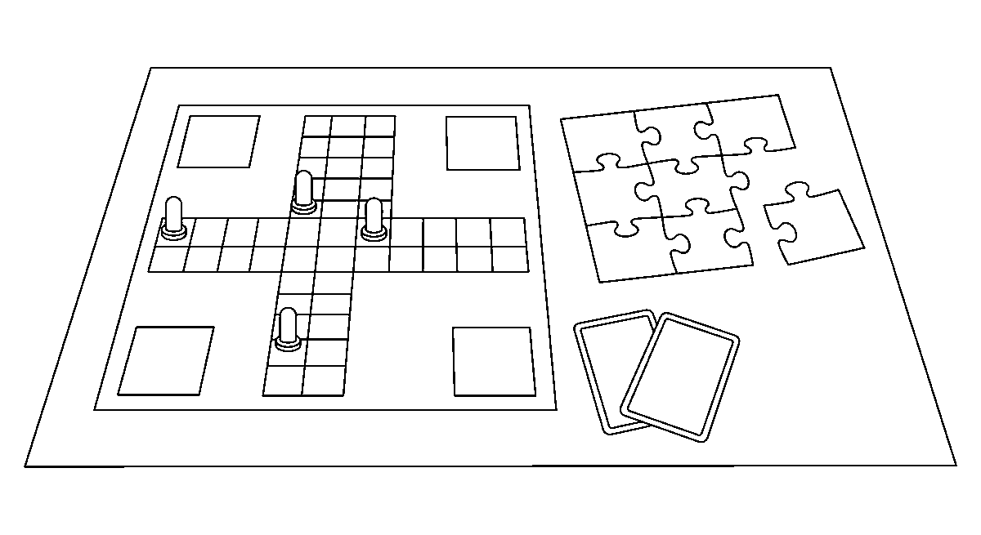
Worksheet
1. An indoor game is played A) in the river B) inside a room C) on the field D) in the rain outside
2. In Ludo the winner is the one whose piece first A) reaches home B) turns over C) leaves the board D) falls down
3. The card game with cards face down trains A) the memory B) the legs C) the lungs D) the voice
4. Which game uses pieces with spots to match ends? A) football B) skipping C) dominoes D) hopscotch
5. Fill in: The pieces of a board game must be put back in the ____ after play.
6. Mention five indoor games.
7. Write two sentences on an indoor game you enjoyed and what it made your mind do.
My own work
Play one indoor game with a friend or a sibling, and write what you had to think about while you played.

PREVOCATIONAL STUDIES (PVS)
Weeks 1 to 6, 8 and 9. Week 7 is Mid-Term Break, Week 10 Revision, Week 11 Examination, Week 12 Closing — those weeks carry no note. Depth: NERDC 2025 · Primary 4 · Prevocational Studies · First Term W1–W4 (pp 833) and Third Term W7 (School Garden Activities, p 835) — this subject is redistributed into the lower classes, so the Primary 4 weeks are the ceiling of vocabulary and the school's own rows decide what each week is about.

WEEK 1 — FARMERS AND THEIR WORK
Depth: NERDC Primary 4 · Prevocational Studies · First Term W1–W2 (Concept of Agriculture, p 833).
You will learn to
• say who a farmer is
• name the kinds of farmer and the work each does
• tell the daily work of a crop farmer
• say that farming is a job that needs skill
Things to know
• A farmer is a person who grows crops or keeps animals for food and for selling.
• Not everybody who has a farm is a farmer: the one who works the land is the farmer.
• Kinds of farmer: crop farmer (yam, cassava, maize, rice, vegetables) · animal keeper (poultry birds, goat, sheep, pig, cattle) · fish farmer (fish in a pond) · tree crop farmer (cocoa, oil palm, rubber). The forester grows and keeps the trees.
• Work of the crop farmer, in order: clear the land → till and make the beds → choose and plant the seed → weed. Then water or wait for rain → guard against pest and bird → harvest → dry, store and sell.
• The animal keeper's daily work: open the house, give water, give feed, clean out the litter, look for the sick one, collect the eggs, close the house at night so the thief and the dog do not come.
• The fish farmer feeds the fish at set times, keeps the water moving and clean, and nets the big ones out.
• A farmer also keeps record: how many bags, how many birds, how much was spent on bag and on medicine.
• Farming work begins early: the farmer is on the farm before the sun is high, when the body is cool and the weeds are soft.
• Farming gives the town its food, the market its money, the factory its raw material — so the farmer works for all of us.
• Tools and machines belong to the next weeks; today we know that the hand, the plan and the patience are the farmer's first three tools.
Words for my notebook
A farmer grows crops or keeps animals for food and for sale. Clear, plant, weed, water, harvest, sell.
Let us talk
1. Who is a farmer?
2. Name three kinds of farmer you know.
3. What does a poultry keeper do every morning?
4. Why does a farmer begin work early?

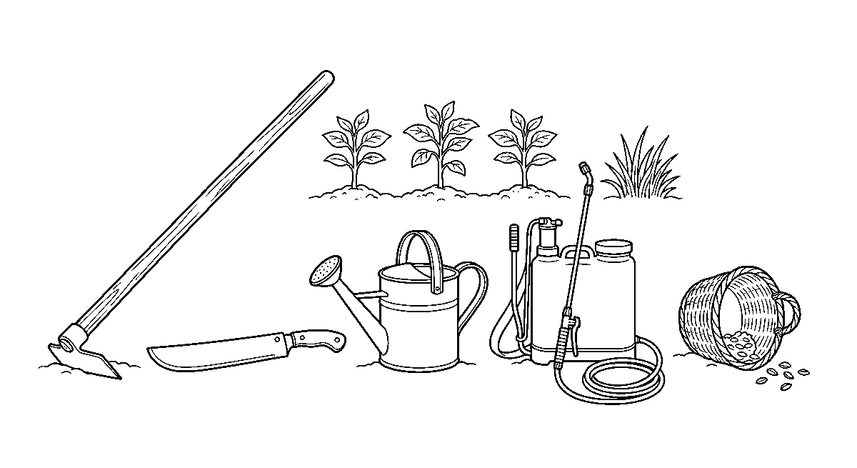
Worksheet
1. A farmer is a person who A) grows crops or keeps animals B) mends shoes C) sells only cloth D) drives a bus
2. A poultry farmer keeps A) goats only B) birds C) fish D) bees only
3. Which work comes first on a new farm? A) harvest B) drying C) selling D) clearing the land
4. Collecting eggs, giving water and cleaning the house are the work of a A) fisherman only B) tailor C) driver D) poultry keeper
5. Fill in: After planting, the farmer removes the ____ so the crop can grow well.
6. Mention the six works of a crop farmer from clearing to selling.
7. Write two sentences on a farmer you know and what he or she grows or keeps.
My own work
Find out what one farmer near us grows or keeps, and write the name of the crop or animal and one thing that person does every day.
Draw a farmer's cutlass, hoe and basket, then colour the basket.

WEEK 2 — FARM VISITS
Depth: NERDC Primary 4 · Prevocational Studies · First Term W1–W2 (p 833) — the farm visit is where the concept of agriculture is seen.
You will learn to
• say what a farm visit is and why we go
• observe and report what I saw on the farm
• keep the rules of the visit
• name the things on the farm I want to ask about
Things to know
• A farm visit is when the class goes to a farm to see with the eyes what was told in the class.
• We go to a crop farm, a poultry house, a fish pond, a garden, or the school's own plot.
• Before we start: the bag is left in the class, the feet are shut well, the hat keeps off the sun, and the water flask is filled.
• Rules of the visit: walk, do not run on the beds; touch nothing without being told; do not pick the fruit; do not chase the birds; stay with the line; ask, then listen.
• What to look for on a crop farm: the shape and height of the plant, the kind of soil, how the rows are lined, whether there are weeds, whether the beds are watered or dry. And any hole or yellow leaf that shows a pest.
• What to look for in the animal house: the type of feed, the water pot, the smell and cleanliness, the space per animal, and whether any animal sits apart — that is the sick one.
• What to ask: When did you plant? What do you feed them? What kills your crop? Where do you sell? What is dear this year?
• The visit has three parts: before (what we will look for), during (what we see and hear), after (what we write and draw).

• Our report has: the name of the farm, the day, the person who showed us, three things we saw, one thing we learnt, one question we still have.
• When we come back we wash the hands and the shoes, and the mud is not carried into the class.
• A farm visit teaches respect for the labour: the bowl of rice is a year of somebody's back.
Words for my notebook
On a farm visit we look, listen and ask; we touch nothing without leave and we write a report after.
Let us talk
1. Why do we go to a farm instead of only reading about one?
2. Name two rules of the visit.
3. What on the farm did you want to touch most?
4. What will your report contain?
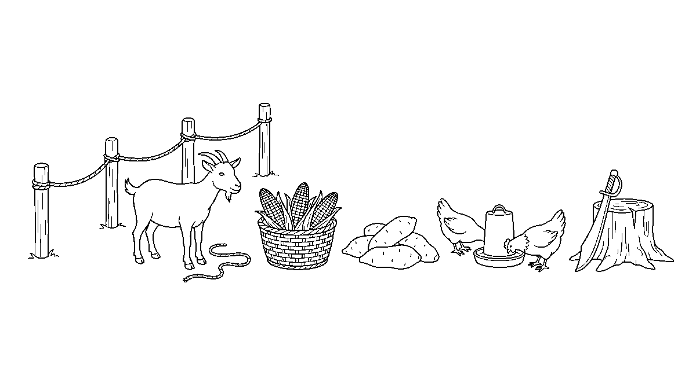
Worksheet
1. A farm visit means the class goes to the farm to A) buy food for the school B) sleep C) see things with the eyes D) hide
2. On the farm we must A) run on the beds B) chase the birds C) pick the fruit D) walk and stay with the line
3. An animal sitting apart from the others is probably A) new B) sleeping well C) sick D) happy
4. A good question to ask the farmer is A) where do you live? B) how old are you? C) when did you plant? D) what is your name?
5. Fill in: Before the visit we leave our bags in the ____ and shut our shoes well.
6. Mention five things to look for on a crop farm.
7. Write two sentences on the farm we visited or would like to visit and what you saw there.
My own work
Write your farm-visit report on one page: where we went, three things you saw, one thing you learnt and one question you still have.

WEEK 3 — COMMON FARM TOOLS: HOE AND CUTLASS
Depth: NERDC Primary 4 · Prevocational Studies · First Term W3–W4 (Simple Agricultural Tools, p 833).
You will learn to
• draw and name the hoe and the cutlass
• say what each tool is used for
• say which part of each tool does the work
• keep the tool safe and store it well
Things to know
• A farm tool is a thing we hold in the hand to make farm work easier; most of ours are simple tools — no engine on them.
• The hoe has a handle (wood) and a broad flat blade at a right angle; it is used for tilling, making ridges and beds, earthing up the plant and weeding between rows.
• The blade of the hoe is pushed into the soil and pulled — the digging is by the arms and the back, not by a swing.

• The cutlass (cutlass, a short heavy blade with a wooden handle) is for clearing: cutting grass, brushing small sticks, cutting the weed and slashing the bush.
• A cutlass cuts by a clean swinging stroke; the blade must be sharp — a blunt blade needs more force and slips more.
• Parts of a tool: blade (the working metal part), edge (the cutting side), handle (the part in the hand), tang/ferrule (the joint that holds the blade on the handle).
• A tool with a loose handle must be fixed before it is used, or the blade will fly off in the swing.
• Safe use: clear the ground of stones and people first, keep an arm's length of space between two workers, never swing toward a person, and never carry a cutlass point-forward.
• Carry a cutlass blade down and away from the body, or sheathed; carry the hoe with the blade down.
• Care: wipe the mud off after use, keep the edge dry so rust does not eat it, put a drop of oil on the metal now and then; a rust-eaten tool breaks.
• Storage: tools hang on a wall or lie on a rack, edge down or sheathed, out of the rain, and never where a child will step on them.
• Sharpening is done with a file or a stone by an adult, and the blade is held away from the body.
Words for my notebook
Hoe: blade and handle — for tilling, ridging and weeding. Cutlass: a sharp edge — for clearing. Clean, dry, sheathed, hung up.
Let us talk
1. Which part of the hoe goes into the soil?
2. What do we use a cutlass for?
3. Why must a tool handle be tight?
4. Where should a cutlass be kept after work?
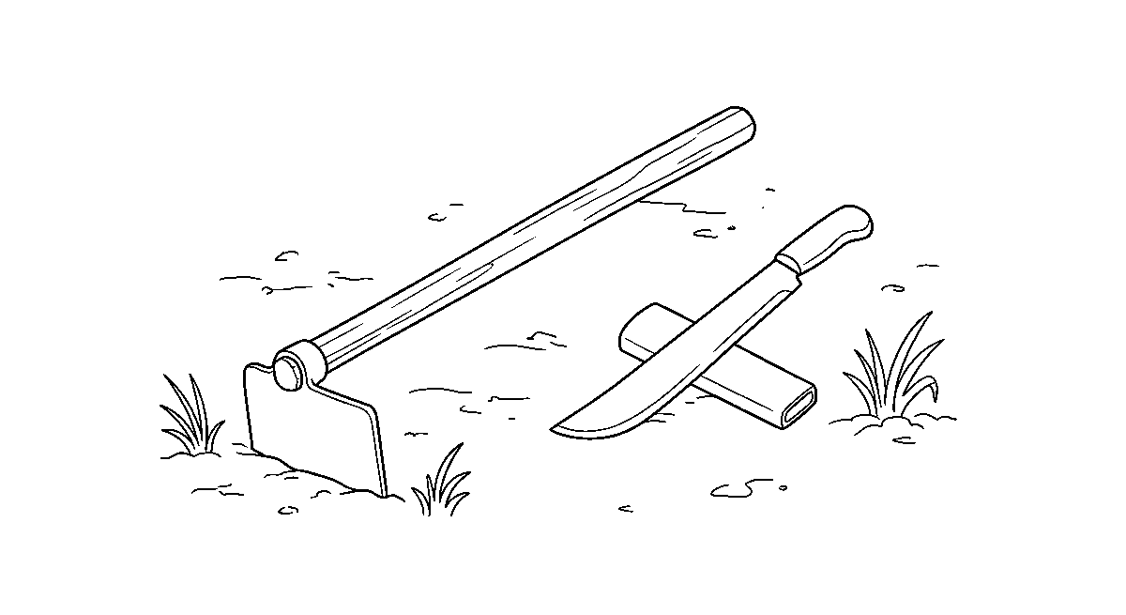
Worksheet
1. The tool used for tilling and making ridges is the A) basket B) cutlass C) rake D) hoe
2. The part of the tool you hold is the A) tang B) blade C) handle D) edge
3. A cutlass works best when its edge is A) wet B) sharp C) blunt D) bent
4. Before swinging a cutlass we must first A) clear people and stones from the ground B) eat C) count the leaves D) water the plant
5. Fill in: Mud is ____ off a tool after use so that rust will not eat it.
6. Draw and label the hoe and the cutlass.
7. Write two sentences on how a tool should be stored after work.
My own work
Draw the two tools again, name the four parts of each, and write one rule of safe use under each drawing.

WEEK 4 — COMMON FARM TOOLS: RAKE AND WATERING CAN
Depth: NERDC Primary 4 · Prevocational Studies · First Term W3–W4 (p 833), with Third Term W7 (School Garden Activities) for the watering work.
You will learn to
• name and draw the rake and the watering can
• say what each is used for
• level a seedbed and water a garden the right way
• tell which tool is for the bed and which for the path
Things to know
• The rake has a long handle and a cross head with teeth (prongs); it is a tool for gathering, leveling and smoothing.
• Work of the rake: pull the stones, sticks and old leaves out of the bed; break the small clods; level the soil after the hoe; smooth the surface before seeds are sown; clean the path.
• Level means the top of the bed is flat all across, so the water stands evenly and does not run off one side.
• Two kinds: the garden/leaf rake with springy teeth, and the heavy soil rake with stiff teeth; the light one is ours.
• A rake is not a toy for the shoulder and never used to fight; its teeth catch a hand or an eye.
• A watering can is a vessel that carries water and pours it gently; it has a body, a handle on top and behind, a spout, and a rose (sprinkler head) full of small holes.
• The rose breaks the water into a soft rain so that a small plant is not knocked flat and the seed is not washed out of the ground.
• Without the rose the water comes as a stream — that is for filling a tub, not for a seedbed.
• Water in the morning or evening; at noon the sun takes the water back before the roots have drunk, and cold water on hot leaves scorches them.
• Water the soil around the plant, not the leaf from far above; a wet leaf at night invites disease.
• New seeds and seedlings want a little water often; a big plant wants more water less often so the roots go down looking for it.
• In the school garden our work is: rake the bed smooth → mark the rows → sow → water with the rose → weed when the leaf is dry → watch growth.
• Care: the can is emptied and left with its lid open and mouth down so it does not rust or smell; the rake is cleared of soil and hung up.
Words for my notebook
Rake: teeth for gathering, leveling and smoothing. Watering can: spout and rose for a soft rain, watered in the cool of the day.
Let us talk
1. What are the teeth of the rake for?
2. What does the rose on the watering can do?
3. When is the best time to water the garden?
4. Which tool makes the top of the bed flat?
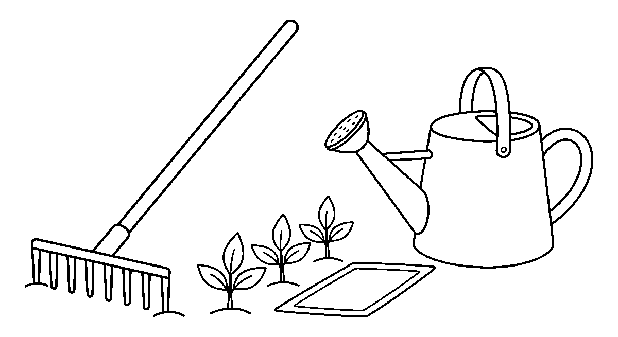

Worksheet
1. The tool with teeth used for leveling a seedbed is the A) rake B) hoe only C) spade D) cutlass
2. The part of the watering can that makes the water fall like rain is the A) base B) lid C) handle D) rose
3. We water the garden best in the A) night with no light B) morning or evening C) hot noon D) rain only
4. Before sowing seeds, the surface of the bed is A) burnt B) covered in stones C) smoothed with the rake D) salted
5. Fill in: A rake is used to ____ the garden of leaves and small sticks.
6. Mention the parts of a watering can.
7. Write two sentences on how you watered a plant and what the plant did after.
My own work
Water the same plant every morning for four days, keep the bed raked smooth, and write one line each day on how it looks.

WEEK 5 — COMMON FARM TOOLS: SPADE AND SHOVEL
Depth: NERDC Primary 4 · Prevocational Studies · First Term W3–W4 (p 833).
You will learn to
• name and draw the spade and the shovel
• tell the spade from the shovel
• say which work each does best
• dig a hole with a straight back
Things to know
• The spade and the shovel look like sisters: both have a long handle, a D or T grip at the top and a broad flat blade at the bottom. Both are pushed with the foot and lifted with the back and arms.
• The spade blade is flat and square-ish with a sharp top edge — made for digging, cutting the soil, lifting turves, and for the hard ground.
• The shovel blade is curved and hollow with a pointed or rounded front — made for lifting and moving loose things: soil, sand, ash, grain, manure.
• The rule the farmers say: a spade digs, a shovel moves.
• Parts to name: grip (handle top), handle (shaft), blade (scoop), socket (the cup that joins the blade to the handle), edge (the part that enters the soil).
• The soil is first watered or loosened; dry hard ground breaks a tool.
• To dig safely: feet apart, back straight, bend the knees, turn the soil with the hips and not with a twist of the waist; the load is carried close to the body.
• Dig by slicing a rectangle and lifting it out, not by hacking a big piece; a clean hole is a deep hole.
• A round-point shovel digs in soft ground and moves a heap; a square-point (transfer) shovel is the one for grain and sand.
• On a farm both are used to dig the planting hole or pit, to make a heap of manure, to cover the seed, to open a drain and to load the wheelbarrow.
• Care: wash the mud off, dry it, oil the blade lightly, store it blade down on a board or hanging. And never leave it standing in the sun on the bare ground where it rusts and the handle dries and cracks.
• A spade is not for prying stones loose by leverage, and never for hitting a nail.
Words for my notebook
Spade: flat blade for digging. Shovel: hollow curved blade for lifting and moving. Straight back, bent knees, load close.
Let us talk
1. Which tool has the hollow curved blade?

2. What do we do to the ground before we dig it?
3. Show me how you bend to lift a heavy scoop.
4. How do we keep a spade from rusting?
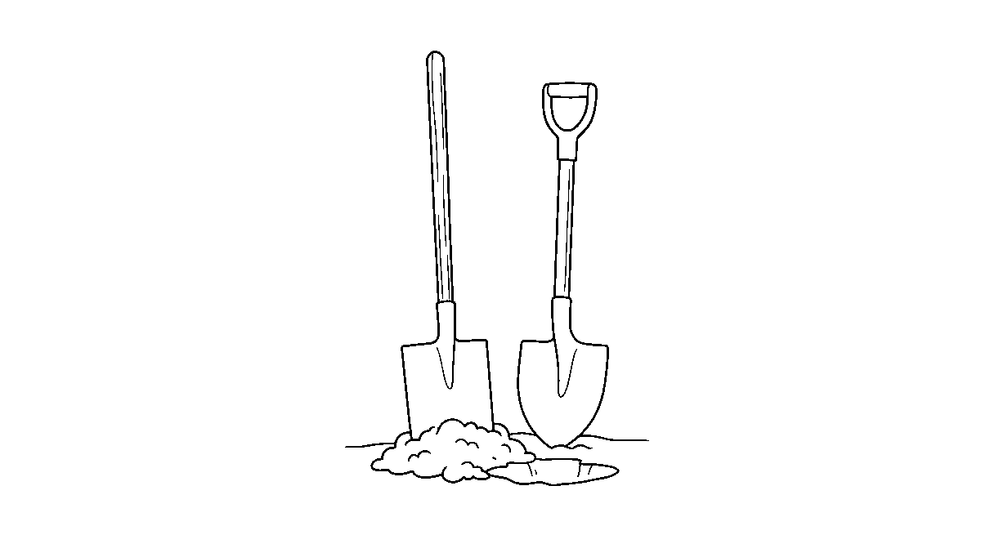
Worksheet
1. The tool whose blade is flat and square, used for digging, is the A) basket B) rake C) hoe D) spade
2. A shovel is best for A) watering B) sowing seeds C) cutting grass D) lifting and moving loose soil
3. Before digging hard ground we should A) salt it B) burn it C) water or loosen it D) leave it
4. When we lift a heavy scoop of soil we should A) twist the neck B) bend the knees and keep the back straight C) hold the breath only D) bend the waist
5. Fill in: The farmers say a spade ____, a shovel moves.
6. Mention the five parts of a spade.
7. Write two sentences on how a spade and a shovel differ.
My own work
Draw both tools side by side and write under the picture which one you would take for (a) digging a new bed and (b) moving a heap of sand.

WEEK 6 — COMMON FARM TOOLS: WHEELBARROW AND BASKET
Depth: NERDC Primary 4 · Prevocational Studies · First Term W3–W4 (p 833).
You will learn to
• name and draw the wheelbarrow and the basket
• say what each carries on the farm
• load and push a barrow without spoiling the back
• mend and keep them well
Things to know
• A wheelbarrow (barrow) is a one-wheeled cart with a box (tray), two handles and two legs; one person pushes it and it carries the load of many.
• Parts of a barrow: wheel and tyre, frame, tray (box), handles (shafts), legs (stands), and sometimes a axle pin.
• The wheel at the front makes it easy to turn and to lift over a stone; the legs let it stand down without tipping.
• A barrow carries: manure, soil, sand, water in a drum, harvested crop, bags, stones, waste — from the heap to the bed, from the farm to the gate.
• A basket is a woven carrier made of palm frond, raffia, bamboo, cane or plastic; it is carried on the head, on the back with a strap, on the hip or in the hands.
• A basket carries yam tubers, cassava, tomatoes, peppers, eggs, maize in a bag, leaves and grass — the harvest of a small farm.
• Baskets come in sizes: the small hand basket, the big market basket, the winnowing basket with a wide flat rim used to fan chaff from grain.

• Loading a barrow: put the heavy thing near the wheel and over it, not at the back handles — that is the difference between light and heavy to lift.
• Balance the load, do not heap above the rim, keep the top level so nothing falls on the path.
• Pushing: stand between the handles, back straight, knees soft, walk with small steps, look where the wheel is going, and on a slope keep the load uphill so it does not run away with you.
• A barrow is not for carrying people, and never for two children at once on a slope.
• Care: the tyre is pumped, the bolt tightened, the tray cleared of wet soil so it does not rust; a basket with a torn rim is re-woven, a split handle is bound with wire or new cane.
• Empty barrow upside down on a dry floor; baskets stacked in a shade, not in the sun which makes the cane brittle.
Words for my notebook
Barrow: one wheel, a tray and two handles — heavy near the wheel. Basket: woven carrier for the harvest, worn on head or back.
Let us talk
1. How many wheels does a wheelbarrow have?
2. Where do we put the heavy part of the load?
3. What is carried in a basket on our farm?
4. What do we do when a basket rim tears?
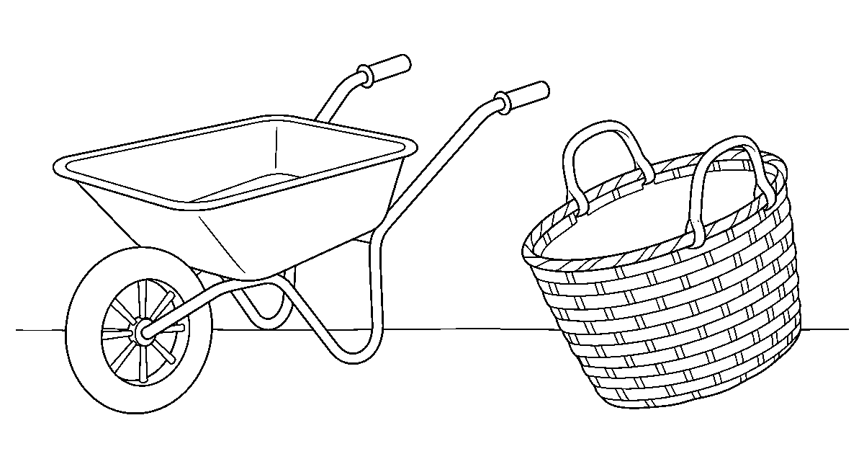
Worksheet
1. A wheelbarrow moves on ____ wheel(s). A) four B) two C) one D) six
2. The heavy part of a load in a barrow should be near the A) rim B) legs C) handles D) wheel
3. A basket on the farm is mostly used for A) spraying B) ploughing C) carrying the harvest D) cutting grass
4. The wide flat basket used to fan chaff from grain is the A) market basket B) water can C) egg cup D) winnowing basket
5. Fill in: A barrow must never be used for carrying ____.
6. Mention the parts of a wheelbarrow.
7. Write two sentences on loading and pushing a barrow safely.
My own work
Carry a light load across a short distance once in a container in your hand and once balanced on your head, then write which was easier to keep steady.

WEEK 8 — IDENTIFYING AND DIFFERENTIATING FARM TOOLS
Depth: no NERDC line is anchored here — the school's own row for this week is followed, using the Primary 4 tool weeks (p 833) as the vocabulary ceiling.
You will learn to
• pick a tool from its shape alone
• say the name of the tool and its work in one breath
• tell two tools apart by the part that does the work
• sort the tools into the right groups

Things to know
• Identifying means knowing a thing by its marks; the marks of a tool are its shape, its material, its working part and its work.
• Look at the working part first, not the handle. Teeth → rake · flat blade at a right angle to a short handle → hoe · long handle with a broad flat blade → spade · curved scoop → shovel · long blade with a wooden grip → cutlass. Then: wheel and tray → barrow · woven body → basket · can with a spout and a rose → watering can.
• Sort by work: for digging — hoe, spade; for clearing — cutlass, rake; for carrying — barrow, basket, head pan; for watering — watering can, knapsack sprayer.
• Sort by the part of the plant or soil it touches: soil tools (hoe, spade, shovel), plant tools (cutlass, watering can), carrying tools (barrow, basket).
• Sort by material: metal and wood (hoe, cutlass, spade, shovel), plastic or metal sheet (watering can), woven plant fibre (basket), rubber and metal (barrow wheel).
• Sort by the strength it needs: back-and-leg tools (spade, shovel), arm tools (hoe, rake), hand tools (cutlass), no-force tools (barrow, basket) — the machine takes the weight.
• Names to keep away from confusion: a spade is not a hoe (the spade is pushed with the foot in line with the handle. The hoe is pulled at a right angle); a shovel is not a spade (the shovel moves, the spade digs); a rake is not a hoe (teeth, not blade).
• Our game: the bag holds five cut-out tool shapes; one child draws one and names it and its work before the class may say "right".
• A tool can also be known by how it is held: two hands (spade, shovel, hoe), one hand (cutlass), pushed not held (barrow), carried not held (basket on the head).
• If you cannot name a tool, describe it: what it is made of, the part that does the work, and where the farmer stands when he uses it.
• We end with the sound of each word said once, then the class calls the tool for its work: "What do I use to level the bed?"
Words for my notebook
Know a tool by its working part: teeth, blade, scoop, edge, wheel, weave, rose. Same job means same group.
Let us talk
1. Which part of a tool should you look at first?
2. Tell me a tool you would use for carrying and one for clearing.
3. How is a hoe held differently from a cutlass?
4. Name two tools that are easy to confuse, and the one difference.
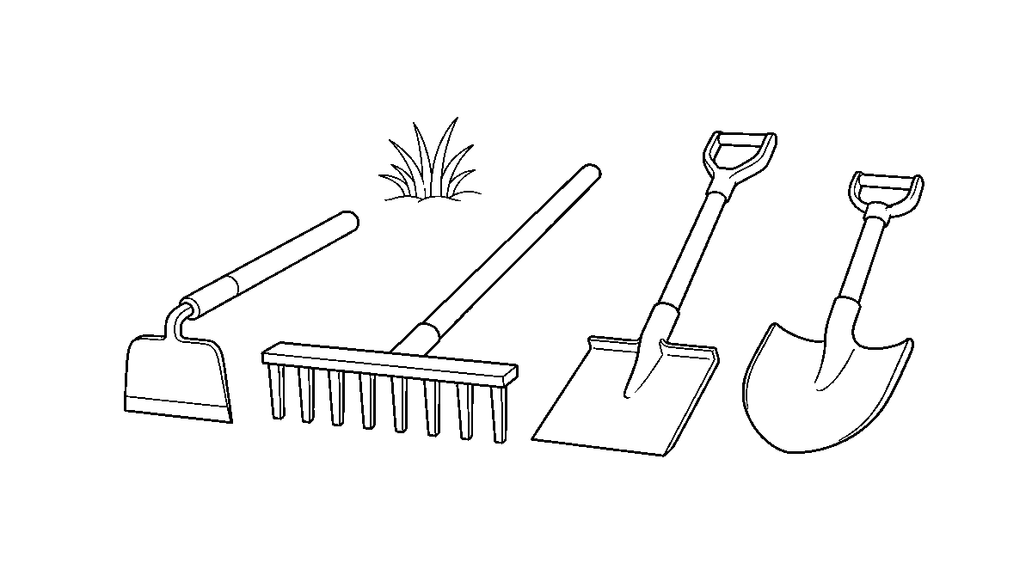
Worksheet
1. We can identify a tool best by looking at its A) owner B) colour of rope C) working part D) price
2. A tool with teeth on a cross head is the A) rake B) hoe C) can D) spade
3. A long handle with a broad flat blade you push with the foot is the A) rose B) cutlass C) spade D) basket

4. Tools for carrying, in a group, are the A) rake and spade B) hoe and cutlass C) barrow and basket D) can and hoe
5. Fill in: A shovel differs from a spade because a shovel ____ things.
6. Sort these into digging, clearing and carrying: hoe, cutlass, basket, spade, barrow, rake.
7. Write two sentences on one tool you can now identify from its shape alone.
My own work
Cut or draw eight tools and mount them in three groups — digging, clearing, carrying — with the name under each.

WEEK 9 — DIFFERENCES BETWEEN SIMILAR TOOLS
Depth: NERDC Primary 4 · Prevocational Studies · First Term W3–W4 (p 833) — differences between similar tools and proper storage.
You will learn to
• tell similar tools apart in one sentence
• say when each of the pair is the better choice
• name the difference in shape, in hold and in work
• say how both are stored
Things to know
• Spade and shovel: the spade's blade is flat and stiff with a sharp top edge so it can cut into the ground; the shovel's blade is curved and hollow so it can hold a loose load. Dig with a spade, move with a shovel.
• Hoe and spade: the hoe's blade is at a right angle to the handle and works by pulling; the spade's blade is in line with the handle and works by pushing with the foot.
• Hoe and hand fork (cultivator): the hoe has a blade for slicing weeds and ridging; the fork has three or four prongs for loosening soil around a plant without cutting the roots.
• Rake and hoe: both are pulled, but the rake gathers with teeth and leaves the bed smooth; the hoe cuts with a blade and turns the soil over.
• Cutlass and machete: both are long blades; a cutlass is shorter and heavier for slashing bush, a machete is longer and lighter for clearing cane and grass in clean strokes.
• Watering can and knapsack sprayer: the can carries water to the root; the sprayer carries a fine mist of medicine or liquid fertilizer to the leaf; the sprayer's tank is pressurized by pumping and its lance has a nozzle.
• Wheelbarrow and head pan (basket): the barrow rolls a big load over distance; the pan or basket is carried into rows too narrow for a wheel.
• Bucket and basin: the bucket is deep for carrying water; the basin is wide and shallow for soaking seeds or washing crop.
• Sickle and cutlass: the sickle is a curved blade in one hand for reaping grass and maize; the cutlass is a straight heavy blade for the bush.
• Even when the pair looks the same, ask: which part moves the soil and which part carries it? That answer nearly always picks the tool.
• Storage of both of a pair: the same rule — clean, dry, edge protected, hung or racked, kept out of children's reach and away from the rain; a tool stored wet is a tool that will be bought twice.
• Tools that are sharpened together and stored apart keep their edges; a cutlass lying on a spade dulls both.
Words for my notebook
Similar tools differ in one part: flat blade or hollow scoop, pulled or pushed, teeth or edge, carried or rolled.
Let us talk
1. Which one would you take to lift sand — spade or shovel? Why?
2. How does a hoe move the soil compared with a spade?
3. What is the difference between a watering can and a sprayer?
4. Why must tools not be stored wet?

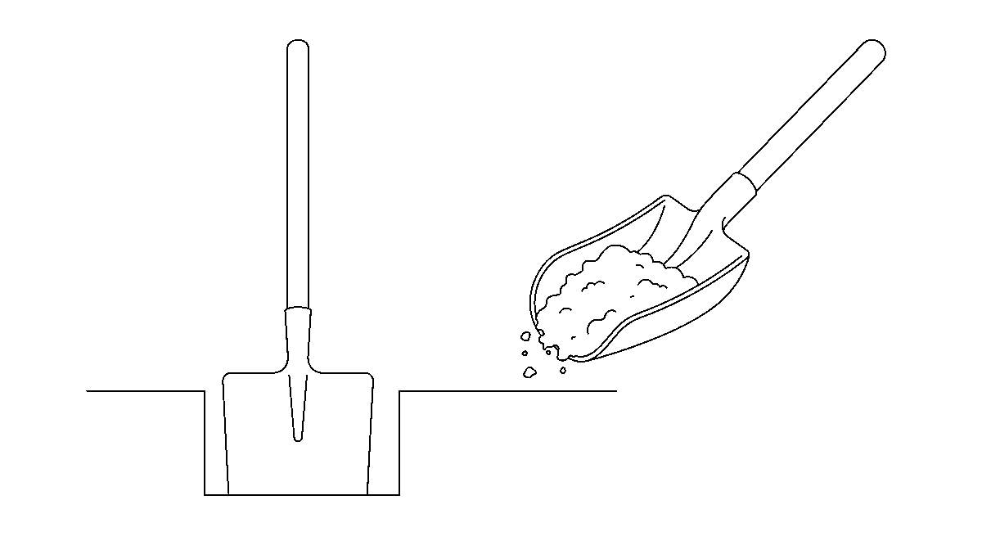
Worksheet
1. The tool with a flat, stiff blade used to cut into the ground is the A) basket B) spade C) rake D) shovel
2. A knapsack sprayer differs from a watering can because it sprays a A) heap of manure B) load of sand C) fine mist of medicine D) stream of water
3. A hand fork loosens soil with its A) rose B) wheel C) prongs D) blade
4. The curved one-hand blade used for reaping grass is the A) spade B) sickle C) cutlass D) hoe
5. Fill in: A cutlass laid on a spade in the store ____ both edges.
6. Mention four pairs of tools that look alike and the one difference for each pair.
7. Write two sentences on which tool you would use to move a heap of soil and why.
My own work
Draw one pair of similar tools, write the difference between them in one line, and write how both should be stored.

SOCIAL AND CITIZENSHIP STUDIES (SCS)
Weeks 1 to 6, 8 and 9. Week 7 is Mid-Term Break, Week 10 Revision, Week 11 Examination, Week 12 Closing and Awards — those weeks carry no note. Depth: NERDC 2025 · Primary 1 · Social and Citizenship Studies · Second Term W3, W4, W7, W8, W9 and W10 (pp 657–658) and Third Term W1–W4 (pp 659–661), with the Nursery 2 Social Habits week on the roles of family members (pp 379–382) — the school moves this band down, so the Primary 1 content is the minimum extent of depth and is told in Nursery 2 language.

WEEK 1 — MARRIAGE
Depth: NERDC Primary 1 · SCS · Second Term W3 (pp 657–658).
You will learn to
• say what marriage is
• name the kinds of marriage ceremony we have in Nigeria
• say that marriage brings a family
• name the duties of a husband and a wife
Things to know
• Marriage is the day a man and a woman are joined to live together as husband and wife, before their families and before the law.
• Marriage is the beginning of a family: the house, the children and the name all start from it.
• Three kinds of ceremony in Nigeria: traditional (family rites, price and blessing by the elders), religious (in a church or a mosque, with vows before God), and court (registry — signed papers before a marriage registrar and two witnesses).
• A marriage can have one or more of these at once: many couples do the traditional rite, then the church, and then sign at the registry.
• A bride is the woman on her wedding day; a groom is the man; the wedding is the ceremony; the reception is the party after it.
• The wedding attire carries the culture: aso-oke, iro and buba, gele, agbada, kaftan, isiagu; the colour and cloth belong to the family's people.
• In marriage the two work together: one does not rule, both decide; they plan the house, the food, the fees and the names.
• The two duties that hold a home: love (care shown in words and in work) and respect (speaking well of each other, and not before the children).
• A child born of married parents has a name, a family, a language and a place in the community — that is what the rite gives.
• Where there is a problem, the wise family talks, calls the elders they trust, and does not fight in front of the children.
• In our class we say it plainly: every child deserves a home, and a home is kept by two people who keep their promise.
Words for my notebook
Marriage joins a man and a woman as husband and wife, and it is how a family begins — by traditional rite, in church or mosque, or at the registry.
Let us talk
1. What is marriage?
2. Name the three kinds of ceremony we have in Nigeria.
3. Who is a groom?
4. What two duties hold a home together?
Worksheet
1. Marriage joins a man and a woman as A) neighbours B) classmates C) husband and wife D) traders
2. Which of these is a marriage ceremony done with signed papers? A) the court registry marriage B) the harvest rite C) the naming rite D) the market rite
3. The woman on her wedding day is called the A) sister B) bride C) aunt D) mother
4. Two duties of a husband and wife are love and A) quarrelling B) sleeping C) respect D) selling

5. Fill in: A wedding cloth worn by Yoruba families for the ceremony is called ____.
6. Mention the three kinds of marriage ceremony in Nigeria.
7. Write two sentences on what marriage gives to a child.
My own work
Draw a wedding scene with the bride and groom in their cultural cloth, and write two lines on what makes a home stay strong.

WEEK 2 — RESPONSIBLE PARENTING
Depth: NERDC Primary 1 · SCS · Second Term W4 (pp 657–658).
You will learn to
• say what parenting means
• name what parents must give a child
• tell what makes a good parent
• say what the child owes back
Things to know
• Parenting is the work of raising a child — feeding, keeping, teaching and loving until the child can stand alone.
• A parent is a father, a mother, or the person who stands in their place; guardian is the grown-up who keeps a child that is not their own.
• Four responsibilities of parents: food, clothing, education and love; without any of the four the child is poor.
• Parents must also give shelter and health: a roof, a clean bed, immunization, treatment when there is sickness.
• A good parent is caring (notices when something is wrong), patient (teaches twice, ten times), provides (works so the fridge is not empty) and teaches right from wrong.
• A good parent names the child, gives the child a language, a faith or a conscience, and a duty in the house.
• Discipline that is responsible: rules that are said before, a correction that is not cruel, and punishment that fits the fault.
• Children's side: obey, respect, say thank you, help in the house, learn what is taught, and do not lie.
• Appreciation is not flattery: it is saying "thank you for the school bag" and doing the work the bag is for.
• A child who is fed but not spoken to has been half-parented; a child who is loved but never corrected is also in trouble.
• Where a child has no father or mother, the grandmother, an aunt, an older brother or a foster home does the parenting; the love is the same work.
Words for my notebook
Parenting is feeding, clothing, teaching and loving a child. The child answers with obedience, respect and hard work.
Let us talk
1. What is parenting?
2. Name the four things a parent must give.
3. What does a good parent do when the child repeats a fault?
4. What does the child give back to the home?
Worksheet
1. Parenting means A) raising and caring for children B) driving C) building houses D) selling food
2. Which is NOT a responsibility of parents? A) clothing the child B) feeding the child C) paying school fees D) doing the child's homework for him
3. A good parent teaches the child A) how to lie B) how to fight C) right from wrong D) how to hide
4. A grown-up who keeps a child that is not his own is a A) guardian B) friend C) neighbour D) stranger
5. Fill in: The four duties of parents are food, clothing, ____ and love.
6. Mention four qualities of a good parent.

7. Write two sentences on something you do that shows you appreciate what your home gives you.
My own work
Write four duties of a child in a family and tick every one you did well this week.
Draw two things that keep your home tidy and colour them.

WEEK 3 — ROLES OF MEMBERS OF THE FAMILY
Depth: NERDC Primary 1 · SCS · Second Term W7 (pp 657–658), with NERDC Nursery 2 · Social Habits · First Term W2 (pp 379–382) for the same topic in our own band.
You will learn to
• name the work of each person in my family
• say what a father and a mother do
• say what my own role is as a child
• tell the work of grandparents, uncles and aunts
Things to know
• A family is the group of people who live together and keep one another: father, mother and children, and often the grandparents.
• Father's role: he provides (work, money, food, school fees), protects the house, guides and teaches the children, and plays with them.
• A father also decides with the mother — the head of the house is a team, not one voice.
• Mother's role: she cares for the children (feeding, nursing, dressing), cooks, keeps the home in order, works outside too, and teaches manners and language.
• The children's role: obey, respect one another and the elders, help with the chores of the house, study well, keep the place tidy, do not break what is not yours.
• Grandparents' role: they give advice and wisdom, tell the stories that carry our history, watch the children when the parents work, and teach the culture and the prayers.
• Extended family: uncles, aunties and cousins are the support of a family — they lend, they keep, they attend the naming ceremony and the funeral.
• Simple chores for a child in Nursery 2: set and clear the plates, sweep one corner, fetch water, arrange the slippers, water a plant, fold my own cloth, keep my books in the bag.
• Everybody working together makes the home light: one person sweeping a compound is slow, three persons finish before dusk.
• Appreciation is naming what each one does: today the food is cooked, today the fees were paid, today the child washed his own plate — all three are work.
• A role is not a punishment; when the child shares the work of the house, he is being trusted, not used.
Words for my notebook
Father provides and protects; mother cares, cooks and teaches; children obey, help and study; grandparents give advice and stories.
Let us talk
1. What are two duties of a father?
2. Who cooks and keeps the home in order in your house?
3. Which chore will you take up at home this week?
4. What do grandparents give that school cannot?
Worksheet
1. The role of the father in the family includes providing and A) cooking for the market B) playing games all day C) protecting the family D) sweeping the road
2. Helping with chores and studying well is the role of A) the driver B) the child C) the visitor D) the neighbour
3. Grandparents give advice, stories and A) punishment B) school fees always C) homework D) wisdom

4. When everybody works together in a home the work becomes A) finished never B) light and fast C) heavier D) secret
5. Fill in: Uncles, aunties and cousins are the ____ family that supports us.
6. Mention two duties each of a father, a mother and a child.
7. Write two sentences on the chore you do in your house and who it helps.
My own work
List the members of your family and write one duty each of them carries; then write the one duty you will carry every day next week.

WEEK 4 — CULTURE (PARTS 1 AND 2)
Depth: NERDC Primary 1 · SCS · Second Term W8 (Culture Part 1) and W9 (Culture Part 2), pp 657–658 — the school keeps both parts in one week.
You will learn to
• say what culture is
• name the elements of culture
• tell the dress, food and greeting of our people
• say how our culture is kept
Things to know
• Culture is the way of life of a people: what they speak, eat, wear, greet, marry, bury, sing and celebrate.
• Culture is learnt, not born with: we catch it from the home, the street and the elders.
• The elements of culture to name: language, food, dressing, festivals, greetings, music and dance, religion, names, marriage and burial rites.
• Nigeria is rich and diverse: three big groups — Hausa, Igbo, Yoruba — and over two hundred and fifty other peoples, each with a culture.
• Traditional dressing: the wrapper and buba (loose shirt), the iro (wrapper tied round the waist) with gele (the head tie), the kaftan and the agbada (the big flowing robe), the fila cap, the hula/beehive cap of the north.
• Nigerian foods to name: jollof rice, pounded yam, egusi soup, tuwo, akara, moi-moi, eba, amala, pepper soup, kilishi, suya, kosai.
• Greetings carry respect: the Yoruba boy prostrates (doba), the Yoruba girl kneels (doble/kunrin); the Hausa man puts his hands together and lowers them. The Igbo elder is greeted with "ndewo/nno" and a seat is offered; in the west a handshake with the right hand is common.
• A greeting said well is a culture kept; a child who forgets to greet has begun to forget his people.
• Festivals in our community: Eid-el-Fitr and Eid-el-Kabir (the Muslim celebrations after the fast and at the rams), Christmas and Easter, the new yam festival (Iwa Ji/Emumu), Egungun, Osun-Osogbo, Durbar of Katsina, Argungu fishing festival, Eyo festival of Lagos.
• At a festival there is dance, drum, masquerade, new cloth, special food, horsing, and the blessing of the elders — that is culture in one place.
• Preserving culture means speaking our own language at home, wearing our cloth on our days, learning the folk tales, eating the food of our people, greeting the elders, and writing the names right.
• Culture is not everything old: it is what our people do with what they have learnt, so a Nigerian child who codes and greets is not losing his culture.
Words for my notebook
Culture is the way of life of a people — language, food, dress, greeting, festival and music. Nigeria has many cultures and we keep ours.
Let us talk
1. What is culture?
2. Name the food of our home and the cloth of our father's people.
3. How does a Yoruba girl greet an elder?

4. Name two festivals in Nigeria and what happens at one.
Worksheet
1. Culture is best described as A) a market name B) a school subject C) the way of life of a people D) a church rite
2. The cloth wrapped and tied on a Yoruba woman's head is the A) hula B) buba C) fila D) gele
3. Pounded yam, egusi soup and jollof rice belong to Nigerian A) names B) food C) dressing D) music
4. The Yoruba boy's way of greeting an elder is to A) shout B) clap only C) prostrate D) run
5. Fill in: The three big ethnic groups of Nigeria are Hausa, Igbo and ____.
6. Mention five elements of culture.
7. Write two sentences on a festival in our community and one thing done there.
My own work
Write or draw four things your family keeps from its culture: the language you speak at home, a food, a cloth and a greeting.

WEEK 5 — INTRODUCTION TO NIGERIA
Depth: NERDC Primary 1 · SCS · Second Term W10 (pp 657–658).
You will learn to
• say that Nigeria is our country and where it is
• name the states and the capital
• name our languages and religions
• say our national motto and know my own state
Things to know
• Nigeria is our country; it is in West Africa, and it faces the sea in the south — the Atlantic (Bight of Benin).
• Nigeria's neighbours: Benin Republic on the west, Niger on the north, Chad on the north-east, Cameroon on the east.
• Nigeria has 36 states and one Federal Capital Territory (FCT) — the FCT holds Abuja, the capital city.
• Before Abuja, the capital was Lagos; the seat of the government moved to Abuja in 1991.
• The largest city and the money town is still Lagos; the three big cities are Lagos, Kano and Ibadan.
• Our official language is English; it is the language of the school, the court and the paper. Our national languages are Hausa, Igbo and Yoruba, and there are more than 250 other languages.
• The major religions are Christianity, Islam and Traditional religion; the north is mostly Muslim, the south mostly Christian, and the middle belt holds both and the old faith.
• Nigeria's national motto is "Unity and Faith, Peace and Progress" — it is written on the coat of arms.
• The flag is green–white–green: green for the farms and the land, white for peace.
• Our national anthem is Arise, O Compatriots; the pledge is said in school on the flag day.
• Our own state: name it, name its capital, and name the local government we live in; a citizen knows at least three circles — home town, state, country.
• Nigeria is the most populous country in Africa (over 200 million people) and one of the biggest producers of crude oil and of farm produce — cocoa, groundnut, palm oil, yam and rubber.
Words for my notebook
Nigeria is in West Africa: 36 states and the FCT with Abuja as capital. English is our official language; our motto is "Unity and Faith, Peace and Progress".
Let us talk
1. Where is Nigeria?
2. How many states does Nigeria have, and what is our capital?
3. Which three languages are called our national languages?

4. Say the motto of Nigeria. What colour is in the middle of our flag?
Worksheet
1. Nigeria is found in the ____ part of Africa. A) northern only B) southern C) western D) eastern
2. The capital city of Nigeria is A) Ibadan B) Kano C) Lagos D) Abuja
3. Nigeria has ____ states and one Federal Capital Territory. A) 50 B) 21 C) 30 D) 36
4. The official language of Nigeria is A) English B) Yoruba C) Hausa only D) Arabic
5. Fill in: The colours of the Nigerian flag are green, ____ and green.
6. Mention the three national languages of Nigeria and our national motto.
7. Write two sentences on your own state, its capital and your local government.
My own work
Write the name of your state, its capital, your local government and one thing the state is known for.

WEEK 6 — ATTITUDES AND VALUES
Depth: NERDC Primary 1 · SCS · Third Term W1 (pp 659–661).
You will learn to
• say what an attitude is and what a value is
• tell a good attitude from a bad one
• name the core values of Nigeria
• show honesty and hard work in class
Things to know
• An attitude is how I think and feel about a thing, and how that shows in what I do.
• A value is what I hold to be important and right — the thing I will not sell.
• Attitude is the way I come; value is what I stand on.
• Good attitudes: positive thinking (I look for what can be done), cheerfulness (I come with a bright face), willingness to help, punctuality, patience, and the readiness to try again.
• Bad attitudes: complaining (the mouth is always finding fault), laziness (the body will not start), selfishness (all for me), rudeness, cheating, giving up.
• An attitude can be changed on purpose: the child who says "I cannot" begins to say "I cannot yet", and next month he can.
• The core values of Nigeria to name: honesty, hard work, respect, integrity, patriotism, discipline, tolerance, commitment to excellence, and the spirit of service.
• Integrity is doing right when nobody is looking; honesty is telling the truth when it costs me.
• Patriotism is loving Nigeria: keeping her things clean, respecting her flag, learning her story, and refusing to spoil what belongs to all of us.
• Tolerance is letting a classmate pray, eat and greet in his own way while I keep mine.
• Values are taught by being seen: the teacher who returns the extra change, the pupil who hands back a found bag, the class that plays without cheating.
• Our class keeps a value of the week: one word on the board, one example each day, and Friday is when we say who showed it.
Words for my notebook
Attitude is how I think and act; value is what I hold dear. Honesty, hard work, respect, integrity and patriotism are our core values.
Let us talk
1. What is an attitude?
2. What is a value?
3. Which bad attitude do you want to change in yourself?

4. What does integrity look like when you find money on the floor?
Worksheet
1. An attitude is best described as A) how we think and feel about things B) a school rule C) a thing we buy D) a market price
2. Which of these is a good attitude? A) cheerfulness B) complaining C) selfishness D) laziness
3. Doing the right thing when nobody is looking is A) integrity B) luck C) fear D) speed
4. Loving your country and keeping her things clean is called A) tolerance B) patriotism C) play D) honesty
5. Fill in: The value that means telling the truth when it costs you is ____.
6. Mention five core values of Nigeria.
7. Write two sentences on one good attitude you showed this week.
My own work
Choose one core value, write it on a card, and keep it on your desk for a week; on Friday write one thing you did that matched it.
Draw one kind thing you did this week and colour it.

WEEK 8 — FINDING HELP IN DANGER (PARTS 1 AND 2)
Depth: NERDC Primary 1 · SCS · Third Term W2 (Part 1) and W3 (Part 2), pp 659–661 — the school keeps both in one week.
You will learn to
• say what danger is and name its kinds
• tell who can help me and when to run to them
• keep calm, speak clearly and give my name and place
• keep safe from strangers
Things to know
• Danger is any situation that can harm us — the body, the eyes, the breath or the life.
• Kinds of danger a child meets: fire, road accidents, getting lost, strangers, bad weather (storm, flood, lightning), deep water, electric wire, sharp objects, poison, a mad dog.
• An emergency is a danger that is happening now and needs help at once: a burn, a fall with blood, somebody not breathing, a house on fire.
• People who help: the grown-up nearest, the teacher, a parent or guardian, the police, the fire service, the doctor or nurse, the neighbour we know, and the community watch.
• Staying calm is the first rescue: a child who screams cannot be heard; a child who breathes and speaks can be helped.
• Numbers to know (as our scheme sets them, and as they stand today): 112 — the national emergency number, free from any phone, for police, fire or ambulance anywhere in Nigeria. 767 — Lagos State emergency line (police, fire and ambulance in Lagos). 199 — the police emergency line in some states; 122 — FRSC for road accidents; 190 — the Federal Fire Service. The safest thing a child does is dial 112 and say what happened.
• What to say in an emergency call, in this order: my name → where I am → what happened → how many people are hurt → the phone number I am calling from. Then stay on the line until told to stop.
• Trusted adults: the ones at home, the ones in the school, the ones with a name tag at the bank, the shopkeeper we buy from every day, the police officer in uniform. If I am lost, I go to a shop, a filling station or a police post — never to a car.
• Stranger rules: do not talk to a stranger, do not follow a stranger, do not accept gifts, sweets or rides, do not go into a stranger's house or car. And do not let anybody touch the parts of the body that the swimsuit covers — say "NO", run, and tell at once.
• Secrets: a bad grown-up may say "do not tell anybody"; we tell that kind of secret the same hour. Telling is not tattling.
• Know by heart: my full name, my home address, my father's and mother's phone numbers, my class and school — a child who can say these is half-found already.

• Body danger drill: fire — get down low, do not run through smoke, use the stairs, never a lift, do not go back for a bag. Road — stop, look both ways, listen, cross at the corner or the bridge; water — never swim alone.
• In a storm or flood we move to high ground and stay away from poles, wires and trees; lightning comes first to the tall thing.
Words for my notebook
Danger is anything that can harm me. Keep calm, say your name and place, and dial 112. Say no to strangers and tell at once.
Let us talk
1. What is danger? Name four kinds near our home.
2. Which number would you dial in an emergency anywhere in Nigeria?
3. What do you say first when you call for help?
4. A stranger offers you a ride and a sweet: what do you do?
Worksheet
1. Danger is a situation that can A) teach us B) amuse us C) harm us D) feed us
2. The national emergency number in Nigeria, free from any phone, is A) 411 B) 112 C) 100 D) 911
3. The first thing to do when help is needed is to A) hide the matter B) go and play C) keep calm and speak clearly D) scream and run
4. A stranger gives you a gift and asks you to come with him. You should A) go quietly B) say no, run and tell a trusted adult C) take the gift and look back D) thank him and wait
5. Fill in: If I am lost, I go to a shop or a police post — never to a ____.
6. Mention the information to give when you call for help, in order.
7. Write two sentences on what you will do if you see a small fire in the house.
My own work
Write from memory your full name, your class, your home street and two phone numbers, and say them aloud once at home tonight until you can say them without looking.
Draw a telephone with the three digits you may dial in danger, and colour the phone.

WEEK 9 — SECURE ENVIRONMENT
Depth: NERDC Primary 1 · SCS · Third Term W4 (Secure Environment Part 1, pp 659–661).
You will learn to
• say what a secure environment is
• name the things that make a place safe
• find the dangers around my home and school
• report a danger I see
Things to know
• A secure environment is a place where people are safe from harm — body, property and feelings all protected.
• Things that make a place secure: a fence and a gate, locks on doors, lights that work at night, a watchman or security guard, a dog that is known, windows with bars, and neighbours who know one another.
• Feeling safe matters as much as being safe: at home, at school and in the community a child should not be afraid of the corner, the man or the noise.
• Dangers in our own environment to name: an open well or pit, a busy road with no bridge, a broken wire on a pole, sharp cutlass or broken glass left on the floor. An uncovered drain, a heap of refuse that breeds mosquitoes, water in a bucket a small child can fall into, a loose wall, a mad dog, a dark passage..
• Rules keep us safe: close the gate behind you, do not open to a stranger, do not climb the fence. Keep off the road to play, do not touch the wire, do not light a fire in the house, do not go into the water alone.

• Staying alert means noticing: the smell of kerosene, the sound of a stranger on the roof, the boy hanging on the gate, the water rising in the street.
• Reporting a danger is a duty, not tattling: "the well has no cover", "the glass is on the corridor", "the wire hangs low" — a child who reports prevents an accident.
• At school the safe signs we learn: no entry, mind the step, caution wet floor, fire exit, keep gate closed — a sign is a rule with a picture.
• Home safety habits: the key is kept in one place (not in the lock), the gas is off at night. The matches are high up, the knife is put away, the child does not sleep in a room with a paraffin stove burning.
• A secure place is also clean and lit: a bright street is a safe street; a compound with no refuse has no rats and no mosquitoes.
• Our class ends with a walk of safety: each child points at one danger on the school ground and one thing that makes the school secure.
Words for my notebook
A secure environment is a safe place — fence, lock, light, guard and rules. Report a danger you see; that is good citizenship.
Let us talk
1. What makes our school a secure place?
2. Name two dangers around our homes.
3. What do you do when you see broken glass on the floor?
4. Why does a light street keep us safe?
Worksheet
1. A secure environment is a place where people are A) quiet only B) many C) safe from harm D) rich
2. Which of these makes a compound secure? A) an open gate B) a working light at night C) a low wire D) a heap of refuse
3. An open well in the yard is dangerous because A) it holds water B) it is old C) it is ugly D) a child may fall into it
4. Telling the person in charge about a danger you saw is A) play B) laziness C) cowardly D) reporting, and it prevents an accident
5. Fill in: The sign "caution — wet floor" is a rule with a ____.
6. Mention four things that make a place secure.
7. Write two sentences on one danger in our school and how we can make it safe.
My own work
Walk once round your own house, write down two dangers you saw and two things that keep the house secure, and say to whom you will report the dangers.
Draw your own gate or door and colour the place where it locks.

YORUBA
Weeks 1 to 6, 8, 9 and 11. No note for Week 7 (Mid-Term Break) or Week 10 (Revision); Week 12 is Closing and Week 13 carries the Examination for this subject.
Week 11 carries a note because the school's own table prints it as a teaching row
("Exam Preparation"), not as an examination week. Depth: this subject is school-generated — there is no NERDC Yoruba scheme to floor it against. The extent of each week is the three strands the school itself prints (Ẹ̀dẹ̀ · Àṣà · Lítíréṣọ̀). The master corpus prints Yoruba without tone marks; tone marks are added in the body of the note so that the child reads the word correctly, and the topic line is left exactly as the school prints it.

WEEK 1 — Ede: Didaruko nnkan ayika ile-iwe / Asa: Eran osin ni ile Yoruba / Litireso: Orin akoniniwa
Depth: school-generated — three strands as printed in the master corpus for N2 S2 W1.
You will learn to
• name the things around the school in Yoruba
• name the animals a Yoruba family keeps and what they are for
• sing the song of the child who knows his mother's face
Things to know — Ẹ̀dẹ̀ (naming things around the school — dídárúkọ̀ nǹkan ayíká ilé-ìwé)
• Last term we named things in the room; this term we go round the school.
• òde ilé-ìwé — the school compound · pápá ìdaráya — the playground · _ilé ìwẹ̀ (tóílẹ̀tì) — the toilet
• ọ̀ṣọ́ — the guard's post · ọ̀fìn (kísíìnì) — the kitchen · ọ̀gbìn — the garden · igí — tree
• ògiri — the fence · ọ̀nà — the road · pátákó ìkẹ́ọ̀ — the teaching board · ìwé — book
• Say the pattern "Ní ilé-ìwé wa, a ní ______." (In our school we have ______.)
• Walking game: we move round the school, and at each place I say one word: "Èyí ni ọ̀gbìn."
• Ask and answer: "Kí ni èyí?" — "Èyí ni ..." · "Níbo ni ... wà?" — "Ó wà ní ..."
• Spelling of the new words goes in the notebook with one drawing beside each.
Things to know — Àṣà (the animals of Yorubaland — ẹranko ìsìn ní ilẹ̀ Yorùbá)
• The school's row prints eran osin: ẹranko ìsìn — the animals a Yoruba family keeps for the rite, the feast and the honouring of a guest.
• ewúrẹ́ — goat · àdìẹ — fowl · ọ̀wọ́ọ̀n — ram · àgbo — sheep · màlúù — cow · àyẹ̀yẹ́ — pigeon · ẹranko ilé — the animals a house keeps.
• The goat and the fowl are the two animals a Yoruba home can keep in a small yard; they eat scraps and they find their own grain.
• When a child is born, the family names him on the eighth day; when a guest of honour comes, the house kills a fowl — that is how the animal enters the rite.
• Every animal has its own sound: ewúrẹ́ says "mèé", àdìẹ says "kòkòrò" (cock) / "gèé" (hen), màlúù says "moooo", ajá says "grrr — ọ̀ọ̀!".
• We are kind to the animals of the house: water before sun, food at the set time, no tying of legs too tight, no beating.
• Some animals are not for eating or keeping: ẹ̀kùn (leopard), ẹ̀jọ́ (python), àlùkò (owl) — in Yoruba tradition they belong to the bush and to ìṣẹ́̀gun, and the child keeps away.
Things to know — Lítíréṣọ̀ (the song the school names: Orin akomoniwa)
• The row prints the song by its first words, as the school writes it elsewhere: "Ọmọ tó mọ ìyá rẹ̀ lójú".
• Ọmọ tó mọ ìyá rẹ̀ lójú, á mọ́ bàbá rẹ̀ lójú; — a child who knows his mother's face will know his father's face too;

• Ọmọ tó ṣe ìbéèrè, kò sẹ́nu mọ́lẹ̀. — a child who asks does not end with his mouth shut.
• Meaning: a child who knows where he comes from knows where he is going; we greet because we were taught.
• Sing it twice: once slowly with the hands flat on the chest, once with a step to each line.
• Answer the line: the class calls "Ọmọ tó mọ̀!" and I answer "Ó mọ́ ilé rẹ̀."
Words for my notebook
Òde ilé-ìwé · pápá ìdaráya · ọ̀gbìn · ogiri. Ewúrẹ́ · àdìẹ · ọ̀wọ́ọ̀n · màlúù — ẹranko tí ilé ń tọ́. Ọmọ tó mọ ìyá rẹ̀ lójú.
Let us talk
1. Name five things you saw outside the class this morning, in Yoruba.
2. Which two animals can a small yard keep?
3. When does a family kill the fowl?
4. Say the first line of the song and what it means.
Worksheet
1. "Pápá ìdaráya" is the A) playground B) garden C) kitchen D) fence
2. The Yoruba for goat is A) agbo B) ewúrẹ́ C) àdìẹ D) màlúù
3. The animal that gives us eggs in the morning is the A) sheep B) goat C) cow D) fowl
4. "Ọmọ tó mọ ìyá rẹ̀ lójú" teaches that a child should A) hide B) run far C) sleep late D) know his own family
5. Fill in: "Ní ilé-ìwé wa, a ní ____." — the missing word is any thing in our school.
6. Name four things around the school in Yoruba and four animals a home keeps.
7. Sing or say two lines of the song and say what the song teaches.
My own work
Walk once round the school, write six Yoruba names of things you saw, and under two of them draw the thing.

WEEK 2 — Ede: Kika alifabeeti H-Q / Asa: Ounje ile wa / Litireso: Ewi kika (ibowo fagba)
Depth: school-generated — three strands as printed for N2 S2 W2.
You will learn to
• read the letters h to q again, better than last term
• name the food of our home in Yoruba
• say a poem on giving honour to an elder
Things to know — Ẹ̀dẹ̀ (reading the letters H–Q — kíkà alífábéètì)
• We met these letters in Week 9 of last term; this week we read them backwards, forwards and out of order.
• The line: h · i · j · k · l · m · n · ń · o · ọ · p — the row says H–Q, and in the Yoruba alphabet the letters in that range are h, i, j, k, l, m, n, o, p, for there is no c, q, v, x or z in Yoruba writing.
• Sound each letter with the seven vowels: ha · hẹ · he · hi · ho · họ · hu, then the same for j, k, l, m, n — say one line fast and one line slow.
• Read the words made from these letters: ilé (house) · ìdí (bottom/reason) · ọ̀nà (road) · omi (water) · inú (inside) · ọkọ̀ (vehicle) · òdo (river) · ọ̀pọ̀ (many).
• The tricky pair: o (oral) and ọ (closed) — òdo (river) is not ọ̀dọ́ (young); say both and hear the mouth change.
• Reading rule: eyes on the line, mouth open, one breath per word, no pointing with the finger at the end of the week.
Things to know — Àṣà (the food of our home — oúnjẹ ilé wa)
• The food of the Yoruba home is pounded and wrapped: ìyan (pounded yam) · àmàlà (yam-flour) · èbà (garri) · ẹ̀̀kọ́ (cassava mash, èkọ́) · túwò (grain swallow).
• Soups that go with them: ẹ̀fẹ́ (leaf soup) · ègúsí (melon seed) · ẹ̀wẹ̀dú (beans pudding soup) · ògọ́rò · árasá (for the little one).

• Small foods and drinks of the home: àkàrà (bean cake) · àrà (roasted plantain) · ìrẹ̀ (corn pap) · ògì (pap with groundnut) · wàìn ọ̀pẹ̀ (palm wine, for the elders only).
• How the food is paired: ìyan goes with ẹ̀wẹ̀dú or ègúsí; àmàlà goes with ógọ́rọ́ or ẹ̀wẹ̀dú; èbà goes with ẹ̀fẹ́ or ègúsí; ìrẹ̀ is for breakfast, not for the feast.
• Foods of the farm we name in the same breath: iṣu (yam) · ọ̀̀̀sà (cassava) · ìbà (cocoyam) · àgbàdọ̀ (maize) · ìrẹsì (rice) · àrà (plantain).
• In the Yoruba home we wash the hands first, we sit on a mat or stool, and we eat with the right hand, three fingers making the spoon.
• Before a big meal the family says "Ẹ̀ jẹun, ọmọ mi"; the child answers "Ọ́ ńlẹ̀, ìyá/bàbá."
• Our own food is not lesser food: the child who knows the name of his food knows the name of his people.
Things to know — Lítíréṣọ̀ (saying a poem on honour for elders — èwì kíkà: ìbọ̀wọ̀ fún àgbà)
• A ẹ̀wì is chanted, not read; it goes with the head and the hands.
• Àgbà kìí rí nǹkan ṣe, — an elder never sees a thing done wrongly
• kó jẹ́ ḱ ọ̀dọ́ ṣe é; — and let the young one do it;
• Ọ̀dọ́ kìí rí nǹkan ṣe, — a young one never sees a thing done wrongly
• kó jẹ́ ḱ àgbà réra lẹ́yìn. — and the elder be left behind.
• Meaning: the old and the young work together; honour is shared, not only given.
• Ways of honour in Yoruba: ìdòbì (the boy prostrates), ìkúnlẹ̀ (the girl kneels), the two hands cupped low when we pass in front, and standing when the elder sits down.
• We say the poem three times: whisper, then normal, then loud with the action.
Words for my notebook
h i j k l m n ń o ọ p · ìyan, àmàlà, èbà, ẹ̀fẹ́, ègúsí · Àgbà kìí rí nǹkan ṣe, kó jẹ́ ḱ ọ̀dọ́ ṣe é.
Let us talk
1. Read from h to p without pointing.
2. Which is the Yoruba word for pounded yam?
3. What does a girl do to greet an elder?
4. Say the poem and give its meaning.
Worksheet
1. Which letter is NOT used in writing Yoruba? A) q B) j C) gb D) ṣ
2. "Ìyan" means A) pounded yam B) rice C) palm oil D) bean cake
3. A Yoruba girl greets an elder by A) shouting B) running C) kneeling D) prostrating
4. "Àmàlà" is made from A) plantain B) yam flour C) cassava D) maize
5. Fill in: The Yoruba for water is ____.
6. Name five foods of our home and the soup that goes with two of them.
7. Say the poem on honour and write what it teaches in one sentence.
My own work
Write the names of the foods eaten in your house this week, and say the poem to somebody at home before you eat.
Draw three foods your family eats and colour them.

WEEK 3 — Ede: Onka 11-20 / Asa: Ere idaraya / Litireso: Alo pipa (apamo / apagbe)
Depth: school-generated — three strands as printed for N2 S2 W3.
You will learn to
• count from eleven to twenty in Yoruba
• name the games we play and the words we say while playing
• begin the telling of àlọ́, with its call and its answer
Things to know — Ẹ̀dẹ̀ (counting 11–20 — ìkà 11–20)
• From ten (ẹ́wọ́/ogún is twenty) we go up with -lá, which means "above ten":

• 11 ọ̀kànlá · 12 èjìlá · 13 ẹ̀tálá · 14 ẹ̀rìnlá · 15 àárúnlá
• 16 ẹ̀fálá · 17 ẹ̀jẹ́lá · 18 ẹ̀jọ́lá · 19 ẹ̀sánlá · 20 ogún
• The other way of counting, "what is taken from twenty": 19 òdínlógún · 18 èjìlógún · 17 ẹ̀tálógún · 16 ẹ̀rìnlógún · 15 àárún lógún
• 14 ẹ̀fálógún · 13 ẹ̀jélógún · 12 ẹ̀jọ́lógún · 11 ẹ̀sánlógún — the two roads meet at the same number.
• Clap and count: 11 claps for ọ̀kànlá up to twenty claps and a stamp for ogún.
• Ask and answer: "Ogún ló nǐ?" — "Bẹ́ẹ̀ni, ogún ni." (Do you have twenty? — Yes, I have twenty.)
• Use the numbers on things: 12 chalks, 15 bottle tops, 20 steps from the gate to the door.
Things to know — Àṣà (games — eré ìdárayá)
• Eré ìdárayá means games that make the body happy and strong.
• Games with words in Yoruba: "Kìké" (hopscotch) · "Aro" (the clapping game, "aro, aro ko lẹ́sẹ̀") · "Ṣégbé-ṣégbé" (a counting-out rhyme) · "Tẹ̀gbẹ̀tẹ̀" (hide and seek) · "Igí àti eré".
• Games with a ball: bọ́ọ̀lù — pass, catch, throw at a mark; games with a rope: fífo ọ̀pá (skipping the rope) and dídè (jumping over a stretched band).
• We say before a game: "Ẹ̀ jẹ́ ká bẹ̀rẹ̀!" and after: "A ṣe é, ẹ̀ ṣé."
• Rule of the Yoruba game: the one who is caught becomes "it" without crying; the winner carries nobody's bag.
• The body of the player: knees bend, hands free, head up, the shout is for cheering and not for insulting.
Things to know — Lítíréṣọ̀ (the telling of àlọ́ — àlọ́ pípá: apamo àti apagbe)
• An àlọ́ is a story made for children, and it is told (àlọ́ pípá), not read.
• The teller opens with a call; the row prints two of them: "Àlọ́ àpámọ̀" and "Àlọ́ àpágbé". The class answers with the same breath.
• Call: "Àlọ́!" — Answer: "Àlọ́ ni!" · Call: "Àpámọ̀!" — Answer: "Ọmọ ẹyẹ́ ló n fò."
• A àlọ́ has three parts: ìbẹ̀rẹ̀ (the opening), àárín (what happens), ìparí (how it ends and what it teaches).
• A short one to tell this week: the Ìjàpá (tortoise) who wanted all the food at the feast of the birds, borrowed feathers, flew up, and fell when the feathers were taken back.
• Its lesson: gbèsè (greed) spoils a person; the one who takes everything ends on the ground.
• After every àlọ́ we say the closing: "Òlúkòòlú ni àlọ́ mi, kí n ó r'ọkọ̀ nínú rẹ̀." (I have told it crookedly — may the carriage be inside it.)
Words for my notebook
ọ̀kànlá · èjìlá · ẹ̀tálá · ẹ̀rìnlá · àárúnlá · ẹ̀fálá · ẹ̀jẹ́lá · ẹ̀jọ́lá · ẹ̀sánlá · ogún. Àlọ́ àpámọ̀! Àlọ́ ni!
Let us talk
1. Count from ọ̀kànlá to ogún.
2. Which game did you play yesterday, and what did you say while playing it?
3. How do we answer when the teller says "Àlọ́"?
4. What did the tortoise learn at the end of his story?
Worksheet
1. The Yoruba for fifteen is A) ogún B) ẹ̀fálá C) àárúnlá D) àárún
2. Ogún means A) twenty B) fifty C) twelve D) ten
3. A story told for children, with a lesson in it, is called A) oríkì B) ẹ̀wì C) àlọ́ D) orin
4. Before a game we say A) "káàrọ̀" B) "a ṣe é" C) "ọ̀ dàbọ̀" D) "ẹ̀ jẹ́ ká bẹ̀rẹ̀"
5. Fill in: 11 in Yoruba is ____ (the "one-above-ten" way).
6. Count from 11 to 20 in Yoruba, then backwards.

7. Tell a short àlọ́ in three sentences and say its lesson.
My own work
Count twenty steps from your door to the gate, saying each number in Yoruba, and write the number at which you turned.
Draw the game you play at break time and colour the ball or the rope.

WEEK 4 — Ede: Alifabeeti P-Y / Asa: Iwa omoluabi / Litireso: Orin kiko (omo rere)
Depth: school-generated — three strands as printed for N2 S2 W4.
You will learn to
• read and name the letters p to y
• say what an ọmọlúàbí is
• sing the song of the good child with the right actions
Things to know — Ẹ̀dẹ̀ (the letters P–Y — alífábéètì p sí y)
• The last of the letters: p · r · s · ṣ · t · ì · w · y.
• Say each with the vowels: pa pe pọ pi po pọ · ra re rọ ri ro rọ · sa sọ ṣa ṣe ṣọ · ta te tọ ti to tọ · wa wọ wi wo wọ · ya yọ ye yi yo yọ.
• The letter ṣ is the one English has not: the tongue is flat and quiet — ṣọ (guard) is not sọ (fall).
• Letters we do not use: c, q, v, x, z; the digraphs we do: gb and j, and the letters with dots: ẹ, ọ, ṣ and ń.
• Read these words now: ọkọ̀ (car) · ọwọ́ (hand) · ìyàwó (bride/younger wife) · ṣùúrú (a food) · tutù (cold) · ìsàlẹ̀ (below) · yíyá (running).
• Write the whole alphabet from a to y in one line, then the seven vowels under it: a e ẹ i o ọ u.
• End of the week test: read any line on the chart from p to y without stopping at the dots.
Things to know — Àṣà (the child of good character — ìwà ọmọlúàbí)
• Ọmọlúàbí is a child brought up well: ọmọ + ilé + àgbà — the child of the elder's house, the one people point at and say "that one is well brought up".
• Marks of an ọmọlúàbí: he greets, he does not lie, he does not steal, he shares, he respects the elder and the younger, he keeps his word, and he works before he plays.
• The Yoruba say: "Ọmọlúàbí kìí ṣe nǹkan tí kò yẹ, bí ẹnikẹ́ni kò bá rí i." — a well-brought-up child does not do a wrong thing even when nobody is watching.
• "Ìwà lẹ́wàá" — character is the real beauty; a fine face with a bad temper is an ugly face.
• "Ọmọ tí a kò kọ́, àgbàlagbà á kà á." — the child who is not taught, grown-up life will correct, and correction from life is harder.
• A ọmọlúàbí in our class: raises the hand, does not laugh at a wrong answer, picks the paper that is not his, returns the pencil.
• We name one ọmọlúàbí each morning — and it is not always the same child.
Things to know — Lítíréṣọ̀ (a song to sing — orin kíkọ́: ọmọ rere)
• A song with an action is learnt faster than a song with only the mouth.
• Ọmọ rere, ọmọ ilé wa, — a good child, the child of our home;
• ó ń kúnlẹ̀, ó ń dọbì; — he kneels, he prostrates;
• ó ń jẹun, kò ń jà, — he eats and does not quarrel;
• ọmọ rere nìyẹn o! — that one is a good child!
• Actions: kneel on line two, touch the floor on line two, rub the tummy on line three, thumbs up on line four.
• Sing it in a circle: one child stands in the middle and is pointed at on the last line; next time it is another child — everybody is a good child in one round.
Words for my notebook
p r s ṣ t ì w y · Ẹ, Ọ, Ṣ, Ń àti gb, j. Ọmọlúàbí = ọmọ tí a kọ́ ní ilé àgbà. Ìwà lẹ́wàá.
Let us talk
1. Read the letters from p to y.

2. Which sounds has English not got?
3. Name five marks of an ọmọlúàbí.
4. Sing the song and show me the action on the second line.
Worksheet
1. Which of these letters is NOT used in writing Yoruba? A) ṣ B) v C) w D) ń
2. "Ọmọlúàbí" means a child who is A) rich B) tall C) the oldest D) well brought up
3. "Ìwà lẹ́wàá" teaches that A) money is beauty B) speed is beauty C) clothes are beauty D) character is beauty
4. The Yoruba word for "hand" is A) ẹsẹ̀ B) etí C) ojú D) ọwọ́
5. Fill in: The seven vowels of Yoruba are a, e, ẹ, i, o, ọ and ____.
6. Write the letters from p to y in order.
7. Say two lines of the song of the good child and what each line shows.
My own work
Write four things an ọmọlúàbí does at home, and practise the song with its actions until you can sing it twice without stopping.
Draw one polite thing you did this week and colour it.

WEEK 5 — Ede: Alifabeeti A-Y (leta nla ati kekere) / Asa: Ojuse ebi / idile / Litireso: Orin kiko lori obi
Depth: school-generated — three strands as printed for N2 S2 W5.
You will learn to
• match the big letter and the small letter, all the way from A to Y
• say the duties of the family in order
• sing a song on the parent and clap the beat
Things to know — Ẹ̀dẹ̀ (capital and small letters, A–Y — lẹ́tà nlá àti kékeré)
• The big letter (lẹ́tà nlá) is used at the beginning of a name and at the start of a sentence: Ọ̀lú, Àṣẹ̀, Mo, Bí.
• The small letter is for the rest of the word: ọ̀lú, àṣẹ̀, mo, bí.
• Say the pairs aloud in ten: Aa Bb Dd Ee Ff Gg Gb Hh Ii Jj.
• Next ten: Kk Ll Mm Nn ŃŃ Oo Ọọ Pp Rr Ss Ṣṣ.
• Last: Tt Ii (with dot: Ìì) Ww Yy — the line is complete when you have said all twenty-five.
• Tricky ones: Gb is one letter, not two — write it Gb gb; the dotted letters must keep their dots, for o and ọ are not the same word.
• Game: I write my own name with the first letter big; then I write it small; then I write my father's name and my town with big first letters.
• A letter that is written well sits on the line and does not fall below it.
Things to know — Àṣà (the duties of the family — iṣẹ́ ẹbí àti ìdílé)
• A dílé (family) is the people of one house; an ẹbí is the wider family — father's brothers and mothers' sisters, the cousins and the grandmothers.
• Duties of the father (bàbá): ìpèsè (providing), ààbò (protection), ìnáwó (paying for what the house needs).
• Duties of the mother (ìyá): cooking (ìpèsè oúnjẹ), nursing the little ones, teaching the language, keeping the house in order.
• Duties of the children (àwọn ọmọ): learning (kíkọ́), helping (ìrànwọ́), respecting (ìbọ̀wọ̀), keeping the place clean, and telling the truth.
• Duties of the grandparents (àgbà): advice (ìmọ̀ràn), the names and the stories (ìtàn àti orúkọ), blessing the children.
• A family where each one carries his own load does not tire; where one carries all, he falls.
• We name our duties in Yoruba with the verb first: Mo ń fọ aṣọ (I wash cloth) · Mo ń ta omi (I fetch water) · Mo ń kọ̀wé (I write).

Things to know — Lítíréṣọ̀ (a song on the parent — orin kíkọ́ lórí òbí)
• The song: Ìyá ọwọ́, Bàbá ọwọ́, — honour to mother, honour to father;
• ọwọ́ méjèèjì ló ń gbé wa sókè. — it is both hands together that lift us up.
• Bí a bá kó wọn jọ, ilé á dúró; — when they stand together, the house stands;
• bí wọ́n bá tì, a ó ṣubú. — if they fall apart, we fall too.
• Clap the beat: two claps on ọwọ́, a rest on the comma, a swing of the arms up on sókè.
• The song is not for singing only: at the end we say "Ẹ̀ ṣé, ìyá. Ẹ̀ ṣé, bàbá." out loud, once each.
Words for my notebook
Aa Bb Dd Ee Ff Gg Gb Hh Ii Jj Kk Ll Mm Nn ŃŃ Oo Ọọ Pp Rr Ss Ṣṣ Tt Ìì Ww Yy · Ìyá ọwọ́, bàbá ọwọ́.
Let us talk
1. Where do we use a big letter?
2. Say three duties of a child at home.
3. Which two hands lift the child up, in the song?
4. Write your own name with the first letter big.
Worksheet
1. The first letter of a person's name is written A) dotted B) big C) crossed D) small
2. "Gb" in the Yoruba alphabet is A) a vowel B) one letter C) not used D) two letters
3. "Ìyá ọwọ́" means A) honour to mother B) mother's food C) the big hand D) father's house
4. Which of these is NOT a duty of children in the family? A) learning B) respecting C) helping D) paying the rent
5. Fill in: The dotted vowels of Yoruba are ẹ, ọ and the letter ____.
6. Write the seven big letters and their small partners for the first half of the alphabet.
7. Sing the song on the parent and say in one sentence what it teaches.
My own work
Write five duties you and your family carry at home, each sentence beginning with "Mo ń ..." or "Ìyá ń ...".

WEEK 6 — Ede: Oro ati idakeji / Asa: Ikini ni asiko iseje / Litireso: Alo apagbe
Depth: school-generated — three strands as printed for N2 S2 W6.
You will learn to
• say Yoruba words and their opposites
• greet people when the community gathers
• tell a short àlọ́ àpágbé with the class answering
Things to know — Ẹ̀dẹ̀ (words and their opposites — ọ̀rọ̀ àti ìdàkejì)
• An opposite (ìdàkejì) is the word on the other side: big and small, hot and cold.
• Pairs to say in one breath: ńlá — kékeré (big — small) · gígùn — kúkúrú (tall — short) · jìnnà — súnmọ́ (far — near) · òkè — ìsàlẹ̀ (up — down)
• ìwájú — ẹ̀yìn (front — back) · ọ̀tún — òsì (right — left) · gbígbóná — tútù (hot — cold) · rírọ̀ — líle (soft — hard)
• funfun — dúdú (white — black) · dídùn — títọ́ (sweet — bitter) · àyọ̀ — ìbànújẹ́ (joy — sorrow) · rírọ̀ — líle (soft — hard).
• Game with the body: when I say ńlá you stretch your arms wide; when I say kékeré you squat; when I say ọ̀tún you point right.
• Use the pair in a sentence: Òkò rẹ̀ ńlá, ṣùgbọ́n àǹfààní rẹ̀ kékeré — his body is big, but his sense is small (a playful line the class laughs at).
• A pair is learnt better when the two words are said together, back to back, ten times in a line.

Things to know — Àṣà (greeting at a gathering — ìkíini ní àṣíkò ìṣẹ̀jọ́)
• An àṣẹjọ (ìṣẹ̀jọ́) is a meeting of the people: the class assembly, the ward meeting, the family gathering, the church or mosque after service.
• When we come into a gathering we say: "Ẹ̀ káàbọ̀, ẹ̀ nı́ káàárọ̀" — and the gathering answers "Ẹ̀ nı́ kaàárọ̀, ọmọ mi."
• The order of greeting at a meeting: the eldest first, then the rest — a child greets the head of the assembly, not the door.
• Standing is the way of the young in a gathering: we stand till the elder says "Ìjọ̀kalẹ̀", sit down and keep quiet.
• To a person who is speaking we do not add our noise; the Yoruba say "Àgbà kìí wà ní ojú ọ̀nà, kí ọmọdé tó tẹ̀ ẹ́ sọ́̀" — the elder is present so the child does not stumble.
• Words to keep at a meeting: "Ẹ̀ ṣé fún àǹfààní" (thank you for the chance to speak) · "Ẹ̀ jọ̀wọ́ ẹ̀ máà gbà mí" (please receive me) · "Ẹ̀ ṣé, ẹ̀ jọ̀wọ́."
• After the meeting, we greet the ones we did not see: "Ṣé ẹ̀ rí mi lójú ìjọ̀"? — and the answer is "Ìméjì".
Things to know — Lítíréṣọ̀ (àlọ́ àpágbé)
• Àpágbé is the family of àlọ́ told to carry the listener away into the story — it begins with a nonsense charm so that the ears open.
• Call: "Àlọ́ àpágbé!" — Answer: "Àpágbé lójú, ẹ̀ ṣé!"
• A short one for this week: the Ajá (dog) who wanted the moon; he jumped, fell, jumped again, and the children laughed until he lay down — and the moon stayed where it was.
• The three questions after any àlọ́: Who was in it? What did they want? What did it teach?
• We take turns: one child tells the opening and the ending, another says the middle — a story belongs to the class, not to one mouth.
Words for my notebook
ńlá—kékeré · gígùn—kúkúrú · jìnnà—súnmọ́ · òkè—ìsàlẹ̀ · ọ̀tún—òsì · gbígbóná—tútù · funfun—dúdú.
Let us talk
1. Say the opposite of "kúkúrú".
2. Who is greeted first at a gathering, and what do you say?
3. What do we do when an elder is speaking?
4. Tell the three parts of the story of the dog and the moon.
Worksheet
1. The opposite of "ńlá" (big) is A) kékeré B) tútù C) gígùn D) òkè
2. "Ọ̀tún" means A) right B) left C) down D) front
3. At a gathering we greet first the A) visitor B) driver C) eldest person D) smallest child
4. "Ẹ̀ káàbọ̀" means A) goodbye B) goodnight C) welcome D) sorry
5. Fill in: The opposite of "gbígbóná" (hot) is ____.
6. Say six pairs of opposite words in Yoruba.
7. Tell a short àlọ́ with its call, its answer and its lesson.
My own work
Say ten opposite words to somebody at home, and next time you enter a gathering, greet in the order the lesson taught and write what was said back to you.
Draw one big thing and one small thing beside it, then colour the small one.

WEEK 8 — Ede: Pipe iro ede (faweli ati konsonanti) / Asa: Iwa rere (ere ranpe) / Litireso: Aroso oloro geere lori aja
Depth: school-generated — three strands as printed for N2 S2 W8.
You will learn to
• pronounce the vowels and the consonants the right way
• say what ọ̀rẹ̀ẹ́-ránpẹ́ (kindness) looks like
• say a fast tongue rhyme on the dog with a sharp sound

Things to know — Ẹ̀dẹ̀ (saying the sounds — pípe ìró ẹ̀dẹ̀: fawẹ̀lì àti kọ́nsọ́nàǹtì)
• Fawẹ̀lì (vowels) are the sounds the mouth makes open, with no lip or tongue stopping them: a · e · ẹ · i · o · ọ · u — seven of them.
• Say them long and short: á à, é ẹ̀ — the mark of the tone changes the word, so the mouth must not be lazy.
• Kọ́nsọ́nàǹtì (consonants) are the sounds made with the lips, teeth or tongue closing: b, d, f, g, gb, h, j, k, l, m, n, ń, p, r, s, ṣ, t, w, y.
• Lips do the work in b, f, gb, m, p, w; the tongue tip in d, j, k, l, n, r, s, ṣ, t, y; the nose in m, n, ń.
• The three that English children always spoil: ọ (mouth open wide and flat), ẹ (the mouth nearly flat but open, not "ay"), and ṣ (the tongue flat, no buzzing).
• Say the pairs and hear the mouth change: òdo (river) — ọ̀dọ́ (young one) · wẹ̀ (to be wet) — wé (to enclose) · ṣa (to weed) — sa (to scatter).
• Practice: put the hand on the throat — m, n, ń, gb buzz; s, ṣ, f, t do not. That is how to tell the sounds apart when you cannot see.
• Reading a sound means writing it: I say a word slowly, and I put a tick for each sound I hear.
Things to know — Àṣà (kindness — ọ̀rẹ̀ẹ́-ránpẹ́)
• Ọ̀rẹ̀ẹ́-ránpẹ́ is the kindness that helps and expects nothing back; it is the best mark of ìwà rere.
• Kindness has hands and a mouth: it carries, shares, feeds, forgives, and it speaks gently.
• The Yoruba say "Ọwọ́ tí a fi ń tọ́ka, ìyẹn ni yóò fi ń gba" — the hand that points will also receive; so point at nobody and help everybody.
• "Kò sí ẹ̀yà tí kò ní ìdí; kò sí ìwà tí kò ní èsì." — every fruit has a stalk, every behaviour has a return: kindness comes home.
• Kindness in the class: give water to the one who is thirsty, let the smaller child go first, cover the friend who wet himself, do not laugh at a broken word.
• Kindness to the animals too: the dog at the gate is given water, the goat is not beaten with a stick.
• The test of kindness: do it once when it is seen, and twice when it is not.
Things to know — Lítíréṣọ̀ (a fast rhyme on the dog — àròsọ olóró gẹ́lẹ́ lórí ajá)
• An àròsọ is a rhyme of hard, sharp sounds said as fast as possible; it trains the mouth, not the memory only.
• The one on the dog:
• Ajá ọ̀dọ́, ajá àgbà, — the young dog and the old dog;
• ó ń sáré, ó ń sọ̀ ẹ̀rùn; — it runs, it sniffs the wind;
• ṣe é ṣé kí á ṣàṣìṣe? — can we be said to have failed?
• Aṣìṣe kìí ṣe ọwọ́ ajá. — a dog's paw does not make mistakes.
• Say it in three speeds: slow and clear, medium, then fast three times — the mouth that trips on the first try should not be laughed at.
• Sounds to catch in it: aj, ágb, sár, ẹ̀rùn, ṣé, ṣà, ọwọ́ — the ṣ cluster is the reason the rhyme is called "olóró" (sharp).
• We finish with the class saying the last line together, in a low voice, and then the loud voice — the loud one is the fun.
Words for my notebook
Fawẹ̀lì: a e ẹ i o ọ u. Kọ́nsọ́nàǹtì: b d f g gb h j k l m n ń p r s ṣ t w y. Ọ̀rẹ̀ẹ́-ránpẹ́ = kindness with the hands.
Let us talk
1. Say the seven vowels and then the consonants made by the nose.
2. What is the difference between the mouth of "o" and "ọ"?
3. Name four acts of kindness in this class.
4. Say the dog rhyme at the fastest speed you can manage.
Worksheet
1. How many vowels are in the Yoruba sound list? A) 5 B) 25 C) 12 D) 7

2. Which of these is a nasal consonant (said with the nose)? A) ṣ B) l C) ń D) p
3. "Ọ̀rẹ̀ẹ́-ránpẹ́" means A) courage B) anger C) kindness D) speed
4. Which word pair shows the difference between o and ọ? A) omi / ọwọ́ B) òdo / ọ̀dọ́ C) ilé / ìdí D) púpọ̀ / ìpèsè
5. Fill in: An ____ is a fast rhyme of hard sounds said quickly.
6. Say the seven vowels and mention three consonants made with the lips.
7. Write two lines of the dog rhyme and say which letters make it hard.
My own work
Practise the dog rhyme three times a day for four days and write down on which day your mouth did not trip.

WEEK 9 — Ede: Atunyewo alifabeeti ati onka 1-20 / Asa: Atunyewo ikini, ounje, eran osin / Litireso: Atunyewo orin, ewi ati alo
Depth: school-generated — a revision row; the school prints no new topic for this week.
You will learn to
• say the whole alphabet, forwards, backwards and out of order
• count one to twenty without stopping
• greet, name foods and animals, and put the term's songs in order
What to revise — Ẹ̀dẹ̀ (letters and numbers)
• The alphabet: a b d e f g gb h i j k l m n ń o ọ p r s ṣ t ì w y — 25 letters; c, q, v, x, z are not Yoruba.
• The seven vowels: a e ẹ i o ọ u; the digraphs: gb, j; the dotted letters: ẹ, ọ, ṣ, ń.
• Big and small letters: Aa Bb Dd Ee Ff Gg Gb Hh Ii Jj Kk Ll Mm Nn ŃŃ Oo Ọọ Pp Rr Ss Ṣṣ Tt Ìì Ww Yy.
• Sounds: lips — b f gb m p w · nose — m n ń · tongue — d j k l n r s ṣ t y.
• Numbers 1–10: ọ̀kan, èjì, ẹ̀ta, ẹ̀rin, àárún, ẹ̀fà, ẹ̀je, ẹ̀jọ, ẹ̀sán, ẹ́wọ́.
• Numbers 11–20: ọ̀kànlá, èjìlá, ẹ̀tálá, ẹ̀rìnlá, àárúnlá, ẹ̀fálá, ẹ̀jẹ́lá, ẹ̀jọ́lá, ẹ̀sánlá, ogún — and the "-lógún" way, 19 = òdínlógún.
What to revise — Àṣà (greeting, food, animals)
• Greetings: ẹ̀ káàárọ̀ · ẹ̀ káàṣánṣá · ẹ̀ káàlẹ̀ · ọ́ dàbọ̀ · ọ́ nàṣẹ́ · ẹ̀ ṣé · ẹ̀ káàbọ̀ · ìdòbì · ìkúnlẹ̀
• Greeting at a gathering: eldest first; stand till you are told to sit; do not add noise to the one speaking.
• Food: ìyan · àmàlà · èbà · ẹ̀kọ́ · túwò, with ẹ̀fẹ́ · ègúsí · ẹ̀wẹ̀dú · ógọ́rò; farm things: iṣu, ọ̀sà, ìbà, àgbàdọ̀, ìrẹsì, àrà.
• Animals of the house: ewúrẹ́ · àdìẹ · ọ̀wọ́ọ̀n · àgbo · màlúù · àyẹ̀yẹ́ — and the ones we keep away from.
• Character words: ìwà rere · ọmọlúàbí · ọ̀rẹ̀ẹ́-ránpẹ́ · ìwà lẹ́wàá.
• Family duties: father ìpèsè, ààbò, ìnáwó · mother cooking, nursing, teaching · children learning, helping, respecting.
What to revise — Lítíréṣọ̀ (songs, poems, tales)
• Songs of the term: Ọmọ tó mọ ìyá rẹ̀ lójú (knowing your own) · Ọmọ rere (good child, with actions) · Ìyá ọwọ́, bàbá ọwọ́ (the parent, both hands).
• The poem: Àgbà kìí rí nǹkan ṣe, kó jẹ́ ḱ ọ̀dọ́ ṣe é (the old and young work together).
• The àlọ́: call "Àlọ́!", answer "Àlọ́ ni!" — three parts: beginning, middle, ending; then the lesson.
• The àròsọ of the dog: said fast, with aj, ṣà, ọwọ́ clear.
• The rule for all of them: say it aloud, with the mouth open, and do not be ashamed of the first try.
Words for my notebook
Mo mọ̀ gbogbo alífábéètì. Mo mọ̀ ká ọ̀kan dé ogún. Mo mọ̀ ẹ̀ káàárọ̀, oúnjẹ ilé wa àti ẹranko tí a ń tọ́.

Let us talk
1. Read the whole alphabet without stopping.
2. Count from 1 to 20; then from ogún down to ọ̀kan.
3. Greet me as the eldest in a gathering.
4. Sing one of this term's songs and say what it teaches.
Worksheet
1. How many letters are in the Yoruba alphabet? A) 21 B) 25 C) 24 D) 26
2. The Yoruba for eighteen is A) ẹ̀jọ́lá B) ẹ̀sánlá C) ẹ̀jọ́ D) ogún
3. "Ẹ̀ káàbọ̀" is said when somebody A) sleeps B) leaves C) eats D) arrives
4. Which food is made from cassava? A) túwò B) ìyan C) ẹ̀kọ́/èbà D) àkàrà
5. Fill in: The animal that gives us eggs is ____.
6. Write the seven vowels and name the two digraphs of Yoruba.
7. Say the lines of one song and one poem from this term, and give what each teaches.
My own work
Copy the three revision lists onto one page, read it aloud tomorrow morning, and tick every line you could say without looking.

WEEK 11 — Exam Preparation
Depth: school-generated revision row; it revises Weeks 1–9 of this term. The school keeps Week 12 for the examination itself and Week 13 for Closing.
You will learn to
• say everything you learnt this term without looking at the book
• write the Yoruba words you must know with their dots and marks
• answer in full Yoruba sentences, not one word
What to revise — Ẹ̀dẹ̀
• the letters a to y, the 25 letters, and what English letters we do not use
• the seven vowels a e ẹ i o ọ u; the digraphs gb, j; the dots on ẹ, ọ, ṣ, ń
• big letters and small letters, and where a big letter is used
• counting ọ̀kan to ogún (1–20), both the -lá way and the -lógún way
• opposite words (ìdàkejì) and the sounds of the vowels and consonants
What to revise — Àṣà
• greetings at each time of day, and how a boy and a girl greet an elder (ìdòbì, ìkúnlẹ̀)
• greeting in order at a gathering (àṣẹjọ), standing till you are told to sit
• the food of our home and the animals a Yoruba family keeps (ewúrẹ́, àdìẹ, àgbo, màlúù)
• ọmọlúàbí, ìwà rere and ọ̀rẹ̀ẹ́-ránpẹ́ — and the duties of father, mother, children and grandparents
What to revise — Lítíréṣọ̀
• the songs: Ọmọ tó mọ ìyá rẹ̀ lójú · Ọmọ rere · Ìyá ọwọ́, Bàbá ọwọ́ — the words, the actions, and what each teaches
• the poem: Àgbà kìí rí nǹkan ṣe, kó jẹ́ ḱ ọ̀dọ́ ṣe é
• the àlọ́: the call and answer, the three parts, and the closing line
• the àròsọ of the dog, said fast
Words for my notebook
Mo mọ̀ alífábéètì, ìkà 1–20, ìkíni, oúnjẹ àti ẹranko ilé wa. Mo sì lè kọ ọ́.
Let us talk
1. Read from a to y, then from y to a.
2. Count to twenty in Yoruba without stopping.
3. Greet me as an elder at a gathering, in the right way.
4. Sing one song of the term and say what it teaches.

Worksheet
1. The Yoruba word for twenty is A) ẹ́wọ́ B) ẹ̀sánlá C) àárún D) ogún
2. Which of these letters is not used in writing Yoruba? A) ń B) x C) gb D) ṣ
3. "Ìkúnlẹ̀" is how ____ greet an elder. A) dogs B) girls C) boys D) strangers
4. The poem "Àgbà kìí rí nǹkan ṣe" teaches A) eating B) speed C) honour for the old and the young working together D) counting
5. Fill in: The opposite of "jìnnà" (far) is ____.
6. Write six Yoruba foods and four animals of the home.
7. Say two lines of any song of this term, then write what the song teaches in one sentence.
My own work
Write one page that holds the four things you must not forget in the examination — the alphabet line, the numbers 11–20, five greetings and one song — and read it back each morning this week.
Draw one picture for each of the four things you will revise and colour the one you know best.

MATHEMATICS & ENGLISH
LITERACY — LANGUAGE DOMAIN

WEEK 1 — CAPITAL LETTERS
Depth: NERDC Nursery 3 · Literacy (Language Domain) · Second Term W1 (pp 470–474).
You will learn to
• name and form all the capital letters A–Z
• say the three times a capital letter must be used
• write my own name and my friends' names rightly
• tell the capital and the small partner of each letter
Things to know
• Letters come in two sizes: capitals (big letters) and small letters (lower case) — A is the capital of a, Q of q.
• Our alphabet has 26 capitals; the Yoruba alphabet has 25 letters and no c, q, v, x or z, so those five capitals are only for English words.
• Rule one — a capital begins every sentence: "The sun is hot." · "I can read."
• Rule two — a capital begins a name: a person's name (**Bola, Musa, Chinelo), a place (Lagos, Abuja, N**igeria), a month or a day.
• Rule three — the word "I" is always a capital, wherever it sits: "Ada and I went."
• Names to practise today: my own first name, a friend's name, my father's name, my town, my country — each with the first letter big and the rest small.
• Days of the week (the first letters are capitals): Monday, Tuesday, Wednesday, Thursday, Friday, Saturday, Sunday — Wednesday and Saturday are the two that lose their first sound when we say them fast.
• Months of the year (all begin with a capital): January, February, March, April, May, June, July, August, September, October, November, December — twelve, and each one is a name, not a common word.
• Forming the letters: every capital stands on the line and rises to the top. The small letters g, j, p, q, y dip their tails below the line, and b, d, f, h, k, l, t go up like a flag.
• Match the pairs at the board: A a · B b · C c … Z z — the shape of some is quite different (G g, R r, Q q), and some are only smaller (C c, S s, X x).
• Convert: "bola went to lagos" → "Bola went to Lagos." — circle every letter that must be made big.
• Where else we see capitals: the school gate sign, the Bible, the shop board, the front of my own exercise book — the capital letter is a small flag that says this is important, this has a name.
Words for my notebook
A capital begins a sentence, begins a name, and is used for the word "I". Monday · January · Lagos · Bola.
Let us talk
1. Say the three rules for using a capital letter.
2. What is the capital partner of "y"? Which small letters go below the line?
3. Write your name and your town with the right big letters.
4. Say the days of the week and then the months.

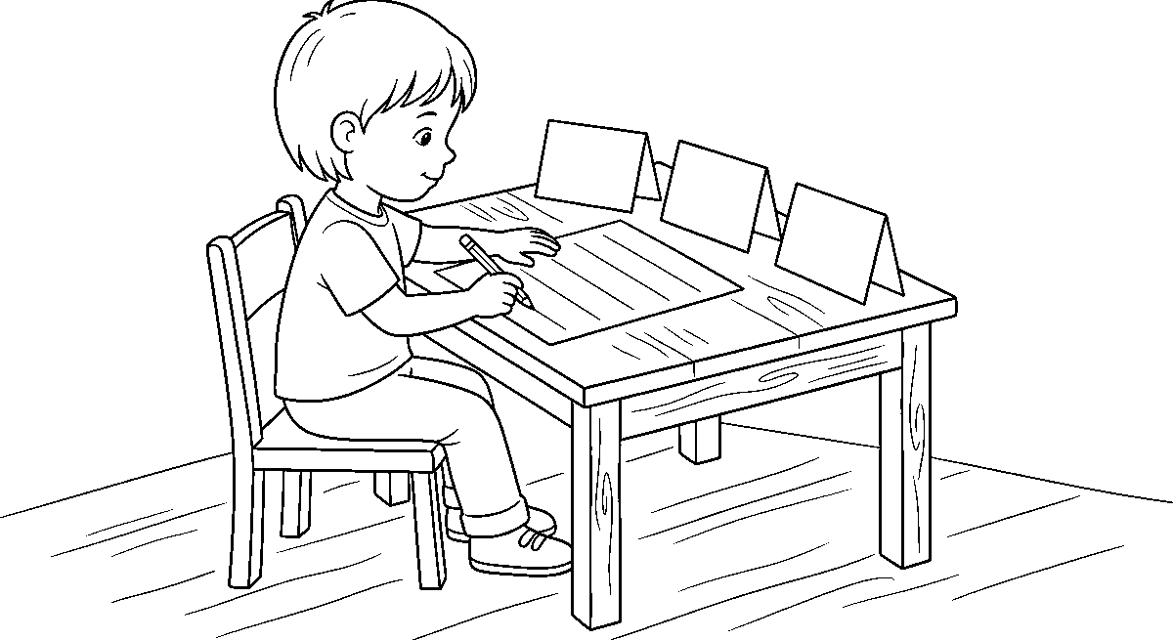
Worksheet
1. A capital letter is used A) only for "I" B) never C) in the middle of every word D) at the start of a sentence
2. Which is written correctly? A) bOLA went to LAGOS B) Bola Went to Lagos C) Bola went to Lagos D) bola went to lagos
3. The first letter of a month is A) a capital B) a dot C) small D) crossed
4. How many letters are in the English alphabet? A) 25 B) 24 C) 27 D) 26
5. Fill in: The word ____ is always a capital letter, wherever it stands.
6. Write the seven days of the week with their first letters big.
7. Correct this sentence: "tunde and ada came from abuja on friday."
My own work
Write five names of people, three names of places, the day you were born on and the month you like best, each beginning with a capital letter.

WEEK 2 — SIGHT WORDS: ONE, WE, SOME
Depth: NERDC Nursery 3 · Literacy (Language Domain) · Second Term W2 (pp 470–474).
You will learn to
• read, write and use the words one, we and some
• say what each word means with my hands
• read short sentences made of these three words
• know that "one" is a number and a word at once
Things to know
• Three new sight words: one · we · some — read them with the eye, not by blending.
• one = 1 — it is a word and a number at the same time: "I have one bag." It also means a single one: "One day I will be big."
• we = me and others together: "we are in class." — the word that has no "you and I" in it but means exactly that.
• some = more than one, but not counted: "some pens", "some water" — it does not tell us how many, only that there is enough for a little.
• One car · two cars · some cars — "one" counts, "some" does not; that is the difference between the number word and the little word.
• Sentences to read: "We see one." · "Some are here." · "We have some." · "One is for me, some are for us."
• Hand signals: one finger for one, both arms wide open for some, the whole class standing together for we — when the word is read, the hand shows the meaning.
• we begins with w (two V shapes joined) and ends with e — do not write "wi" or "wee"; some has a quiet s at the front and an e at the end that is not shouted.
• Sound hunt: which of the three words has the sound /w/? (we) · which ends in the sound /n/? (one) · which begins with /s/? (some).

• Memory game: the three cards face down; turn two, say both words, and if you can say a sentence with them you keep the pair.
• Writing: each word is written three times — once small and fast, once big and slow, once in a sentence.
• Counting connection: one, two, three… — "one" is the first number we ever say; the word is the number, and the number is a shape (1).
• Look for them at home: "one" on a page of a book, "some" on a food packet, "we" in a song — tick each word when you find it.
Words for my notebook
one · we · some — "I have one bag." "We are in class." "We have some water."
Let us talk
1. Which word means me and you together?
2. Is "one" a number or a word? (Both — say why.)
3. Give me three of something and one of something else; which word describes each?
4. Read this: "Some are here, we see one."
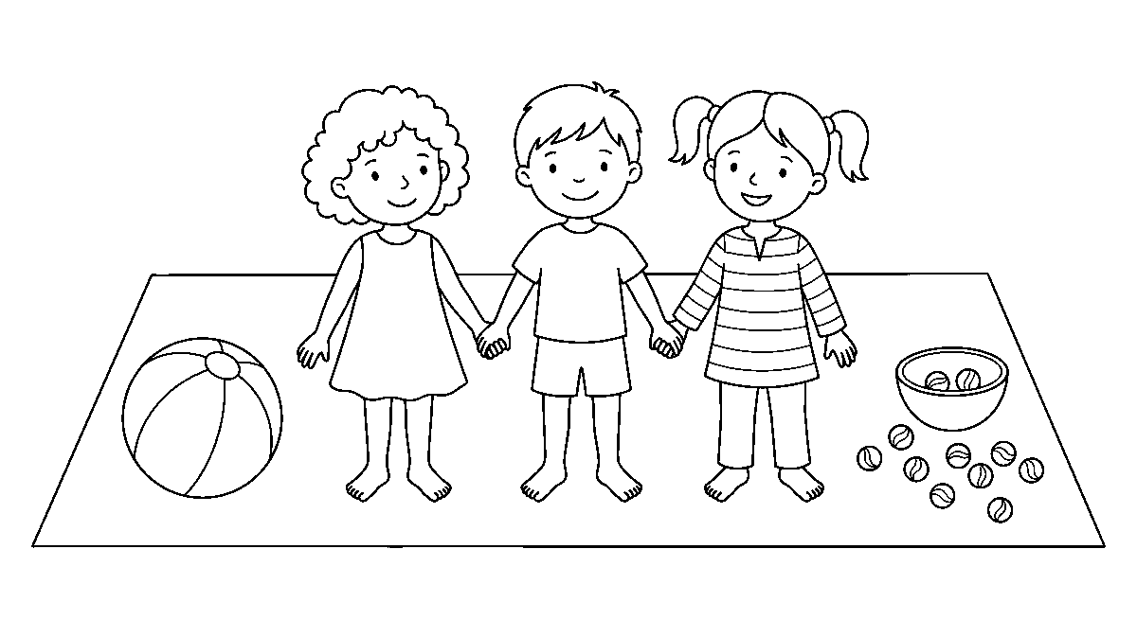
Worksheet
1. "____ have some pens." A) Am B) One C) We D) Some
2. The word "some" tells us A) none B) exactly how many C) more than one, not counted D) only one
3. "one" is a word and also A) a colour B) a name C) a sound D) a number
4. Which sentence is right? A) We have some. B) We has some. C) One are here. D) Some are we.
5. Fill in: "I can see ____ bag." (the number word)
6. Write one sentence with "we" and one with "some".
7. Say the three words as fast as you can, then write them.
My own work
Find one thing, then some things, in your own bag; write one sentence about each and read them to the class tomorrow.

WEEK 3 — DOUBLE CONSONANTS
Depth: NERDC Nursery 3 · Literacy (Language Domain) · Second Term W3 (pp 470–474).
You will learn to
• see two same consonants together in a word
• say and read words with bb, dd, gg, ll, mm, nn, pp, rr, ss, tt, zz
• know that a double consonant is one sound, written twice
• spell the double letter without forgetting it
Things to know
• A double consonant is the same consonant letter written twice together: rabbit, ladder, off, egg, bell.
• The twelve to look for: bb · dd · ff · gg · ll · mm · nn · pp · rr · ss · tt · zz.

• Words for each pair: rabbit (bb) · ladder, add (dd) · off, muffin (ff) · egg, giggle (gg) · bell, ball, tall (ll) · summer, hammer (mm) · dinner, banner (nn) · happy, puppy (pp) · purr, carrot (rr) · dress, miss (ss) · butter, kettle (tt) · buzz, jazz (zz).
• The big rule to hear: the double consonant makes one sound, not two — we do not say "e-g-g"; we say egg once and let the g be firm.
• The short vowel rule (first idea): the double consonant usually comes right after a short vowel — a in happy is short; compare hoping and hopping: the double tells the ear the o is short.
• Position: a double consonant comes in the middle (rabbit, dinner) or at the end (off, buzz, fill) — never at the start of an English word; that is a good test question.
• Word building with cards: ra + bb + it → rabbit; la + dd + er → ladder. Now take the double out and the word is wrong — "raler" is not a word: that is why the doubled letter matters.
• Sorting game: write the words in two columns — has a double consonant / has none: egg · pen · bell · sun · happy · cat · off · ball.
• Spelling check: after I write a word, I look at it and ask "is there a pair in it?" — the pairs are the ones we lose most in writing.
• Reading aloud: "The puppy sat on the ladder and saw the big red ball." — say every word with a double consonant again, slowly.
• Names can carry a double letter too — Anna (nn) and Rebecca (cc); if anybody in our class has a name with a pair in it, write it on the wall chart under that pair.
Words for my notebook
rabbit · ladder · egg · bell · summer · dinner · happy · butter · dress · buzz — one sound, two letters.
Let us talk
1. What is a double consonant?
2. Say the sound in "off" — is it one g or two sounds?
3. Which words have a double: "pen", "egg", "sun", "ball"?
4. Where can a double letter come in a word — the start, the middle, or the end?
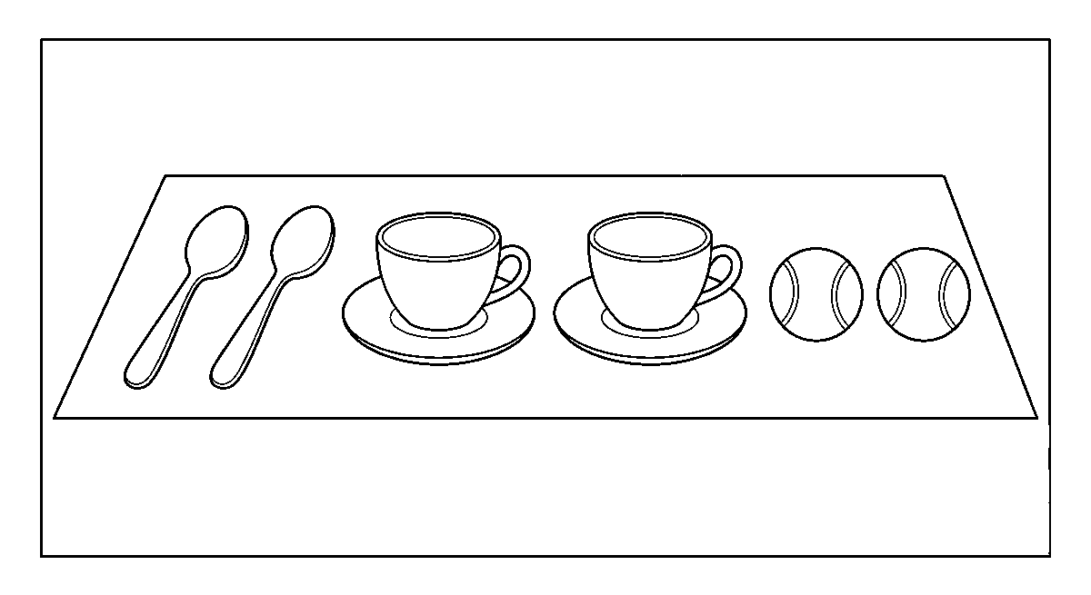
Worksheet
1. A double consonant is A) two vowels B) a silent letter C) a full stop D) two same consonants together
2. Which word has "gg"? A) gig B) egg C) off D) add
3. The double consonant is pronounced A) silently B) as a vowel C) twice, clearly D) as one firm sound
4. Which word has a double letter? A) pen B) hopper C) hop D) cup
5. Fill in: ra__it — the missing letters are ____.
6. Write five words with double consonants and underline the pair in each.
7. Say the sentence "The puppy sat on the ladder" and name the two words with doubles.

My own work
Look through one page of your story book and circle every word that has a double consonant; write five of them in your notebook.
Draw an egg, a comb and a lamp; write the double letter under each picture, then colour the lamp.

WEEK 4 — SIGHT WORDS: EGG, ADD, INK, COMB
Depth: NERDC Nursery 3 · Literacy (Language Domain) · Second Term W4 (pp 470–474).
You will learn to
• read and write egg · add · ink · comb
• see the double consonant inside two of them
• say why the b in "comb" is not sounded
• put all four words into sentences
Things to know
• The four words: egg (what the hen lays) · add (to put together — the maths word) · ink (the black liquid in a pen) · comb (the thing for the hair; and a hive of bees is also a comb).
• egg has gg and add has dd — the double consonants of last week are now living inside words I must know whole.
• ink is three letters and three sounds: /ɪ/ /n/ /k/ — the k after n is a firm finish, and it is also the sound of the word ending in "think, drink, pink".
• comb has a silent letter: the b is written but not said — we say /kəʊm/, "kome"; the b sleeps at the end.
• Other sleeping letters to name: knee (k silent), write (w silent), light (gh silent), comb (b silent) — we say it this way: English still writes what it used to say, even after the mouth moved on.
• Why "comb" keeps its b: long ago the b was sounded; the spelling stayed when the talking changed — the word's history is written on its back.
• Sentences to read: "Add one egg." · "The comb has ink on it." · "Do not put ink on the egg." · "We can add the egg."
• Use the words together: What do you add? (egg) — What do you comb with? (comb) — What is inside the pen? (ink) — this is the sense-check we do when a word is wrong.
• Write each word four ways: small, big, in the air with the finger, and once inside a sentence of my own.
• Sight-word review: the words learnt so far (Week 5–6 of Letter Work, plus one/we/some, plus today's four) are put on one big chart; I read the chart once forwards, once backwards.
• Sorting: which are maths or school words (add, ink) and which are home words (egg, comb)? A word can belong to both — say so.
Words for my notebook
egg · add · ink · comb. The b in "comb" is silent — we say "kome".
Let us talk
1. Which of today's words has a double letter?
2. Why do we not say the b in "comb"?
3. Say a sentence with "add" about your lunch.
4. What is the sound at the end of "ink"?

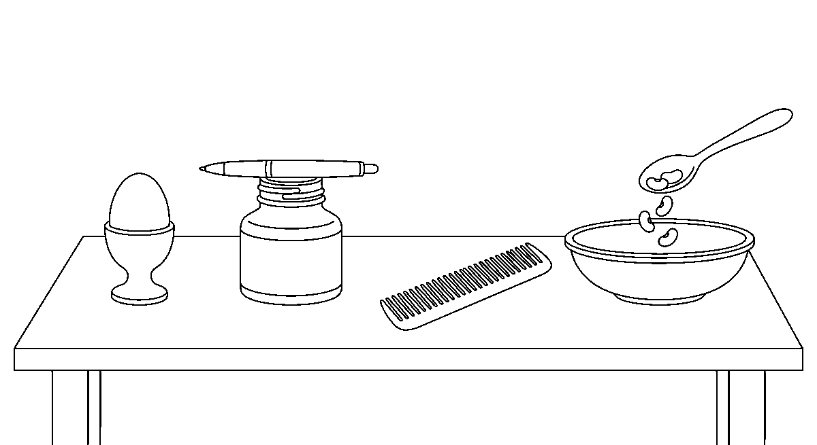
Worksheet
1. "____ the numbers together" A) Ink B) Comb C) Egg D) Add
2. The silent letter in "comb" is A) o B) m C) b D) c
3. Which word has "dd"? A) add B) egg C) comb D) ink
4. Ink comes from A) a hen B) a pot of water only C) a comb D) a pen
5. Fill in: "The hen lays an ____."
6. Write a sentence for each of the four words.
7. Say two other words that have a silent letter, and which letter sleeps in each.
My own work
Write four sentences using today's words, then find at home one thing you comb with and one thing you add to your food.
Draw one thing for each of your four sight words and colour the four pictures.

WEEK 5 — ALTERNATIVE SPELLINGS (PART 1): ai / ae / ay AND ee / ea
Depth: NERDC Nursery 3 · Literacy (Language Domain) · Second Term W7 (pp 470–474).
You will learn to
• say the long a sound and the three ways it is spelled
• say the long e sound and the two ways it is spelled
• choose the right spelling by where the sound sits in the word
• read and write the word families rain/train and tree/see
Things to know
• Alternative spellings = the same sound written in different ways; English does this a lot, and it is why spelling must be learnt, not only sounded out.
• The long a sound is the letter's own name: /eɪ/ — as in "day".
• Three ways to write it: ai (rain, train, mail, wait, pain) · ay (day, play, say, tray, way) · ae (aerobics, aerial) — the last one is rare, so know it and do not chase it.
• The position rule to keep: ai sits in the middle of a word (rain, tail, nail); ay sits at the end (day, play, say, may).
• The long e sound is /iː/ — the mouth wide, a smile sound.
• Two ways to write it: ee (tree, bee, see, feet, sleep, green) · ea (eat, sea, tea, read, dream, leaf, seat).
• The same sound, different spelling: see and sea sound alike; rain and reign sound alike and only the spelling tells them apart.
• Word families for the week: rain / train / grain · play / say / tray / day · tree / bee / free / three · tea / sea / pea.
• Read the line: "The bee saw the rain, so she flew to the tree and sat on a leaf." — say every word with the long a and the long e.

• Choosing practice: fill ai or ay — r_n → rain · d_ → day · tr_n → train · pl_ → play · s_ → say. Then say why: the sound at the end of the word takes ay, the sound in the middle takes ai.
• Spelling out loud: say the word, then say the letters, then say which team the sound plays for: "play — p-l-a-y — the long a at the end, so ay."
• Why one sound has four coats: English came from many languages, and each brought its own spelling habits; the sound is the child, the spellings are the coats.
Words for my notebook
Long a: ai (rain) · ay (day) · ae (aerobics). Long e: ee (tree, bee) · ea (eat, sea, tea). Same sound, different spelling.
Let us talk
1. What are alternative spellings?
2. Where in a word do we usually put "ai"? Where do we put "ay"?
3. Say three words with "ee" and three with "ea".
4. Spell "train" aloud and say which spelling team the sound plays for.
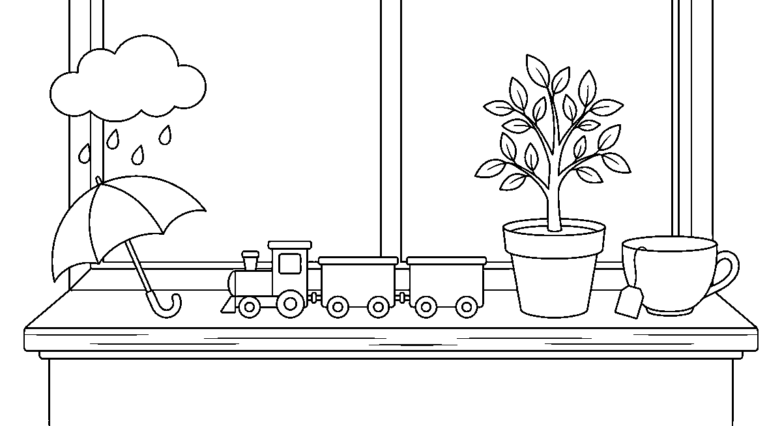
Worksheet
1. The sound in "day" can be written A) ee B) ai at the end C) ea D) ay at the end
2. Which word uses "ai"? A) sea B) bee C) rain D) play
3. "ee" in tree, bee and see makes the A) long e B) short i C) silent e D) long a
4. Which spelling is correct? A) trane B) trayn C) traine D) train
5. Fill in: What you drink with milk is t____a (tea) — write the two missing letters.
6. Write two words with "ai", two with "ay", two with "ee" and two with "ea".
7. Say the sentence about the bee and the rain, and pick out the four long-sound words.
My own work
Write three sentences: one about rain, one about playing in the day, and one about tea or the sea — then underline the letters that make the long sound.
Draw the sky on a bright day and the rain on a wet day; colour only the bright one.

WEEK 6 — ALTERNATIVE SPELLINGS (PART 2): igh/y/ie, oi/oy, ou/ow + SIGHT WORDS: BE, WAS, LIKE, HERE
Depth: NERDC Nursery 3 · Literacy (Language Domain) · Second Term W8 (pp 470–474).
You will learn to
• write the long i sound in three ways
• use oi / oy and ou / ow by where they sit in the word
• read and write the sight words be, was, like, here
• spell new words by choosing the right pattern
Things to know
• The long i sound is the letter's own name: /aɪ/ — as in "I".

• Three coats for it: igh (high, night, light, right, fight) · y (my, fly, cry, try, shy, by) · ie (tie, pie, lie, die).
• The position rule: igh sits in the middle or end of a word and keeps the gh silent; y usually comes at the end; ie is for a short word's end (tie, pie).
• The oy sound /ɔɪ/: oi in the middle (oil, coin, boil, soil, point) · oy at the end (boy, toy, joy, enjoy).
• The ow sound /aʊ/: ou in the middle (out, shout, house, mouse, blouse) · ow at the end (cow, how, now, brown, snow).
• Careful: ow can also say long o — snow, grow, low — so if the word does not sound like "cow", it is the other ow; the ear decides, the rule only helps.
• Four new sight words: be (to be: "Be quiet.") · was (the past of is/am: "I was four last year.") · like ("I like rice.") · here ("Come here.").
• Sentences to read: "I like the night." · "She was here." · "Do not cry, boy!" · "The mouse came out of the house."
• Choosing spelling in a new word: I hear the sound, then ask where does it sit? — middle or end? Then I put the right coat on it.
• Note the trap: like has a silent e at the end and the i says its own name — that is the family of "hide, time, five" and it belongs to this week's sound.
• Write the four sight words and use each in one sentence of my own; the sentences must be true about me.
Words for my notebook
igh / y / ie for long i · oi / oy · ou / ow. be · was · like · here. Middle: oi, ou, ai. End: oy, ow, ay.
Let us talk
1. Say three ways of writing the long i sound.
2. Which do you use at the end of a word: oi or oy? ou or ow?
3. What does "was" tell us that "is" does not? (the past)
4. Spell "night" aloud and say why the h is there.
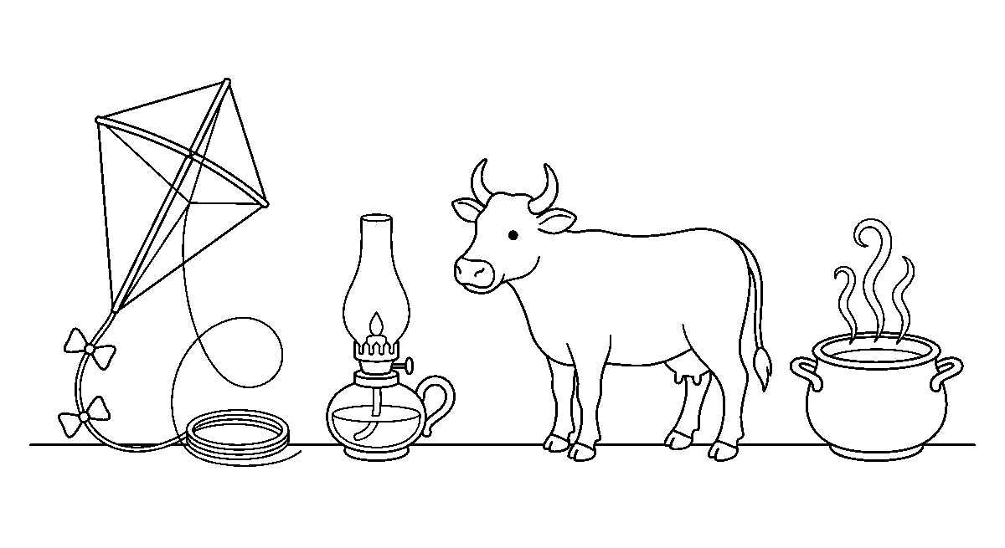
Worksheet
1. The long i sound in "night" is written A) igh B) ie C) neet D) y only
2. Which word is spelled right? A) boi B) bouy C) bui D) boy
3. "The c__ is brown" A) cai B) cie C) cow D) cou
4. "I ____ here yesterday" A) am B) be C) was D) like
5. Fill in: In "my, fly, cry" the long i is written by the letter ____.
6. Write two words for each pattern: igh, y, ie, oi, oy, ou, ow.
7. Use "like" and "here" in one sentence each.
My own work
Write five sentences about what you like: "I like …", and in each sentence use one word with igh, oi/oy or ou/ow.
Draw a high hill and a small bird on it, then colour the bird.

WEEK 8 — TRIGRAPHS: are, air, tch, ure + SIGHT WORDS: HAIR, MATCH, PURE
Depth: NERDC Nursery 3 · Literacy (Language Domain) · Second Term W9 (pp 470–474).
You will learn to
• say what a trigraph is
• read the trigraphs are, air, tch and ure
• know that are and air make the same sound
• read the sight words hair, match, pure inside real words
Things to know
• A digraph is two letters making one sound (sh, ch, ee, gh); a trigraph is three letters making one sound — are, air, tch, ure.
• are says /eə/ — the same sound as air: care, share, dare, bare, square · hair, fair, pair, chair, stairs.
• That is the surprise of the week: care and air rhyme, so the e at the end of "are" does not add a sound of its own — it only helps the spelling.
• tch says /tʃ/ — the same sound as ch, but it comes after a short vowel: catch, match, watch, kitchen, pitch, featcher — after a short vowel we write tch. After a long vowel or another consonant we write ch: beach, lunch.
• ure says /ʊə/ ("oor") or /jʊə/ ("yoor"): pure, cure, sure, picture, nature, future.
• The three sight words of the week are made of these trigraphs: hair (air) · match (tch) · pure (ure) — they must be read whole and also understood as patterns.
• Read: "I comb my hair, strike a match, and hold a pure white shell." — say each word slowly and name its trigraph.
• Sort by sound, not by spelling: /eə/ — care, share, air, chair, pair, square (six words, one sound, two spellings).
• Say the sound and hear the trigraph: in "catch", the t and ch join into one push of air: /k/ /æ/ /tʃ/.
• Writing practice: complete the word — h__ __ r → hair; m__ tch → match; p__ re → pure — then read the whole word back.
• The trigraph hunt: in the class story book, find one word with air/are, one with tch, one with ure; the class writes them on one line on the board.
Words for my notebook
are = air (/eə/) — care, chair · tch after a short vowel — catch, match · ure — pure, picture, nature.
Let us talk
1. What is a trigraph? How is it different from a digraph?
2. Say two words where "are" and "air" sound the same.
3. Why does "match" need a t before ch?
4. Read the sentence about the hair, the match and the shell.
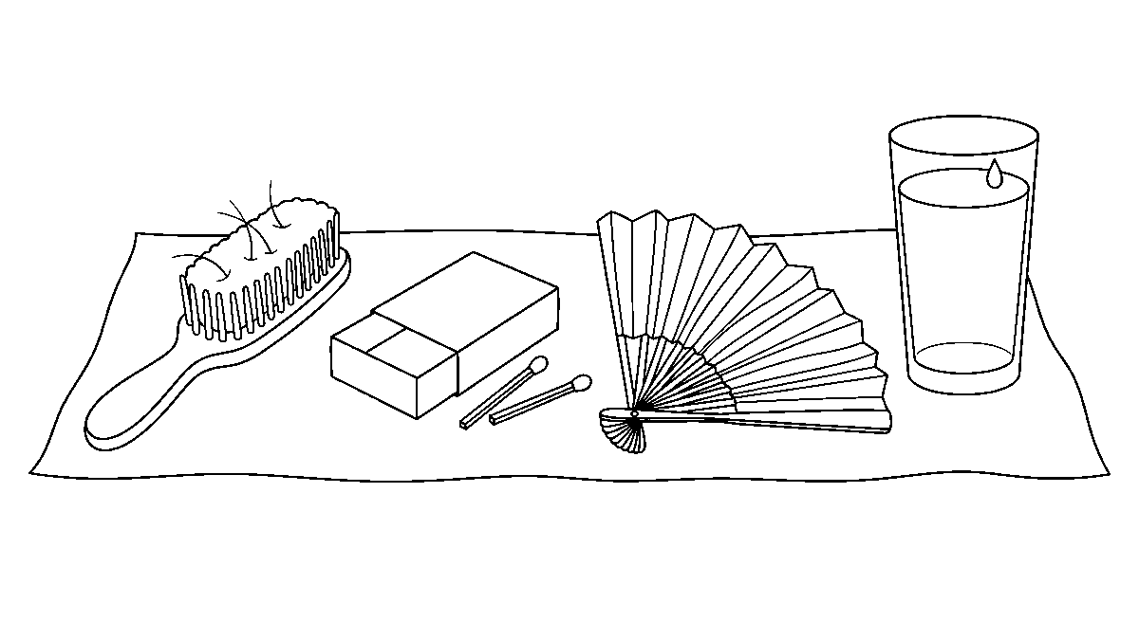

Worksheet
1. A trigraph is A) a silent letter B) two letters, one sound C) three sounds D) three letters, one sound
2. Which word has the same middle sound as "air"? A) art B) care C) ache D) arm
3. "tch" comes after A) a capital B) a long vowel C) a full stop D) a short vowel
4. Which word has "ure"? A) turn B) tent C) picture D) tune
5. Fill in: h__ __ — the word for what grows on your head is ____.
6. Write two words each for are, air, tch and ure.
7. Read: "The fair girl has a chair and a hair band," and say which words carry the same sound.
My own work
Cut three cards and write a trigraph on each (air, tch, ure); put a letter or two before it to build as many real words as you can in five minutes.

WEEK 9 — ARTICLES: THE USE OF 'a', 'an' AND 'some' + SIGHT WORDS: THERE, LIVE, FOUR, DO, THEY, GIVE
Depth: NERDC Nursery 3 · Literacy (Language Domain) · Second Term W10 (pp 470–474).
You will learn to
• choose a, an or some before a thing
• know the six sight words: there, live, four, do, they, give
• read and write sentences that use both
• say why an goes before a vowel sound
Things to know
• An article is the little word that stands before a thing to tell us how we mean it: a, an and some.
• a goes before a word that begins with a consonant sound: a cat · a dog · a book · a ball · a university (the u here says /j/, a consonant sound, so a is right).
• an goes before a word that begins with a vowel sound: an apple · an egg · an orange · an umbrella · an hour (the h sleeps, so the ear hears a vowel — an).
• some goes before more than one thing or a thing you cannot count: some eggs · some boys · some water · some rice.
• The rule is by the ear, not the eye: "an honest man" (silent h) and "a one-way road" (the o says /w/) are the two that make the class laugh and learn.
• One or many? a pen (one), an ant (one), some pens (many) — a and an never go before a plural; some never before a single thing.
• The six sight words: there (that place: "Put it there.") · live (to be alive; and a house: "We live in Lagos.") · four (4 — the number word, same sound as "for", different meaning) · do (the question helper: "Do you see it?") · they (other people: "They are my friends.") · give ("Give me the bag.")
• Sentences to read and copy: "Give me an egg." · "They live there." · "Do you want some water?" · "I have four pens there." · "There are some boys on the road."
• there vs their: there is a place, their is belonging ("their bag") — the middle letters are the difference; write "there" with here inside it, because here is a place too.
• Choice drill at the mouth: I hold up a thing and say the whole phrase — "a pen", "an orange", "some stones" — three times each, quickly.
• End of term writing: five sentences about my family using live, there, four, they, give and one article in each; read them to the class and let them hear if an article is wrong.
Words for my notebook
a + consonant sound (a dog) · an + vowel sound (an egg, an hour) · some + many or uncountable (some eggs, some water). there · live · four · do · they · give.
Let us talk
1. Which goes before "apple" — a or an? Why?

2. Why do we say "an hour"?
3. What is the difference between "there" and "their"?
4. Say a sentence with "some" and one with "four".
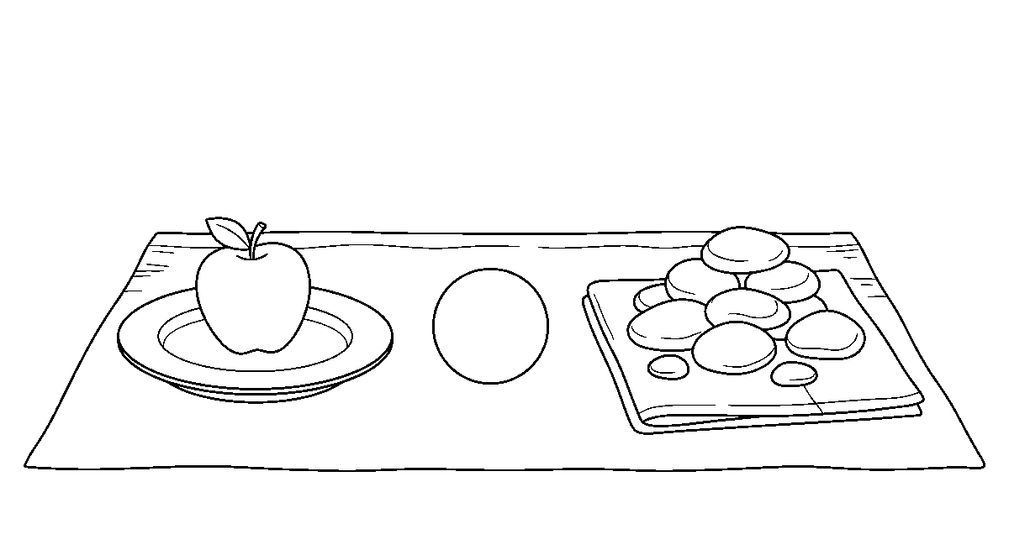
Worksheet
1. "____ elephant is big." A) a B) some C) the two D) an
2. Which is correct? A) a egg B) an egg C) an eggs D) some egg
3. "They live ____ with their family." A) four B) do C) there D) their
4. "I have ____ (4) books." A) fore B) for C) fur D) four
5. Fill in: "Do you want ____ water?" (a, an or some)
6. Write three phrases with "a" and three with "an", one of them before a word that starts with a silent letter.
7. Use "give" and "some" in one sentence and "they" and "live" in another.
My own work
Write five sentences about your home: who lives there, what you have four of, what you give a friend, and where one thing is — check every "a" and "an" before you show it.
LITERACY — LETTER WORK

WEEK 1 — REVIEW OF THREE-LETTER WORDS (CVC)
Depth: NERDC Nursery 3 · Literacy (Letter Work) · Second Term W1 (pp 458–464).
You will learn to
• blend three sounds into a word and read it
• read and write the word families -at, -an, -en, -in, -og, -un, -op
• match each word to its picture
• write words as they are said to me
Things to know
• CVC means consonant – vowel – consonant: three letters, one vowel in the middle — c a t, p e n, b e d.
• Blending is saying the sounds and running them together: "c… a… t… cat" — never say the letter names ("see-ay-tee"), say the sounds (/k/-/æ/-/t/).
• The trick that keeps the sound clean: do not add "uh" — /m/ is a hum, not "muh".
• Six families to read this week, one line each:
–at: cat · bat · hat · mat · rat · sat · fat
–an: fan · man · pan · can · ran · tan
–en: pen · hen · ten · men · wen
–in: pin · tin · win · fin · sin · kin
–og: dog · log · fog · hog · jog
–un: sun · bun · run · fun · gun · nun
• –op: mop · top · hop · pop · stop · prop — and note that cup, pup, sup belong to the -up family, not this one
• Change the first sound and the word changes: cat → bat → hat → mat → rat; the -at stays the same.
• Change the middle sound: bat → bet → bit → bot → but — five words, one letter apart.

• Read a whole line of a family, then read it backwards (top, pop, mop, hop) — the eye must not need the order.
• Matching to pictures: the picture of a fan goes with f-a-n; say the word slowly and count the sounds — three sounds, three letters.
• Dictation: I hear the word, I say it in sounds, then I write the letters under my own voice; then I read back what I wrote.
• Writing with a pencil: the letters sit on the line; a, c, e, g, i, m, n, o, p, r, s, u, v, w, z are small letters only in these words. And the first word of nothing needs a big letter here.
• Confidence rule: if I stumble, I go back to the first sound and start again slowly — nobody is laughed at for reading slowly.
Words for my notebook
cat, hat, mat · pen, hen, ten · dog, log, fog · sun, bun, run. Three sounds make one word.
Let us talk
1. Blend this for me: /k/ /æ/ /t/.
2. What word family is "pin, tin, win"?
3. Change one sound in "bat" to make a new word.
4. How many sounds are in "dog"?
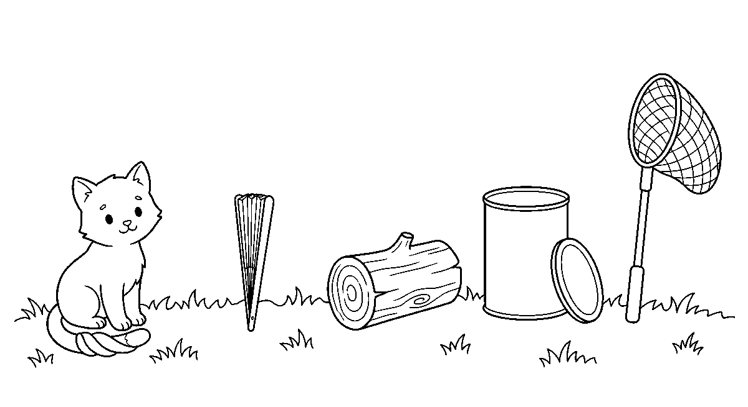
Worksheet
1. CVC means a word made of A) five letters B) three consonants C) two vowels D) consonant, vowel, consonant
2. The word made by /b/ /æ/ /t/ is A) bat B) but C) bit D) bet
3. pen, hen and ten all belong to the word family A) -en B) -in C) -an D) -un
4. In "cat", the middle sound is A) a vowel B) a silent letter C) a consonant D) a digraph
5. Fill in: m, p, t and r all rhyme with ____ (-at family).
6. Write one line for each of three word families you read today.
7. Read five words from the -og family and use one in a sentence.
My own work
Choose one word family and write six words in it; under the last one, draw the thing it names.

WEEK 2 — FOUR-LETTER WORDS: CVCC PATTERN (PART 1)
Depth: NERDC Nursery 3 · Literacy (Letter Work) · Second Term W2 (pp 458–464).
You will learn to
• read four-letter words that end in two consonants
• blend the ending -nd, -nt and -st
• write CVCC words from a picture
• say what the last two letters do to the word
Things to know
• A CVCC word has four letters: consonant, vowel, consonant, consonant — the last two consonants stand together at the end: hand, tent, nest.
• We already know three-letter words; here we add one more sound at the tail — that is all that changes.

• The -nd family: hand · sand · land · band · mend · wind — the d is quiet in the mouth but it is heard at the end.
• The -nt family: bent · sent · tent · went · rent · mint — after the t the mouth just stops; we do not add "uh".
• The -st family: best · rest · test · west · nest · last — the t at the end is a small tap.
• Blend the four sounds: h-a-n-d → hand; say them slowly, then faster, then as one word; count on the fingers: four sounds, four letters.
• Read a line where the head changes but the tail stays: ban · band · sand · stand — one new letter makes a new word.
• Sort the words: which family does "gift" go in? — ft, not this week's line; which does "land" go in? — nd.
• Picture work: the picture of a tent goes with t-e-n-t; a picture of a band (a rubber band) with b-a-n-d; the hand with h-a-n-d.
• Write from a dictation: b-e-d is three sounds; s-e-n-t is four — the number of sounds must match the number of letters.
• Meaning: a hand is a body part, a band holds hair or paper, sand is what we play with, land is the ground under us — the last two letters stay, the first two change the meaning.
• Read the sentence: "The hen went to the tent." — say which words are CVCC in it.
Words for my notebook
hand, sand, land · bent, sent, tent, went · best, rest, nest, west. Four sounds, four letters.
Let us talk
1. How many sounds are in "hand"?
2. Say three words that end in -nt.
3. What is the difference between "sand" and "band"?
4. Read the sentence "The hen went to the tent" and pick out the four-letter words.
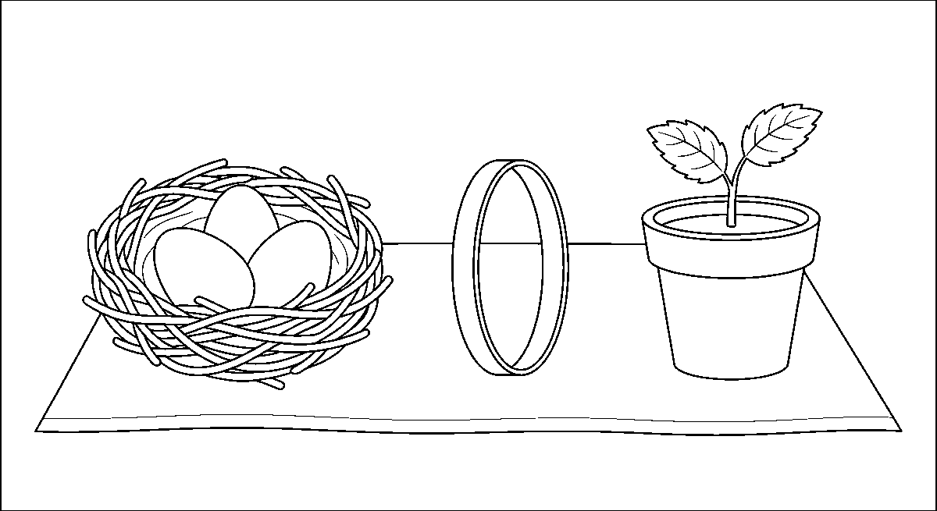
Worksheet
1. A CVCC word has A) two vowels B) five consonants C) three letters D) four letters with two consonants at the end
2. hand, sand and land all end in A) -nd B) -st C) -mp D) -nt
3. The word made by b-e-n-t is A) bent B) bean C) burn D) ban
4. Which word belongs to the -st family? A) lamp B) nest C) mint D) mend
5. Fill in: tent, sent and went all end in ____.
6. Write three words for each of -nd, -nt and -st.
7. Use two of today's words in one sentence each.
My own work
Find five things at home whose names end in two consonants, write their words and mark the last two letters.

WEEK 3 — FOUR-LETTER WORDS: CVCC PATTERN (PART 2)
Depth: NERDC Nursery 3 · Literacy (Letter Work) · Second Term W3 (pp 458–464).

You will learn to
• read the ending families -mp, -nk and -ft
• blend four sounds in a new word without stopping
• read a sentence full of CVCC words
• write four-letter words from my own speaking
Things to know
• The -mp family: jump · lamp · camp · bump · damp · stamp — after the m, the lips close again for the p; that is why -mp looks like two lips sounds together.
• The -nk family: bank · tank · pink · sink · wink · bunk — the nose sound n slides into the k; say "nk" without a vowel between.
• The -ft family: left · gift · lift · soft · raft — the f bites the lip and the t taps.
• Three new endings plus last week's three make six tails: -nd, -nt, -st, -mp, -nk, -ft; a four-letter word is now something I can attack, not guess.
• Blend and read: c-l-a-m-p? (that's CLVC) — read: jump, lamp, camp, damp — the vowel u, a, a, a changes the head, the tail stays.
• Change the head, keep the tail: pink → wink → sink → bunk; gift → lift → left → soft.
• Read the sentences aloud, one breath each:
"The lamp is on the bank." · "Do not jump in the damp." · "She put the gift on the soft sand."
• Writing practice: say the word in sounds, write the letters, then count the sounds and the letters again — four and four.
• Dictation list for the week: jump, bank, pink, gift, lamp, sink, soft, camp.
• Word recognition game: the flash card is shown for a count of three; I must say the word, and to do that I must read the whole word, not the first letter.
• Meaning of the hard ones: a bank is the side of a river or the place money is kept; a tank holds water; a camp is where we sleep in tents; damp is wet in a cold way.
• Write your own line: "I can jump." — read it back with the finger under every word.
Words for my notebook
jump, lamp, camp · bank, tank, pink, sink · left, gift, lift, soft. Six tails: nd, nt, st, mp, nk, ft.
Let us talk
1. Say the six tails we have learnt in two weeks.
2. What sound do the lips make at the end of "jump"?
3. Read: "The lamp is on the bank."
4. Give a word that rhymes with "wink".
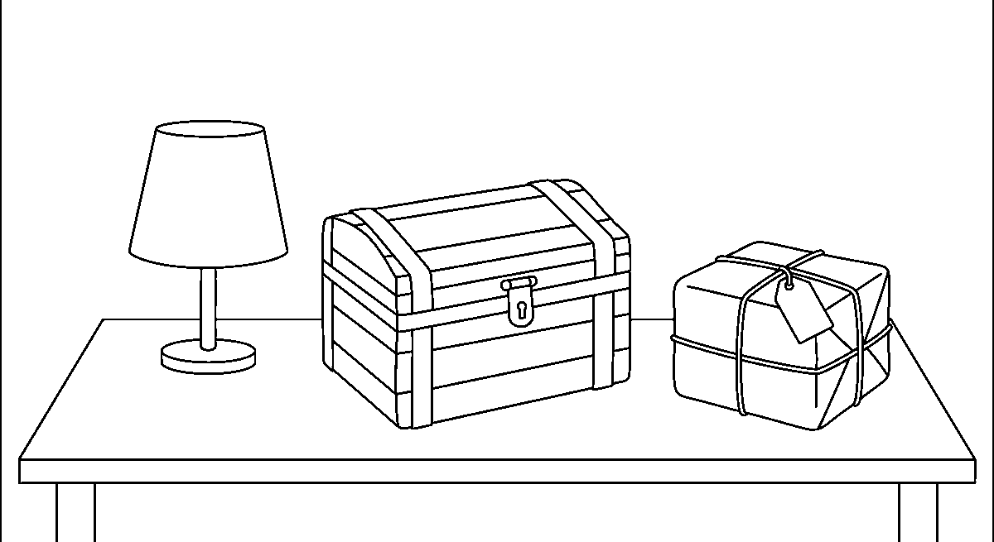
Worksheet
1. jump, lamp and camp all end in A) -mp B) -nk C) -nd D) -ft
2. The word for a place to keep water is a A) nest B) tank C) tent D) lamp

3. gift, lift and left end in A) -nt B) -st C) -ft D) -mp
4. Which word is NOT in the -nk family? A) sink B) bump C) bank D) pink
5. Fill in: A wet, cold floor is said to be ____.
6. Write a sentence using one -mp word and one -nk word.
7. Read four CVCC words that are not on the wall chart and spell them aloud.
My own work
Make two cards for each tail (-mp, -nk, -ft) with the word on one side and a small picture on the other, then use them to test yourself.
Draw a hand, a lamp and a tent; colour the one that keeps you warm at night.

WEEK 4 — FOUR-LETTER WORDS: CCVC PATTERN
Depth: NERDC Nursery 3 · Literacy (Letter Work) · Second Term W4 (pp 458–464).
You will learn to
• read words that start with two consonants
• say the l blends and the r blends
• blend a consonant cluster without putting a sound between
• write CCVC words
Things to know
• A CCVC word has two consonants at the front and then a vowel and a consonant: blu-e → blue, flag, drum, tree.
• Two consonants that run together are called a blend; a blend is still said sound by sound, fast — not "buh-lag" but /bl/ag.
• The l-blends (the second sound is l):
bl — blue, black, block, blind · cl — clap, clip, club, clay · fl — flag, flip, flat, fly
gl — glad, glue, glow, globe · pl — play, plug, plan, plum · sl — slap, slip, sled, slow
• The r-blends (the second sound is r):
br — brush, brick, bring, brown · cr — crab, crop, cry, crown · dr — drum, drip, drop, draw
fr — frog, from, free, front · gr — grip, grab, grass, grey · pr — pray, prop, press, pride · tr — tree, trip, tray, troop
• Say the pair first: "fl — fla — flag"; then add the tail: /fl/ + /a/ + /g/ → flag.
• Tricky: gl is not kl; br is not "bur"; keep the r growl, do not turn it into a vowel.
• Sort the words by their blend — the l-blends: flag, blue, play · the r-blends: crab, drum, grass, frog, tree
• Read the sentence: "The frog can sit by the green tree and grab a fly." — say every word that starts with a blend.
• Writing: the two first letters are close together, no space inside a blend — f-l-a-g, not "f lag".
• Put a blend in front of a family you already know: -ap → clap, flap, slap, gap · -ag → flag, drag, brag (drag and brag are new — learn these two only) · -op → stop, flop
• Play the blend game: I pull a blend card (br) and a family card (-ick) and say the word: brick; the class says it back and writes it.
• End of the week: read a page of mixed four-letter words — CVCC and CCVC together, without a finger.
Words for my notebook
bl, cl, fl, gl, pl, sl · br, cr, dr, fr, gr, pr, tr · flag, drum, tree, blue, frog, clap.
Let us talk
1. What is a blend?
2. Say three words that begin with fl.
3. Which blend starts the word "grass"?
4. Read the sentence about the frog and the tree.

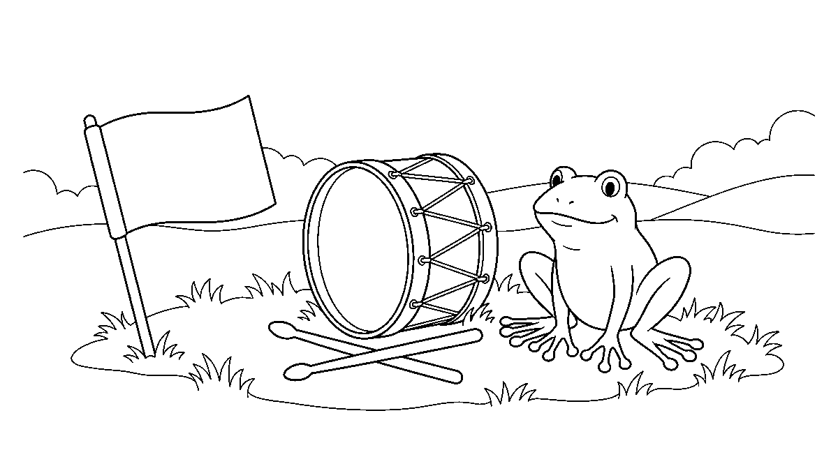
Worksheet
1. A CCVC word begins with A) a full stop B) one letter C) two consonants D) two vowels
2. Which two sounds make the blend in "flag"? A) l and a B) f and l C) f and r D) a and g
3. crab, crop and crown all begin with A) cl B) br C) gr D) cr
4. Which word begins with the blend dr? A) tray B) grip C) draw D) play
5. Fill in: In "blue", the first two letters are the blend ____.
6. Write three words beginning with bl and three beginning with tr.
7. Read a CCVC word and a CVCC word of your own, and say what is different about them.
My own work
Make two columns in your book: l-blends and r-blends. Write four words under each, and put a small picture beside one word in each column.

WEEK 5 — INTRODUCTION TO SIGHT WORDS (PART 1)
Depth: NERDC Nursery 3 · Literacy (Letter Work) · Second Term W7 (pp 458–464).
You will learn to
• say what a sight word is
• read ten sight words at once without blending
• use the words in a simple sentence
• play the flash-card and memory games with them
Things to know
• A sight word is a word we see so often that we know it by its shape, the way we know a face — we do not blend it.
• Why not blend? Because many of them break the rules: "the" is not "t-h-e" said fast; we just know it.
• The ten words of this week: I · a · the · is · am · and · it · in · at · on.
• I is always a big letter, even in the middle of a sentence — because it is me.
• a is one small letter; the is three; both tell us which thing we mean: "Give me a cup" (any cup) vs "Give me the cup" (that cup).
• is / am say what a thing is: "It is a cat." "I am four."
• and joins: "The dog and the hen."
• in / at / on are place words: the pen is in the bag; I am at school; the cup is on the table.
• Read them by the eye and no more: the card shows for three seconds — say the word, do not sound it.
• Sentences to read and copy: "I am a boy." · "It is a cat." · "The pen is in the bag." · "I am at school."
• Flash-card drill: ten cards, shuffled; put them in the order you know them best to worst; move the worst three to the front of the pack every day.

• Memory game: the cards lie face down; turn two; if they are the same word, keep them and say a sentence with it.
• Matching to pictures: on goes with the cup above the table; in goes with the pen inside the bag — the picture and the word must agree.
• Writing: a, it, in, on, at are short words but they must be written on the line, not floating under it; the has the tall h; I is tall alone.
• Sight words read fast is the beginning of reading for pleasure: when these ten are free in my eye, my brain can think about the story instead of the letters.
Words for my notebook
I · a · the · is · am · and · it · in · at · on — read them with your eyes, not your mouth.
Let us talk
1. What is a sight word?
2. Why is "I" always a big letter?
3. Say a sentence with "in" and one with "on".
4. Which word joins two things — "and" or "the"?
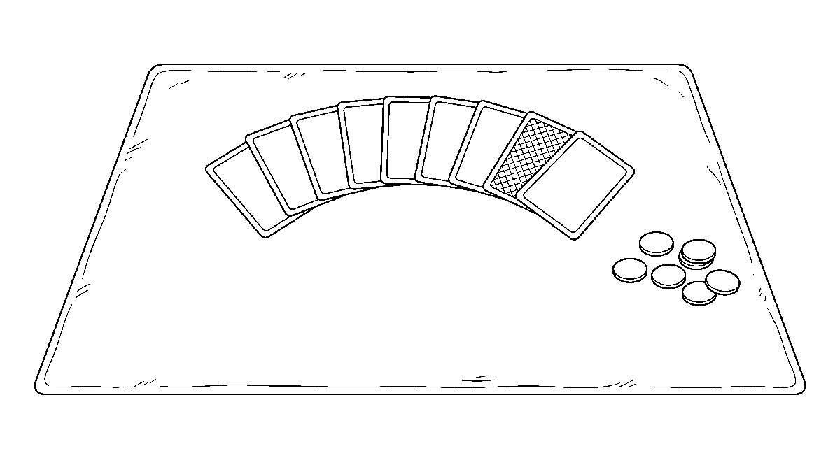
Worksheet
1. A sight word is a word we A) never use B) always spell aloud C) only write D) know at once by looking
2. "The pen is ____ the bag." A) and B) in C) on D) at
3. Which sentence is right? A) I Am a boy. B) I am a boy. C) I am a boy D) i am a boy.
4. The word that joins two things is A) is B) a C) and D) the
5. Fill in: "It ____ a dog."
6. Read all ten sight words of this week in any order.
7. Write two sentences using four of the ten sight words.
My own work
Cut ten small cards, write one sight word on each, and play the memory game with your own pack until you can say all ten in thirty seconds.

WEEK 6 — INTRODUCTION TO SIGHT WORDS (PART 2)
Depth: NERDC Nursery 3 · Literacy (Letter Work) · Second Term W8 (pp 458–464).
You will learn to
• learn ten more sight words
• read them quickly in a game of bingo
• put sight words together with CVC words to make a sentence
• write sentences that begin with a big letter
Things to know
• The ten new words: he · she · we · me · my · to · go · no · up · can.
• he is for a boy or a man · she is for a girl or a woman · we is me and you together · me is me when somebody does something to me: "Give it to me."
• my says a thing belongs to me: "This is my bag."

• to shows where a thing goes: "I go to school." · up is the other side of down: "Look up."
• go and no look alike but sound different — no begins with the nose, go begins with the throat: the g is the difference.
• can says I am able: "I can run." — the sentence everybody likes best.
• Twenty sight words are now in my eye (this week's ten plus last week's ten); the pack of cards grows by ten.
• Sentences mixing sight words and CVC words: "I can run." · "We go up." · "She can see a hen." · "He can pat the dog." · "My pen is in the bag."
• Sight-word bingo: a card with nine boxes; I call a word, you mark it if you have it; three in a line and you shout "Bingo!" and read the line back.
• Speed rule: the word must be said in less than one second — this is the only reading that is allowed to be fast, because it is already known.
• Writing: begin the sentence with a big letter and end it with a full stop; leave a space between words — "Icanrun" is three words crushed together.
• Build a sentence with cards: put the word cards on the table in an order, read it, then move one card and read the new sentence.
• Reading at home this week: find one of these words on every page of your story book and put a tick beside it — the words are everywhere.
Words for my notebook
he · she · we · me · my · to · go · no · up · can · I can run. We go up.
Let us talk
1. Which word do you use for your mother — he or she?
2. What is the difference between "go" and "no"?
3. Say a sentence with "can" about yourself.
4. Read this: "She can see a hen." How many words do you already know by sight?
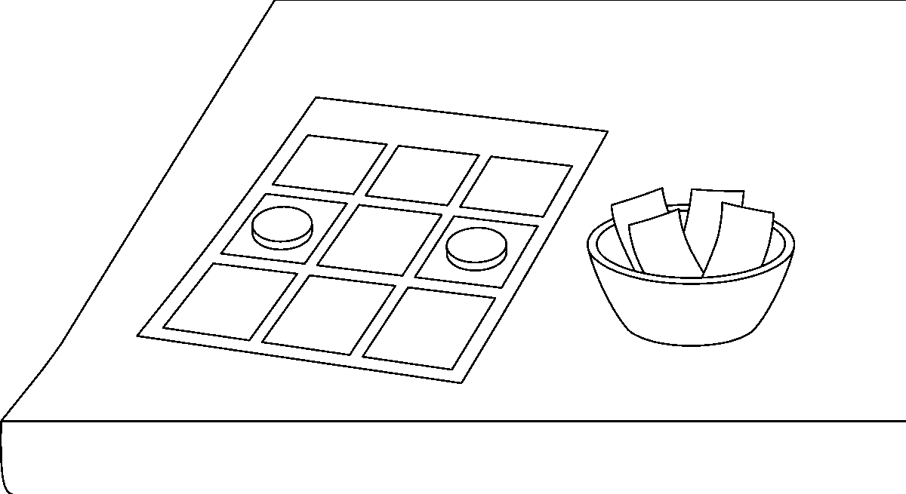
Worksheet
1. "____ can swim," said about a girl. A) My B) He C) It D) She
2. The word that means a thing belongs to you is A) up B) me C) my D) no
3. Which sentence is written best? A) I can run. B) i can run C) I can Run. D) I Can run
4. "Look ____ and see the bird." A) to B) no C) up D) my
5. Fill in: "We go ____ school." (the word that shows where)
6. Read the twenty sight words of Weeks 5 and 6 in shuffled order.
7. Write two sentences using "can" and "my", with a big letter and a full stop.
My own work
Write three sentences about what you can do: "I can …", "I can … and I can …", "My brother can …" — with a space between the words.
Cut four letters out of an old newsprint and paste them in your book beside your sight words.

WEEK 8 — SIMPLE SENTENCE READING AND WRITING
Depth: NERDC Nursery 3 · Literacy (Letter Work) · Second Term W9 (pp 458–464).
You will learn to
• say what a sentence is
• read simple sentences with the right stops
• begin with a capital letter and end with a full stop
• write my own three-line sentences
Things to know
• A sentence is a group of words that makes one complete sense: "The cat sat on the mat" tells me a whole thing — a who and a what he did.
• Two things a sentence must have: a name of a thing or person (who/what) and what about it (did/is/saw) — "cat the on" is a heap of words, not a sentence.
• Three rules of writing a sentence — the sentence uniform: 1) a capital (big) letter at the start, 2) a space between every word, 3) a full stop at the end.
• Why the spaces? Without them the eye cannot find where one word stops and the next begins: thecat is one long mistake.
• Why the full stop? It tells the reader: here, breathe — and it tells the writer: that thought is finished.
• Read these, one breath per sentence: "The cat sat on the mat." · "I can see a dog." · "Ben has a red pen." · "We went to the shop." · "She is in the bath."
• Reading with the finger under the line, then without: the finger helps the eye not to jump back.
• Matching sentences to pictures: the picture of a cat on a mat goes with "The cat sat on the mat" — not with "The dog ran".
• Oral sentence making: I look at a thing in the class and say one sentence about it; then a friend makes a second sentence about the same thing.
• Build a sentence from word cards: The / dog / is / on / the / mat → put the cards in order, read it, then move one card and read the new sentence.
• Sentence length: three words is already a sentence ("I am Ben"); six words is a good one; more than eight is where the marks are lost, so keep mine short.
• Our class book: each child writes one sentence on a strip; the strips are pinned in order and read together on Friday as "Our Book, Part One".
Words for my notebook
A sentence says a whole thing. Big letter first, space between, full stop last.
Let us talk
1. What three things does a written sentence need?
2. Say a sentence about the board.
3. Which of these is a sentence: "the red pen" or "The pen is red."?
4. Why do we put spaces between words?
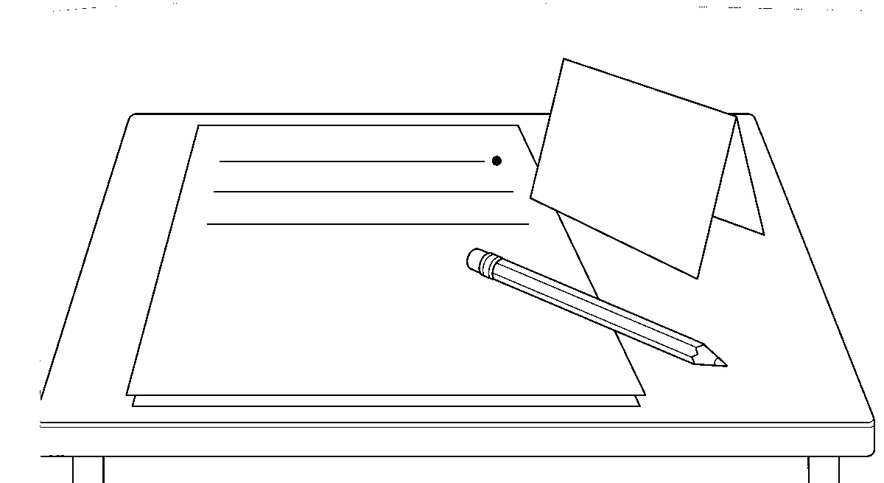

Worksheet
1. A sentence must A) make complete sense B) have ten words C) end in a question D) rhyme
2. Which is written correctly? A) The Cat is black B) The cat is black. C) the Cat is black. D) the cat is black
3. The full stop tells the reader to A) begin again B) breathe and stop C) erase D) shout
4. Which is NOT a sentence? A) We went home. B) The red bag. C) I can run. D) She is my friend.
5. Fill in: The first letter of a sentence is a ____ letter.
6. Write three sentences about your way to school, each with a big letter and a full stop.
7. Read one of your sentences aloud and say what the "who" and the "what" are in it.
My own work
Write five sentences on what you did yesterday, and read each one back checking the three rules with a pencil tick.
Draw one picture for the sentence you wrote best and colour it.

WEEK 9 — RHYMING WORDS AND WORD FAMILIES
Depth: NERDC Nursery 3 · Literacy (Letter Work) · Second Term W10 (pp 458–464).
You will learn to
• say what rhyming is and hear it in a word
• group words into families by their ending sound
• make up my own rhyme
• tell why rhyming helps me read
Things to know
• Two words rhyme when they sound the same at the end — the beginning is different: cat / hat, pen / ten.
• cat, bat, rat are one word family: they share the -at; the first letter changes, the tail sound stays.
• Rhyming is heard, not seen: boat and coat rhyme, but cat and cart do not — so say them aloud and listen.
• Families to sort into lines: -at (cat, hat, mat, rat, bat) · -en (pen, hen, ten, men) · -og (dog, log, fog, jog) · -ump (jump, bump, lump, stump) · -ight (light, night, fight, might) · -and (hand, sand, land, band).
• Find the odd one out: pin, tin, cup, win → cup (it is -up); map, nap, tap, hop → hop.
• Rhymes are inside our songs and poems: "Jack and Jill went up the hill / pail came tumbling down" — hill / will / still rhyme. And pail / tail / whale rhyme; the ending sound, not the spelling, is what matters.
• Play the rhyme chain: I say sun, you say bun, the next says run — the chain goes round the class and does not break.
• Making my own rhyme: take a name and match it — "Kemi, Kemi dreamy", "Ada with the paddle" — then every child makes one line, no matter how funny it sounds.
• Listening game: I say two words; if they rhyme, clap once; if not, keep the hands down — bed/red clap, bed/bag nothing.
• Why it matters: a child who hears that cat, hat, sat end the same way will read a new word -at word he has never seen — rhyming is how the eye learns to predict.
• Finish with the rhyme we chant and stamp: "This is the way we read our words, / read our words, read our words; / this is the way we read our words, / blend them all together!"
Words for my notebook
Rhyming words sound the same at the end: cat–hat, pen–ten, jump–bump, hand–sand.
Let us talk
1. What is rhyming?
2. Say three words that rhyme with "log".

3. Do "boat" and "coat" rhyme? Do "cat" and "cart"? Why?
4. Say one rhyme line you made yourself.
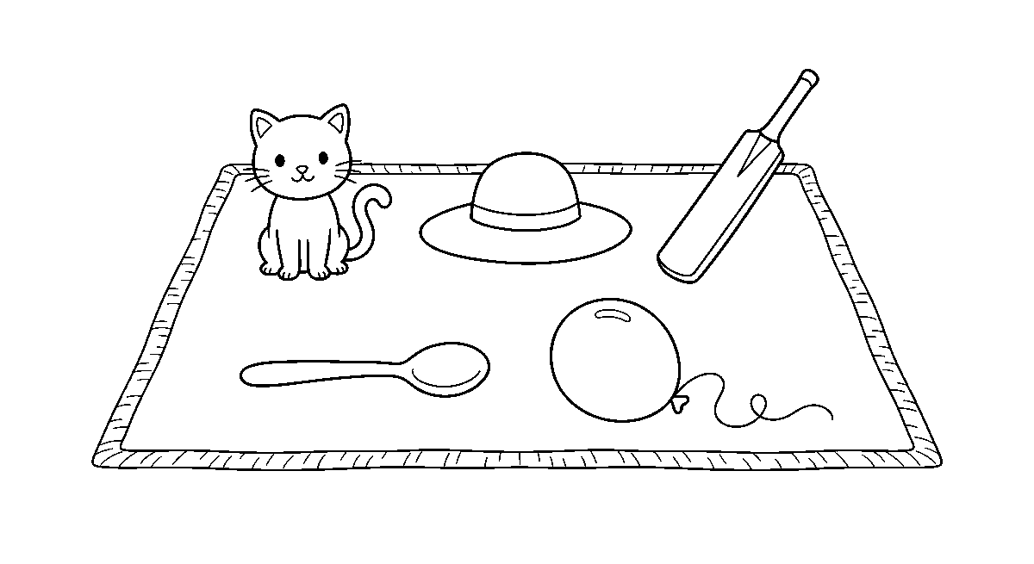
Worksheet
1. Words that rhyme A) sound the same at the end B) are sight words C) begin the same D) are long
2. Which word rhymes with "pen"? A) ten B) pin C) pan D) pit
3. cat, hat and sat belong to the word family A) -an B) -og C) -en D) -at
4. Which pair does NOT rhyme? A) hand/sand B) bed/bag C) boat/coat D) light/night
5. Fill in: jump, bump and lump all belong to the ____ family.
6. Write two lines of your own rhyme and put a line under the words that rhyme.
7. Say five words from the -og family and then five from the -and family.
My own work
Choose one word, find six words that rhyme with it, and write a two-line rhyme using three of them for a friend to read.
NUMERACY

WEEK 1 — WHOLE NUMBERS 1–99 (PART 1: 11–20)
Depth: NERDC Primary 1 · Mathematics · Second Term W1 (pp 620–621).
You will learn to
• count on from ten to twenty and back
• read, recognise and write the numbers 11 to 20
• say which digit is the tens and which is the ones
• put eleven numbers in order
Things to know
• Last term we counted to ten (1–10); this term the door opens to 11–20, and after it the numbers run on to 99.
• 11 is not "one one" said twice — it is one ten and one more; 12 is one ten and two; up to 19 = one ten and nine; then 20 = two tens with no one left over.
• Say it in English too: eleven, twelve, thirteen, fourteen, fifteen, sixteen, seventeen, eighteen, nineteen, twenty — thirteen and fifteen are the two we often spell wrong.
• Our bundle: ten sticks tied with a rubber = one ten. Eleven is one bundle and one loose stick.
• Place value: in 14, the 1 is the tens digit (it means ten) and the 4 is the ones digit (it means four single ones) — the same digit means a different thing by the place it sits in.
• Two columns on the table: Tens | Ones. Fourteen is written 1 under Tens and 4 under Ones; twenty is 2 under Tens and 0 under Ones.
• Zero (0) means "none in this place" — it is not nothing, it is a place-holder that keeps the 2 in the right column.
• Ordering: 11 < 12 < 13 … < 20. The next number is always one more; the previous is one less.
• Before 15 is 14; after 15 is 16; between 15 and 17 is 16.

• Writing the numerals: start at the top, go down in one stroke for 1, and round the belly of the number for 2 and 3; 11–19 are always two digits side by side, and 20 ends with 0.
• Counting game: eleven children stand; we count round them twice, then two more join and we say 13 without starting again from 1.
• Number hunt at home: 11 spoons, 12 bottle caps, 13 steps, 15 tiles, 20 beads on one string.
Words for my notebook
11 = 1 ten + 1 one · 14 = 1 ten + 4 ones · 20 = 2 tens + 0 ones. Tens | Ones.
Let us talk
1. Count from ten to twenty, then backwards.
2. In the number 17, which digit is the tens?
3. What comes before 19? What comes after 19?
4. How many loose sticks do you add to one bundle to make 13?
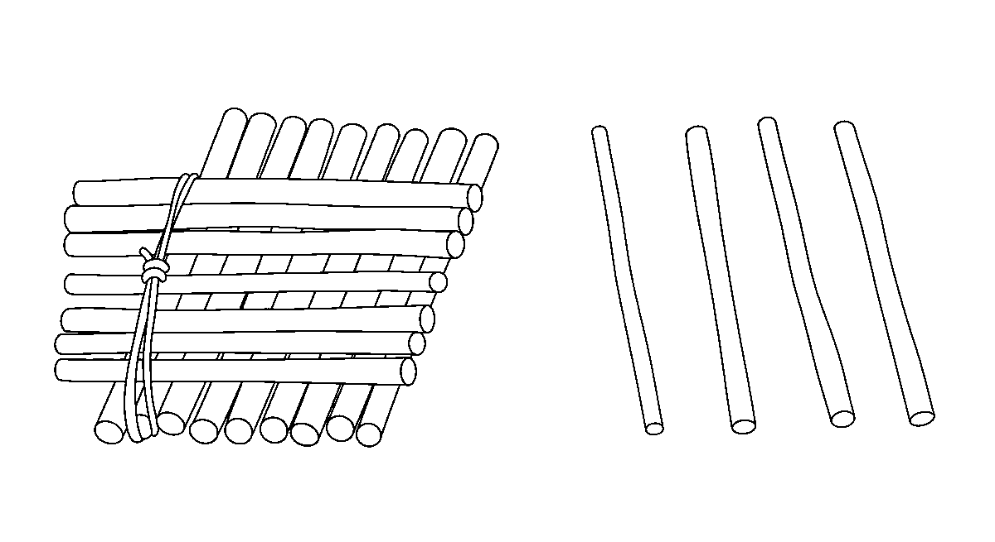
Worksheet
1. Eleven is the same as A) ten ones and ten B) one ten and one C) two tens D) one and one
2. In the number 16, the digit 1 stands for A) one B) sixteen C) ten D) six
3. The number that comes just before 20 is A) 11 B) 21 C) 18 D) 19
4. Two tens and no ones written as a numeral is A) 22 B) 20 C) 12 D) 2
5. Fill in: In 14, the ____ digit is 4.
6. Write the numbers 11 to 20 in order, then say which of them is one more than 15.
7. Show 17 with sticks: how many bundles of ten and how many loose sticks?
My own work
Collect twenty small things, tie ten into one bundle with a thread, and write how many are in the bundle and how many are loose.

WEEK 2 — WHOLE NUMBERS 1–99 (PART 2: 21–50)
Depth: NERDC Primary 1 · Mathematics · Second Term W2 (pp 620–621).
You will learn to
• count on from twenty to fifty
• skip count in tens up to fifty
• read and write the numbers 21 to 50
• compare two numbers within fifty
Things to know
• The twenties come next: 20, 21, 22 … 29, then 30 = three tens.
• After 29 the tens digit changes and the ones goes back to 0 — that is the hinge; the same happens at 39, 49 and every ten after.
• Skip counting by tens: 10, 20, 30, 40, 50 — the hand claps once on each ten, and the mouth says the ten only.
• Skip count by fives too: 5, 10, 15, 20, 25, 30, 35, 40, 45, 50 — one hand shows five fingers, so ten is two hands.
• Names to spell well: twenty-one, twenty-two, twenty-three, twenty-four, thirty, forty (not "fourty"), fifty.

• Place value with our bundle: 34 = three tens and four ones; 47 = four tens and seven ones; 50 = five tens and no ones.
• Patterns within 50: 2, 4, 6, 8, 10 … (the twos, jumping by two) · 1, 3, 5, 7, 9 … (the odds) · 5, 10, 15 … (the fives).
• Ordering: put 23, 32, 30, 22 in a line from the smallest — 22, 23, 30, 32; the tens digit decides first, and the ones only after.
• Comparing: 41 > 39 (forty-one is greater than thirty-nine) · 27 < 34 · 50 = 50; the open mouth of > and < faces the bigger number.
• Ten more and ten less: ten more than 26 is 36; ten less than 40 is 30 — the tens digit moves and the ones stays.
• On the number line 0–50, a jump of ten is one big step; a jump of one is a small step; 45 + 10 is one big step to the right.
Words for my notebook
10, 20, 30, 40, 50 · 34 = three tens and four ones · 41 > 39 · forty, not fourty.
Let us talk
1. Count in tens from ten to fifty, then backwards.
2. Which is bigger, 38 or 41? How do you know?
3. What number is ten more than 25?
4. Say the next three numbers after 39.
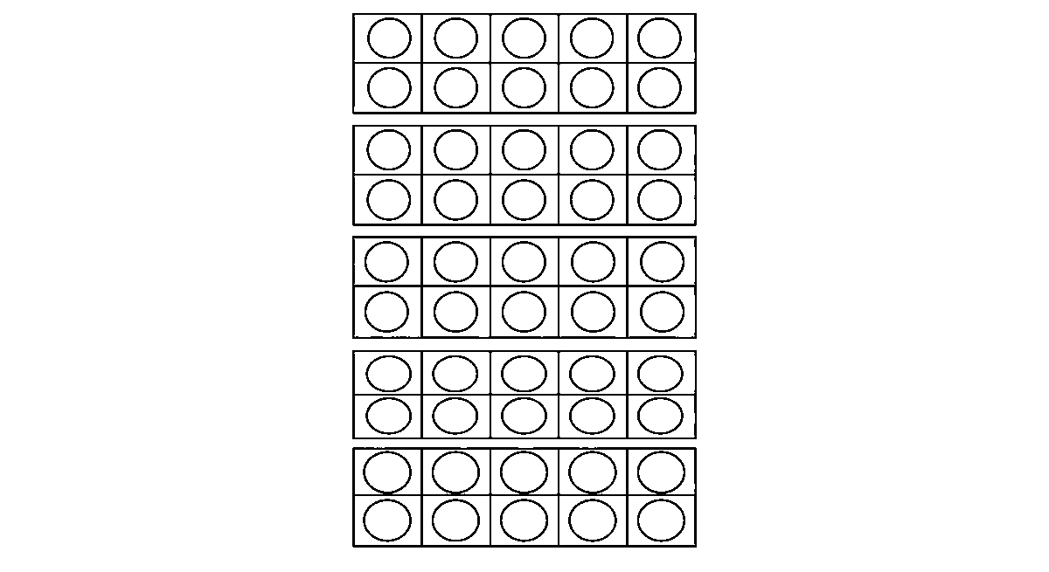
Worksheet
1. Skip counting by tens gives 10, 20, 30, ____ and 50. A) 40 B) 41 C) 35 D) 45
2. Forty-seven is made of A) seven tens and four ones B) forty and one C) four tens and seven ones D) four and seven
3. The correct sign for 27 ____ 34 is A) < B) > C) = D) +
4. Ten more than 36 is A) 26 B) 46 C) 63 D) 37
5. Fill in: The numeral for twenty-nine is ____.
6. Write these in order from the smallest: 44, 40, 39, 41.
7. Count in fives from 5 to 50 and write the six numbers that end in 5.
My own work
Draw a number line from 20 to 50 and mark 25, 30, 35 and 40 on it; then write one number between 30 and 35.

WEEK 3 — WHOLE NUMBERS 1–99 (PART 3: 51–99)
Depth: NERDC Primary 1 · Mathematics · Second Term W3 (pp 620–621).
You will learn to
• count on from fifty to ninety-nine
• skip count by tens up to ninety and beyond
• say the tens and the ones of any number to ninety-nine
• arrange numbers from 1 to 99 up and down
Things to know
• The fifties, sixties, seventies, eighties and nineties: 51 … 60 … 70 … 80 … 90 … 99.
• One hundred is the next door: 100 = ten tens — it is the first number with three digits (1, 0, 0).

• Skip counting by tens to 90: 10, 20, 30, 40, 50, 60, 70, 80, 90, and then 100.
• The tens names that trip the mouth: sixty, seventy, eighty, ninety — say thirteen/thirty, fifteen/fifty, sixteen/sixty and hear the difference.
• Place value in a three-place table: Tens | Ones for 51–99 — 63 has 6 tens and 3 ones; 88 has the same digit twice, but the first means eighty and the second means eight.
• Counting on from any number: from 74 say 75, 76, 77 … to 90 without going back to 1; counting back from 90 down to 51.
• Ascending order (smallest to largest): 31, 45, 58, 66, 72, 90 · Descending order (largest to smallest): 90, 72, 66, 58, 45, 31.
• How to order two numbers: look at the tens first; if they are the same, look at the ones — so 58 < 62, but 78 > 74.
• Before, after, between: the number after 89 is 90; before 100 is 99; between 60 and 62 is 61.
• Rounding to the nearest ten (first idea only): 63 is nearer 60 than 70; 68 is nearer 70 — say "about sixty", "about seventy".
• The hundred chart on the wall: ten numbers in a line, ten lines — move right = one more, move down = ten more.
Words for my notebook
51…99 · 100 = ten tens · 63 = six tens and three ones · ascending up, descending down.
Let us talk
1. Count in tens from ten to one hundred.
2. Which is bigger, 74 or 69? What did you look at first?
3. What number comes just before 90?
4. In 88, what does the first 8 mean?
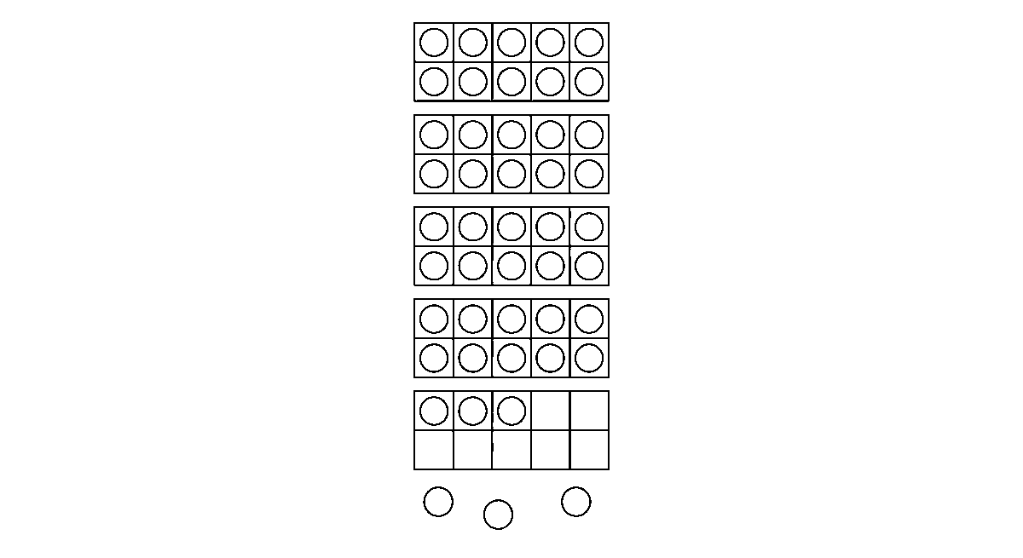
Worksheet
1. Eighty-six is written as A) 60 B) 86 C) 68 D) 18
2. The number just after 99 is A) 100 B) 109 C) 90 D) 98
3. Arrange from the largest: 45, 39, 61, 57 A) 61, 57, 45, 39 B) 39, 45, 57, 61 C) 57, 61, 45, 39 D) 45, 61, 39, 57
4. Seven tens and five ones make A) 12 B) 70 C) 75 D) 57
5. Fill in: 100 is the first number with ____ digits.
6. Write six numbers between 60 and 70 in ascending order.
7. Say the tens and the ones in 91 and in 48, and tell which is bigger.
My own work
Write your age, your class number, your father's or mother's shoe size and your house number as numerals; then put those four numbers in order from the smallest.
Draw thirty shells in rows of ten, then colour every row you can count.

WEEK 4 — ORDERING NUMBERS (QUANTITATIVE APTITUDE)
Depth: NERDC Primary 1 · Mathematics · Second Term W4 (pp 620–621).
You will learn to
• use the signs >, < and =
• put numbers in ascending and descending order

• say before, after and between
• read a number line from 0 to 99
Things to know
• Greater than ( > ) means the left side is bigger: 72 > 69.
• Less than ( < ) means the left side is smaller: 45 < 50.
• Equal to ( = ) means both sides are the same amount: 30 + 20 = 50.
• Trick for remembering: the sign is a crocodile's mouth and it always opens toward the bigger number — it wants the bigger one.
• Two numbers with the same number of digits: compare the left digit first (tens), then the right one (ones). 6 tens and 8 ones is more than 6 tens and 3 ones, so 68 > 63.
• Numbers with different digits: a two-digit number is always more than a one-digit number: 10 > 9.
• Ascending order = going up the stairs: 12, 24, 33, 41, 55 · descending = going down: 55, 41, 33, 24, 12.
• Ordering five numbers: circle the smallest first, put it down, then find the next smallest in what is left — one at a time, never all at once.
• Before = one less · after = one more · between = the number in the middle of two neighbours (between 39 and 41 is 40).
• The number line 0–99: ten jumps of ten reach one hundred; moving right adds, moving left takes away; 40 + 7 = 47 is four big jumps then seven small ones.
• Estimation (first idea): "about" a number — 48 sweets in a jar is about 50; the line we draw is never measured exactly, so we say "a little less than 50".
• Pattern questions in the aptitude part: what comes next in 5, 10, 15, 20, ___ (25)? in 90, 80, 70, ___ (60)? in 2, 4, 8, ___ (16, because we double).
Words for my notebook
68 > 63 · 45 < 50 · 30 + 20 = 50 · before, after, between · ascending goes up, descending comes down.
Let us talk
1. Which way does the crocodile mouth open?
2. Put 51, 15, 55 and 50 in order from the smallest.
3. What is between 69 and 71?
4. On the number line, where do you land from 30 if you jump two tens?
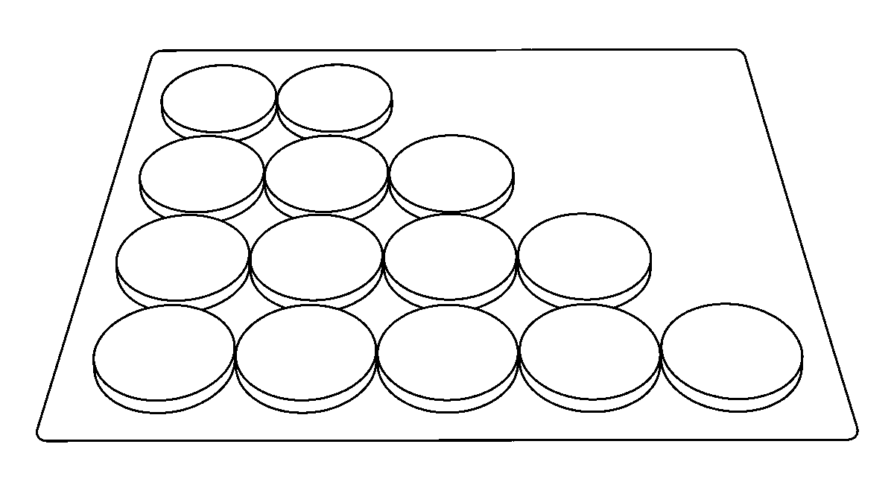
Worksheet
1. The correct sign for 39 ____ 41 is A) < B) = C) + D) >
2. 7 tens and 2 ones ____ 7 tens and 5 ones: A) < B) none C) > D) =
3. The number after 89 is A) 79 B) 100 C) 88 D) 90
4. In ascending order, which comes first: 44, 27, 39, 51? A) 44 B) 27 C) 39 D) 51
5. Fill in: The sign ____ means "greater than".
6. Arrange in descending order: 63, 36, 71, 40.
7. Use the number line to find 40 + 25 and write the jump you made.

My own work
Write five two-digit numbers on cards, put them in ascending order on the table, then turn them over and say the order from memory.

WEEK 5 — ADDITION AND SUBTRACTION (QUANTITATIVE APTITUDE, WITHIN 20)
Depth: NERDC Primary 1 · Mathematics · Second Term W7 (pp 620–621).
You will learn to
• add within 20 without regrouping
• take away within 20 without regrouping
• answer a word problem with two numbers in it
• do quick mental sums
Things to know
• Addition ( + ) means putting together; the answer is the sum: 7 + 5 = 12.
• Subtraction ( − ) means taking away or finding the difference: 12 − 5 = 7.
• Addition and subtraction are neighbours: if 7 + 5 = 12, then 12 − 5 = 7 and 12 − 7 = 5 — one fact gives three.
• No regrouping this term: the ones are added to the ones and the tens to the tens — 12 + 5: 2 ones + 5 ones = 7 ones, and the 1 ten stays, so 17.
• Do it with the sticks: 12 = one bundle and two loose; add 5 loose ones → one bundle and seven loose = 17.
• Counting on is the fast way for small numbers: 13 + 4 → say 13 and count on 14, 15, 16, 17.
• Counting back for taking away: 17 − 5 → start at 17 and go back 5 jumps → 12.
• Use the ten-frame (a box of ten): 8 + 5 → fill the frame with 8, add 5; the frame takes 2 and 3 are left over → one full ten and 3 = 13.
• Word problems: to find the total we add (9 oranges + 6 oranges = ?); to find what is left we subtract (15 beads − 7 given away = ?). To find how many more we subtract (Ade has 8, I have 5, he has 3 more).
• Read a word problem twice: first for the story, second for the numbers and the word that tells the work ("altogether", "left", "more than", "each").
• Mental maths to be quick at: 10 + 8 · 20 − 6 · 9 + 9 · 15 − 5 · double 6 · half of 12 · 7 + 3 + 2.
• Real life: the market (₦10 + ₦5 = ₦15 for two things), the bus (12 seats, 4 get off, 8 remain), my family (5 at home + 3 coming back = 8 for the meal).
Words for my notebook
7 + 5 = 12 · 12 − 5 = 7 · "altogether" = add, "left" = take away.
Let us talk
1. What is 9 + 6? Say how you got it.
2. If 8 + 7 = 15, what is 15 − 8?
3. Which sum does "altogether" tell you to do?
4. Say three pairs of numbers that make 12.
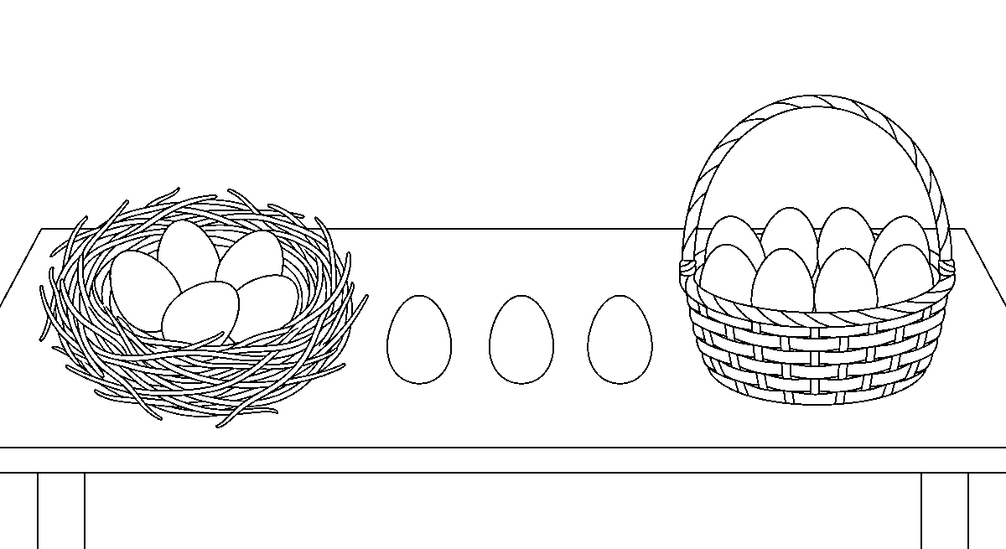

Worksheet
1. 6 + 7 = A) 12 B) 11 C) 14 D) 13
2. 18 − 5 = A) 15 B) 23 C) 13 D) 12
3. If 9 + 4 = 13, then 13 − 9 = A) 9 B) 3 C) 13 D) 4
4. Ten more than 8 is A) 10 B) 12 C) 80 D) 18
5. Fill in: To find what is left, we use ____.
6. There are 11 oranges and 6 bananas. How many fruits altogether?
7. Ada had 17 kolanuts and gave 6 away. Write the subtraction and the answer.
My own work
Write two word problems from your own morning at home (one for adding, one for taking away), solve both, and show the sticks or fingers you used.
Draw nine stones and take four away; colour the stones that are left.

WEEK 6 — OPEN SENTENCES (1)
Depth: NERDC Primary 1 · Mathematics · Second Term W8 (pp 620–621).
You will learn to
• find the missing number in an addition sentence
• use objects to hunt for the missing addend
• fill the gap in a number sentence within 10 and within 20
• check my answer by putting it back
Things to know
• A number sentence is maths written with numbers and signs: 3 + 4 = 7.
• An open sentence has a gap in it — a box □, a bracket ( ), or a blank line — and the gap is a number we must find: 3 + □ = 5.
• The box is a question: "what number goes here to make the sentence true?"
• Find it with objects: put 3 stones down; add stones one by one until you have 5; you added 2, so □ = 2.
• Find it by counting on: 3 + □ = 5 → count on from 3 to 5 → 2.
• Find it by the neighbour fact: 5 − 3 = 2, so 3 + 2 = 5.
• Sentences to fill within 10: 4 + □ = 9 · □ + 6 = 10 · 2 + □ = 8 · 7 = □ + 5 (the box can be on either side — it is the same question).
• Sentences within 20: 11 + □ = 15 · □ + 7 = 13 · 10 = □ + 4 · 18 = 12 + □.
• Check your answer: put the number you found back into the box and read the sentence — if it is true, the answer is right; if not, do not rub it out in a hurry, count again.
• Two boxes at once are possible: □ + □ = 8 has more than one answer (4 + 4, 5 + 3, 6 + 2…) — we say "one answer is", not "the only answer is".
• The equals sign means the same on both sides, not "the answer comes now": 5 + 3 = 4 + 4 is true, and the class always likes that one.
• Oral drill to keep quick: "3 and how many make 7?" — "3 and 4 make 7!"
Words for my notebook
3 + □ = 5, and □ = 2 because 5 − 3 = 2. The box asks: what number goes here?
Let us talk
1. What is the missing number in 6 + □ = 10?
2. How did you find it — counting on, objects, or subtracting?
3. Is 5 + 3 = 4 + 4 true? How do you know?
4. Make an open sentence with the answer 7 in it.

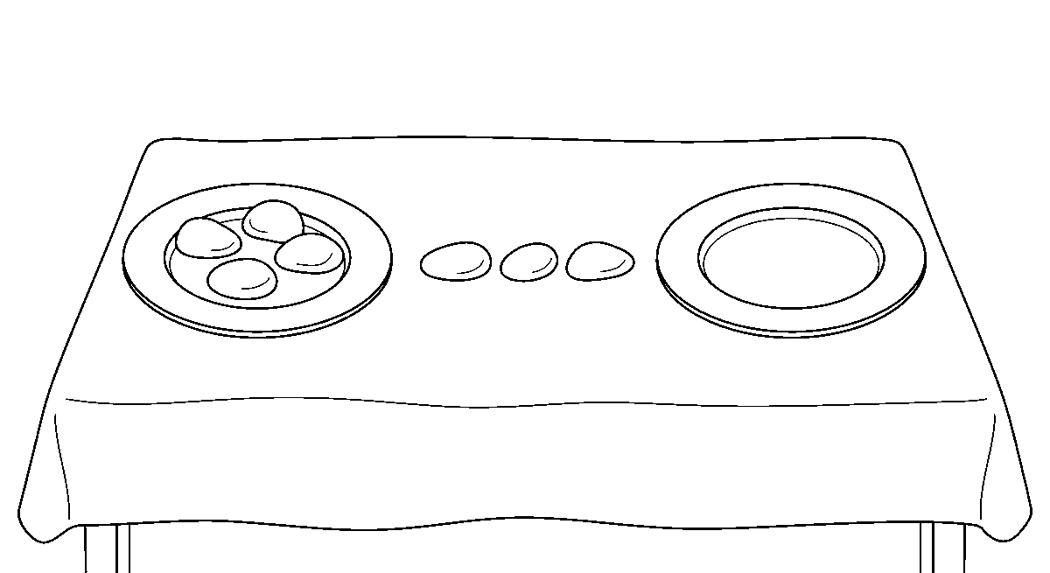
Worksheet
1. In 2 + □ = 6, the box is A) 6 B) 3 C) 4 D) 8
2. In □ + 5 = 12, the box is A) 5 B) 6 C) 17 D) 7
3. Which sentence is true? A) 5 + 5 = 10 B) 3 + 4 = 8 C) 6 + 2 = 9 D) 4 + 3 = 9
4. In 10 = □ + 4, the box is A) 4 B) 14 C) 6 D) 10
5. Fill in: 7 + ____ = 13.
6. Write two open sentences whose missing number is 5.
7. Fill the box and check: 9 + □ = 14.
My own work
Write five open sentences for a friend to solve, with the answers 2, 4, 6, 8 and 10 hidden in the boxes; then swap and solve your friend's five.
Draw an empty box for the missing number, write a number in it and colour the box.

WEEK 8 — OPEN SENTENCES (2)
Depth: NERDC Primary 1 · Mathematics · Second Term W9 (pp 620–621).
You will learn to
• find the missing number in a subtraction sentence
• tell the difference between the two kinds of gap
• mix addition and subtraction gaps in one page
• solve a problem that hides one number
Things to know
• A subtraction open sentence: 5 − □ = 2 — the box is what was taken away.
• The other kind: □ − 4 = 6 — the box is the number we started with; to find it we go back up with addition: 6 + 4 = 10, so □ = 10.
• Rule of thumb: gap after the sign → subtract; gap before the sign → add — 9 − □ = 5 (9 − 5 = 4) · □ − 5 = 4 (4 + 5 = 9).
• Do it with stones: 9 stones, hide some under a cup, 5 are left → the cup has 4.
• More within 20: 14 − □ = 9 (5) · □ − 6 = 8 (14) · 17 − 8 = □ (9) · □ − 9 = 5 (14).
• Mixed practice on one page — read the sign before you put in the number. 8 − □ = 3 and 8 + □ = 3 are not the same question (the second cannot be answered with counting numbers, and that is a good thing to notice).
• Three-number sentences: 10 − □ + 3 = 10 → work it both ways and find □ = 3.
• Problem solving: "There were 16 pupils in the class; some went out to fetch water and 9 remained. How many went out?" → 16 − □ = 9, so 7 went out.
• Checking is always the same: put the number back into the sentence and read it — 16 − 7 = 9 is true.
• Keep the two neighbour facts: if 8 + 6 = 14 then 14 − 6 = 8 and 14 − 8 = 6; a page of open sentences is easy when you know the addition.
• Speed drill (mental): 12 − □ = 5 · 15 − □ = 6 · □ − 7 = 8 · □ − 4 = 11 — say the answer, do not write it.

Words for my notebook
5 − □ = 2 → □ = 3. □ − 4 = 6 → □ = 10. Gap after the sign: subtract; gap before it: add.
Let us talk
1. What number makes 11 − □ = 4 true?
2. How is □ − 4 = 6 different from 6 − □ = 4?
3. What is the first thing to look at in an open sentence?
4. Tell a one-line story that fits 15 − 6 = 9.
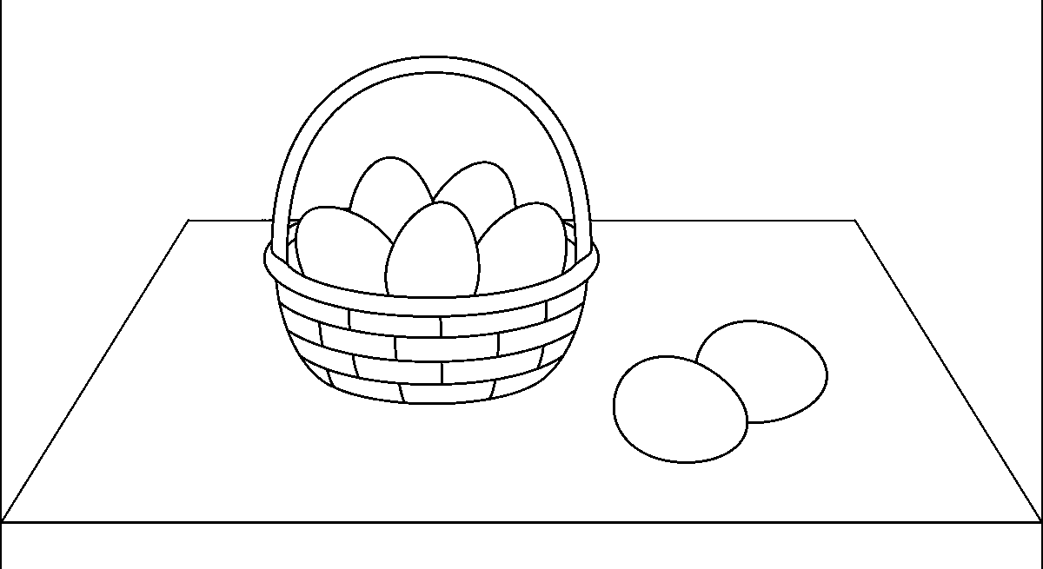
Worksheet
1. In 9 − □ = 4, the box is A) 9 B) 13 C) 4 D) 5
2. In □ − 3 = 7, the box is A) 21 B) 10 C) 7 D) 4
3. In 14 − □ = 6, the box is A) 20 B) 8 C) 14 D) 6
4. Which sentence needs addition to find the box? A) □ − 5 = 4 B) 10 − □ = 2 C) 9 − □ = 3 D) 12 − □ = 7
5. Fill in: □ − 8 = 6, so the box is ____.
6. There were 17 eggs; some broke and 8 remained. Write the open sentence and answer it.
7. Make two open sentences with the answer 6 in them — one for adding, one for taking away.
My own work
Write five open sentences on the back of your exercise (two with the gap at the front, three with the gap at the back), solve them, and check every one by putting the number back.
Draw two plates with stones on them and colour the plate that makes your sentence true.

WEEK 9 — MONEY (INTRODUCTION)
Depth: NERDC Primary 1 · Mathematics · Second Term W10 (pp 620–621), with the value of the naira as it stands in Nigeria in 2026.
You will learn to
• name the coins and notes of Nigeria
• say how much each is worth
• count money up to ₦50
• buy and sell in the market game without change mistakes
Things to know
• Our money is the naira, written with the sign ₦; its small part is the kobo (100 kobo = ₦1).
• Coins the scheme begins us with: ₦1 and ₦2 — round, metal, they ring on the table; the ₦1 and ₦2 coins are still our money, but they are not seen every day now.
• The coins a child is most likely to hold today are ₦50, ₦100 and ₦200 coins; the notes are ₦5, ₦10, ₦20, ₦50, ₦100, ₦200, ₦500 and ₦1000.
• In 2026 the Central Bank said again that the small notes (₦5, ₦10, ₦20, ₦50, ₦100) are still legal money — you may not see them often because traders do not keep many, not because they are wrong money.
• Look at a note: it has the number and the words ("five naira"), a colour of its own, the face of a Nigerian on it, and the ₦ sign; the bigger the number, the more it can buy.

• Values to know in order: ₦5 < ₦10 < ₦20 < ₦50 < ₦100.
• Counting money: ₦5 + ₦5 + ₦5 + ₦5 + ₦5 + ₦5 + ₦5 + ₦5 + ₦5 + ₦5 = ₦50 (ten fives) · ₦20 + ₦20 + ₦10 = ₦50 · ₦10 + ₦10 + ₦5 + ₦5 + ₦2 + ₦2 + ₦1 + ₦1 + ₦1 = ₦50 in small pieces.
• Skip counting is the fast way with money: count fives — 5, 10, 15, 20 … ; count tens — 10, 20, 30, 40, 50.
• Buying and selling: the price of the thing first, then the money given, then what comes back (change) — if a biscuit is ₦10 and I give ₦50, I get ₦40 back.
• Market game: one child is the seller with the price card; the buyer must pay the exact money first, then pay with a bigger note and take change.
• Care of money: notes are not folded into a ball, not written on, not put in water. Coins are not swallowed and not pushed into a slot that is not for them; money is kept in a purse or a tin with a lid.
• Saving (the first idea): what is left goes into the tin — the tin that is filled a little every week is heavier than the hand that spends all at once; a five-naira note saved is still five naira.
Words for my notebook
Our money is the naira (₦). ₦1, ₦2 coins · ₦5, ₦10, ₦20, ₦50 notes. ₦20 + ₦20 + ₦10 = ₦50. Price − money given = change.
Let us talk
1. What is our money called, and what sign is written on it?
2. Which is worth more, a ₦10 or a ₦20 note? How can you tell?
3. If a sweet is ₦5 and you pay with ₦20, how much comes back?
4. What should we never do to a note?
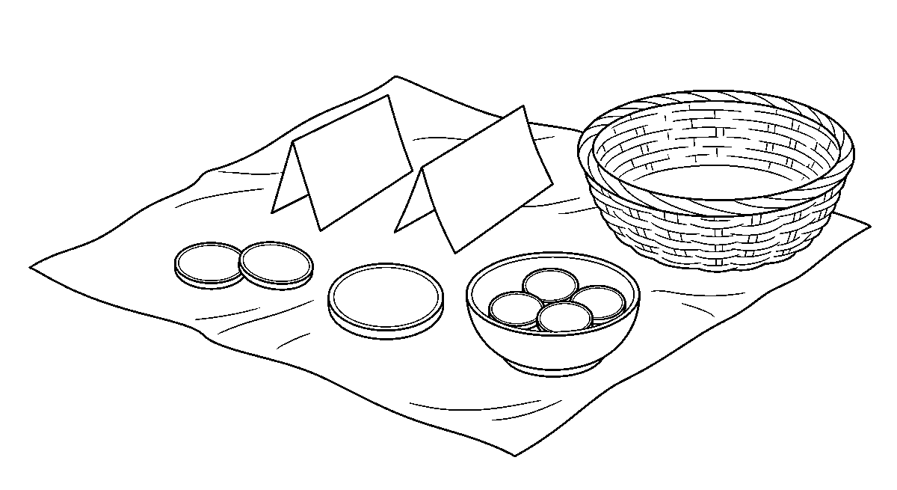
Worksheet
1. Our money in Nigeria is called the A) naira B) franc C) shilling D) cedi
2. The sign written for naira is A) ¢ B) ₦ C) $ D) £
3. ₦20 + ₦20 + ₦10 is A) ₦30 B) ₦50 C) ₦60 D) ₦40
4. A biscuit costs ₦10 and you give ₦50. Your change is A) ₦40 B) ₦60 C) ₦10 D) ₦50
5. Fill in: Ten five-naira notes make ____ naira.
6. Name four notes of Nigeria from the smallest to the bigger, and two coins.
7. Write two sentences on something you would buy with ₦50 and how you would pay for it.
My own work
Set out the coins and notes in your purse or a family tin, write each value you find, and add up how much the ₦5 and ₦10 notes make together.

GENERAL KNOWLEDGE
Weeks 1 to 6, 8 and 9. Week 7 is Mid-Term Break, Week 10 Revision, Week 11 Examination, Week 12 Closing — those weeks carry no note. Term theme: My Community & My Country — Nigeria. This subject is school-generated — there is no NERDC scheme for it — so each week's extent is the school's own `Breakdown (Subtopics)` list, reproduced line for line as bullets below.

WEEK 1 — PEOPLE IN MY COMMUNITY: OUR HELPERS
Depth: school-generated — the school's own subtopic list for N2 S2 W1.
You will learn to
• name the helpers of my community and what each one does
• say where each helper works
• tell why each helper is important to me
• say thank you to a helper in words and in behaviour
Things to know
• Helpers in my community: doctor, nurse, teacher, police officer, firefighter, tailor, farmer, and beside them the driver, cleaner, water-seller, shopkeeper, mason, barber, welder, midwife.
• What each one does: the doctor treats the sick · the nurse gives the medicine and cleans the wound · the teacher teaches reading, counting and good manners · the police officer keeps us from thieves and stops the road · the firefighter puts out fire · the tailor sews our cloth · the farmer grows the food we eat.
• Where they work: doctor and nurse at the hospital or the clinic · teacher at the school · police officer at the police station or on the road · firefighter at the fire station with the red engine · tailor at the sewing shop by the market · farmer on the farm.
• Why they matter: if the farmer stops, the market is empty; if the nurse stops, the sick have no help; if the police stops, the road is not safe.
• How we say thank you to helpers: greet them, say "Ẹ̀ ṣé" / "thank you", do what they ask, keep the place clean they swept, do not waste what they made, and never spoil their tools.
• Our community helpers song: "Doctor, nurse and teacher too, / police officer and farmer who feeds me — / thank you. Thank you, all of you, / you work for me, I work for you!" — one line for each helper, with a hand action.
• Role play: one child wears the coat, one carries the bag, one holds the ruler; the rest must guess the helper and ask one question — "What do you do when a child falls?"
• A helper who visits the class is a lesson: the nurse shows how to wash hands, the tailor shows a needle and a tape, the farmer brings two yams and a handful of rice in the pod.
• What I must ask of myself: a helper is not a servant; and one day I shall be one of these people.
Words for my notebook
Doctor — hospital. Teacher — school. Police — police station. Farmer — farm. We thank helpers by working with them, not by spoiling their things.
Let us talk
1. Which helper did you see this week, and what was he doing?
2. Where does a nurse work?
3. What would happen if the cleaners did not come?
4. How do you thank a helper?
Worksheet
1. The helper who treats sick people is the A) farmer B) tailor C) driver D) doctor
2. A teacher works at the A) clinic only B) fire station C) farm D) school
3. The farmer is important because he A) drives the bus B) grows our food C) stops the road D) sews cloth
4. We thank a helper by A) spoiling his tools B) hiding C) greeting him and keeping the place clean D) running from him

5. Fill in: The police officer works at the police ____.
6. Name five helpers in our community and where each one works.
7. Write two sentences on one helper who helped you or your family.
My own work
Draw three helpers and write under each what he or she does; then greet one helper you meet tomorrow and say what you said.

WEEK 2 — MY COUNTRY — NIGERIA (INTRODUCTION)
Depth: school-generated — the school's own subtopic list for N2 S2 W2.
You will learn to
• say that my country is Nigeria and that I am a Nigerian
• name the colours of the flag and what they mean
• point to our country on a picture
• know our money is the Naira
Things to know
• My country's name is Nigeria; my state is Lagos (or the state written on my bag), and the country is made of 36 states and the FCT.
• Saying it out loud: "My name is ____. I am a Nigerian." — a name and a country are the two things I carry first.
• The Nigerian flag is green — white — green, two green bands with a white band in the middle, and it flies at the school gate on Monday.
• What the colours mean (the first idea): green is for our farms and land (the trees, the yam, the rice) and white is for peace — peace in the middle, holding the two sides together.
• How to hold a flag: it is never dragged, never on the ground, never used as a cloth; it goes up the pole slowly and comes down without flipping.
• Nigeria on the map: our country is big — it sits in West Africa, next to Benin Republic, Niger, Chad and Cameroon. And the sea is at its bottom; from Lagos to the far north is more than a day in a bus.
• Our capital city is Abuja; our biggest city, where we are, is Lagos.
• Our money is the Naira, written ₦; we use coins (₦½, ₦1, ₦2) and notes (₦5, ₦10, ₦20, ₦50, ₦100 and above); on the notes are our own faces and our own things.
• Our languages: English is the language of the school; Hausa, Igbo and Yoruba are the big languages of the people, and there are more than 250 other languages.
• Our motto is "Unity and Faith, Peace and Progress"; our anthem begins "Arise, O compatriots".
• The song of the week — "One Nigeria": "One Nigeria, one people, / one flag and one song; / thirty-six states, many tongues, / to you, my country, I belong."
• Colouring the flag: two green sides, one white middle, no other colour; the top line is straight like the gate.
Words for my notebook
Nigeria · Abuja · green-white-green · Naira (₦) · "Arise, O compatriots" · I am a Nigerian.
Let us talk
1. What is your country's name?
2. What do the green and the white on our flag mean?
3. What is our money called, and what sign is written on it?
4. Which city is the capital, and which city do we live in?
Worksheet
1. The colours of the Nigerian flag are A) white-green-blue B) green-white-green C) green-yellow-red D) red-white-green
2. The white on our flag stands for A) peace B) water C) farms D) money
3. Our money is called the A) dirham B) Naira C) cedi D) shilling
4. The capital city of Nigeria is A) Abuja B) Ibadan C) Lagos D) Kano

5. Fill in: "Arise, O ____" is the first line of our anthem.
6. Name the three big languages of Nigeria and the language of our school.
7. Write two sentences on Nigeria as a big country and where we are in it.
My own work
Colour a flag of your own drawing: two green bands, one white band, and under it write "My country is Nigeria."

WEEK 3 — NIGERIAN FOOD, CLOTHES AND FESTIVALS
Depth: school-generated — the school's own subtopic list for N2 S2 W3.
You will learn to
• name the foods of Nigeria and the dishes they become
• tell the clothes we wear, everyday and traditional
• name the festivals we celebrate and what happens at them
• share food and say what music and dance do at a festival
Things to know
• Foods we grow and eat: rice, yam, beans, plantain, cassava, maize, groundnut and the fruits orange, mango, banana, watermelon, pineapple, agbalumọ̀.
• Nigerian dishes: jollof rice, fried rice, coconut rice, pounded yam, eba, amala, tuwo, akara, moi-moi, egg soup, vegetable (ewédú) soup, egusi soup, pepper soup, suya, kosai, pap and bread.
• Where food begins: the farm, then the market, then the cooking pot — rice comes from a paddy, yam from a mound, garri from cassava pressed and roasted.
• Clothes for every day: school uniform, T-shirt and shorts, dress and slippers, sandals; the clothes must be clean and matched, not torn.
• Traditional clothes: ankara (the printed cloth), lace (the fine see-through cloth), buba and wrapper, iro and gele, agbada (the big flowing robe), kaftan and trousers with a fila cap, isiagu (the lion-head cloth of the east).
• When we wear them: a wedding, a naming ceremony, a festival, church or mosque on a feast day, the last day of term.
• Festivals we celebrate: Christmas (the birth of Christ — new cloth, church, food for all), Eid-el-Fitr and Eid-el-Kabir (Sallah) (after the fast. And at the rams — meat shared with the neighbour), New Year, birthdays, and the big cultural days: Egungun, Osun-Osogbo, Durbar, the New Yam festival, Eyo.
• At every festival there is music and dance: talking drum (gángan), dùndún, bàtá, udu (clay pot), ogene (metal gong), flute, shaker; the drum talks because the drummer copies the rise and fall of Yoruba words.
• Sharing food with neighbours is the law of a festival: the plate that goes next door comes back with food in it; a family that eats alone is a family that has forgotten the festival.
• Show and tell: I bring or describe my favourite food, and I come in the cloth of my father's people while the class asks two questions.
Words for my notebook
Jollof rice, pounded yam, eba, amala, akara, moi-moi. Ankara, lace, agbada, iro and gele, kaftan. Christmas, Sallah, New Yam, birthdays.
Let us talk
1. What is your favourite Nigerian food, and what is it made from?
2. Name a cloth of your people and when you wear it.
3. What happens at your favourite festival?
4. Why do we carry food to the neighbour on a feast day?
Worksheet
1. Amala and eba are both made from A) rice B) palm oil C) beans D) yam and cassava
2. The big flowing robe worn by men on feast days is the A) gele B) ankara C) buba D) agbada

3. The meal after the Muslim fast is A) Eid-el-Fitr B) Easter C) New Yam D) Christmas
4. At a festival the talking thing is usually the A) plate B) broom C) hoe D) drum
5. Fill in: The printed Nigerian cloth with many bright patterns is called ____.
6. Mention four foods of Nigeria and three clothes we wear on special days.
7. Write two sentences on the food and the cloth of your own best festival.
My own work
Write the name of one Nigerian food and one Nigerian cloth; then, with somebody at home, name one thing you both do at the next festival.

WEEK 4 — OUR WEATHER AND SEASONS
Depth: school-generated — the school's own subtopic list for N2 S2 W4.
You will learn to
• name the kinds of day by the look of the sky
• tell the rainy season from the dry season in Nigeria
• choose clothes for the weather
• keep the class weather chart for a week
Things to know
• A day is sunny (the sun is out, the sky clear, the ground hot), cloudy (the sky is covered, the sun hides), rainy (water falls from the cloud), windy (the air moves and the trees bend).
• Weather is what the sky is doing today; season is the weather that comes again at the same time each year.
• Nigeria has two big seasons: the rainy season (about April to October — water from the sky, farms green, rivers full. Mosquitoes many) and the dry season (about November to March — no rain, dust, the sun is hard, the harmattan blows).
• The harmattan is the dry wind that comes from the Sahara in December to February: mornings are cool, the air is dusty and hazy, the sky looks white and thin, lips and hands crack. And the mornings may need a sweater though noon is hot.
• Words for the day: hot (harmattan noon, March sun), warm (a cloudy day), cold/cool (a harmattan morning, rain at night), humid (the air feels wet before rain).
• Clothes for each weather: sun — hat, light cotton, sandals; rain — umbrella, rain coat, gum boots, a plastic bag on the bag. harmattan dust — a light shawl or sweater, nose and hands washed often; wind — nothing loose to carry away.
• Weather tells us what to wear before we dress; the sky tells us whether to bring a bag for books or a bucket for water.
• The class weather chart: seven columns (Monday to Sunday), and each day one box is coloured — sun, cloud, rain, wind — with the count of how hot: "họ́t", "cool", "cold" — one word under the picture.
• Our weather song: "Sun in the morning, rain in the night, / harmattan dust and a cool, cool light; / umbrella or sweater, hat or a shawl — / the sky tells me what to wear, after all."
• What weather can do to us: rain can flood a street, wind can carry a roof, the sun can burn the head. So we do not play in the storm, we do not stand under a lone tree when there is lightning, and we drink water when we work in the sun.
Words for my notebook
Sunny · cloudy · rainy · windy. Rainy season (April–October) and dry season (November–March); the harmattan is cool, dusty and hazy.
Let us talk
1. What was the sky doing this morning?
2. Which season are we in now, and how can you tell?
3. What clothes do you wear on a rainy morning?
4. What does the harmattan do to your hands and lips?

Worksheet
1. A day with water falling from the cloud is a ____ day. A) rainy B) windy C) dusty D) sunny
2. In Nigeria the rainy season is about A) December only B) June to July only C) one month D) April to October
3. The harmattan makes the air A) hot and rainy B) dry, dusty and cool C) dark all day D) wet and sticky
4. On a rainy morning we carry A) a sweater only B) a fan C) a bucket of sand D) an umbrella
5. Fill in: Weather is what the sky is doing ____, and a season is weather that comes back each year.
6. Name the two seasons in Nigeria and one thing each does to our body or our house.
7. Write two sentences on your class weather chart for the week.
My own work
Fill one week of a weather chart of your own: each morning look at the sky, draw sun, cloud, rain or wind, and write the one word for how the morning felt.

WEEK 5 — PLANTS AROUND ME
Depth: school-generated — the school's own subtopic list for N2 S2 W5.
You will learn to
• name the plants in my environment
• say the four parts of a plant and what each does
• name the fruits and vegetables I eat
• water a plant and watch it grow
Things to know
• Plants in my environment: trees (mango, iroko, oil palm, neem, flame tree), flowers (hibiscus, rose), grass (the lawn and the roadside), vegetables (ugu, waterleaf, spinach, tomatoes, pepper).
• A plant is not only big things: the small green thing at the wall's foot is a plant too, and it has all four parts.
• The four parts to name: root, stem, leaf, flower (and then the fruit and the seed).
• What each part does: the root holds the plant in the ground and drinks water from the soil · the stem carries water up and holds the plant up · the leaf catches sunlight and makes the plant's food · the flower becomes the fruit, and the fruit keeps the seed.
• Where the new plant hides: inside the seed — one seed, one plant; that is why the fruit is a box.
• Fruits I eat: orange, mango, banana, watermelon, pineapple, agbalumọ̀ (sweetsop), avocado · Vegetables I eat: tomato, pepper, ugu, waterleaf, spinach, carrots, onions.
• What plants give us: food (fruit, yam, leaves), shade (the tree at the gate), fresh air (the leaf takes the bad air and gives the good one we breathe), medicine (neem leaf), wood, cloth, and beauty.
• Care of a plant: water it in the cool of the morning, do not break the young stem, do not burn the grass round it, do not tie a rope to cut the bark. And pull the weeds beside it, not the plant.
• Planting in class: a bean seed in a tin of soil, one cup of water, a place with light; we draw the tin on Monday and again a week later.
• What to watch for: first the soil lifts, then a green loop comes up, then two leaves, then more — and each day the pot is heavier than the day before because the root is going down.
• Plants and weather: in the rainy season everything greens; in the dry season the grass goes yellow and the tree drops its leaves to keep its water.
Words for my notebook
Root, stem, leaf, flower, fruit, seed. The root drinks, the stem carries, the leaf makes food, the seed makes a new plant.

Let us talk
1. Name four plants you saw on the way to school.
2. Which part of the plant drinks the water?
3. What does a flower become?
4. When is the best time to water a plant?
Worksheet
1. The part of a plant that holds it in the soil and drinks water is the A) fruit B) leaf C) root D) flower
2. The part that catches sunlight to make food is the A) seed B) leaf C) stem D) root
3. Inside a fruit we usually find the A) water only B) stone only C) root D) seed
4. Which of these is a vegetable? A) banana B) mango C) orange D) ugu
5. Fill in: The flower of a plant becomes the ____.
6. Mention the four parts of a plant and what each one does.
7. Write two sentences on the seed you planted and what happened to it.
My own work
Keep your tin plant for one week: water it in the morning, count the leaves on Friday and write how tall it is by the matchbox.

WEEK 6 — MY SENSES AND SIMPLE SAFETY
Depth: school-generated — the school's own subtopic list for N2 S2 W6.
You will learn to
• name the five senses and the organ of each
• use the senses to know a thing safely
• keep away from the dangers of the home
• cross the road the right way and know the stranger rule
Things to know
• The five senses and their organs: sight — eyes · hearing — ears · smell — nose · taste — tongue · touch/feel — skin (hands).
• What each tells me: the eye tells colour and shape; the ear tells sound and direction; the nose tells smell (a good soup, a gas leak). The tongue tells taste — sweet, sour, bitter, salty; the skin tells hot, cold, rough, smooth, sharp, pain.
• The senses warn us: a smell of smoke tells us to run, a hot cup tells the hand to let go, a bad smell on milk tells us not to drink it.
• Never test a thing with the wrong sense first: do not taste or smell an unknown powder; look, then ask — the nose can be burned by acid fumes.
• Care of the senses: no sharp thing in the ear, no staring at the sun, no loud sound near the ear, eyes kept an arm's length from a screen, hands washed before eating.
• Safety at home — the four dangers of a child: fire (matches, kerosene stove, burning coal), hot water (the pot on the floor. The bath mixed with cold first), sharp objects (knife, cutlass, broken glass, razor, nail), medicines (a pill that looks like a sweet is not a sweet).
• Home rules: matches are left where they are, not picked up; nothing is touched on the cooking table. A broken glass is reported and swept by a grown-up, not held in the hand; medicine is taken only when it is given, never from the shelf.
• Road safety: hold a grown-up's hand, not the finger; stop at the kerb; look left, right, left again; listen for the engine. Cross at the bridge (footbridge) or the zebra corner; never run across and never chase a ball into the road.
• Stranger danger: never follow a stranger, never take gifts, sweets or a ride, never go into a stranger's room or car, shout "help!" loudly if somebody holds you. And tell somebody the same hour about anything a grown-up asked you to keep secret.

• The safe and unsafe picture game: a green card for safe, a red card for unsafe — the hand on the pot is red. The grown-up's hand held is green, the sweet from a stranger is red, the crossing at the bridge is green.
• Safety songs and the class poster: our own poster has four pictures and four rules, and it is put on the door so the whole school sees it.
Words for my notebook
Eyes see, ears hear, nose smells, tongue tastes, skin feels. Red card = danger: fire, hot water, sharp things, medicine, strangers.
Let us talk
1. Which sense tells you that milk has turned?
2. Why must you not taste an unknown powder?
3. What are the four dangers of the home?
4. Show me how you look before you cross the road.
Worksheet
1. The organ of hearing is the A) skin B) ear C) nose D) tongue
2. Before we cross the road we should A) close our eyes B) run C) look left, right and left again D) shout
3. A stranger gives you a sweet and asks you to come with him. You should A) take the sweet and look back B) thank him quietly C) go with him D) refuse, shout and tell
4. A broken glass on the floor should be A) left for the next person B) picked up with the hand C) kicked aside D) reported so that a grown-up sweeps it
5. Fill in: The sense of taste is in the ____.
6. Mention the five senses with the organ of each.
7. Write two sentences on one safety rule you will keep this week.
My own work
Look round your house and write two safe things and two unsafe things you can see; put a tick beside the one you will move or report.

WEEK 8 — NIGERIAN ANIMALS, BIRDS AND THEIR HOMES
Depth: school-generated — the school's own subtopic list for N2 S2 W8.
You will learn to
• name farm animals in Nigeria and what they give us
• put each animal in the home we build for it
• name our national bird and the king of animals
• match an animal to its sound and to its home
Things to know
• Farm animals and their uses: goat (meat and milk, and it eats the weeds round the house), cow (milk, meat, and its dung makes the farm ground rich), chicken (eggs and meat. And its feathers), sheep (wool and meat), pig (meat), rabbit (meat and fur), and beside them the duck (eggs) and the guinea fowl (eggs and meat — the common protein of the north).
• What each gives: eggs from bird and fowl · milk from the cow and the goat · meat from nearly all of them · hide and leather from the cow and goat · wool from the sheep · manure from all of them for the farm.
• Animals and their homes: the dog lives in a kennel · the chicken in a coop (poultry house) · the cow in a shed/byre · the goat in a pen · the pig in a sty · the rabbit in a hutch · the horse in a stable · the sheep in a fold · and the bush animals make their own: the bird a nest, the rat a burrow, the python a hole, the monkey the trees.
• Our national bird is the eagle — it is on our coat of arms with the two horses. The eagle sees far, so it stands for strength and vision; its house is the top of a tall tree or a rock.
• The lion is called the king of animals because he walks with his head up and the rest of the bush makes way for him; his sound shakes the bush and his home is the open savannah.

• Other animals of Nigeria to know: the elephant (biggest land animal, in the north-east), the leopard, the buffalo, the hippo in the river. The crocodile, the gorilla and chimpanzee in the Cross River forests, the python, the tortoise of our stories.
• Animals that live with us in stories: the tortoise (Ìjàpá) — clever but greedy · the rabbit — quick but easily frightened · the lion — strong but to be flattered · and in the tales, the little animal beats the big one with the head, not the leg.
• Picture matching: animal to home (dog—kennel), animal to sound (hen—gèé, cock—kòkòrò, goat—mèé, cow—moooo, dog—gbáà! ), animal to baby (cow—calf, goat—kid, sheep—lamb, hen—chick).
• Kindness rule: an animal that lives with us is fed, watered, kept clean and not tied too short; a bird's egg taken from the nest for play is a bird that will not come back to our street.
Words for my notebook
Dog—kennel · chicken—coop · cow—shed · goat—pen · bird—nest. The eagle is our national bird; the lion is the king of animals.
Let us talk
1. Which two animals give us milk and eggs?
2. What is the home of the dog called?
3. Which bird is on our coat of arms?
4. What does the tortoise teach us in the stories?
Worksheet
1. The home of a dog is called a A) kennel B) hutch C) coop D) sty
2. The bird that lays our eggs and lives in a coop is the A) eagle B) hen C) owl D) parrot
3. Our national bird, which is on the coat of arms, is the A) eagle B) hen C) pigeon D) vulture
4. Which animal is called the king of animals? A) the elephant B) the leopard C) the buffalo D) the lion
5. Fill in: The home of a rabbit is called a ____.
6. Name four farm animals and one thing each gives us.
7. Write two sentences on an animal you know, its home and its sound.
My own work
Draw four animals and draw their homes beside them, then write the sound of two of the animals as you hear it.

WEEK 9 — SONGS, RHYMES AND STORIES OF NIGERIA
Depth: school-generated — the school's own subtopic list for N2 S2 W9.
You will learn to
• sing Nigerian nursery rhymes and a lullaby
• listen to a folktale and say what it teaches
• hear the first lines of our anthem
• retell a story in my own words in the circle
Things to know
• A nursery rhyme is a small song with a game in it: "Two two two, eye eye eye" type action songs, "Àlọ́, àlọ́! Àlọ́ ni!" and the counting songs we clap.
• A lullaby is the song a mother sings to make a child sleep; it is soft, slow, and it names the child: "Sleep, my little one; the sun has gone; the bird is in the tree; sleep, sleep, sleep."
• Nigerian folk songs are for work and for play: the pounding song (with the pestle), the water-seller's song, the farmer's song, the harvest song, and the dance songs of each people.
• Folktale 1 — the tortoise and the wisdom of the world: Ìjàpá put all the world's wisdom in a gourd and went up a tree to hide it, the gourd tied on his front. His small son called out, "Tie it on your back!" — and Ìjàpá knew that a child had more sense than he. He dropped the gourd. It broke, and the wisdom flew out and was scattered for everybody. Lesson: no person is wise enough alone; wisdom is shared, and a child may teach an elder..

• Why the lizard nods: the anole (lizard) keeps his head up and down because he once carried a message he forgot on the way — so he nods to ask whether it was right. Lesson: do what you are sent to do, and finish it.
• Tales that teach, with their one word: honesty (the woodcutter's axe that was not his) · sharing (the pot that fed the village) · obedience (the girl who did not listen and followed the strange bird) · hard work (the two farms — one weeded daily, one left to grass).
• Songs about Nigeria: the anthem "Arise, O compatriots" — today only the first listening: stand, be quiet, hear the melody once, and say one word you heard ("compatriots", "toil", "serve", "peace", "justice"). Our pledge is not yet ours to write, but it is ours to stand for.
• A second Nigeria song for us: "Nigeria, my country, the land of my birth; / green is the farm and the flag is my worth." — one verse, with the hand on the chest.
• Storytelling circle: one child is the teller, the rest answer "Àlọ́ ni!". The teller shows a picture card, tells the tale in four lines — who, what happened, what went wrong, what we learn — then the class retells it in their own words, one line each.
• A story that is retold becomes yours; a story that is only heard stays in the class.
Words for my notebook
Rhyme, lullaby, folk song, àlọ́. Wisdom is for everybody. "Arise, O compatriots" is our national anthem.
Let us talk
1. What is a lullaby for?
2. Who carried the world's wisdom in a gourd?
3. What lesson did the tale teach?
4. Name one Nigerian song and when it is sung.
Worksheet
1. The song a mother sings to make a child sleep is a A) march B) work song C) lullaby D) harvest song
2. In the tale, the animal that carried all the world's wisdom was the A) tortoise B) lion C) dog D) rabbit
3. The tortoise's little son taught him that wisdom should be A) hidden in a tree B) sold C) shared and not hidden D) forgotten
4. Before we retell a tale we say the call A) "Ọ́ dàbọ̀!" B) "Káàlẹ̀!" C) "Ẹ̀ ṣé!" D) "Àlọ́!"
5. Fill in: "Arise, O ____" is the national anthem of ____.
6. Name four things that tales teach us, and one tale for each.
7. Write four lines of a story you retold in the circle: who, what happened, what went wrong, what we learn.
My own work
Choose one tale from this week, tell it at home to whoever is there, and write the four lines of it in your book before Friday.
Draw the animals in your favourite Nigerian tale and colour each one.

EXAMINATION PRACTICE — BASIC SCIENCE (NURSERY 2 · 2ND TERM)
Time: 1 hour · Total: 50 marks
SECTION A — OBJECTIVE (30 MARKS)
Choose the correct option and ring the letter.
1. Food is anything we eat or drink that gives the body ___
A) work for our hands only B) a bad smell and colour C) energy and help to grow
D) only a full belly and nothing else
2. The meal we take in the morning before coming to school is ___
A) lunch B) breakfast C) dinner D) supper
3. The meal we take in the middle of the day is called ___
A) supper B) breakfast C) tea D) lunch
4. Yam, rice, beans and plantain are foods that come from ___
A) plants B) stones C) water only D) animals
5. Eggs, milk, meat and fish are foods that come from ___
A) plants B) trees C) animals D) rivers only
6. Living things are things that ___
A) never move or feed B) have life in them C) are made in a factory
D) cannot grow at all
7. Which of these is a non-living thing?
A) a mango tree B) a catfish C) a snail D) a piece of chalk
8. Which is NOT one of the signs of life?
A) feeding and breathing B) having young ones C) shining brightly in the dark
D) moving and growing
9. A fish breathes inside water with its ___
A) ears B) gills C) nose D) scales
10. A snail goes back into its shell when you touch it. This shows that living things ___
A) answer what happens around them B) never move at all by themselves
C) do not need any air at all D) make their own houses of clay
11. The young one of a dog is called a ___
A) kitten B) calf C) puppy D) chick
12. A frog begins its life in water as a ___
A) chrysalis B) tadpole C) caterpillar D) puppy
13. Between the caterpillar and the butterfly comes the stage called the ___
A) chrysalis B) tadpole C) young fowl D) seedling
14. A baby animal that takes milk from its mother is called a ___
A) fish B) bird C) reptile D) mammal
15. The first growth of a seed, when the root comes out, is called ___
A) pollination B) germination C) boiling D) harvesting
16. The part of a young plant that grows down into the soil is the ___
A) fruit B) leaf C) root D) flower
17. Which of these is NOT needed for a plant to grow?
A) air B) space to spread C) sunlight D) a basket of sweets
18. Water that is clean and safe for drinking is ___
A) clear and without bad smell B) full of floating dirt C) warm like soup
D) thick with red colour
19. A canoe and a ferry are means of transport on ___
A) sand B) road C) water D) rail
20. The thing that keeps a passenger safe inside a moving car is the ___
A) big shoe B) seat belt C) school bag D) sun cap
21. Our bones give the body ___
A) shape, support and protection B) colour and smell C) nothing at all at all
D) only a bad hardness
22. The bone of the head that protects the brain is called the ___

A) spine B) kneecap C) rib D) skull
23. The bones of the chest that keep the heart and the lungs safe are the ___
A) skulls B) ribs C) fingers D) ankles
24. The bone of the back that lets us bend and keeps us upright is the ___
A) spine B) skull C) wrist D) elbow
25. To keep our bones strong we should take ___
A) bread with no butter B) sweets and chalk C) only cold water
D) milk, eggs, fish and beans
26. Technology means the ___
A) songs that we sing in the class B) stories that the elders tell at night
C) tools and machines people make to work D) things that only grow on the farm
27. A mobile phone is useful in an emergency because it can ___
A) carry a load to the market B) call for help for a sick person
C) cook food for the family D) keep our bones straight
28. Making water that is dirty safe for drinking is called ___
A) pollution B) germination C) transportation D) purification
29. Boiling water is done mainly to ___
A) kill the germs inside it B) make the water heavier C) cool the kettle down
D) add more dirt to it
30. After water has been boiled it should be ___
A) drunk while it is still hot B) kept open in the sun
C) left to cool in a clean covered cup D) poured back in the bucket
SECTION B — SUB-OBJECTIVE (10 MARKS)
Answer briefly.
31. Give three reasons why we eat food.
32. Name the three main meals of the day.
33. Mention four foods that come from plants and two that come from animals.
34. Name the seven signs of life in living things.
35. Mention four things animals need in order to grow well.
36. Write the stages in the life of a hen in order.
37. Write the stages of a plant's life in order.
38. Name the parts of the body described: head bone, chest bones, back bone.
39. Mention four ways of making water safe to drink.
40. Name the sources of water you know.
SECTION C — THEORY (10 MARKS)
Answer in full sentences.
41. What is food? Give four reasons why living things need food. (2 marks)
42. Explain the difference between living things and non-living things, and give three examples of each. (2 marks)
43. Describe how an animal grows from its young one to adult, using any two animals you know. (2 marks)
44. What is transportation? Name means of transport on land, on water and in the air, and two rules for travelling safely. (2 marks)
45. Why must dirty water be made clean before we drink it? Explain the four ways of doing it. (2 marks)

EXAMINATION PRACTICE — CULTURAL AND CREATIVE ARTS (CCA) (NURSERY 2 · 2ND TERM)
Time: 1 hour · Total: 50 marks
SECTION A — OBJECTIVE (30 MARKS)
Choose the correct option and ring the letter.
1. A hand fan is used to ___
A) keep us cool by moving air B) cut paper into pieces C) carry books to class
D) dry our wet clothes in the rain
2. The two kinds of fan we can make in class are the paddle fan and the ___
A) ceiling fan B) round fan C) folding fan D) window fan
3. The stick we hold a fan by is called its ___
A) spine B) handle C) wing D) cover
4. Thick paper used for a paddle fan is ___
A) cardboard B) a wet napkin C) a thin polythene bag D) a soft handkerchief
5. A design that repeats itself is called a ___
A) story B) picture C) pattern D) letter
6. Colour splash art is made by ___
A) cutting the paper with scissors B) sewing two pieces of cloth
C) drawing only straight ruler lines D) dropping and flicking paint on paper
7. Before splashing paint we should first ___
A) sweep the whole of the floor B) put on an apron and cover the table
C) wash our hands with the soap D) eat our lunch inside the room
8. Blue and yellow mixed together will give the colour ___
A) brown B) black C) green D) orange
9. Art that shows a feeling instead of a thing is called ___
A) a poster B) a copy book C) a portrait D) abstract art
10. A hedgehog is covered on its back with ___
A) spikes B) feathers C) long hair D) scales
11. The round part of a hedgehog's body ends in front in a ___
A) flat shell B) long tail C) pointed nose D) big ear
12. To make spikes on a paper hedgehog we can use ___
A) a comb and water B) a fork dipped in paint C) chalk and a duster
D) a spoon and a plate
13. Using paint, paper and twigs together in one picture is called ___
A) mixed media art B) only drawing C) flat printing D) a sand collage
14. How a thing would feel is called its ___
A) number B) colour C) name D) texture
15. A picture made by sticking torn and cut paper on a surface is a ___
A) mural B) collage C) model D) mosaic
16. Tearing paper gives an edge that is ___
A) hard and straight B) wet and heavy C) soft and feathered D) hot and sharp
17. On the friendship tree, one leaf carries ___
A) the name of a friend B) the price of the tree C) a drawing of a bird
D) only our class number
18. A paper bead is made by rolling paper and then ___
A) boiling the paper in water B) putting it in a cold tin
C) sewing it on a piece of cloth D) gluing the tip and letting it dry
19. Jewellery worn round the wrist is called a ___
A) necklace B) anklet C) bracelet D) ring
20. When we thread beads in an order that repeats, we are making a ___
A) pattern B) poem C) picture D) promise
21. A foam collage differs from a paper collage because it ___
A) needs no glue at all B) must be painted with water C) lies perfectly flat always
D) rises up from the paper in layers

22. Putting one piece of foam above another to make a picture look thick is ___
A) shading B) layering C) tearing D) counting
23. In a sand collage, sand is sprinkled on the picture ___
A) before any drawing is made B) instead of using paper
C) after glue is put on that part D) only on the table edge
24. Sand, clay and shells used in art are called ___
A) factory materials B) painted materials C) old materials D) natural materials
25. Extra sand on a sand picture is ___
A) shaken off back into the tin B) left to cover the drawing C) blown on the floor
D) watered with the plants
26. A cone hat is rolled from paper and held with ___
A) only our hands B) glue, tape or staples C) a wet piece of cloth
D) a heavy stone
27. An elastic is put round the hat to ___
A) make it heavier B) hide the colour C) keep it on the head D) shorten the cone
28. Walking round the class wearing the hats we made is called a ___
A) hat parade B) hat market C) hat counting D) hat lesson
29. Glued work should be tested only after it has ___
A) been wetted again B) been left in the sun C) been folded D) dried well
30. A craft foam sheet is a material that feels ___
A) thin like a handkerchief B) soft and thick C) hard like a stone D) wet and cold
SECTION B — SUB-OBJECTIVE (10 MARKS)
Answer briefly.
31. Name three materials used for making a hand fan.
32. Mention four ways of decorating a fan or a hat.
33. Give four things needed for colour splash art.
34. Name the parts of a hedgehog we draw in our picture.
35. Mention four materials for making jewellery in class.
36. Name four things we do to make a foam or paper collage.
37. Give the four steps of a sand collage in order.
38. Write the four stages of making a cone hat in order.
39. Mention three rules for using scissors and glue in art.
40. Say the two kinds of fan we can make and what a fan is for.
SECTION C — THEORY (10 MARKS)
Answer in full sentences.
41. Describe how you made your hand fan, from the material to the testing of it. (2 marks)
42. What is a collage? Explain how you made your paper collage or your friendship tree. (2 marks)
43. Write on the hedgehog you made: its parts, how you gave it spikes and what texture means. (2 marks)
44. Describe how you made jewellery in class and what you must be careful with. (2 marks)
45. Write on any two of the art work of this term: what you used and what you learnt from it. (2 marks)

EXAMINATION PRACTICE — CHRISTIAN RELIGIOUS STUDIES (CRS) (NURSERY 2 · 2ND TERM)
Time: 1 hour · Total: 50 marks
SECTION A — OBJECTIVE (30 MARKS)
Choose the correct option and ring the letter.
1. God is called our Father in ___
A) our school only B) heaven C) the river D) the market
2. A father at home is different from God because God ___
A) is a spirit and never dies B) eats our food C) sleeps in the afternoon
D) lives in another house
3. God's love for us is said to be perfect and ___
A) small B) far away C) everlasting D) changing
4. God gives us food, rain and the people who keep us. This shows that God ___
A) forgets small children B) cares and provides C) needs our help
D) only watches from far
5. Prayer is best described as ___
A) talking to God B) singing to a friend C) sleeping quietly
D) reading a book aloud
6. We can pray ___
A) once in the whole week B) only when we are in trouble
C) only inside a church building D) at any time and in any place
7. When we do wrong and say sorry to God, He ___
A) punishes every child B) forgives us C) forgets us D) leaves us alone
8. The prayer Jesus taught His disciples is called ___
A) the morning song B) the harvest prayer C) the Lord's Prayer
D) the school pledge
9. "God, thank You for today. Forgive my wrong. Help me tomorrow." This short talk with God is a ___
A) prayer B) picture C) lesson D) song
10. Children of God are told to call God ___
A) Master only B) Stranger C) Neighbour D) Father
11. God knows my name, my face and my ___
A) desk number B) bag colour C) thoughts D) shoes only
12. Because God is with us, we are never ___
A) alone B) late C) hungry D) small
13. Trusting God is like leaning on ___
A) a tall ladder B) a strong wall C) a wet cloth D) a weak rope
14. The Bible says, "Children, ____ your parents."
A) forget B) follow nowhere C) fear only D) obey
15. Times we are told to pray every day are ___
A) Saturday morning only B) when it is raining hard C) morning, table and night
D) once in the whole month
16. Before we eat, we ___ God for the food.
A) owe B) thank C) blame D) forget
17. At home a child shows respect to his father and mother by ___
A) answering them politely B) shouting at them C) hiding from them
D) ignoring them
18. Which of these is NOT the behaviour of a child of God?
A) sharing things B) saying sorry C) being friendly D) telling lies always
19. When somebody hurts us and says sorry, a child of God should ___
A) take his bag B) fight him twice C) forgive him D) never speak to him
20. On the Lord's day, Christians go to ___
A) the market to sell B) church to worship God C) the river to swim
D) the farm to plough
21. Offerings in church should be given with a ___
A) cheerful heart B) sleepy head C) angry look D) crying face
22. Taking care of the animals and trees God made is part of ___

A) keeping a shop B) making a market C) winning a prize D) caring for creation
23. Which of these spoils the environment God made?
A) watering the plants B) pouring refuse in the gutter C) keeping the drain open
D) sweeping the yard
24. Jesus is called the ____ of God.
A) brother B) cousin C) Son D) servant only
25. Jesus was born in the town of ___.
A) Bethlehem B) Kano C) Jericho D) Ibadan
26. A miracle is a work that ___
A) needs big machines B) any child can do C) a doctor always does
D) only God can do
27. The Bible books that first tell us about Jesus are Matthew, Mark, Luke and ___.
A) Joshua B) John C) Acts D) Romans
28. Jesus taught the people mostly by ___
A) stories called parables B) singing songs alone C) drawing on the wall
D) long written letters
29. Jesus said, "Suffer the little ____ to come unto me."
A) kings B) birds C) children D) dogs
30. In the story of the lost son, the father ___ when his son came back.
A) took his clothes B) shut the door on him C) sent him away
D) ran out to embrace him
SECTION B — SUB-OBJECTIVE (10 MARKS)
Answer briefly.
31. Mention four things God does for us as a Father.
32. Name four times or ways we pray every day.
33. Mention five things we must do as children of God.
34. Name four things we do in church on the Lord's day.
35. Mention four ways of taking care of what God created.
36. Name four miracles of Jesus.
37. Mention four people Jesus was kind to.
38. Name the four books that tell us about Jesus.
39. Give two lessons from the parable of the sower and one from the lost son.
40. State two things Jesus said are the greatest commands.
SECTION C — THEORY (10 MARKS)
Answer in full sentences.
41. Who is God as our Father? Explain four things He does for His children. (2 marks)
42. What is prayer? Explain when we should pray and what we can say to God. (2 marks)
43. Mention and explain five things children of God must do at home and in church. (2 marks)
44. How can we take care of the things God created? Give four ways. (2 marks)
45. Write on what you learnt about Jesus Christ: who He is, how He taught, and how He treated children. (2 marks)

EXAMINATION PRACTICE — BASIC DIGITAL LITERACY (NURSERY 2 · 2ND TERM)
Time: 1 hour · Total: 50 marks
SECTION A — OBJECTIVE (30 MARKS)
Choose the correct option and ring the letter.
1. The old counting frame with beads on wires is called the ___
A) monitor B) abacus C) printer D) keyboard
2. Charles Babbage is remembered because he made the ___
A) steam engine B) printing press C) first mobile phone
D) plan of a counting machine
3. The woman who wrote the first steps for a machine was ___
A) Ada Lovelace B) Margaret Ekpo C) Queen Amina D) Funmilayo Ransome-Kuti
4. As computers changed, they became smaller and ___
A) slower B) dearer C) faster D) heavier
5. A machine of the fifth generation can learn and answer questions; this is called ___
A) a paper tape reader B) artificial intelligence C) a slow old typewriter
D) a hand-driven generator
6. Hardware means the parts of a computer that we can ___
A) print on paper B) hear but not see C) only dream of D) touch and see
7. Which of these is software?
A) a drawing app B) the mouse C) the keyboard D) the power cable
8. The brain of the computer is the ___
A) monitor B) fan C) CPU D) cover
9. The part that keeps our work in the computer until we call it again is the ___
A) power switch B) screen glass C) mouse pad D) hard drive
10. Work kept in RAM is lost when ___
A) we close the file B) the power goes off C) the fan stops D) the desk is swept
11. The big board inside the machine that joins all the parts is the ___
A) speaker B) lamp C) motherboard D) keyboard
12. The keys used for typing on a computer are the ___
A) keyboard B) scanner C) projector D) printer
13. The order of letters on a keyboard is called the ___
A) Friday layout B) QWERTY layout C) ABC layout D) number layout
14. The key that moves us to the next line is ___
A) Esc B) Caps Lock C) Shift D) Enter
15. To make all the letters big we press ___
A) Caps Lock B) the space bar C) Backspace D) the wheel
16. Clicking once on the mouse is for ___
A) shutting the machine down B) cooling the CPU C) choosing something
D) printing a page
17. To open a folder we usually ___
A) shake the mouse B) double-click it C) pull the cable D) press Caps Lock
18. Moving an icon by holding the button, moving the mouse and letting go is ___
A) scanning B) saving C) printing D) drag and drop
19. A device that takes our voice into the computer is the ___
A) microphone B) fan C) monitor D) printer
20. While speaking into a microphone we should ___
A) drop it on the table for fun B) shout straight into it very close
C) hold it by the body, not the cable D) put it under running water
21. The right sitting position for computer work keeps our ___
A) hands wet with water B) back straight and eyes level C) shoes clean and laced up
D) bag closed on the floor
22. A device that puts a paper drawing into the computer is the ___

A) speaker B) projector C) mouse D) scanner
23. A small camera on top of the screen that shows our face on a call is the ___
A) printer B) router C) webcam D) keyboard
24. A device joined to the computer with no wire at all uses ___
A) a long rope B) Bluetooth C) a nail D) glue
25. A flash drive carries ___
A) food for lunch B) water for the plant C) chalk for the board
D) our work in the pocket
26. A monitor shows us ___
A) the work of the computer on a screen B) the papers that need cutting
C) the dust inside the box D) the sound of the machine only
27. A blurry picture on a screen means the picture has ___
A) too many small dots B) too few small dots C) no colour at all D) a bigger box
28. The printer that squirts tiny drops of liquid is the ___
A) laser printer B) typewriter C) scanner D) inkjet printer
29. Too much paper in a printer tray will make the printer ___
A) wake up B) sing C) jam D) cool down
30. The sound from a headphone is heard by ___
A) only the person wearing it B) everybody in the room C) nobody at all
D) the whole class
SECTION B — SUB-OBJECTIVE (10 MARKS)
Answer briefly.
31. Name the three things that kept changing as computers grew older to newer.
32. Mention the four parts found inside a computer box.
33. Sort these into input and output: keyboard, monitor, mouse, printer, microphone, speakers.
34. Mention four things we can do with the mouse.
35. Name four peripherals that can be joined to a computer.
36. Mention four rules of the computer lab.
37. Name the parts of a printer we work with.
38. Mention three ways a monitor can be spoiled.
39. Give three rules for caring for headphones.
40. Mention four things we must do before printing.
SECTION C — THEORY (10 MARKS)
Answer in full sentences.
41. Explain the difference between hardware and software and give two examples of each. (2 marks)
42. Describe the keyboard and the mouse and say how we take care of them. (2 marks)
43. What is an input device? Write on the microphone, the scanner and the webcam. (2 marks)
44. Write on any two output devices: what each one does and how we care for it. (2 marks)
45. State four safety rules for using a computer and its power. (2 marks)

EXAMINATION PRACTICE — NIGERIAN HISTORY (NURSERY 2 · 2ND TERM)
Time: 1 hour · Total: 50 marks
SECTION A — OBJECTIVE (30 MARKS)
Choose the correct option and ring the letter.
1. A hero is a person we ___
A) admire for the way he helps others B) fear because he is very strong
C) pay money to come and see D) avoid whenever he is kind
2. A woman who is a hero is called a ___
A) queen mother B) market woman C) heroine D) princess only
3. Doing the right thing when your heart is beating fast with fear is ___
A) pride B) rest C) play D) bravery
4. Selfless service means helping others ___
A) only when you are paid B) without asking for a reward C) once and never again
D) for a big prize
5. Which of these is NOT a quality of a hero?
A) being kind to the sorrowful B) keeping one's own good word
C) taking things from the weak D) always telling people the truth
6. People who keep our class clean and sweep the market before dawn are ___
A) everyday heroes B) only workmen C) not important D) strangers to us
7. Teachers are heroes in our community because they ___
A) sell books to us B) give us knowledge every day C) close the school gate
D) drive us home
8. The people who run into smoke to put out a fire are ___
A) farmers B) teachers C) traders D) firefighters
9. A police officer is a hero because he ___
A) cooks for the street B) sells fuel C) keeps us safe from thieves
D) sweeps the gutter
10. An everyday hero at home is ___
A) a father or mother who works for us B) a man we only see on TV
C) the driver of a big bus D) a stranger at the market gate
11. A national hero is a person whose work was for ___
A) one market B) his own family C) one shop only D) the whole country
12. Herbert Macaulay was born in Lagos in the year ___
A) 1999 B) 1864 C) 1960 D) 2006
13. Herbert Macaulay was trained as a ___
A) surveyor and an engineer B) soldier with a gun C) town doctor and healer
D) motor bus driver
14. Macaulay formed the first political ___ in Nigeria.
A) farm B) school C) party D) army
15. Macaulay is remembered because he used the newspaper, the court and ___ to fight for the people
A) fighting with guns B) hiding in the bush C) leaving the country
D) speaking and protesting
16. Nnamdi Azikiwe was called Zik of ___
A) Africa B) the school C) Lagos D) Europe
17. Azikiwe used a newspaper called The West African ___ to teach the people.
A) Paper B) Pilot C) Pilot Bird D) Press
18. Azikiwe became the first ____ of Nigeria.
A) captain B) farmer C) president D) chief
19. Azikiwe was born in the year ___
A) 1904 B) 2015 C) 1960 D) 1999
20. Queen Amina ruled the land of ___
A) Benin only B) Warri C) Kano D) Zazzau, now Zaria
21. Queen Amina is remembered for the ___
A) ships she built B) school she opened C) city walls round the towns

D) bridges over the sea
22. The walls built in Queen Amina's time are called ___
A) gele B) ganuwa C) agbada D) iro
23. Funmilayo Ransome-Kuti came from the town of ___
A) Sokoto B) Jos C) Onitsha D) Abeokuta
24. She led the market women against ___
A) free schooling B) the price of cloth C) an unfair tax D) the new road
25. Margaret Ekpo organised the market women of ___
A) Badagry B) Aba C) Calabar only D) Zaria
26. Volunteering means ___
A) offering to help before you are asked B) telling another child to work
C) refusing a duty D) waiting until you are paid
27. Which of these is a small act of service at school?
A) hiding his book B) pushing him in the queue C) carrying a friend's heavy bag
D) taking his chalk
28. Cleaning the gutter of the school helps the community because ___
A) nobody will ever see us do it B) it looks very busy to the visitors
C) we can skip our own class today D) the water will flow and sickness falls
29. Keeping our environment clean and helping the old are part of ___
A) keeping a secret B) being a good citizen C) winning a prize D) making a market
30. A desk in the classroom belongs to everybody, so it is called ___
A) public property B) a teacher's bag C) a stranger's good D) my own property
SECTION B — SUB-OBJECTIVE (10 MARKS)
Answer briefly.
31. Mention the three qualities that make a hero.
32. Name five heroes of our community and what each does.
33. Give four things Herbert Macaulay did for Nigeria.
34. Mention four lessons we can learn from the life of Azikiwe.
35. Name three things Queen Amina did for her people.
36. Mention four ways the heroines of this term fought for their people.
37. Give four acts of service we can do at home without being told.
38. Name four things we can do for elderly people.
39. Mention four ways of keeping our community clean.
40. Name the two cities and the walls: Amina ruled at ____ and her walls are called ____.
SECTION C — THEORY (10 MARKS)
Answer in full sentences.
41. Who is a hero? Explain the three qualities of a hero with examples. (2 marks)
42. Write on the work of Herbert Macaulay and why he is called the father of Nigerian nationalism. (2 marks)
43. Give an account of Nnamdi Azikiwe: his praise-name, his work and the office he held. (2 marks)
44. Write on any two Nigerian heroines and what they did for their people. (2 marks)
45. What is selfless service? Explain four ways we can serve our school and community. (2 marks)

EXAMINATION PRACTICE — PHYSICAL AND HEALTH EDUCATION (PHE) (NURSERY 2 · 2ND TERM)
Time: 1 hour · Total: 50 marks
SECTION A — OBJECTIVE (30 MARKS)
Choose the correct option and ring the letter.
1. Feelings of the heart such as joy, fear and anger are called ___
A) muscles B) emotions C) games D) rules
2. The feeling of being sure that you can do a thing is called ___
A) sleep B) anger C) confidence D) pride only
3. When we lose a game and do not fight or cry wildly, we show good ___
A) sportsmanship B) noise C) dress D) speed
4. Nervousness before a race is best beaten by ___
A) skipping breakfast B) shouting at friends C) running away from it
D) practising the race more
5. A hard feeling some children get when they lose is ___
A) patience B) excitement C) disappointment D) contentment
6. Working together with your team toward one goal is called ___
A) sleeping B) teamwork C) hiding D) counting
7. Welcoming a new child who does not know the rules of the game is ___
A) hospitality B) fear C) pride D) anger
8. Accepting another child's mistake without laughing at him is ___
A) cheating B) speed C) noise D) tolerance
9. Playing by the rules and taking what the one who judges says is ___
A) shouting B) fairness C) luck D) pride
10. Sometimes leading and sometimes following in a game teaches us ___
A) singing B) reading C) leadership D) drawing
11. Marching is best described as ___
A) organised walking in rhythm and formation B) running about in any way you like
C) hopping on only one leg around D) lying down quietly on the mat
12. The foot that starts when we march forward is the ___
A) back foot B) left foot C) right foot D) both at once
13. The command that makes everybody stand straight and keep quiet is ___
A) Play B) Halt C) Attention D) Rest
14. Keeping an arm's length between us in the line is done to ___
A) look taller B) reach the gate first C) hear the drum
D) avoid kicking another child
15. Marching is good for the body because it develops ___
A) a loud and a shouting voice B) posture, discipline and coordination
C) having a very big and round belly D) strong nails on both of the hands
16. Swinging and twisting the body before running are done to ___
A) waste some time B) cool the class down C) warm the muscles first
D) finish the lesson early
17. A jump should be landed with the knees ___
A) lifted high up to the chest B) crossed behind the other leg
C) straight and locked at all times D) bent, so that the landing is soft
18. Bending sideways with one arm over the head stretches the ___
A) waist and the sides of the trunk B) hair and the top of the head
C) toes and the nails only D) ears and the small fingers
19. Loud, jerky movements in exercise are dangerous because they ___
A) make us run much more faster B) keep the whole class quite cool
C) can pull a muscle or hurt a joint D) help us to breathe better
20. A race run on a marked path is called a ___
A) field day B) marching drill C) board game D) track event
21. After crossing the finishing line we should ___
A) keep going a little and then walk B) sit right down there at once
C) lie flat down on the track D) turn and run back quickly

22. The first thing to do with a machine that gives smoke is to ___
A) blow the smoke away with hands B) leave it and tell the one in charge
C) pull the cable out very hard D) pour some cold water on it
23. Running with a partner side by side to the line is called ___
A) relay singing B) hopping C) marching D) running in pairs
24. Climbing is safest when ___
A) you climb fast with your eyes shut B) two children climb one above the other
C) three points stay on the ladder while one moves D) you carry a bag in your hands
25. Looking up before climbing to choose which rung to use is a way of ___
A) solving the problem B) warming the feet C) resting the arms D) cooling the head
26. Posture means the way we ___
A) write our names in the book B) hold our body when we sit or stand
C) choose the shoes for the day D) eat our food in the morning
27. While sitting to write, the feet should be ___
A) up on the chair B) hanging in the air C) crossed behind D) flat on the floor
28. The position we should avoid while sleeping, because it twists the neck, is lying ___
A) on the tummy B) flat on the back C) on the side D) half sitting up
29. A school bag is best carried on ___
A) one shoulder only B) both shoulders C) the head always D) the fingers
30. Indoor games are mostly good for training the ___
A) legs only B) lungs only C) mind and patience D) voice
SECTION B — SUB-OBJECTIVE (10 MARKS)
Answer briefly.
31. Mention three good feelings that come from playing games.
32. Name four hard feelings a game can bring.
33. State four things a game teaches us about living with people.
34. Give four marching commands we use in class.
35. Mention four kinds of body exercise learnt this term.
36. Name four safety rules for climbing.
37. Mention two kinds of start in a short race and the rule about the lane.
38. State four rules for good sitting and standing posture.
39. Name five indoor games we can play in a room.
40. Give two reasons for balancing indoor games with outdoor play.
SECTION C — THEORY (10 MARKS)
Answer in full sentences.
41. Write on the feelings that come from games and how a child can manage them. (2 marks)
42. Explain what marching is and give four of its benefits to a pupil. (2 marks)
43. Describe how you swing, twist, jump and bend in exercise, and say why we warm up first. (2 marks)
44. Write on climbing: how to do it safely and what it does for the body. (2 marks)
45. What is good posture? Explain how to sit, stand, read and sleep well. (2 marks)

EXAMINATION PRACTICE — PREVOCATIONAL STUDIES (PVS) (NURSERY 2 · 2ND TERM)
Time: 1 hour · Total: 50 marks
SECTION A — OBJECTIVE (30 MARKS)
Choose the correct option and ring the letter.
1. A farmer is a person who ___
A) drives a big bus to the town B) sells cloth inside the market
C) grows crops or keeps animals for food D) mends our shoes at the roadside
2. The farmer who keeps birds for eggs and meat is a ___
A) poultry farmer B) fish farmer C) tree farmer D) miner
3. Work that begins a new farm, before any seed is planted, is ___
A) selling the produce B) drying the grain C) harvesting the crop
D) clearing the land
4. After planting, the farmer removes the ___
A) stones from the market B) weeds C) birds from the sky D) roof from the shed
5. The last work in growing a crop, before the money comes, is ___
A) watering the weeds B) plucking the roof C) harvesting and selling
D) burning the fence
6. A fish farmer feeds his fish at set times and keeps the ___
A) water clean and moving B) birds away from the roof C) tools in the sun
D) fire in the shed
7. Why does a farmer begin his work very early in the morning?
A) because the sun is brighter at noon
B) because the body is cooler and weeds are soft
C) because the tools are heavier in rain D) because the market is shut down later
8. A farm visit is when the class goes to the farm to ___
A) play football with the bigger boys B) have a long sleep on the grass
C) buy plenty of food for the house D) see with the eyes what the class was told
9. Before we start a farm visit we should ___
A) carry our lunch in an open bag B) run to the gate first
C) shut our shoes and fill the water flask D) leave our books on the ground
10. On the farm we must not ___
A) pick the fruit or chase the birds away B) wash our hands when we come back
C) look at the plants in the rows D) ask the farmer any good question
11. An animal that sits apart from the others in the house is probably ___
A) sleeping well B) happy C) the newest D) sick
12. A good question to ask the farmer on a visit is ___
A) what is your father's name? B) when did you plant this crop?
C) how old is your gate? D) where do you sleep?
13. A farm tool is a thing we use to ___
A) make farm work easier B) sew the school uniform C) cook the family food
D) wash our plates
14. The tool with a broad blade used for tilling and making ridges is the ___
A) basket B) watering can C) hoe D) rake
15. A cutlass is used mainly for ___
A) carrying the harvest to the market B) watering the young seedlings daily
C) sowing the small seeds in rows D) clearing the grass and small sticks
16. A tool with teeth for gathering leaves and leveling a seedbed is the ___
A) rake B) spade C) cutlass D) basket
17. A watering can has a spout with small holes called a ___
A) leaf B) handle C) rose D) root
18. The tool with a flat stiff blade that is pushed with the foot into the ground is the ___
A) shovel B) spade C) basket D) sickle

19. Which tool is better for lifting and moving loose sand?
A) a hoe B) a watering can C) a rake D) a shovel
20. A wheelbarrow carries a big load because it has a ___
A) wheel, a tray and two handles B) sharp edge under the front
C) net and a heavy wooden lid D) very long rope for pulling it
21. In loading a barrow, the heavy things are put ___
A) under the wheel B) near the wheel and over it C) at the back by the handles
D) on top of everything
22. A wheelbarrow must never be used for carrying ___
A) a bag of manure B) sand or soil C) people or children D) the harvest
23. A woven carrier used for the harvest and put on the head is a ___
A) basket B) watering can C) shovel D) sprayer
24. Before we swing a cutlass we must first ___
A) water the grass around it B) count the leaves on the bush C) hide our tools
D) clear the people and the stones away
25. A tool is kept after work by ___
A) burying it deep in the planting bed B) cleaning off the mud, drying and hanging it
C) leaving it there on the wet ground D) pouring cold water on the blade
26. The tool used to fan chaff from grain is the ___
A) cutlass B) watering can C) winnowing basket D) spade
27. A knapsack sprayer differs from a watering can because it sends a ___
A) big stream of water on the root B) whole load of clean soil
C) heavy heap of farm manure D) fine mist of medicine on to the leaf
28. A sickle is a curved one-hand blade used for ___
A) carrying water B) reaping grass and maize C) digging a big pit D) tying the yam
29. The farmers' saying about the two tools that look alike is: a spade digs, a shovel ___
A) dries B) sings C) moves D) sleeps
30. Tools must not be left where a child can step on them, so they are ___
A) racked or hung with the edge covered B) stood up out in the hot sun
C) thrown down inside the gutter D) hidden under the young crop
SECTION B — SUB-OBJECTIVE (10 MARKS)
Answer briefly.
31. Name the four kinds of farmer we learnt and what each keeps or grows.
32. Mention five works of a crop farmer in order.
33. Name four things to look for on a crop farm during a visit.
34. Draw and name the parts of a tool: the working metal and the part in the hand.
35. Mention the parts of a watering can.
36. Name four tools used for carrying on the farm.
37. Sort these into digging and clearing: hoe, cutlass, spade, rake.
38. Mention the parts of a wheelbarrow.
39. Name two pairs of tools that look alike and the one difference in each.
40. Give four rules for storing farm tools well.
SECTION C — THEORY (10 MARKS)
Answer in full sentences.
41. Who is a farmer? Explain the work of any two kinds of farmer. (2 marks)
42. Write on a farm visit: the rules we keep and four things we look for. (2 marks)
43. Name four farm tools and say what each is used for. (2 marks)

44. Explain the difference between a spade and a shovel, and between a hoe and a rake. (2 marks)
45. Write on the care and storage of farm tools. (2 marks)

EXAMINATION PRACTICE — SOCIAL AND CITIZENSHIP STUDIES (SCS) (NURSERY 2 · 2ND TERM)
Time: 1 hour · Total: 50 marks
SECTION A — OBJECTIVE (30 MARKS)
Choose the correct option and ring the letter.
1. Marriage is the day when a man and a woman are joined as ___
A) buyer and seller B) neighbours only C) husband and wife
D) classmates and friends
2. Marriage is important to us because it is how a ___ begins.
A) family B) school C) town D) market
3. The marriage done with signed papers before a registrar is a ___
A) traditional marriage B) church marriage C) naming rite D) court marriage
4. A marriage ceremony done in a mosque or a church is called a ___
A) court marriage B) naming marriage C) religious marriage D) market marriage
5. The woman on her wedding day is called the ___
A) aunt B) bride C) daughter only D) groom
6. Two duties that hold a marriage together are love and ___
A) respect B) sleeping C) fighting D) selling
7. Parenting means ___
A) building new houses for the rich B) selling our goods in the market
C) feeding, teaching and caring for the children
D) driving to school every single morning
8. Which of these is NOT a duty of parents?
A) making sure the child is clothed well
B) doing the child's own school homework for him C) paying the school fees every term
D) giving the children their daily food
9. A grown-up who keeps a child that is not his own is called a ___
A) guardian B) visitor C) stranger D) classmate
10. A good parent teaches the child ___
A) how to run away B) how to lie C) how to hide things D) right from wrong
11. In the family, providing for the home and protecting it is the role of the ___
A) neighbour B) baby C) father D) driver
12. Keeping the home in order, cooking and caring for the little ones is the role of the ___
A) mother B) watchman C) visitor D) cousin
13. A child's role in the family includes obeying, helping and ___
A) spending the money B) studying well C) closing the gate D) selling the food
14. Grandparents help the family by giving advice, stories and ___
A) punishment B) new clothes C) school fees always D) wisdom
15. Uncles, aunties and cousins who lend a hand are called the ___
A) age grade B) nuclear class C) extended family D) market group
16. Culture is best described as ___
A) the way of life of a people B) a kind of food only C) the name of a street
D) a school rule
17. Which of these is NOT an element of culture?
A) festivals and greetings B) the price of fuel C) dressing D) language
18. The cloth tied on a Yoruba woman's head is the ___
A) buba B) fila C) hula D) gele
19. The head tie or cap worn by men in the north is called a ___
A) fila B) iro C) gele D) wrapper
20. Amele, eba and pounded yam belong to Nigerian ___
A) music B) food C) dressing D) names
21. The Yoruba way of greeting an elder by a boy is to ___

A) shout B) run C) clap only D) prostrate
22. A kneeling greeting for an elder is done by a Yoruba ___
A) stranger B) dog C) girl D) driver
23. Nigeria is found in the ___ part of Africa.
A) western B) northern only C) eastern D) southern only
24. The capital city of Nigeria is ___
A) Lagos B) Abuja C) Ibadan D) Kano
25. Nigeria has ___ states and one Federal Capital Territory.
A) fifty B) twenty C) thirty-six D) twelve
26. The official language used in our schools in Nigeria is ___
A) Hindi only B) French C) Arabic D) English
27. Our national motto says "Unity and Faith, ___ and Progress."
A) Prayer B) Peace C) Plenty D) Power
28. Telling the one in charge about an open pit you saw is called ___
A) making a noise B) telling a story C) reporting a danger D) hiding a matter
29. An attitude is best described as ___
A) how we think and feel about a thing B) a thing we buy at the market
C) a long journey D) a school song
30. Doing the right thing when nobody is looking is called ___
A) speed B) pride C) luck D) integrity
SECTION B — SUB-OBJECTIVE (10 MARKS)
Answer briefly.
31. Mention the three kinds of marriage ceremony we have in Nigeria.
32. State four duties of parents to their children.
33. Give four roles of children in the family.
34. Name four elements of culture.
35. Mention four foods and two clothes of Nigeria.
36. Name the three big ethnic groups of Nigeria.
37. State four core values of Nigeria.
38. Mention four dangers that can harm a child at home.
39. Name the people we can run to when we are in danger.
40. Give four things that make a place secure.
SECTION C — THEORY (10 MARKS)
Answer in full sentences.
41. What is marriage? Describe the three kinds of ceremony found in Nigeria. (2 marks)
42. Explain four duties of parents and four duties of children in a family. (2 marks)
43. What is culture? Write on the food, dressing and greetings of our people. (2 marks)
44. Write on Nigeria: where it is, its states and capital, its languages and its flag. (2 marks)
45. What is danger? Explain how a child finds help and keeps safe from strangers. (2 marks)

EXAMINATION PRACTICE — YORUBA (NURSERY 2 · 2ND TERM)
Time: 1 hour · Total: 50 marks
SECTION A — OBJECTIVE (30 MARKS)
Choose the correct option and ring the letter.
1. "Papá ìdárayá" in our school means the ___
A) fence B) garden C) kitchen D) playground
2. The Yoruba word for a book is ___
A) tébèèlì B) ìwé C) ọ̀nà D) pátákó
3. "Ọ̀giri" is the ___
A) fence round a place B) roof of a house C) door of a class D) bag of a pupil
4. The Yoruba for goat is ___
A) àdìẹ B) màlúù C) ewúrẹ́ D) agbo
5. The animal that brings eggs to the house every morning is the ___
A) oúnjẹ B) ọ̀wọ́ọ̀n C) ewúrẹ́ D) àdìẹ
6. The Yoruba for twenty is ___
A) ẹ́wọ́ B) ogún C) àárún D) ọ̀kànlá
7. "Ọ̀kànlá" is the number ___
A) twelve B) eighteen C) eleven D) fifteen
8. The number between 14 and 16 in Yoruba is ___
A) ogún B) ọ̀kànlá C) mẹ́tàlá (ẹ̀tálá) D) mẹ́rìndínlógún (ẹ̀rìnlá)
9. Which of these letters is NOT used in writing Yoruba?
A) q B) gb C) ń D) ṣ
10. The letters made by joining two sounds in Yoruba include gb and ___
A) x B) j C) v D) c
11. The seven vowels of the Yoruba alphabet are a, e, ẹ, i, o, ọ and ___
A) y only B) ü C) w D) u
12. The Yoruba word for water is ___
A) omi B) ọ̀nà C) ilé D) inú
13. "Ìyan" is food made from ___
A) roasted maize B) pounded yam C) boiled rice D) fried beans
14. The soup made from melon seed is called ___
A) ẹ̀fẹ́ B) ógọ́rọ́ C) ègúsí D) ẹ̀wẹ̀dú
15. "Ọmọlúàbí" means a child who is ___
A) well brought up B) never taught C) very rich D) always last
16. "Ìwà lẹ́wàá" teaches that true beauty is in the ___
A) shoes B) character C) face only D) clothes
17. The Yoruba word for the hand is ___
A) ẹsẹ̀ B) etí C) ọwọ́ D) ojú
18. At a gathering, a child greets first the ___
A) smallest child B) visitor at the gate C) driver outside
D) eldest person present
19. When an elder is speaking to the assembly, a child should ___
A) walk out and go and play ball B) stand or sit quite quiet and listen
C) add his own noise to the talk D) answer the elder very loudly
20. The opposite of "ńlá" (big) in Yoruba is ___
A) gígùn B) òkè C) kékeré D) tútù
21. The opposite of "jìnnà" (far) is ___
A) súnmọ́ B) ẹ̀yìn C) ọ̀tún D) gbígbóná
22. "Ọ̀tún" means the ___
A) front only B) back only C) left side D) right side
23. The story told for children, with a lesson inside, is called ___
A) ẹ̀wì B) àlọ́ C) àkọ́ D) oríkì
24. When the teller says "Àlọ́!", the class answers ___
A) "Káàlẹ̀!" B) "Ẹ̀ ṣé!" C) "Àlọ́ ni!" D) "Ọ́ dàbọ̀!"
25. A fast rhyme of hard sounds that trains the mouth is called ___
A) àròsọ B) oúnjẹ C) ìkíni D) àṣẹjọ

26. The animal that keeps the house and barks is called ___
A) eku B) ologbo C) ẹyẹ D) ajá
27. Things we should never do to a farm animal is to ___
A) always give it clean water daily B) keep its place neat and clean
C) tie its leg too tight and beat it badly D) give it food at the set time
28. The song "Ọmọ tó mọ ìyá rẹ̀ lójú" teaches a child to ___
A) forget his name B) know his own family C) run far away D) hide his face
29. "Ẹ̀ káàbọ̀" is said when somebody ___
A) eats B) sleeps C) leaves D) arrives
30. The word for honour or giving respect in Yoruba is ___
A) ìbọ̀wọ̀ B) ìdí C) ìjọ̀sùn D) ìkòkò
SECTION B — SUB-OBJECTIVE (10 MARKS)
Answer briefly.
31. Name six things in and around the school, in Yoruba.
32. Count from ogún down to ọ̀kan in Yoruba.
33. Name five foods of the Yoruba home and one soup.
34. Say four greetings with the time they are used.
35. Mention five animals a Yoruba home keeps.
36. Write the seven vowels of the Yoruba alphabet.
37. Name four duties of each: father, mother, children and grandparents.
38. Give six opposite word pairs in Yoruba.
39. Say the parts of an àlọ́ story in order.
40. Mention three songs of this term and what one of them teaches.
SECTION C — THEORY (10 MARKS)
Answer in full sentences.
41. Name the things round the school in Yoruba and write two sentences on your classroom. (2 marks)
42. Count in Yoruba from eleven to twenty, and write the two ways of saying nineteen. (2 marks)
43. Write on the food of your home: name five dishes and say how two of them are paired with soup. (2 marks)
44. Explain who an ọmọlúàbí is and mention five of his marks. (2 marks)
45. Tell a short àlọ́ in Yoruba or English with its call, its answer and the lesson it teaches. (2 marks)

EXAMINATION PRACTICE — MATHEMATICS & ENGLISH · LITERACY (LANGUAGE DOMAIN) (NURSERY 2 · 2ND TERM)
Time: 1 hour · Total: 50 marks
SECTION A — OBJECTIVE (30 MARKS)
Choose the correct option and ring the letter.
1. A capital letter is used at ___
A) the end of a word B) before every small letter C) the middle of a name
D) the start of a sentence
2. A sentence is written correctly when it begins with ___
A) capitals on every word B) a small letter and ends with a comma
C) a capital letter and ends with a full stop D) a full stop and no spaces
3. The word that is always a capital, wherever it stands, is ___
A) I B) and C) a D) the
4. The first letter of the name of a month must be ___
A) crossed B) a small letter C) a dot D) a capital
5. A double consonant in a word means ___
A) a silent letter B) three letters, one sound C) the same consonant written twice
D) two vowels together
6. Which word has a double consonant?
A) spoon B) rabbit C) table D) chair
7. The sound in "egg" is written with ___
A) gg B) cc C) dd D) ck
8. English writes "comb" with a b because ___
A) it came from a Yoruba root word B) b is always written at word end
C) the letter b is sounded twice over D) the b was silent, the spelling stayed
9. A silent letter is a letter that is ___
A) spoken twice B) written but not spoken C) always a vowel
D) used to begin a sentence
10. The long a sound in "rain" is written ___
A) ay B) ea C) ai D) ee
11. The long a sound at the end of a word is usually written ___
A) ee B) ai C) ea D) ay
12. Which spelling is correct?
A) train B) trane C) traine D) trayn
13. The words "bee", "tree" and "see" use the sound ___
A) long a with ai B) short i C) long e with ee D) silent e
14. "Sea" and "see" sound the same but are ___
A) rhyming words B) spelled differently C) both names D) both numbers
15. The long i sound in "night" is written ___
A) igh B) eye C) ie D) y
16. "Boy" and "toy" end with the sound written ___
A) ou B) oi C) oy D) ow
17. The word "coin" is spelled with ___
A) oy at the end B) ie C) igh D) oi in the middle
18. "Out", "shout" and "house" use the sound written ___
A) oi B) ou C) ai D) ow
19. "Cow", "how" and "now" end with the sound written ___
A) igh B) ou C) ow D) oi
20. A trigraph is ___
A) three letters making one sound B) two letters making one sound
C) three separate sounds D) a silent letter
21. "Care" and "chair" show that ___
A) care has a silent letter c B) are and air make the same sound
C) air has two vowel sounds D) are is longer than air is
22. The trigraph tch is written after ___
A) a full stop B) a capital C) a long vowel D) a short vowel
23. Which word carries the trigraph ure?
A) picture B) centre C) little D) proper

24. We use "an" before a word that begins with ___
A) any letter B) a consonant sound C) a vowel sound D) a capital only
25. Which phrase is correct?
A) some honest mans B) an honest man C) a honest man D) an house of egg
26. "Give me ____ water" — the correct word is ___
A) one B) a C) an D) some
27. Which is correct: "I have ____ (4) pens"?
A) four B) four's C) fore D) for
28. "There" and "their" are different because ___
A) both of them are number words B) there is a place, their is belonging
C) their is a place to sit down D) they sound nothing at all alike
29. The word "was" tells us something that ___
A) is a colour B) is a question C) already happened D) will happen tomorrow
30. "Like" and "hide" both have ___
A) two full stops B) a silent k C) a short i sound D) a long i sound
SECTION B — SUB-OBJECTIVE (10 MARKS)
Answer briefly.
31. Write your own name, your town and your country, each with the right first letter.
32. Write the seven days of the week, each with a capital first letter.
33. Find the double consonants in: ladder, summer, buzz, muffin.
34. Write the four ways the long a sound is spelled, with one word each.
35. Write four words with ee and four with ea.
36. Write three words with igh and three with y for the same sound.
37. Choose a or an: apple, book, egg, orange, pen, hour.
38. Use some, a or an: water, boys, one pen, many eggs.
39. Write the six sight words of this term.
40. Correct this sentence: "bola and ada went to abuja on monday."
SECTION C — THEORY (10 MARKS)
Answer in full sentences.
41. Write the three rules for using a capital letter and give an example of each. (2 marks)
42. What is a silent letter? Explain with "comb", "knee" and "write". (2 marks)
43. Explain alternative spellings: write four words for the long a sound and four for the long e sound. (2 marks)
44. What is a trigraph? Give words with are, air, tch and ure. (2 marks)
45. When do we use a, an and some? Write five examples and explain the one with a silent letter. (2 marks)

EXAMINATION PRACTICE — MATHEMATICS & ENGLISH · LITERACY (LETTER WORK) (NURSERY 2 · 2ND TERM)
Time: 1 hour · Total: 50 marks
SECTION A — OBJECTIVE (30 MARKS)
Choose the correct option and ring the letter.
1. A CVC word is made of ___
A) two vowels and a consonant B) consonant, vowel, consonant C) three consonants
D) five letters
2. The word made by the sounds /b/ /æ/ /t/ is ___
A) bat B) but C) boat D) bit
3. Pen, hen and ten all belong to the word family ___
A) -un B) -an C) -en D) -in
4. In the word "dog", the middle sound is a ___
A) full stop B) vowel C) consonant cluster D) digraph
5. The last two letters in "hand" are ___
A) nd B) nt C) st D) mp
6. Bent, sent and went all end in ___
A) -ft B) -st C) -nd D) -nt
7. Which word belongs to the -st family?
A) mend B) mint C) nest D) lamp
8. The words jump, lamp and camp all end in ___
A) -mp B) -nd C) -ft D) -nk
9. Which word is NOT in the -nk family?
A) pink B) bump C) sink D) bank
10. A CCVC word begins with ___
A) three vowels B) two vowels C) a full stop D) two consonants
11. The two sounds at the start of "flag" are ___
A) f and r B) a and g C) f and l D) l and a
12. Crab, crop and crown all begin with the blend ___
A) br B) cr C) gr D) cl
13. Which word begins with the blend dr?
A) play B) tray C) grip D) drum
14. The blend at the start of "blue" is ___
A) bl B) cl C) br D) fl
15. Words that rhyme are words that ___
A) are both long B) have capitals C) sound the same at the end
D) begin the same way
16. The word that rhymes with "pen" is ___
A) pit B) ten C) pin D) pan
17. A sight word should be read by ___
A) counting its lines B) copying a picture C) sounding out every letter
D) knowing it at once
18. Which sentence uses the right word? "The pen is ____ the bag."
A) in B) on C) at D) and
19. "The dog ____ the cat ran" — the word that joins the two is ___
A) is B) and C) my D) the
20. "I can run." Which two words in it are sight words?
A) can only B) run and can C) I and can D) none at all
21. A sentence must always begin with a ___
A) capital letter B) small letter C) comma D) full stop
22. A written sentence ends with a ___
A) dash B) colon C) question mark only D) full stop
23. "The cat sat on the mat" tells us ___
A) just three letters in all B) one whole thing about the cat
C) only a single small sound D) the name of a place
24. Words like cat, hat and sat are grouped because they share the ___
A) same ending sound B) same length of line C) same first letter D) same picture
25. The sentence "i am a boy" is wrong because it has no ___

A) full stop at the end B) space between words C) sight word
D) capital letter at the start
26. Blend the sounds /s/ /l/ /æ/ /p/ : the word is ___
A) sapl B) salp C) slap D) slape
27. The word "gift" belongs to the family ending in ___
A) -ft B) -mp C) -st D) -nd
28. "Stop, flop and pop" all end in ___
A) -up B) -op C) -ap D) -ip
29. Which of these is a sight word we learnt this term?
A) pencil case B) table C) garden D) there
30. Two words rhyme. "Light" rhymes with ___
A) lathe B) lute C) night D) lake
SECTION B — SUB-OBJECTIVE (10 MARKS)
Answer briefly.
31. Write one line of words for each family: -at, -og and -un.
32. Say the four sounds in "hand" and write the word.
33. Write two words ending in -nt and two ending in -st.
34. Sort these into -mp, -nk and -ft: lamp, pink, gift, camp, sink, soft.
35. Name five sight words from Weeks 5 and 6.
36. Write the four l-blends and the four r-blends we practised.
37. Write one sentence that begins with "The" and ends with a full stop.
38. Put the words in order: is / The / on / mat / cat / the — write the first three words and how many there are.
39. Write three words that rhyme with "ball" and three that rhyme with "lake".
40. Read and spell: clap, brush, jump, nest.
SECTION C — THEORY (10 MARKS)
Answer in full sentences.
41. What is blending? Blend and write four CVC words from the -at family. (2 marks)
42. Explain a CVCC word and give six words ending in -nd, -nt or -st. (2 marks)
43. What is a blend? Write five CCVC words and say the two sounds at their start. (2 marks)
44. Write the ten sight words of this term and use four of them in sentences. (2 marks)
45. What is a sentence? Write five rules you keep when you write one, and give an example. (2 marks)

EXAMINATION PRACTICE — MATHEMATICS & ENGLISH · NUMERACY (NURSERY 2 · 2ND TERM)
Time: 1 hour · Total: 50 marks
SECTION A — OBJECTIVE (30 MARKS)
Choose the correct option and ring the letter.
1. Eleven is the same as ___
A) one one and one ten only B) one ten and one one C) two tens and one one
D) ten tens and one
2. In the number 16, the digit 1 stands for ___
A) one ten B) sixteen ones C) one one D) six tens
3. The number that comes just before 20 is ___
A) 21 B) 18 C) 19 D) 11
4. Two tens and no ones written as a numeral is ___
A) 12 B) 22 C) 2 D) 20
5. Skip counting by tens gives 10, 20, 30, ___ and 50.
A) 40 B) 41 C) 35 D) 45
6. Forty-seven is made of ___
A) forty and one B) four tens and seven ones C) seven tens and four ones
D) four and seven
7. The correct sign for 27 ____ 34 is ___
A) + B) = C) > D) <
8. Ten more than 36 is ___
A) 46 B) 26 C) 37 D) 63
9. Eighty-six is written as ___
A) 68 B) 60 C) 86 D) 18
10. The number just after 99 is ___
A) 98 B) 100 C) 90 D) 109
11. In 100 there are ___
A) ten tens B) ten ones C) one hundred tens D) one hundred hundreds
12. Arrange these from the largest: 45, 39, 61, 57. ___
A) 57, 61, 45, 39 B) 45, 61, 39, 57 C) 61, 57, 45, 39 D) 39, 45, 57, 61
13. Seven tens and five ones make ___
A) 57 B) 12 C) 70 D) 75
14. The number between 69 and 71 is ___
A) 68 B) 70 C) 71 D) 72
15. The correct sign for 39 ____ 41 is ___
A) > B) − C) < D) =
16. In ascending order, which comes first among 44, 27, 39 and 51?
A) 27 B) 51 C) 44 D) 39
17. 6 + 7 = ___
A) 12 B) 11 C) 14 D) 13
18. 18 − 5 = ___
A) 23 B) 13 C) 15 D) 12
19. If 9 + 4 = 13, then 13 − 9 = ___
A) 4 B) 9 C) 5 D) 13
20. In 2 + □ = 6, the number in the box is ___
A) 3 B) 6 C) 8 D) 4
21. In □ + 5 = 12, the number in the box is ___
A) 6 B) 5 C) 7 D) 17
22. In 9 − □ = 4, the number in the box is ___
A) 9 B) 5 C) 13 D) 4
23. In □ − 3 = 7, the number in the box is ___
A) 10 B) 7 C) 4 D) 21
24. Our money in Nigeria is the ___
A) kobo coin only B) naira note only C) cedi D) Naira
25. ₦20 + ₦20 + ₦10 makes ___
A) ₦30 B) ₦40 C) ₦50 D) ₦60
26. A biscuit costs ₦10 and you pay with ₦50; your change is ___
A) ₦10 B) ₦40 C) ₦50 D) ₦60

27. Ten five-naira notes together make ___
A) ₦100 B) ₦10 C) ₦15 D) ₦50
28. The ₦1 and ₦2 coins are still ___
A) our money, though seldom seen now B) only kept inside a bank
C) not money at all today D) worth more than a ₦100 note
29. On the number line, 40 + 25 lands you at ___
A) 70 B) 60 C) 65 D) 55
30. Which is bigger, 74 or 69, and what did you look at first?
A) 69, the tens digit B) 74, the tens digit C) 69, the ones digit
D) 74, the ones digit
SECTION B — SUB-OBJECTIVE (10 MARKS)
Answer briefly.
31. Write the numbers 11 to 20 in figures.
32. Count in tens from ten to one hundred.
33. Give the tens and the ones in 63 and in 91.
34. Arrange in descending order: 51, 24, 66, 39.
35. Put in the correct sign: 45 ____ 54, 72 ____ 27, 30 + 20 ____ 50.
36. Solve: 8 + 6, 15 − 7, 9 + 9 and 20 − 6.
37. There are 11 oranges and 6 bananas. How many fruits, and what operation did you use?
38. Fill the boxes: 7 + □ = 13, □ − 8 = 6 and 14 − □ = 6.
39. Count the money: ₦20 + ₦10 + ₦5 + ₦5, and ₦50 − ₦20.
40. Name four notes of Nigeria from the smallest and two coins we count with.
SECTION C — THEORY (10 MARKS)
Answer in full sentences.
41. Write the numbers from 31 to 50 and say how many tens and ones are in 47. (2 marks)
42. Explain the difference between > and <, and arrange 38, 83, 33 and 88 from the smallest. (2 marks)
43. Solve these and show your work: 12 + 5, 17 − 6, 9 + 8, 20 − 13. (2 marks)
44. What is an open sentence? Find the box in 6 + □ = 15 and in □ − 7 = 8. (2 marks)
45. Write on the naira: the coins and notes you know, and how you pay ₦50 for a thing that costs ₦35. (2 marks)

EXAMINATION PRACTICE — GENERAL KNOWLEDGE (NURSERY 2 · 2ND TERM)
Time: 1 hour · Total: 50 marks
SECTION A — OBJECTIVE (30 MARKS)
Choose the correct option and ring the letter.
1. The helper who treats people when they are sick is the ___
A) tailor B) farmer C) doctor D) driver
2. A nurse works mainly at the ___
A) market B) hospital or clinic C) filling station D) farm
3. The helper who sews our school cloth is the ___
A) tailor B) barber C) mason D) pilot
4. Where does a police officer work? He works at the ___
A) school kitchen B) motor park C) police station D) poultry house
5. The farmer is important to the town because he ___
A) drives the bus B) grows the food we eat C) keeps the gate D) sews our uniforms
6. Our money in Nigeria is called the ___
A) franc B) shilling C) cedi D) Naira
7. The sign written for the Naira is ___
A) ₦ B) $ C) £ D) ¢
8. The colours of the Nigerian flag are ___
A) white and blue only B) green and gold C) green, white and green
D) red, white and black
9. The white colour on our flag stands for ___
A) water B) market C) farms D) peace
10. The green colour on our flag is for our ___
A) planes and birds B) farms and land C) books and pens D) cars and roads
11. Our capital city is ___
A) Abuja B) Sokoto C) Ibadan D) Lagos
12. On a simple map, our country Nigeria is found in ___ Africa.
A) East B) South only C) North only D) West
13. The eagle is important to us because it is our ___
A) pet in the house B) national bird C) fish of the river D) farm animal
14. The animal called the king of animals is the ___
A) rabbit B) goat C) lion D) dog
15. The home of a dog is called a ___
A) kennel B) coop C) hutch D) stable
16. A chicken is kept in a ___
A) nest on a tall tree B) coop or a poultry house C) sty or a pig hole
D) stable for a horse
17. The language used for our lessons in school is ___
A) Latin B) French C) Arabic only D) English
18. A day with clouds and water falling from the sky is a ___
A) windy day B) sunny day C) rainy day D) dusty day
19. The harmattan season in Nigeria brings air that is ___
A) wet and muddy B) dry, dusty and cool C) dark all day D) hot and rainy
20. On a rainy morning the thing we carry to keep dry is an ___
A) plate B) fan C) broom D) umbrella
21. The part of a plant that drinks water from the soil is the ___
A) root B) flower C) fruit D) leaf
22. A flower on a plant later becomes the ___
A) branch B) stone C) fruit D) shadow
23. The things a plant gives us for our home are ___
A) iron and tin B) books and pens C) only fire and ash
D) food, shade and fresh air
24. Which of these is a vegetable and not a fruit?
A) ugu B) mango C) banana D) orange
25. We hold a grown-up's ___ when we cross a busy road.
A) bag B) hand C) shoe D) finger only

26. Before crossing the road a child should first ___
A) shout at all of the cars B) close both eyes and then jump
C) stop and look left, right, then left D) run across as fast as possible
27. The sense we use for smelling food is the ___
A) nose B) ear C) tongue D) skin
28. A dangerous thing at home that must never be touched is ___
A) a folded towel on the bed B) a school shoe by the door
C) a wooden spoon for the pot D) a bottle of medicine on the shelf
29. The tortoise in our folktales is known for being clever and ___
A) big as an elephant B) greedy C) fast always D) strong like a horse
30. In the story of the wisdom gourd, the tortoise learnt that wisdom must be ___
A) sold at the market B) hidden in a tree C) shared with everybody
D) buried in the farm
SECTION B — SUB-OBJECTIVE (10 MARKS)
Answer briefly.
31. Name five helpers in our community and what each does.
32. Say where four of these helpers work: doctor, teacher, police, farmer.
33. Name the two colours of our flag and what each means.
34. Mention four Nigerian foods and two clothes we wear on special days.
35. Name the two seasons in Nigeria and one thing each brings.
36. Name four parts of a plant and what the root does.
37. Match four animals with their homes: dog, fowl, cow, rabbit.
38. Name the five senses with the organ of each.
39. Mention four dangers of the home we must keep away from.
40. Name three songs, rhymes or tales we learnt this term.
SECTION C — THEORY (10 MARKS)
Answer in full sentences.
41. Who are community helpers? Write on four of them and why we thank them. (2 marks)
42. Describe the Nigerian flag, our money and where our country is. (2 marks)
43. Write on the weather: the two seasons of Nigeria and the clothes for each. (2 marks)
44. Name plants around you: four parts of a plant and what each part does. (2 marks)
45. Tell a story or a rhyme you learnt this term and say what it teaches. (2 marks)

